Databases Project 2 Daniel Soden

(a)

Mock up textual analysis

Blue = Entities
Red = Attributes
Green = Relationships

MTU Thoroughbreds runs a number of horse clinics around Ireland. A particular clinic will
have many vets who is a member of staff. A member of staff manages at most one clinic (not
all staff manage clinics). Each clinic in the MTU Thoroughbreds clinics chain will have a
unique clinic number (clinicNo) along with address, phone number. Each member of staff will
have a unique staff number (staffNo). Further staff details such as first name, last name,
address, DOB, salary, position will also be stored. When a Horse owner contacts a clinic, the
owner’s Horse is registered with the clinic. An owner can own more than one Horse, but a
Horse can only register with one clinic. Each owner has a unique owner number (ownerNo),
name, address, phone number and each Horse has a unique Horse identifier (HorseID), DOB,
Horse Colour, Horse name. When the Horse comes to the MTU Thoroughbreds clinic, it
undergoes an examination by a member of the Veterinary staff. The examination may result in
the Horse being prescribed with one or more treatments. Each consultation has a unique
consultation number (consultNo) and each type of treatment has a unique treatment number
(treatNo).

Entities:
- Clinic
- Staff
- Owner
- Horses
- Consultations
- Treatments
Relationships:
- A clinic has many members of staff and a member of staff manages one clinic.
- A Horse is registered to only one clinic however one clinic can have many horses.
- An owner can own multiple horses but we assume a horse has only one owner.
- A horse can go through multiple unique consultations and a consultation is only done on one horse
- One staff member can carry out many consultatations and a consultation is carried out by one member of staff.
- A consultation can lead to multiple treatments and multiple consultations can cause treatments. This results in a many to many relationship therefore this must be resolved with a bridge table to adhere to normalization.
Multiplicties:
- Clinic to staff – One to many
- Staff to clinic – One to one (or zero)
- Horse to clinic – one to one
- Clinic to horse – one to many
- Owner to horse – one to Many
- Horse to owner – One to one
- Staff to consultation – One to many
- Consultation to staff – Many to one
- Consutlation to horse – One to one
- Horse to consulation – One to many
- Consultation to treatment – Many to many (Resolved)
- Consultation to Consultation_Treatment – One to Many
- Treatment to Consultation_Treatment – Many to one
(b)

Clinic:
- clinicNo – Primary key
- Address
- Phone number

Staff:

staffNo – Primary Key
clinicNo – Foreign Key – Where the staff member is located
fName
lName
staffAddress
DOB
Salary
position – (Manager is a specifically important position to identify for the connection to clinic)

Owner:
ownerNo – Primary key
fName
lName
telNo
address

Horses:
horseID – Primary key
ownerNo – Foreign key – At first I had thought I could use these foreign keys as a composite but an owner can have multiple of his horses in the one clinic
clinicNo – Foreign key
colour
horseName

Consultation:
consultNo – Primary key
staffNo – Foreign Key
horseID – Foreign key - to identify which horse is being identified

Consultation_Treatment– Bridge Table (Reduce many to many)

consultNo – Foreign key – Composite key 1 Making up the primary key
treatmentNo – Foreign key Composite key 2 Making up the primary key

Treatments:
treatmentNo – Primary key
success – My own attribute added to determine the nature of the treatment

(c)

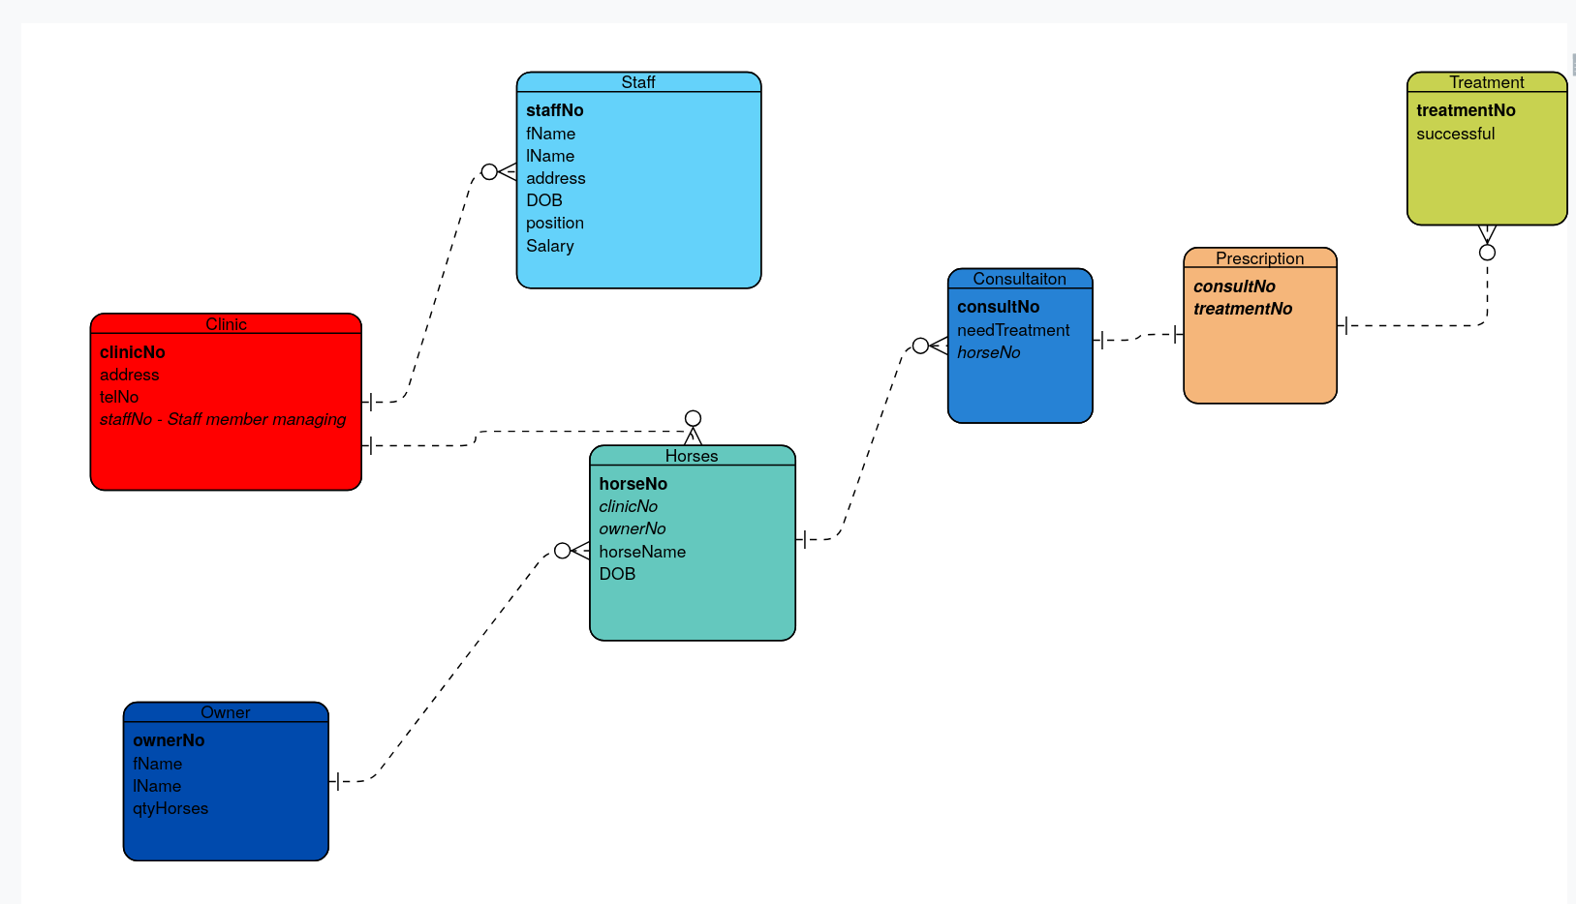
(d)

Staff Table: BCNF
Our staff table covers BCNF as it has:
- Unique column names
- Values are atomic
- No partial or transitive dependencies for attributes
- Has the super key of staffNo and clinicNo so it can access any piece of data throughout the entire database
Horse Table:
The horse entity covers BCNF as it aligns with
- Having unique column names
- Atomic values
- No partial or transitive dependencies
- Has horseNo,clinicNo and ownerNo as super keys to access any other attribute throughout the database.

Clinic Table :

The clinic is in BNCF as it:
- Sticks to 1Nf with unique column names and atomic values
- Respects the rules of 2NF and 3NF by having no partial or transitive dependencies
- And finally has a super key in clinicNo which is used in staff and especially the horse table.

Consultation Table:

This table aligns with BCNF as it has unique columns and atomic values, doesn’t have partial nor transitive dependencies due to the inclusion of the Consultation_Treatment table and finally has the superkey of consultNo and horseNo which lets it traverse throughout the database

Treatment Table:
The treatment table is quite a small table with only treatmentNo and successful as attributes however these are still unique and atomic values thus adhering to 1NF. From here we need to look at it’s dependencies and for these although we have the bridge table, from treatmentNo we can access any other tables, thus adhering to 2NF,3NF and BCNF.

Owner Table:

Going back to an earlier portion of the diagram, the ownerNo table aligns perfectly with all normal forms. It has all unique column names, atomic values, it can’t have any dependencies as it it’s own sole table connected through horse. This also brings us to how its in BCNF due to superkey of ownerNo which gives the table access to horseNo and so on so forth.

(e).

See SQL code files

