Group Project Product Backlog – Dementia Application

Group Members:

- Group leader & Machine Learning – Daniel Soden
- Database & Backend – Fawaz Olatunji
- Mobile Development – Ben Murphy
- Website Development – Gavin Moore

- Each group member in this project will do an equal amount of work relative to their role and also help others out when needed. For example, sectors such as machine learning and website development may not be as involved as say constructing and connecting a database across the project, or as complex as implementing all the different requirements in the mobile application’s questionnaire. So we will all pull our weight and help each other in other areas where required.
- Elements of this product backlog may change, this is primarily a guidline to keep us on track for each sprint.

Daniel Soden – Machine Learning/Agent Product backlog

Tech Stack:

Language(s): Primarily python3.13 , with some bash scripting when needed
Framework(s): CrewAI and Tensorflow
Other relevant technology: Git/Github & Deepseek platform

Product Backlog (Broken down into sprints)

Sprint 1 – Agent Setup

- Create yaml file for research agent
- Setup deepseek api for retrieval of data
- Create yaml file for research task
- Create yaml file for reporting agent
- Create yaml file for reporting task
- Design system to weekly retrieve said reports in a json format and send it to a mongodb or other form of database

Sprint 2 – Tensorflow beginnning

- Begin research and testing on taking train and test data with tensorflow
- Reformat cc and cd dementia data into true false speech pairs showing which do and don’t have dementia
- Begin tinkering with manual training of formatted data and then testing out with dementia data
- Test out training deepseek on the formatted cc and cd data and try out responses using crewai or simple query calls in python

Sprint 3 – Close up Tensorflow work

- Design and train a tensorflow model on this cc and cd data for risk assesment that returns back a value from 0-3 signifying no risk,low risk, medium risk, high risk.
- With said data, using deepseek, give a breakdown on why this user may or may not have dementia and save as a markdown response which is parsed on the mobile end for users upon payment

Fawaz Olatunji – Backend/Database

Tech Stack:

Language(s): Golang & PostgreSQL

Frameworks(s): Fiber (Go)

Product Backlog (Broken down into sprints)

Sprint 1 – Database design, Gin setup

- Get to terms with golang, gin and sqite syntax/differences between mysql syntax
- Design 2/3NF database tables for users, accounts, tests, results etc for exchange between mobile and web
- Have basic functionality of web server running for future of exchange of data between web and mobile.
- SQL Scripts made for creation of tables and potential selects designed.
- Tinker with docker containers so that product can run seamlessly on any machines.

Sprint 2- API Design

- Look into how to save user data in mobile and web applications and be able to select said data from either side
- Ensure data saved is able to be encrypted and decrypted easily (bcrypt etc)

Sprint 3 – Local Hosting

- Using docker, host the Postgresql and Mongo instance for the user and AI data
- Have the AI and web server running locally on Ben’s server.
- Look into optimizations for data being sent to and from the mobile app and web app

Ben Murphy – Mobile

Tech Stack:

Language(s): Kotlin

Frameworks(s): Jetpack compose (UI) & Springboot (Connection to backend)

Other relevant technology: Local android app simulation on personal device

Product Backlog (Broken down into sprints)

Sprint 1 – Basic UI, Signup, Login & Home

- Get to terms with Kotlin and then Jetpack compose elements for android
- Create a general mockup of three primary starting pages (Login,register & Home dashboard)
- Work on implementing said mockup in simplistic design pieces
- Create classes in kotlin to store user information
- Implement basic login & register functionality with volatile arraylist
- Create basic jetpack compose component for ai news cards in dashboard

Sprint 2- Questionnaire design

- Create classes for questions, results and any other necessary data stores
- Create singleton database connection to save patient data (patient end is mobile)
- Create components for question pages, keep answers in an array and save at the end of questionnaire.
- Tinker with speech to text api and if possible integrate into prototype tile in home page
- Integrate AI Components loading each week at home dashboard

Sprint 3 – Connection wrap up

- Along with AI news summaries for patients, include components on home dashboard showing statistics relating to the users likelihood of having dementia
- Implement payment system that upon finishing questionnaire and speech test, can get roughly accurate results from Large Language model

Gavin Moore – Web

Tech Stack:

Language(s): HTML, CSS & Typescript

Frameworks(s): ReactJS & Tailwind CSS

Product Backlog (Broken down into sprints) – Sprint content similar to Ben’s to keep progress parity.

Sprint 1 – Basic UI, Signup, Login & Home

- Get to terms with Reactjs and then tailwindcss so we can construct individual components
- Create a general mockup of three primary starting pages (Login,register & Home dashboard)
- Work on implementing said mockup in simplistic design pieces
- Create types in Typescript to store user information
- Implement basic login & register functionality with volatile array
- Create React component for ai research cards in dashboard

Sprint 2- Doctor evaluation design

- Create types for patient results and any other necessary data stores
- Create singleton database connection to save doctor and result data (doctor end is web)
- Create components for tables storing a doctors multitude of patients and their status
- Integrate AI Components loading each week at home dashboard

Sprint 3 – Connection wrap up

- Along with AI news summaries for doctors, include components on home dashboard showing statistics relating to the number of patients to evaluate and other information
- Ensure data can be sent to and from mobile application to the web application

Prototype/Progress

Code available at: github.com/daniel04soden/group-project

NMS-Backend – Database table setup and fiber hello world

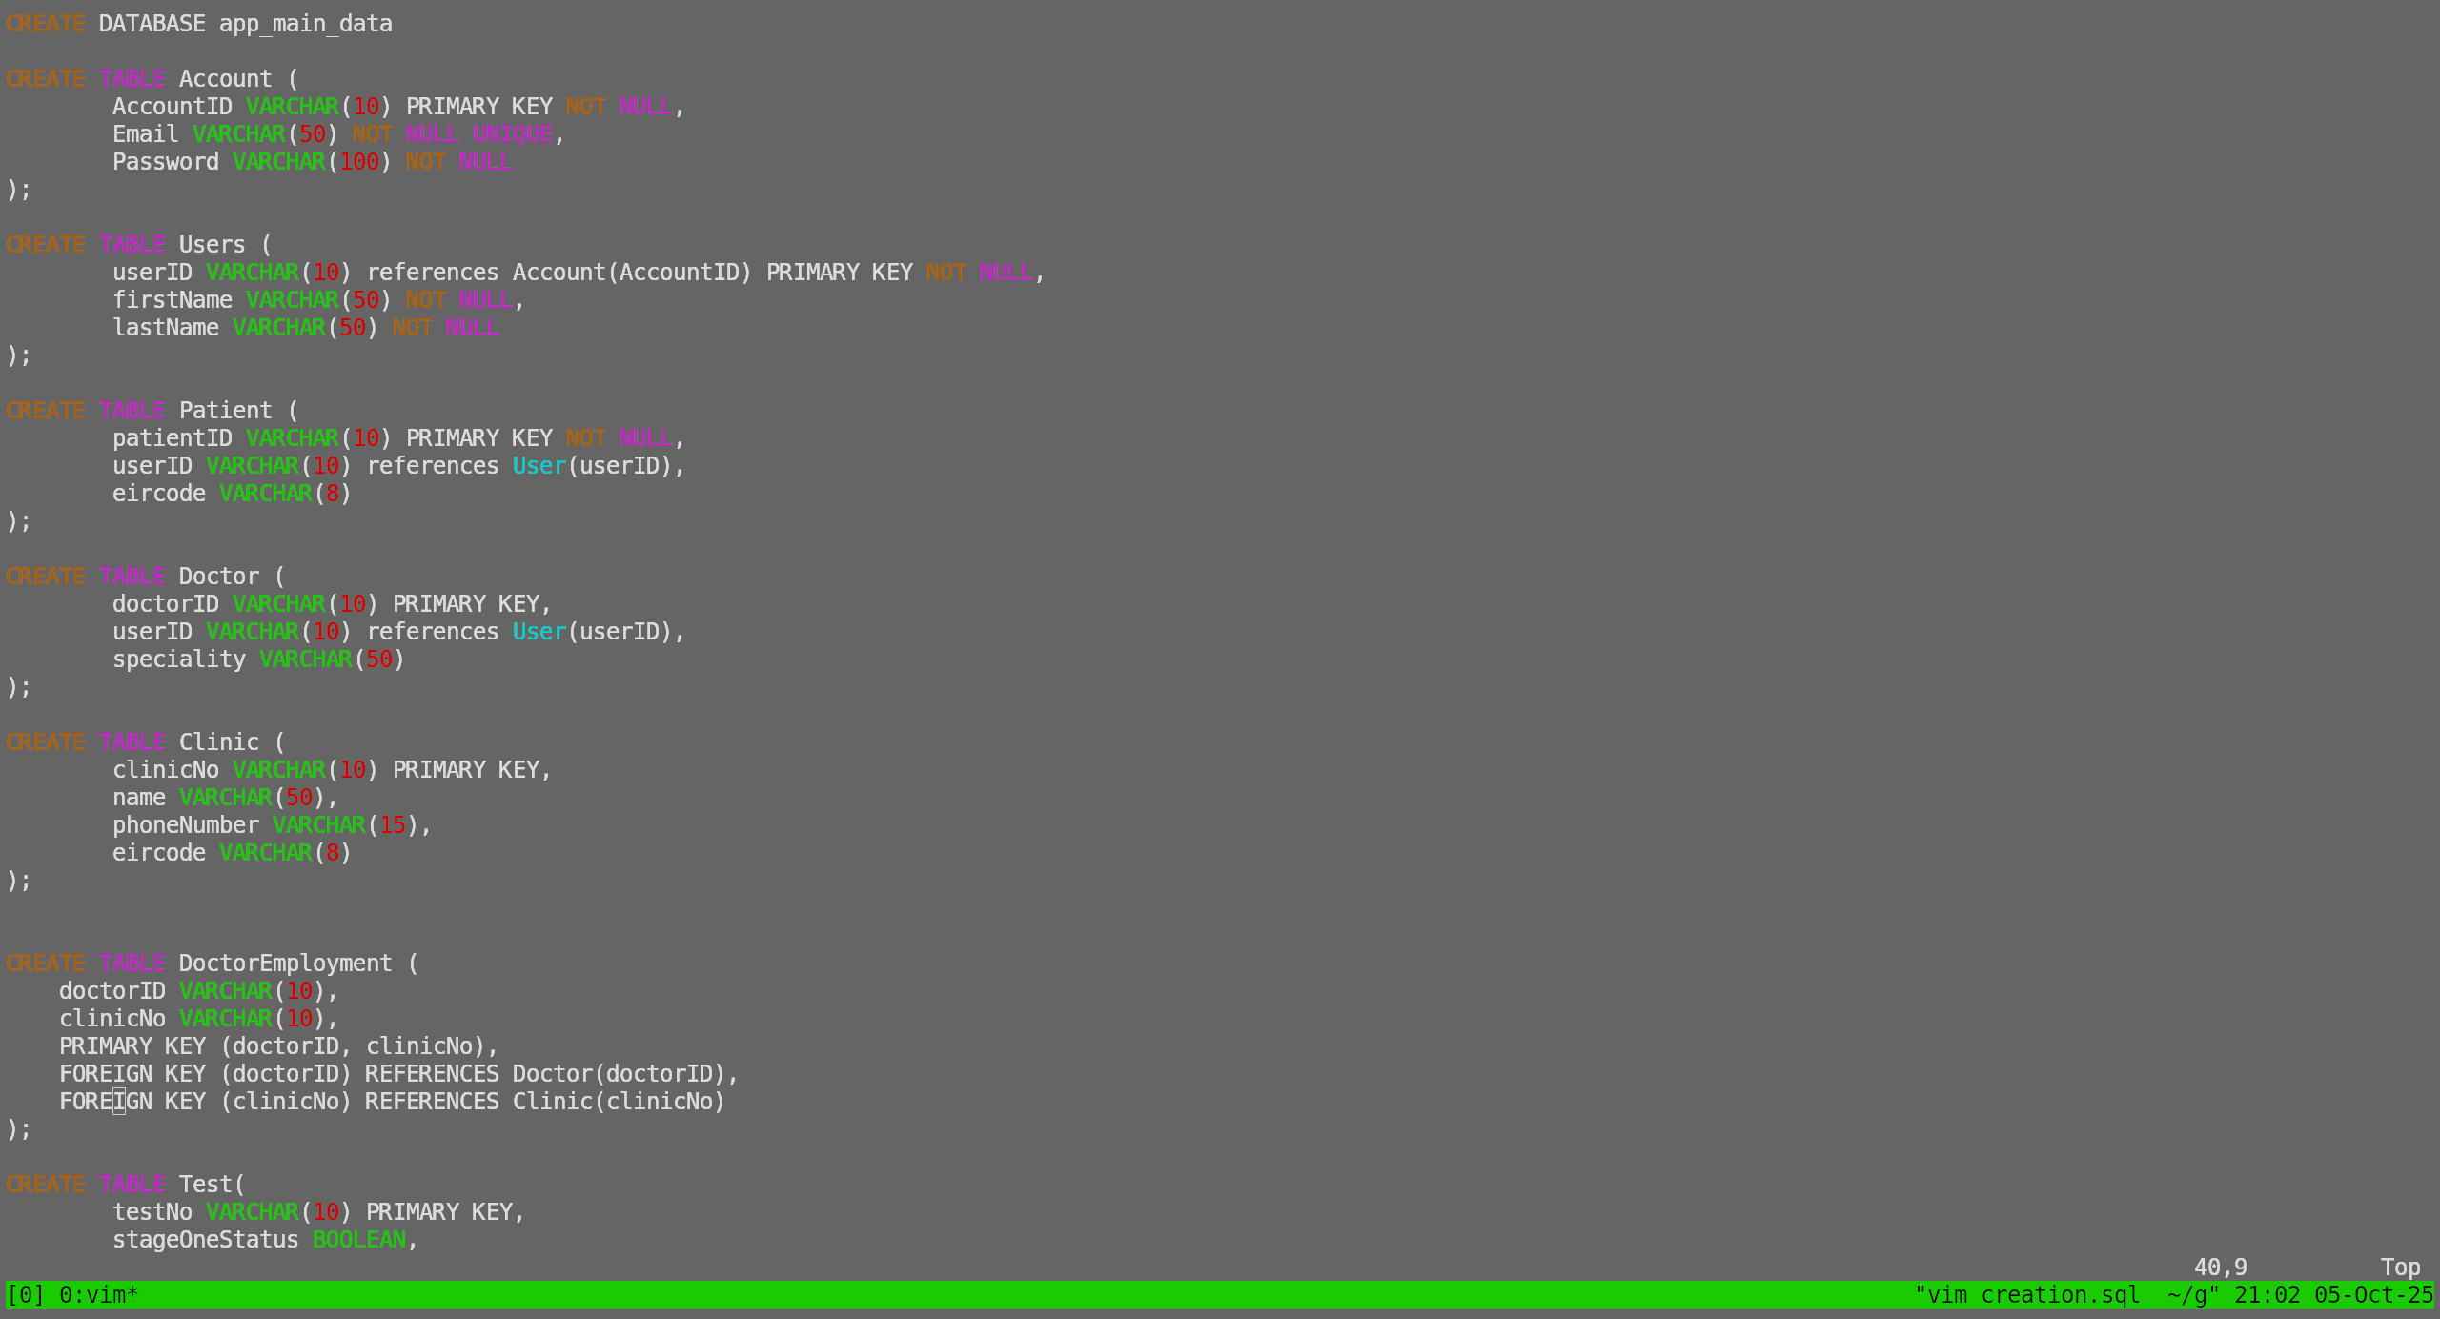
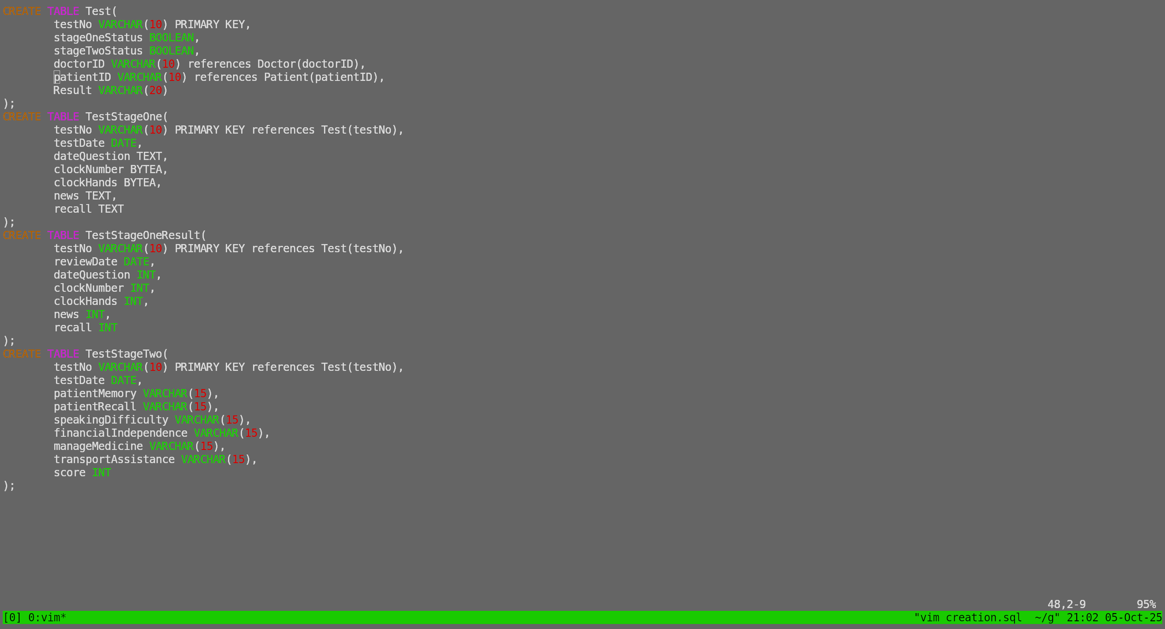

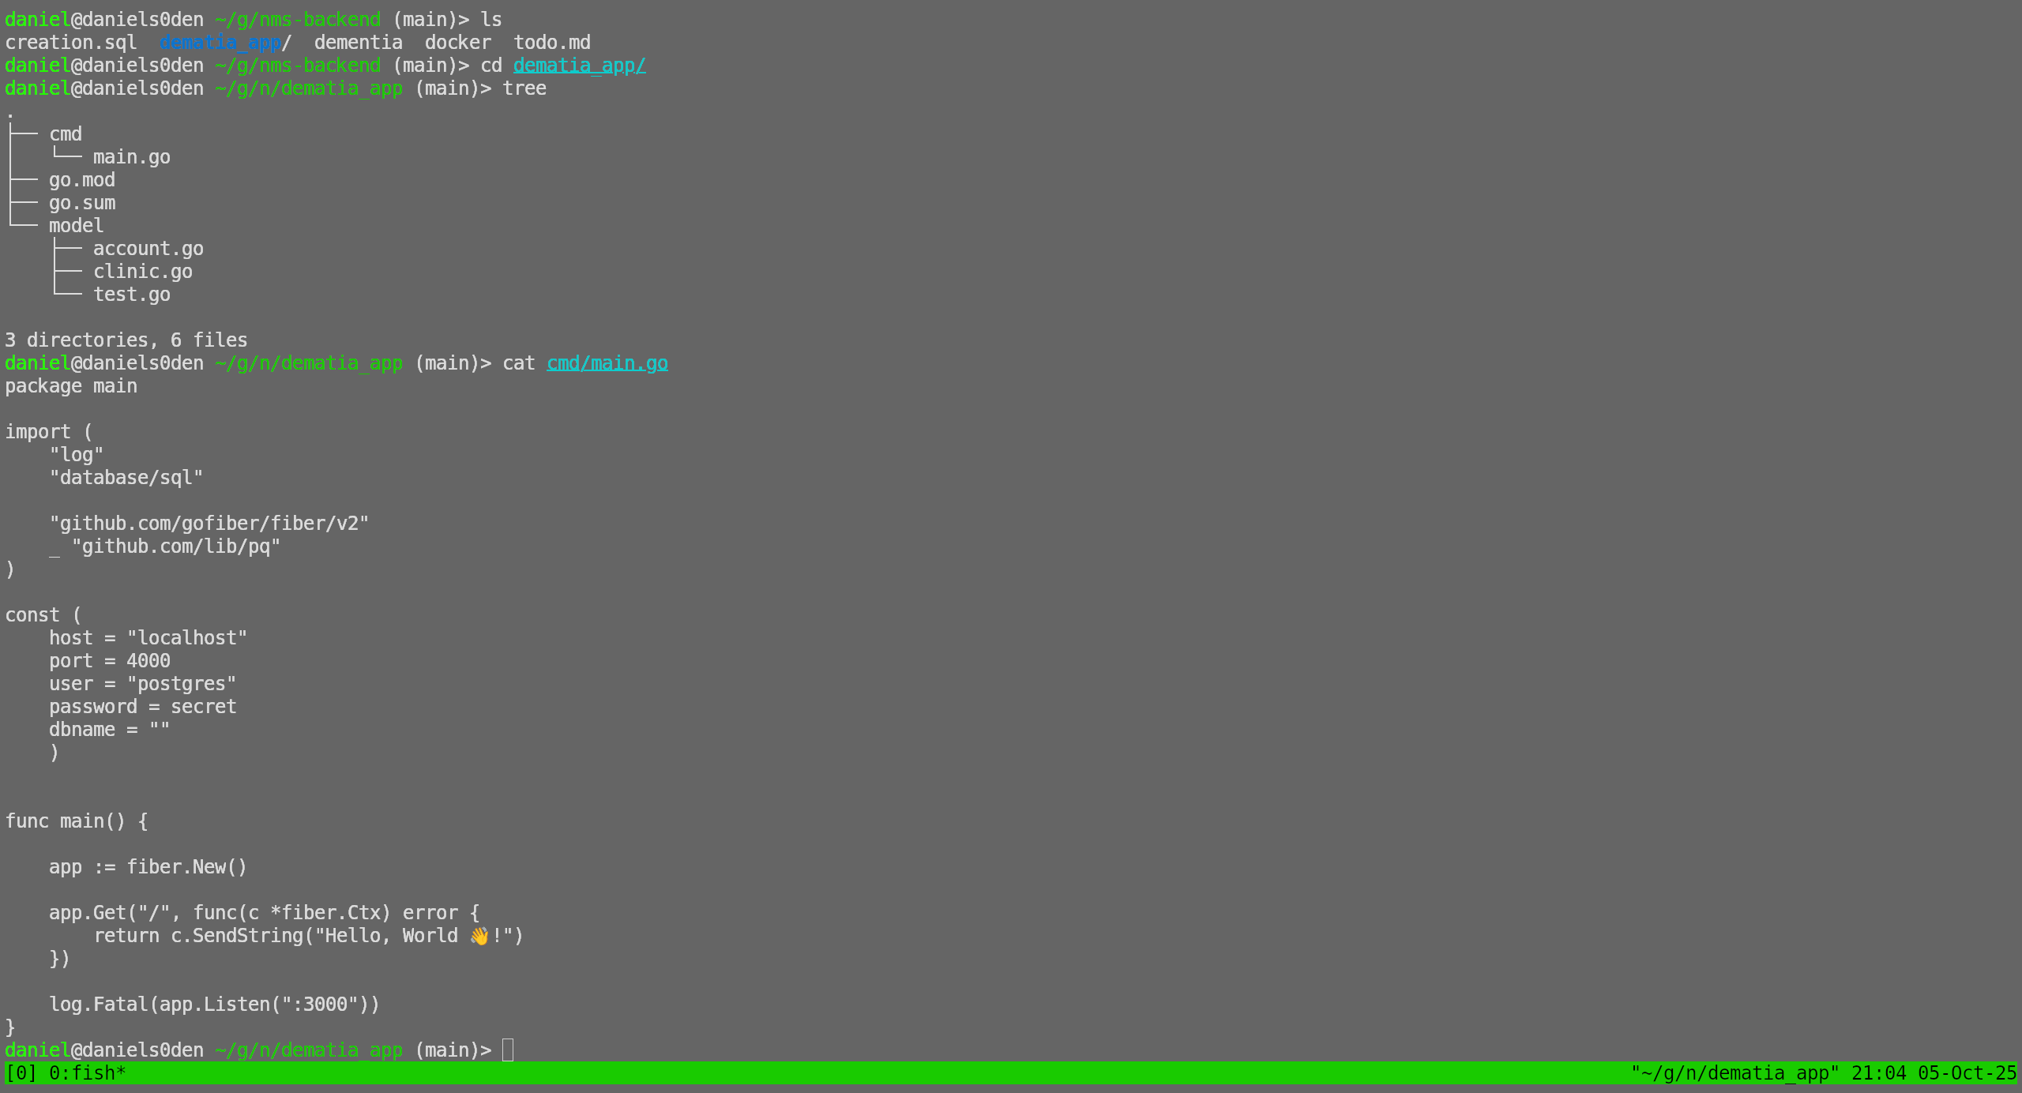
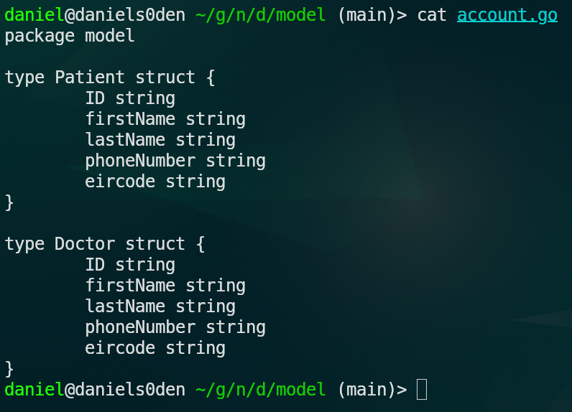
NMS-AI – Article research and retrieval

Agent descriptions:

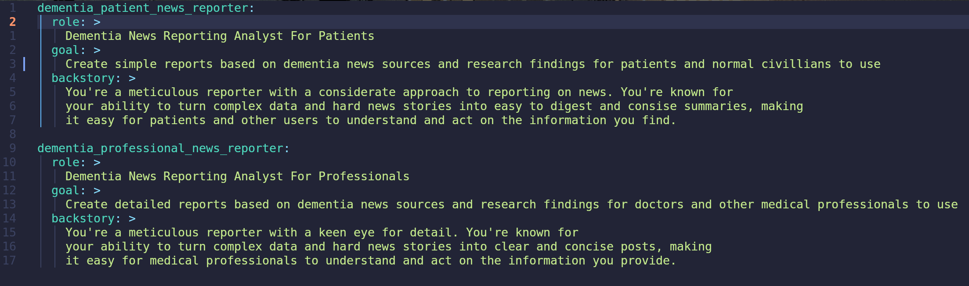

Task description for agents:

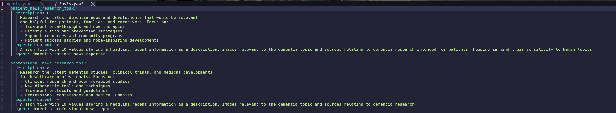
Sample json output:

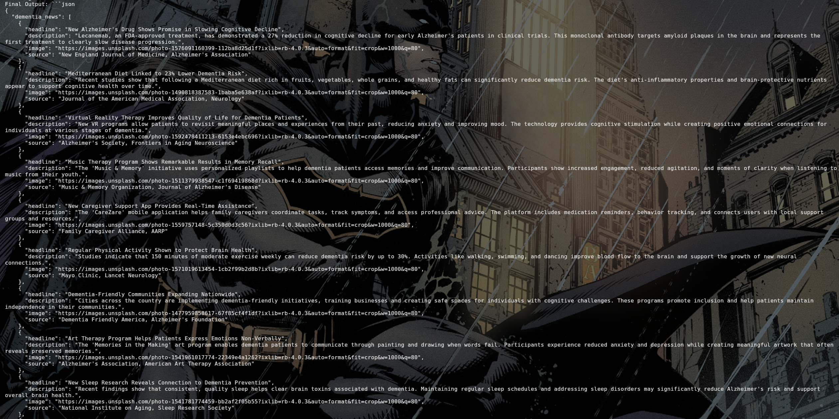
NMS-Web – Web application login,register and dashboard

Login Page:

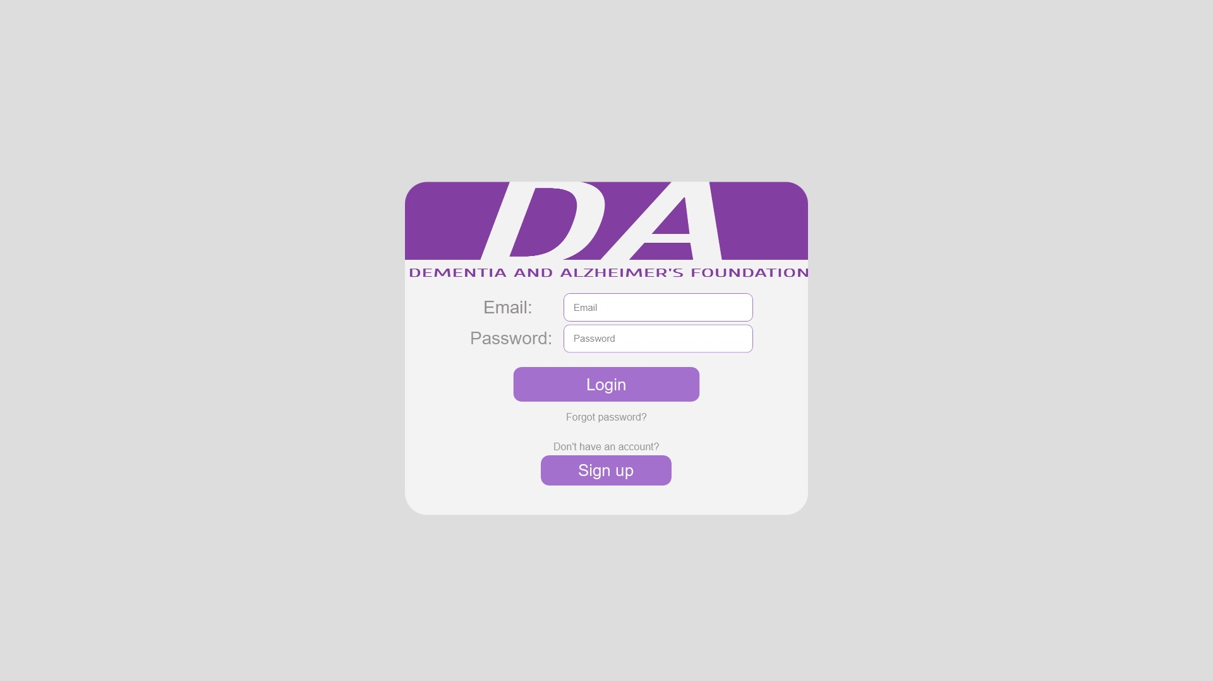
Registration Page:
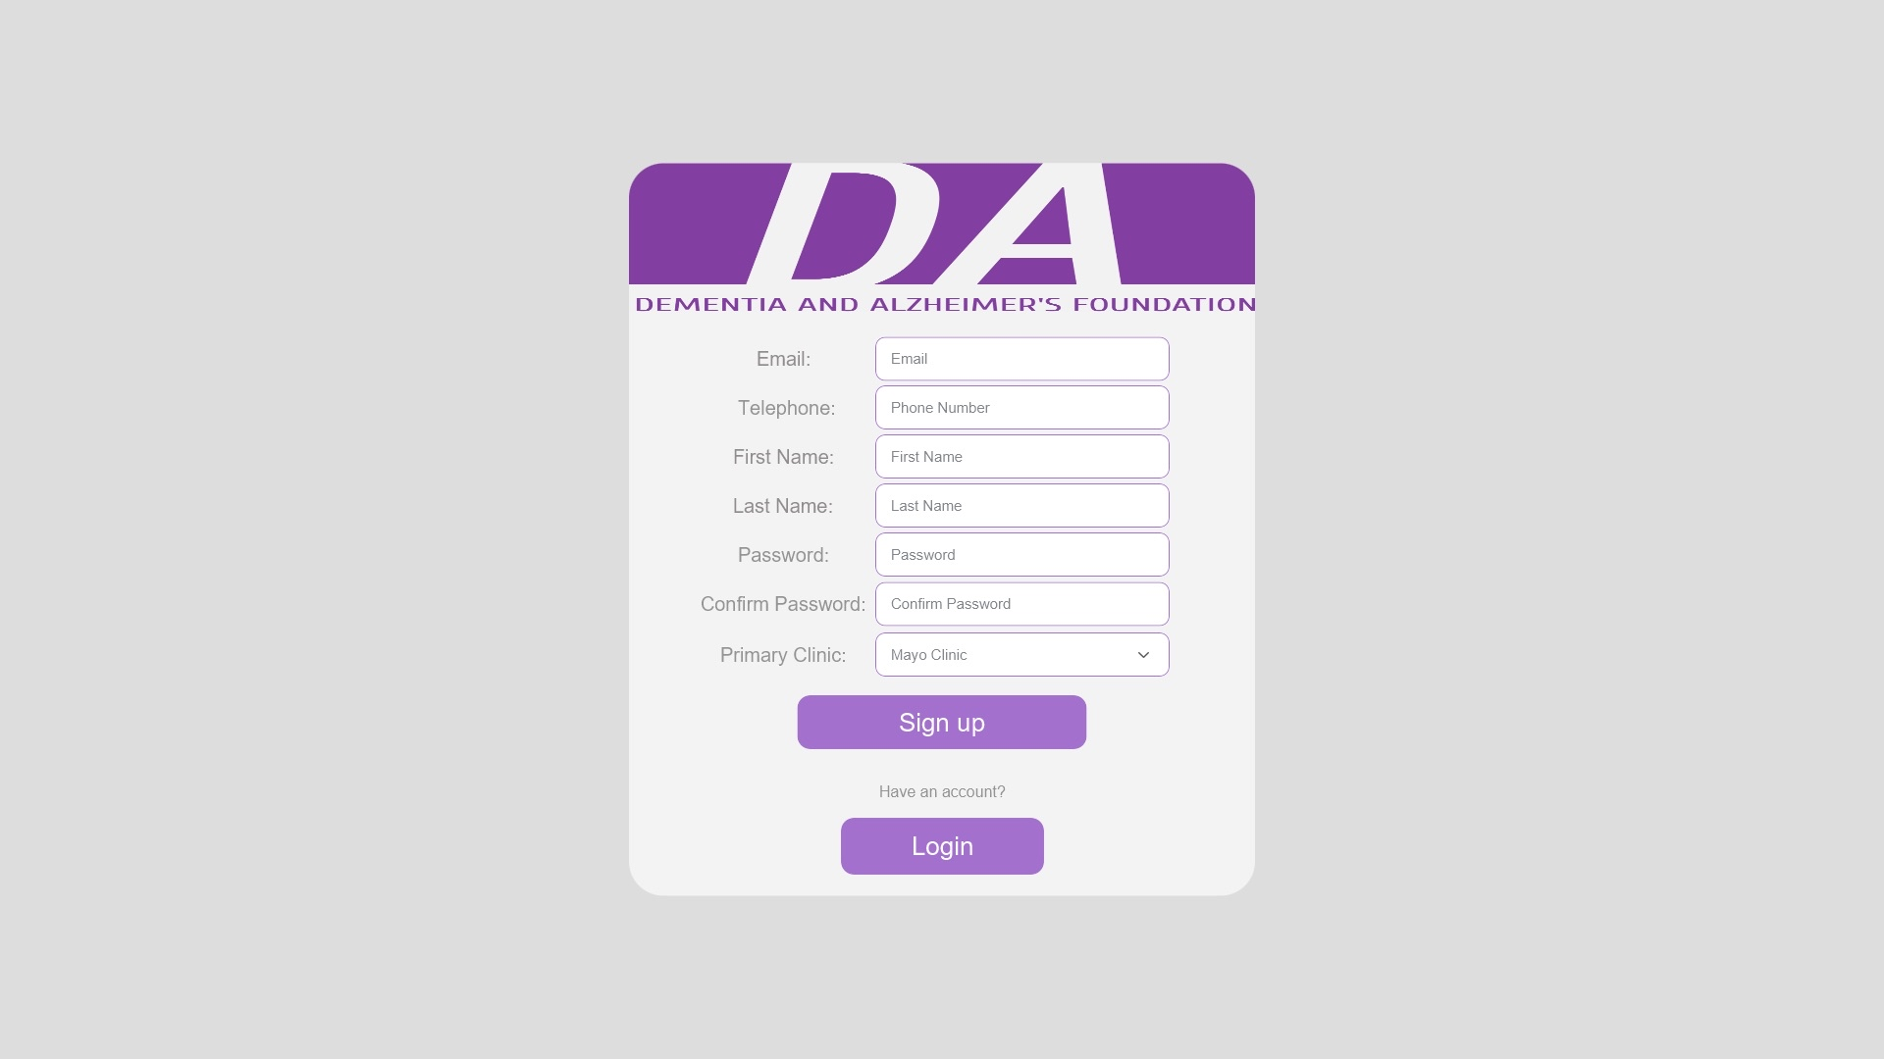

Home page:

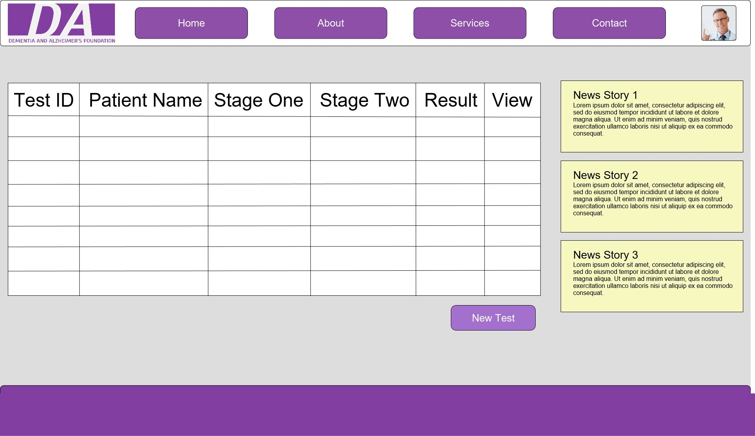

NMS-Mobile – Mobile application login,register, dashboard and test questions



