Daniel Soden Assignement 2 Report

Introduction:

For the next assignemtn as a continuation of our previous three stages, we will be implementing various design patterns,database connectivity, multi-threading and finally in a separate project folder, testing out Java’s use of heaps and stacks.

Assignment 2 Stage 1:

To start off we need to make a menu items to work with serialization and de-serialization in our Customer and product classes. Although the spec primarily requires only one demonstration of the singleton pattern and this form of serialisation and deserialisation, the code for both customers and products is so similar, I’ll demonstrate it across both classes.Keep in mind this report is being created sequentially as I complete the individual stages as to track progress so the following code when RDBMS connectivty is implemented, is subject to change.

To start off I made the customer and product controllers demonstrate the singleton pattern:

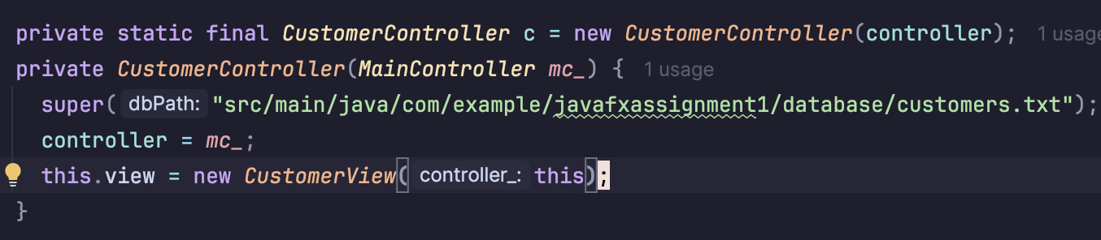

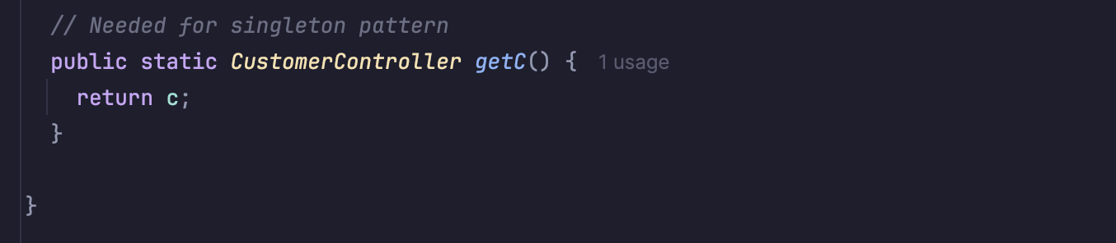
Then I did the same for the Product controller given these are going to be the classes that immplement serialization and de-serialization.

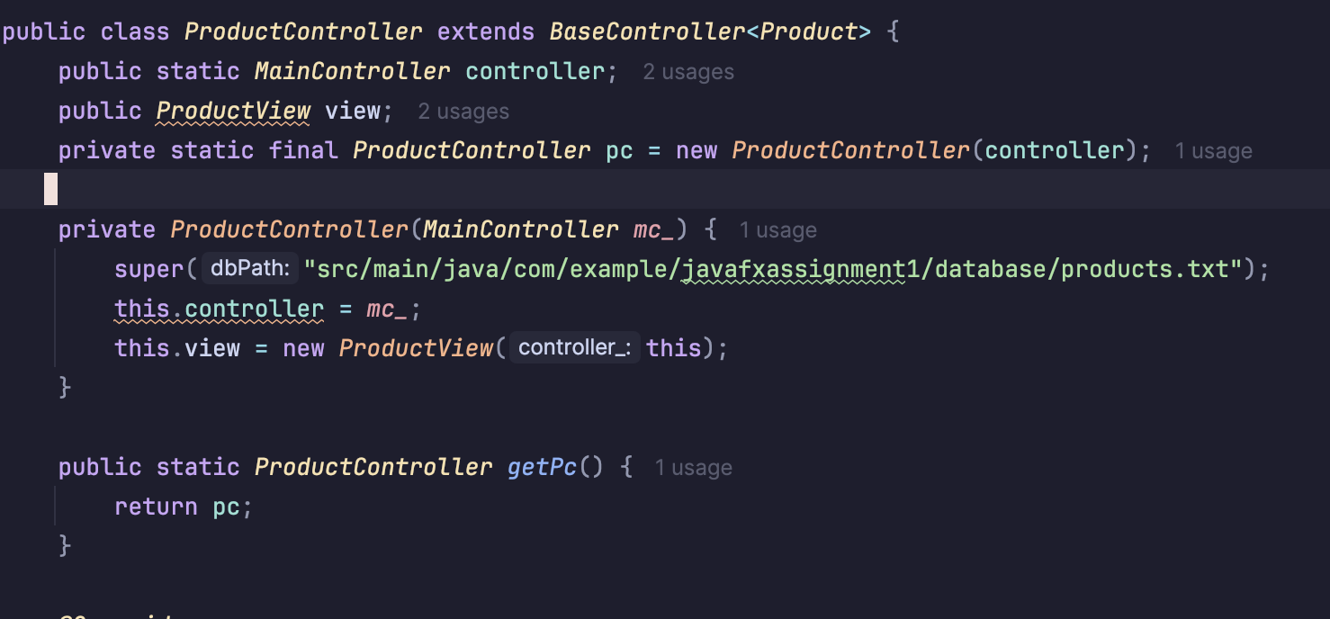
Finally here are these controllers having their single instance being demonstrated in the main controller, which I also made a singleton class.

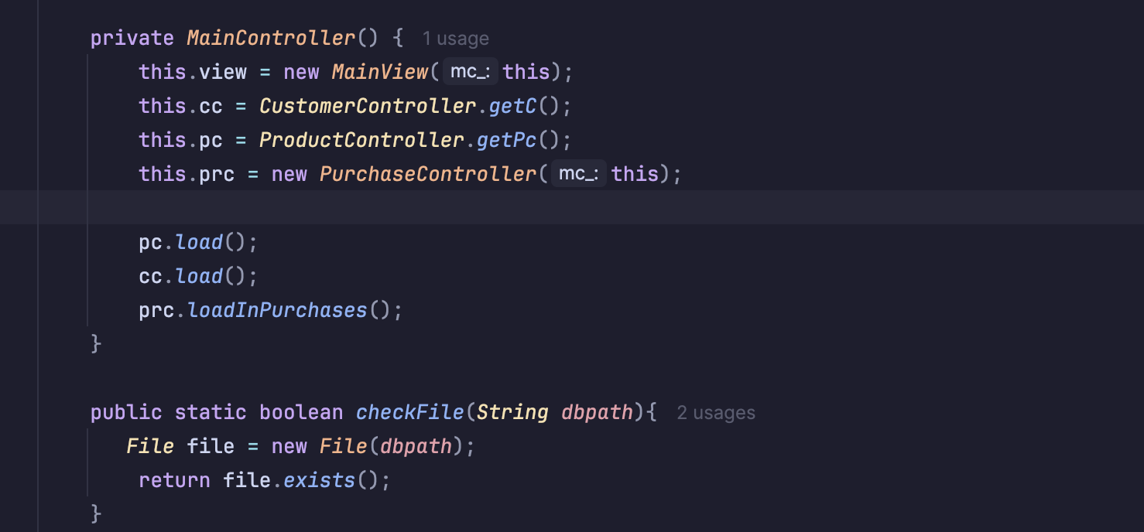
Here we are using their getters as to only use the one new static instance within their classes.

Assignment 2 Stage 2:

To start us off, following the structure of builders in the notes I made these adjustments to my model package:
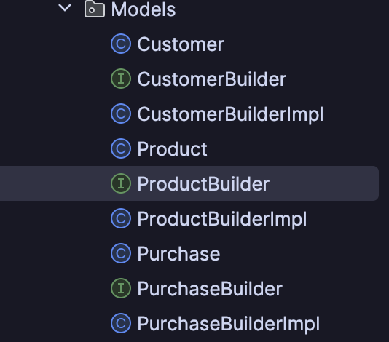

From here following the guideline of builders I created a general interface of setters for these builders and then implemented such interfaces in the Impl class:

