HW1 Object Detection Report
  - NYCU_314706007 莊竣堯

1. Model Description
  - Overview

Tried different models from papers on dense object detection task, lastly choose to use YOLOv8m structure for best result. I run the model on Google Colab, and YOLOv8m is the biggest YOLOv8 model that can put inside 15GB vram, and also has efficient speed and quality.

1.2 Architecture
- Yolov8m follows Backbone–Neck–Head structure.
  - Backbone: feature extraction (Conv, C2f, SPPF)
  - Neck: multi-scale feature fusion (upsampling + concatenation)
  - Head: detection at three scales (P3, P4, P5)
- Custom modifications
  - Changed input size: 640
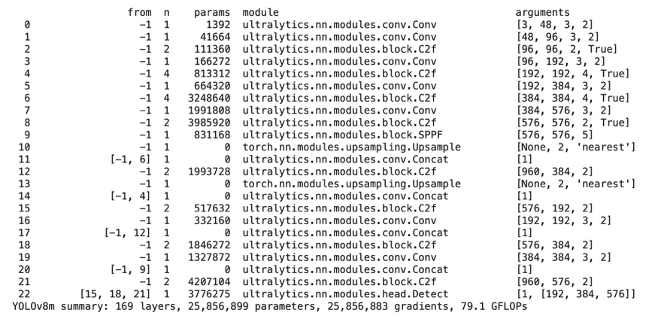
  - Modified number of classes to one class

2. Implementation Details

2.1 Dataset

Skipping 4 annotation entries without images: 00000604, 00000605, 00000606, 00000607

train images: 1140 | val images: 126 | total boxes: 38619, train/val ratio: 0.1

test images: 1864

2.2 Preprocessing & Augmentation
- Preprocessing:
Resize / Letterbox | Resizes the image so that its longest side = 640 while keeping aspect ratio. Pads with gray (114,114,114) to make it square.
Convert to RGB | Converts BGR (OpenCV default) → RGB.
Normalize | Divides pixel values by 255 → scales from [0,255] → [0,1].
Convert to Tensor | Converts H×W×3 to 3×H×W, and ensures float32.
Batch + Device transfer | Adds batch dimension, moves to CUDA, and applies half precision (FP16) if enabled.

- Augmentation:
Mosaic (p=1.0) | Combines 4 images into one large image, random placements. Strongly improves small-object recall.
MixUp (p=0.15) | Linearly blends two images and labels — regularization for dense scenes.
Random affine transform | Random rotation (±10°), translation (±10%), scale (0.5–1.5×), and shear (±2°).
Horizontal flip (p=0.5) | Mirror the image and swap bounding boxes horizontally.
HSV color-space augment | Random hue (±5°), saturation (±30%), and value (±30%).
Brightness/Contrast jitter | Varies lighting slightly per batch.

2.3 Hyperparameters
Parameter | Value | Description
Image Size | 640 | Input resolution
Batch Size | 16 | Number of images per batch
Epochs | 50 | Total training epochs
Optimizer | Adam / SGD | With learning rate schedule
Learning Rate | 0.01 | Initial LR
Momentum | 0.937 | As used in YOLOv8 default
Weight Decay | 0.0005 | Regularization term

2.4 Loss Functions
- Bounding box loss: CIoU + Distribution Focal Loss
- Classification loss: Binary Cross-Entropy (BCE)
- Confidence loss: BCE

2.5 Training Strategy
- In validation, set confidence threshold to 0.01, and IOU overlap threshold to 0.6 to get more bounding boxes. This is because the training data has dense object, so I think the more boxes we have the more likely we predict correctly and achieve higher score in Kaggle competition. The result also shows some improvement compare to different threshold.

3. Result Analysis

3.1 Quantitative Results
Model | mAP@50 | mAP@50–95 | Precision | Recall
YOLOv8n | 0.985 | 0.832 | 0.983 | 0.970
YOLOv8m | 0.990 | 0.867 | 0.986 | 0.975
Both YOLOv8 variants achieved excellent accuracy on the pig-detection dataset.
The medium model (YOLOv8m) performed slightly better than the nano version, showing higher mAP and balanced precision (0.986) and recall (0.975).
Its improvement mainly comes from the larger network capacity and effective augmentations such as Mosaic, MixUp, and HSV adjustments.

3.2 Qualitative Results
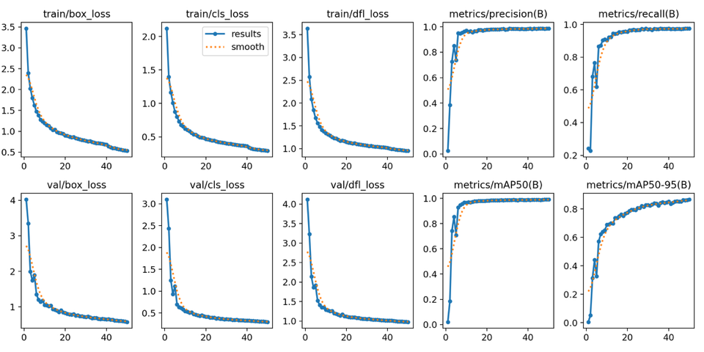

(a) Training curves – learning behavior
Loss curves decrease smoothly and stabilize after ~40 epochs, while precision, recall, and mAP steadily approach 1.0.
The close alignment between training and validation curves indicates good convergence and strong generalization.
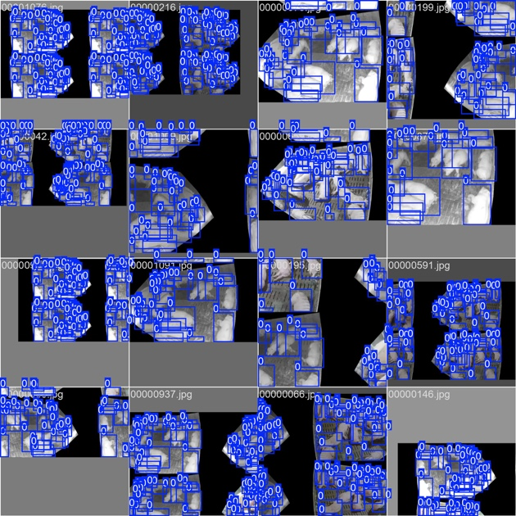

(b) Training-phase detections
Mosaic-composed images show consistent, high-confidence detections across varied scales and lighting.
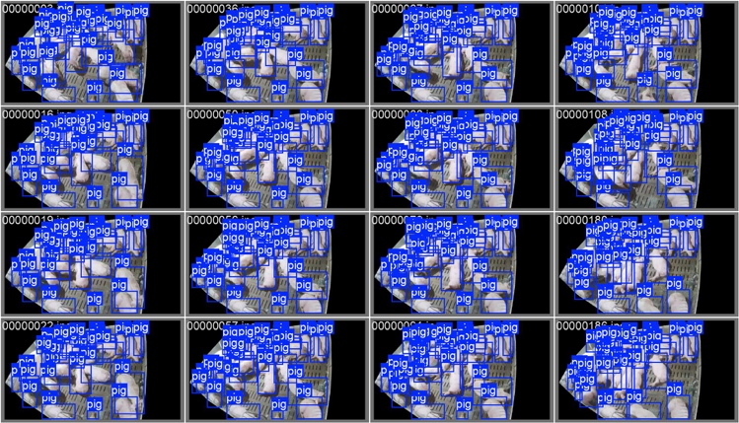
This confirms that data augmentation is functioning correctly and helps the model handle overlaps and occlusions effectively.

(c) Validation-phase detections
Validation images display accurate, single bounding boxes for each pig with confidence above 0.95.
The model generalizes well from augmented data to real scenes, achieving precise localization and minimal duplicate or missed detections.
Error analysis:
- Occasional misses occur for piglets or animals at image borders.
- Mild confidence drops appear under motion blur or low illumination.
These residual errors are consistent with the quantitative gap between mAP@50 (almost 1.0) and mAP@50–95 (≈ 0.86), reflecting tighter IoU thresholds being more sensitive to small-box localization.

4. Short Conclusion
This project demonstrated the successful customization of YOLOv8m for pig detection. The model was trained directly on a pig-specific dataset with tailored preprocessing, augmentations (Mosaic, MixUp, HSV, affine), and optimized hyperparameters for stable convergence. The final model achieved mAP@50 = 0.99, mAP@50–95 = 0.867, precision = 0.986, and recall = 0.975, showing excellent detection accuracy across different lighting, poses, and enclosure conditions. Remaining errors mainly involve small piglets, overlapping individuals, or motion blur, suggesting that future improvements could include targeted small-object augmentation and higher-resolution inputs. Overall, the fine-tuned YOLOv8m delivers high accuracy, real-time inference, and efficiency, making it a strong candidate for smart livestock monitoring and precision-farming applications.

