**Lab Report (Workshop 3)**

1. Project Download
2. Checkstyle config with Javadoc Comments and Indentation

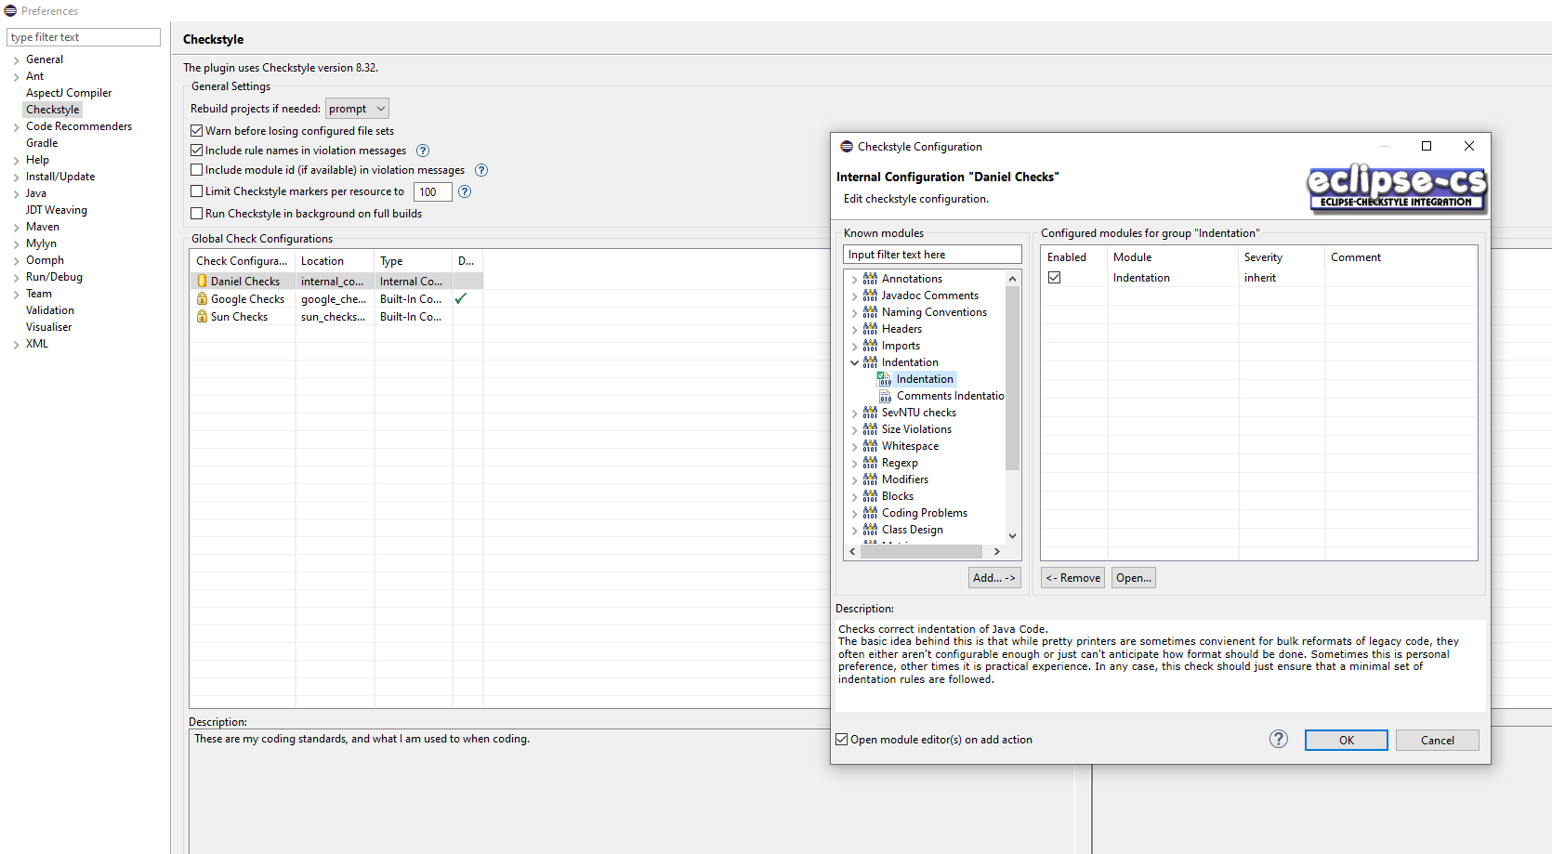

1. 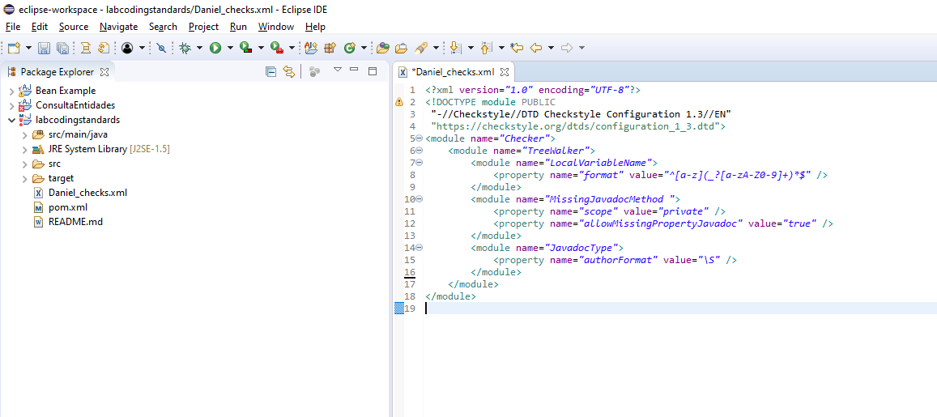Configure Checkstyle with XML
2. Checkstyle XML with headers

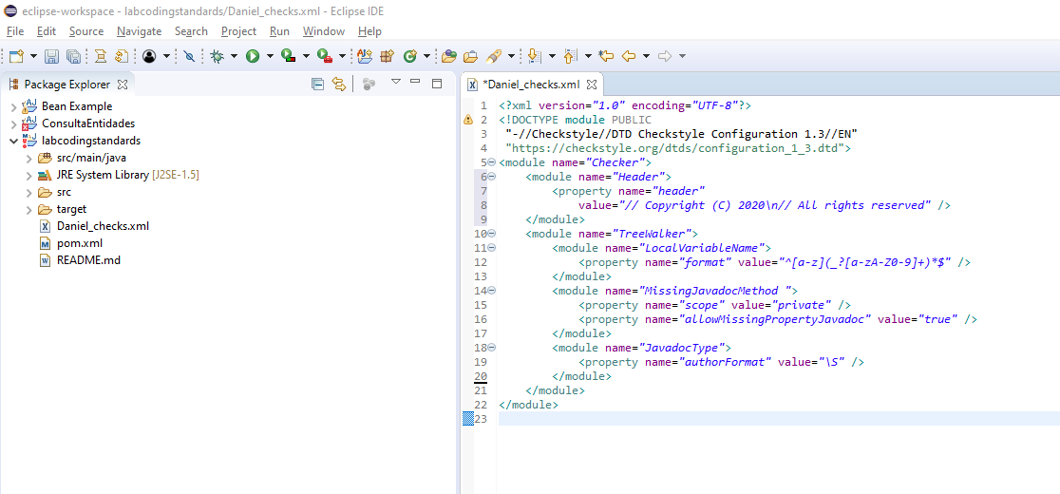

1. 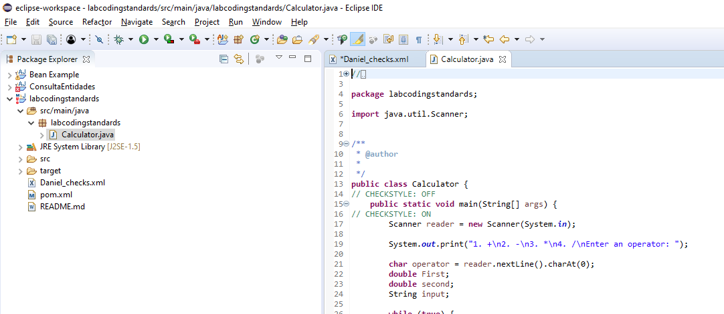Suppressing checkstyle
2. 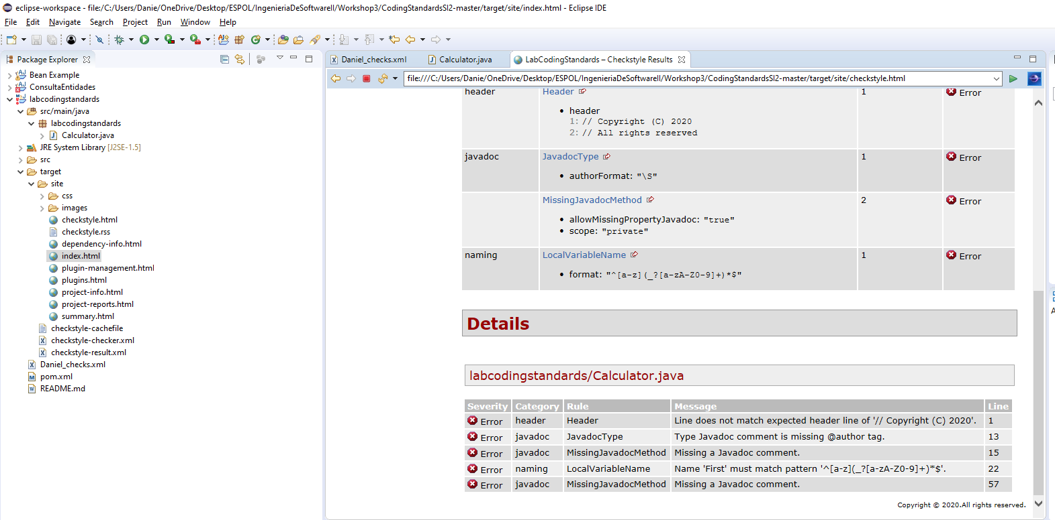Maven run
3. Autonomus work part:
   1. First checkstyle report:

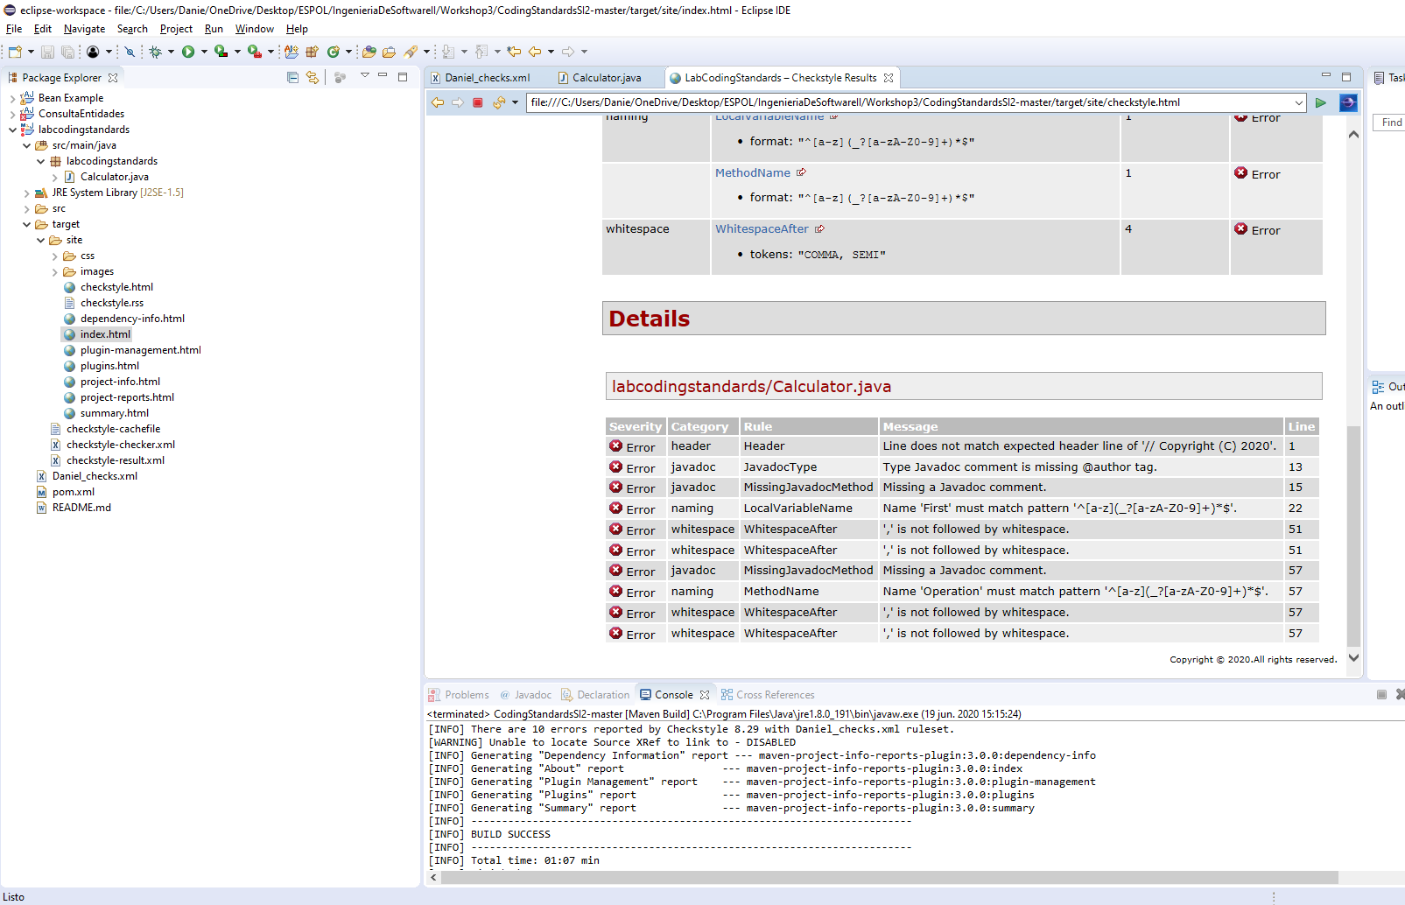

* 1. 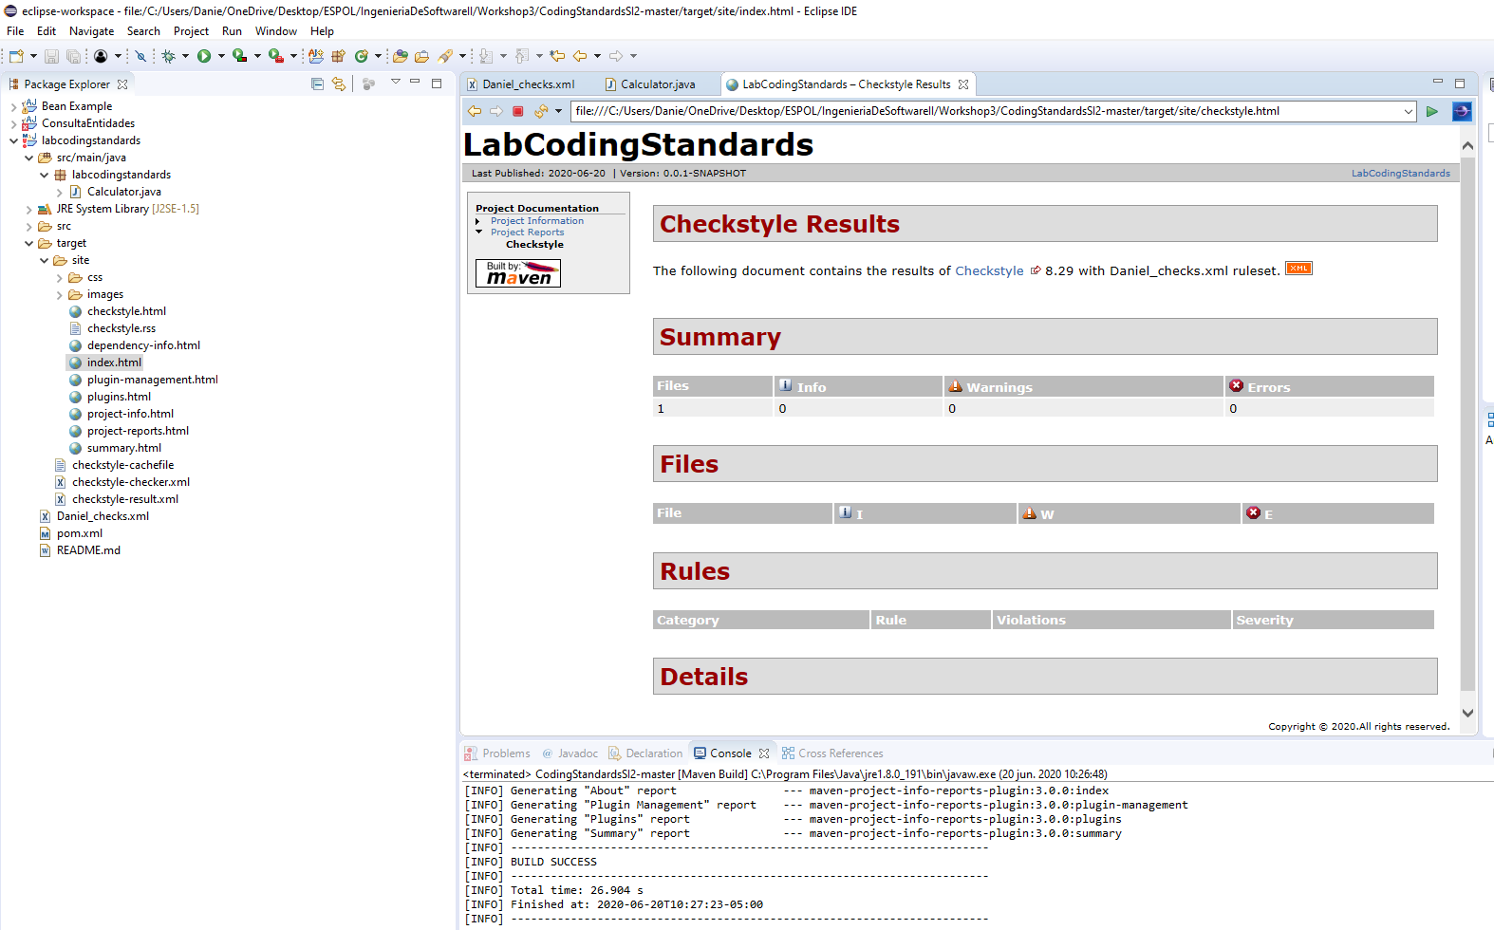Second checkstyle report (after correction):

Notes: for some reason de CHECKSTYLE OFF and ON comments did not affect the behavior of Checkstyle.

Repository Link: <https://github.com/daniel0ar/SE2_WorkShop3>