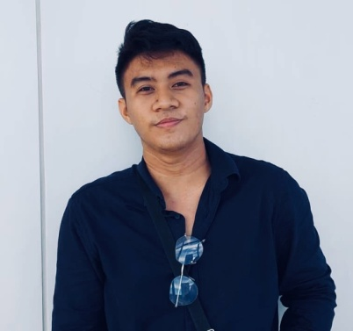

| **MARK DANIEL B. SY**  Masin Norte Candelaria Quezon  +639501441526  dandansy12@gmail.com |
| --- |

| **OBJECTIVES** |
| --- |

* To secure a challenging position in a reputable organization to expand my learnings, knowledge, and skills.
* Secure a responsible career opportunity to fully utilize my training and skills, while making a significant contribution to the success of the company.

| **PERSONAL INFORMATION** |
| --- |

Age : 23 y/o

Gender : Male

Date of Birth : February 06, 2000

Place of Birth : Masin Norte Candelaria Quezon

Religion : Catholic

Citizenship : Filipino

Civil Status : Single

Name of Mother : Victoria B. Sy

Name of Father : Michael C. Sy

| **EDUCATIONAL ATTAINMENT** |
| --- |

**Tertiary**  : **Bachelor of Science in Information**

**Technology (3nd year)**

Pamantasan ng Lungsod ng SanPablo

Brgy. San Jose, San Pablo City, Laguna

2018 TO PRESENT

| **SKILLS** |
| --- |

* Speaks Filipino and English languages
* Computer literate
* Skills in WEB DEVELOPING
* Layout Artist (Campus Journalism)
* Creative thinker

| **PERSONALITY** |
| --- |

* Very much willing to learn new things
* Responsible
* Hands on in the tasks given
* Hardworking

| **AFFILIATIONS** |
| --- |

| **Organization** | **Position** | **Year** |
| --- | --- | --- |
| 1. **BagongSinag***(Official School Publication of DalubhasaanngLunsodng San Pablo)* | Layout Artist | 2018-2019 |

| **CHARACTER REFERENCES** |
| --- |

* **Mr. Ralph KristianEustaquio**

College Nurse/ Publication Co-Adviser

DalubhasaanngLunsodng San Pablo

+639177010443

*I hereby declare that the details furnished above are true and correct to the best of my knowledge and belief and I undertake to inform you of any changes therein, immediately.*

*__________________________*

MARK DANIEL BAUTISTA SY

Applicant