Nicolas Sanchez

MW 8:30-9:45

3/4/20

Prof. Kubala

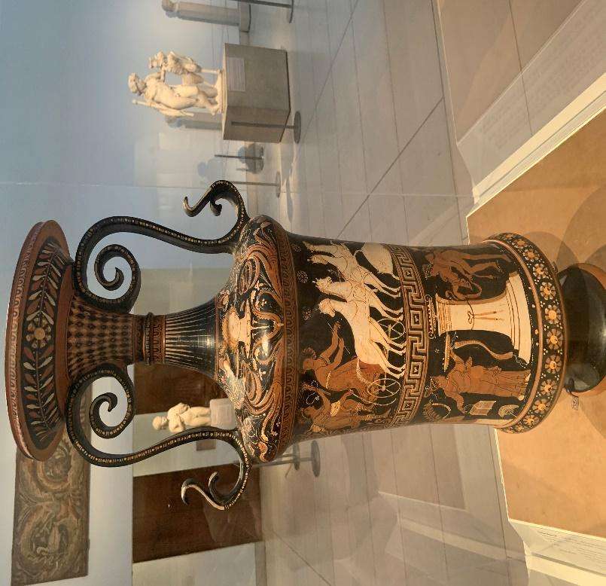

The item that I am researching for this assignment is called a *loutrophoros*. The questions that I will attempt to answer about this piece of artwork have to do with what medium was used to craft this item, what technique was used to make it, from what period it originates, where it was found, and what it meant to the people who used it. The sources I have used were very helpful in allowing me to answer these questions, and the UHD Library Database was the best place to look for them. Most of these sources are research journals that attempt to look at the time period in which these types of urns were used and the conditions for when they were used.