Results

Introduction
This is a quarto document. You would write your results normally, just like in word, but it adds all kinds of extra features. Here, you can add all your R code and analysis and integrate it into your writing, side-by-side. Lets show you an example.

Code chunks
First, there are special ‘code chunks’ that are inside the document. These are places where you put all your code. Here’s an example:

In line code

Results

Result2
Alright, now we are out of the code chunk and we write text just like normal again. However, in the work space we have some objects stored in R that we have access to now. So, if we want to summarize something about them we can do that here. Lets summarize the x and y objects above.
$$x_{b}=\frac{1}{2}$$
We can $σ_{3}$ see that the mean of x is 10.335527, which should match closely to the value 10….the inline code chunk you see above will render executable code. So, when you render the document that number will be put there.

Figures
Now, what about figures? We can create a figure in the code chunk below:
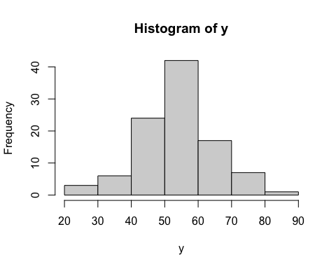
Fig 1- Here we talk about the figure
Now that we have this figure code chunk we can reference the figure by simply calling the label, which is Figure 1. We can see the summary in @tab-tab1
Mean | StDev
10.33553 | 1.898205
55.88096 | 9.766503

