Results

Fonti Kar

2020-09-10

$$I_{t}=V_{I}+(t^{2}.V_{S})+(2t.Cov_{I,S})$$

where $V_{I}$ is the among individual variance in intercepts, $t$ is the specific temperature at which repeatability is calculated for, $V_{S}$ is the among individual and $COV_{I,S}$ is the covariance between the intercept and slope at the among individual level. Temperature specific repeatability ($R_{t}$) is calculated as follows:

$$R_{t}=\frac{I_{t}}{(I_{t}+V_{session}+V_{e})}$$

where: $I_{t}$ is the variance among individuals at a particular temperature, $V_{session}$ is the variance due to sampling session and $V_{e}$ is residual variance.

$$R_{slope}=\frac{V_{I,slope}}{(V_{I,slope}+V_{series,slope})}$$

where: $V_{I,slope}$ is the among individual variance in the temperature slope term and the $V_{series,slope}$ is the among sampling session within individual variance in the temperature slope term

Table 1 Model coefficients of full model testing whether developmental temperature affects the elevation and slope of the thermal reaction norm of metabolic rate. This model used an imputated dataset, n = 6000

|  |  |  |  |
| --- | --- | --- | --- |
| Parameter | Estimate | Q2.5 | Q97.5 |
| b_lnmr_Intercept | -7.618 | -7.84 | -7.397 |
| b_lnmass_Intercept | -1.442 | -1.449 | -1.436 |
| b_lnmr_treatment29 | 0.135 | -0.069 | 0.344 |
| b_lnmr_temp | 0.077 | 0.072 | 0.081 |
| b_lnmr_z_age | -0.035 | -0.078 | 0.009 |
| b_lnmr_treatment29:temp | -0.005 | -0.011 | 0.002 |
| bsp_lnmr_milnmass | 0.622 | 0.507 | 0.733 |
| var_id__lnmr_Intercept | 0.012 | 0.001 | 0.038 |
| var_id__lnmr_temp | 0 | 0 | 0 |
| var_samp_session__lnmr_Intercept | 0.01 | 0.003 | 0.029 |
| var_series_temp__lnmr_Intercept | 0.044 | 0.04 | 0.049 |
| cov_id__lnmr_Intercept__lnmr_temp | -0.000115 | -0.000823 | 6.63e-05 |
| sigma_lnmr | 0.041 | 0.038 | 0.043 |
| sigma_lnmass | 0.043 | 0.041 | 0.045 |

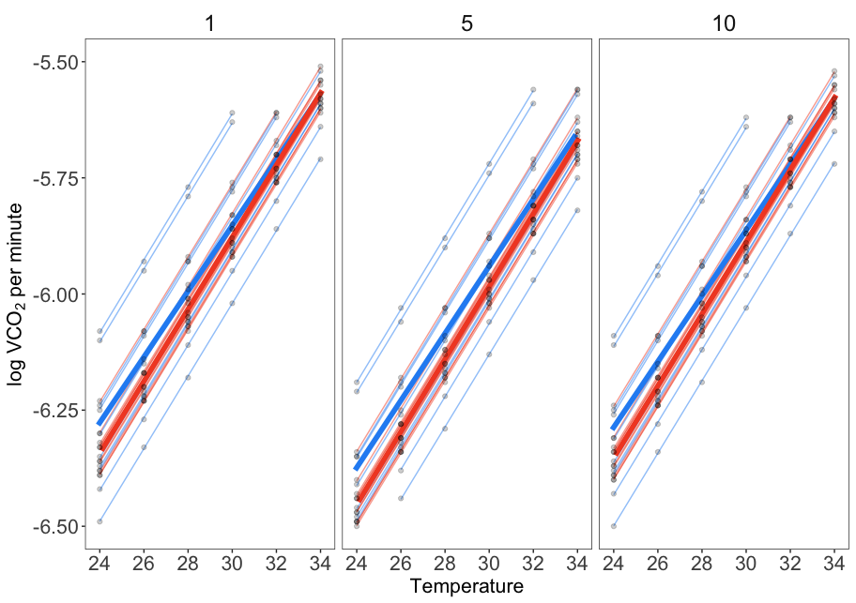

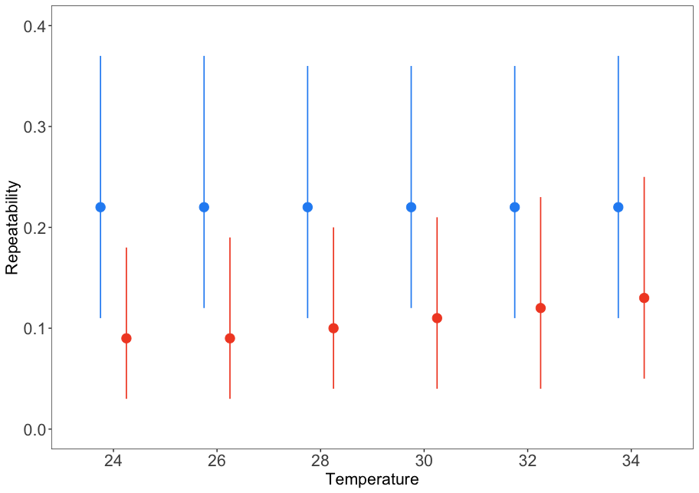

Table 2 Temeprature specific, adjusted repeatability estimates of log transformed metabolic rate for lizards from two developmental temperatures (n_hot = 25, n_cold = 26). These values were estimated from an imputation analysis, n_obs = 6000

|  |  |  |  |  |
| --- | --- | --- | --- | --- |
| treatment | temp | rpt | Lower | Upper |
| cold | 24 | 0.22 | 0.11 | 0.37 |
| cold | 26 | 0.22 | 0.12 | 0.37 |
| cold | 28 | 0.22 | 0.11 | 0.36 |
| cold | 30 | 0.22 | 0.12 | 0.36 |
| cold | 32 | 0.22 | 0.11 | 0.36 |
| cold | 34 | 0.22 | 0.11 | 0.37 |
| hot | 24 | 0.09 | 0.03 | 0.18 |
| hot | 26 | 0.09 | 0.03 | 0.19 |
| hot | 28 | 0.1 | 0.04 | 0.2 |
| hot | 30 | 0.11 | 0.04 | 0.21 |
| hot | 32 | 0.12 | 0.04 | 0.23 |
| hot | 34 | 0.13 | 0.05 | 0.25 |

## How does developmental temperature affect temperature specific repeatability

Across both treatment grounts, repeatability did not change across acute temperatures (Fig.2, Table XX). There were no differences in repeatability between developmental temperatures (Fig. 2, Table XX). Although in the complete case analysis there was a trend for the cold developmental temperatures to have on higher repeatabilty compared to the hot developmental temeprature however credible intervals overlapped partially (Fig. XX, Table XX) and this result was not reflected in the more conservative imputation analysis. The slope of the thermal reaction norm was repeatable in both treatment groups, however there were no treatment differences (Fig. XX and). This result should be interpretted with caution as repeatability of the slope was estimated with a large degree of uncertainty (95% CI)