ESM

Fonti Kar

2020-11-03

## Heterogenous variance

Model with homogenous variance was best supported by WAIC values. As such, we did not explicitly model residuals in all subsequent models

Table S1 Comparisons of WAIC values for homogenous and hetergenous residuals

|  |  |  |  |
| --- | --- | --- | --- |
| Model | WAIC value | ELPD Diff | SE Diff |
| Homogenous residuals | -3.61 | 0 | 0 |
| Heterogenous residuals | -2.09 | -0.76 | 2.08 |

Table S2 Model coefficients of full model testing whether developmental temperature affects the elevation and slope of the thermal reaction norm of metabolic rate. This model used a complete case dataset, n = 3818

|  |  |  |  |
| --- | --- | --- | --- |
| Parameter | Estimate | Q2.5 | Q97.5 |
| b_Intercept | -6.294 | -6.364 | -6.22 |
| b_treatment29 | -0.001 | -0.062 | 0.058 |
| b_z_temp | 0.262 | 0.246 | 0.279 |
| b_z_lnmass | 0.129 | 0.105 | 0.152 |
| b_z_age | -0.035 | -0.078 | 0.008 |
| b_treatment29:z_temp | -0.016 | -0.039 | 0.006 |
| var_id__Intercept | 0.009 | 0.006 | 0.015 |
| var_id__z_temp | 0 | 0 | 0.001 |
| var_samp_session__Intercept | 0.01 | 0.003 | 0.031 |
| var_series_temp__Intercept | 0.044 | 0.04 | 0.048 |
| cov_id__Intercept__z_temp | -0.00018 | -0.00128 | 0.000692 |
| sigma | 0.041 | 0.038 | 0.043 |

Table S3 Model coefficients of main effects model testing developmental temperature affects the elevation of the thermal reaction norm of metabolic rate. Output of this model was generated from an imputation analysis, n = 6000

|  |  |  |  |
| --- | --- | --- | --- |
| Parameter | Estimate | Q2.5 | Q97.5 |
| b_lnmr_Intercept | -6.292 | -6.366 | -6.219 |
| b_zlnmass_Intercept | 0 | -0.032 | 0.032 |
| b_lnmr_treatment29 | -0.003 | -0.062 | 0.055 |
| b_lnmr_z_temp | 0.254 | 0.241 | 0.265 |
| b_lnmr_z_age | -0.034 | -0.077 | 0.009 |
| bsp_lnmr_miz_lnmass | 0.128 | 0.104 | 0.152 |
| var_id__lnmr_Intercept | 0.009 | 0.006 | 0.014 |
| var_id__lnmr_z_temp | 0 | 0 | 0 |
| var_samp_session__lnmr_Intercept | 0.01 | 0.003 | 0.028 |
| var_series_temp__lnmr_Intercept | 0.044 | 0.04 | 0.049 |
| cov_id__lnmr_Intercept__lnmr_z_temp | -0.00017 | -0.00122 | 0.000672 |
| sigma_lnmr | 0.041 | 0.038 | 0.043 |
| sigma_zlnmass | 1 | 0.958 | 1.046 |

Table S4 Model coefficients of main effects model testing developmental temperature affects the elevation of the thermal reaction norm of metabolic rate. This model used a complete case dataset, n = 3818

|  |  |  |  |
| --- | --- | --- | --- |
| Parameter | Estimate | Q2.5 | Q97.5 |
| b_Intercept | -6.293 | -6.373 | -6.218 |
| b_treatment29 | -0.003 | -0.064 | 0.057 |
| b_z_temp | 0.254 | 0.242 | 0.266 |
| b_z_lnmass | 0.128 | 0.107 | 0.15 |
| b_z_age | -0.034 | -0.078 | 0.008 |
| var_id__Intercept | 0.009 | 0.006 | 0.015 |
| var_id__z_temp | 0 | 0 | 0.001 |
| var_samp_session__Intercept | 0.01 | 0.003 | 0.028 |
| var_series_temp__Intercept | 0.044 | 0.04 | 0.049 |
| cov_id__Intercept__z_temp | -0.000184 | -0.00131 | 0.000648 |
| sigma | 0.041 | 0.038 | 0.043 |

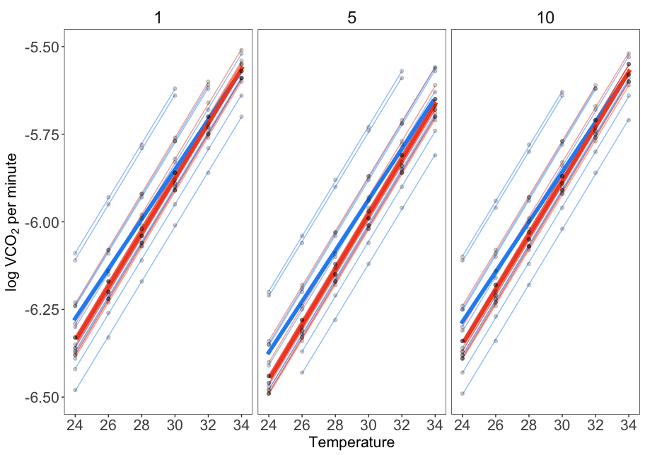

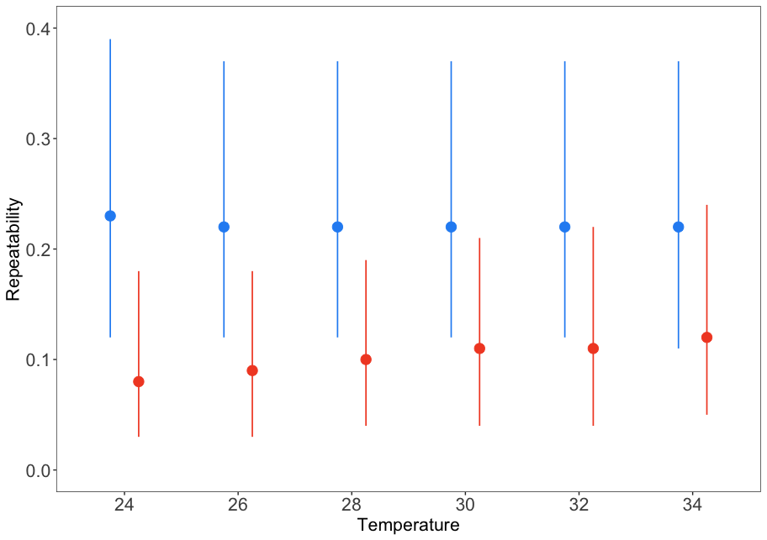

Table S5 Temeprature specific, adjusted repeatability estimates of log transformed metabolic rate for lizards from two developmental temperatures (n_hot = 25, n_cold = 26). These values were estimated from complete case dataset, n_obs = 3818

|  |  |  |  |  |
| --- | --- | --- | --- | --- |
| treatment | temp | rpt | Lower | Upper |
| cold | 24 | 0.24 | 0.12 | 0.4 |
| cold | 26 | 0.23 | 0.12 | 0.38 |
| cold | 28 | 0.22 | 0.12 | 0.37 |
| cold | 30 | 0.21 | 0.11 | 0.36 |
| cold | 32 | 0.21 | 0.1 | 0.36 |
| cold | 34 | 0.2 | 0.09 | 0.35 |
| hot | 24 | 0.09 | 0.03 | 0.2 |
| hot | 26 | 0.09 | 0.03 | 0.19 |
| hot | 28 | 0.09 | 0.03 | 0.19 |
| hot | 30 | 0.1 | 0.04 | 0.2 |
| hot | 32 | 0.11 | 0.04 | 0.22 |
| hot | 34 | 0.12 | 0.04 | 0.25 |

Table S6 Model coefficients of model whether body mass, temeperature and age predicts variation in metabolic rate. This imputation model used an subset dataset of lizards in the cold developmental temperature only n = 26, n_obs =

|  |  |  |  |
| --- | --- | --- | --- |
| Parameter | Estimate | Q2.5 | Q97.5 |
| b_lnmr_Intercept | -6.29 | -6.368 | -6.211 |
| b_zlnmass_Intercept | -0.05 | -0.091 | -0.007 |
| b_lnmr_z_temp | 0.262 | 0.243 | 0.279 |
| b_lnmr_z_age | -0.025 | -0.093 | 0.036 |
| bsp_lnmr_miz_lnmass | 0.117 | 0.081 | 0.153 |
| var_id__lnmr_Intercept | 0.015 | 0.008 | 0.028 |
| var_id__lnmr_z_temp | 0 | 0 | 0.001 |
| var_samp_session__lnmr_Intercept | 0.01 | 0.003 | 0.028 |
| var_series_temp__lnmr_Intercept | 0.046 | 0.039 | 0.053 |
| cov_id__lnmr_Intercept__lnmr_z_temp | -0.000628 | -0.00292 | 0.000782 |
| sigma_lnmr | 0.045 | 0.041 | 0.049 |
| sigma_zlnmass | 0.886 | 0.831 | 0.945 |

Table S7 Model coefficients of model whether body mass, temeperature and age predicts variation in metabolic rate. This imputation model used an subset dataset of lizards in the hot developmental temperature only n = 25, n_obs =

|  |  |  |  |
| --- | --- | --- | --- |
| Parameter | Estimate | Q2.5 | Q97.5 |
| b_lnmr_Intercept | -6.296 | -6.365 | -6.228 |
| b_zlnmass_Intercept | 0.05 | 0.003 | 0.096 |
| b_lnmr_z_temp | 0.246 | 0.229 | 0.264 |
| b_lnmr_z_age | -0.025 | -0.072 | 0.022 |
| bsp_lnmr_miz_lnmass | 0.132 | 0.104 | 0.164 |
| var_id__lnmr_Intercept | 0.005 | 0.002 | 0.011 |
| var_id__lnmr_z_temp | 0 | 0 | 0.001 |
| var_samp_session__lnmr_Intercept | 0.009 | 0.003 | 0.025 |
| var_series_temp__lnmr_Intercept | 0.043 | 0.037 | 0.049 |
| cov_id__lnmr_Intercept__lnmr_z_temp | 0.000277 | -0.000651 | 0.00152 |
| sigma_lnmr | 0.037 | 0.034 | 0.041 |
| sigma_zlnmass | 1.113 | 1.047 | 1.183 |

Table S7 Model coefficients of model whether body mass, temeperature and age predicts variation in metabolic rate. This model used a complete case dataset of lizards in the cold developmental temperature only n = 26, n_obs = 1897

|  |  |  |  |
| --- | --- | --- | --- |
| Parameter | Estimate | Q2.5 | Q97.5 |
| b_Intercept | -6.293 | -6.376 | -6.214 |
| b_z_temp | 0.262 | 0.244 | 0.28 |
| b_z_lnmass | 0.118 | 0.081 | 0.155 |
| b_z_age | -0.027 | -0.094 | 0.037 |
| var_id__Intercept | 0.016 | 0.008 | 0.03 |
| var_id__z_temp | 0 | 0 | 0.001 |
| var_samp_session__Intercept | 0.011 | 0.003 | 0.034 |
| var_series_temp__Intercept | 0.046 | 0.039 | 0.053 |
| cov_id__Intercept__z_temp | -0.000663 | -0.00306 | 0.000776 |
| sigma | 0.045 | 0.041 | 0.049 |

Table S9 Model coefficients of model whether body mass, temeperature and age predicts variation in metabolic rate. This imputation model used a complete case dataset of lizards in the hot developmental temperature only n = 25, n_obs = 1921

|  |  |  |  |
| --- | --- | --- | --- |
| Parameter | Estimate | Q2.5 | Q97.5 |
| b_Intercept | -6.293 | -6.361 | -6.222 |
| b_z_temp | 0.246 | 0.229 | 0.263 |
| b_z_lnmass | 0.133 | 0.102 | 0.164 |
| b_z_age | -0.025 | -0.07 | 0.018 |
| var_id__Intercept | 0.005 | 0.002 | 0.01 |
| var_id__z_temp | 0 | 0 | 0.001 |
| var_samp_session__Intercept | 0.009 | 0.003 | 0.026 |
| var_series_temp__Intercept | 0.043 | 0.037 | 0.049 |
| cov_id__Intercept__z_temp | 0.000255 | -0.000688 | 0.00171 |
| sigma | 0.037 | 0.034 | 0.041 |

Table S10 Model coefficients of model whether body mass, temeperature and age predicts variation in metabolic rate. In this model, we fitted a ‘series’ as random intercept with temeperature as a random slope to estimate repeatability of the slope. See Statistical Analyses for details. This imputation model used an subset dataset of lizards in the cold developmental temperature only n = 26, n_obs =

|  |  |  |  |
| --- | --- | --- | --- |
| Parameter | Estimate | Q2.5 | Q97.5 |
| b_lnmr_Intercept | -6.289 | -6.342 | -6.237 |
| b_zlnmass_Intercept | -0.05 | -0.09 | -0.01 |
| b_lnmr_z_temp | 0.261 | 0.244 | 0.278 |
| b_lnmr_z_age | -0.012 | -0.049 | 0.029 |
| bsp_lnmr_miz_lnmass | 0.136 | 0.099 | 0.172 |
| var_id__lnmr_Intercept | 0.015 | 0.007 | 0.028 |
| var_id__lnmr_z_temp | 0 | 0 | 0.001 |
| var_series__lnmr_Intercept | 0.015 | 0.01 | 0.022 |
| var_series__lnmr_z_temp | 0 | 0 | 0.002 |
| var_series_temp__lnmr_Intercept | 0.037 | 0.03 | 0.043 |
| cov_id__lnmr_Intercept__lnmr_z_temp | -0.000579 | -0.00303 | 0.00084 |
| cov_series__lnmr_Intercept__lnmr_z_temp | -0.00043 | -0.00273 | 0.00136 |
| sigma_lnmr | 0.045 | 0.041 | 0.049 |
| sigma_zlnmass | 0.886 | 0.833 | 0.942 |

Table S11 Model coefficients of model whether body mass, temeperature and age predicts variation in metabolic rate. In this model, we fitted a ‘series’ as random intercept with temeperature as a random slope to estimate repeatability of the slope. See Statistical Analyses for details. This imputation model used an subset dataset of lizards in the hot developmental temperature only n = 25, n_obs =

|  |  |  |  |
| --- | --- | --- | --- |
| Parameter | Estimate | Q2.5 | Q97.5 |
| b_lnmr_Intercept | -6.299 | -6.328 | -6.268 |
| b_zlnmass_Intercept | 0.05 | 0.003 | 0.096 |
| b_lnmr_z_temp | 0.245 | 0.229 | 0.262 |
| b_lnmr_z_age | -0.003 | -0.038 | 0.03 |
| bsp_lnmr_miz_lnmass | 0.124 | 0.093 | 0.155 |
| var_id__lnmr_Intercept | 0.003 | 0 | 0.008 |
| var_id__lnmr_z_temp | 0 | 0 | 0.001 |
| var_series__lnmr_Intercept | 0.013 | 0.008 | 0.019 |
| var_series__lnmr_z_temp | 0.001 | 0 | 0.002 |
| var_series_temp__lnmr_Intercept | 0.035 | 0.03 | 0.041 |
| cov_id__lnmr_Intercept__lnmr_z_temp | 0.000272 | -0.000577 | 0.00153 |
| cov_series__lnmr_Intercept__lnmr_z_temp | -0.00134 | -0.00388 | 0.000432 |
| sigma_lnmr | 0.037 | 0.034 | 0.041 |
| sigma_zlnmass | 1.113 | 1.043 | 1.182 |

Table S10 Model coefficients of model whether body mass, temeperature and age predicts variation in metabolic rate. In this model, we fitted a ‘series’ as random intercept with temeperature as a random slope to estimate repeatability of the slope. See Statistical Analyses for details. This model used a complete case dataset of lizards in the cold developmental temperature only n = 26, n_obs = 1897

|  |  |  |  |
| --- | --- | --- | --- |
| Parameter | Estimate | Q2.5 | Q97.5 |
| b_Intercept | -6.291 | -6.342 | -6.241 |
| b_z_temp | 0.261 | 0.244 | 0.278 |
| b_z_lnmass | 0.136 | 0.098 | 0.172 |
| b_z_age | -0.011 | -0.05 | 0.028 |
| var_id__Intercept | 0.015 | 0.007 | 0.029 |
| var_id__z_temp | 0 | 0 | 0.001 |
| var_series__Intercept | 0.015 | 0.01 | 0.022 |
| var_series__z_temp | 0 | 0 | 0.001 |
| var_series_temp__Intercept | 0.037 | 0.03 | 0.044 |
| cov_id__Intercept__z_temp | -0.000575 | -0.00289 | 0.000882 |
| cov_series__Intercept__z_temp | -0.000417 | -0.00283 | 0.00138 |
| sigma | 0.045 | 0.041 | 0.049 |

Table S11 Model coefficients of model whether body mass, temeperature and age predicts variation in metabolic rate. In this model, we fitted a ‘series’ as random intercept with temeperature as a random slope to estimate repeatability of the slope. See Statistical Analyses for details. This model used a complete case dataset of lizards in the cold developmental temperature only n = 26, n_obs = 1921

|  |  |  |  |
| --- | --- | --- | --- |
| Parameter | Estimate | Q2.5 | Q97.5 |
| b_Intercept | -6.298 | -6.329 | -6.268 |
| b_z_temp | 0.246 | 0.229 | 0.263 |
| b_z_lnmass | 0.124 | 0.095 | 0.155 |
| b_z_age | -0.004 | -0.037 | 0.03 |
| var_id__Intercept | 0.003 | 0 | 0.008 |
| var_id__z_temp | 0 | 0 | 0.001 |
| var_series__Intercept | 0.013 | 0.008 | 0.019 |
| var_series__z_temp | 0.001 | 0 | 0.002 |
| var_series_temp__Intercept | 0.035 | 0.03 | 0.042 |
| cov_id__Intercept__z_temp | 0.000308 | -0.000551 | 0.00158 |
| cov_series__Intercept__z_temp | -0.00134 | -0.00366 | 0.00037 |
| sigma | 0.037 | 0.034 | 0.041 |

Table S14 Model coefficients of model testing whether body mass, temeperature and age predicts variation in metabolic rate. This was an imputation model used a subset dataset of sampling session one only n = 25, nobs = 3000. Mass and MR was log transformed and Age was z-transformed. Bolded estimates are significantly different from zero. Values with * indicate very small values that are still greater than zero

|  |  |  |  |
| --- | --- | --- | --- |
| Parameter | Estimate | Q2.5 | Q97.5 |
| b_lnmr_Intercept | -8.117 | -8.693 | -7.54 |
| b_lnmass_Intercept | -1.638 | -1.656 | -1.619 |
| b_lnmr_treatment29 | -0.049 | -0.663 | 0.579 |
| b_lnmr_temp | 0.082 | 0.066 | 0.097 |
| b_lnmr_z_age | -0.017 | -0.096 | 0.064 |
| b_lnmr_treatment29:temp | 0 | -0.022 | 0.021 |
| bsp_lnmr_milnmass | 0.322 | 0.094 | 0.556 |
| var_id__lnmr_Intercept | 0.016 | 0 | 0.109 |
| var_id__lnmr_temp | 0 | 0 | 0 |
| var_series_temp__lnmr_Intercept | 0.043 | 0.028 | 0.06 |
| cov_id__lnmr_Intercept__lnmr_temp | -0.000338 | -0.00299 | 6.94e-05 |
| sigma_lnmr | 0.039 | 0.031 | 0.047 |
| sigma_lnmass | 0.034 | 0.03 | 0.04 |

Table S15 Model coefficients of model whether body mass, temeperature and age predicts variation in metabolic rate. In this model, we fitted a ‘series’ as random intercept with temeperature as a random slope to estimate repeatability of the slope. See Statistical Analyses for details. This model used a complete case dataset of lizards in the cold developmental temperature only n = 26, n_obs = 1897

|  |  |  |  |
| --- | --- | --- | --- |
| Parameter | Estimate | Q2.5 | Q97.5 |
| b_lnmr_Intercept | -7.626 | -8.156 | -7.082 |
| b_lnmass_Intercept | -1.2 | -1.217 | -1.184 |
| b_lnmr_treatment29 | 0.593 | 0.066 | 1.145 |
| b_lnmr_temp | 0.086 | 0.073 | 0.1 |
| b_lnmr_z_age | -0.035 | -0.135 | 0.071 |
| b_lnmr_treatment29:temp | -0.02 | -0.039 | -0.002 |
| bsp_lnmr_milnmass | 0.767 | 0.485 | 1.046 |
| var_id__lnmr_Intercept | 0.032 | 0 | 0.135 |
| var_id__lnmr_temp | 0 | 0 | 0 |
| var_series_temp__lnmr_Intercept | 0.031 | 0.02 | 0.044 |
| cov_id__lnmr_Intercept__lnmr_temp | -0.000389 | -0.00301 | 0.000291 |
| sigma_lnmr | 0.033 | 0.026 | 0.041 |
| sigma_lnmass | 0.029 | 0.025 | 0.033 |