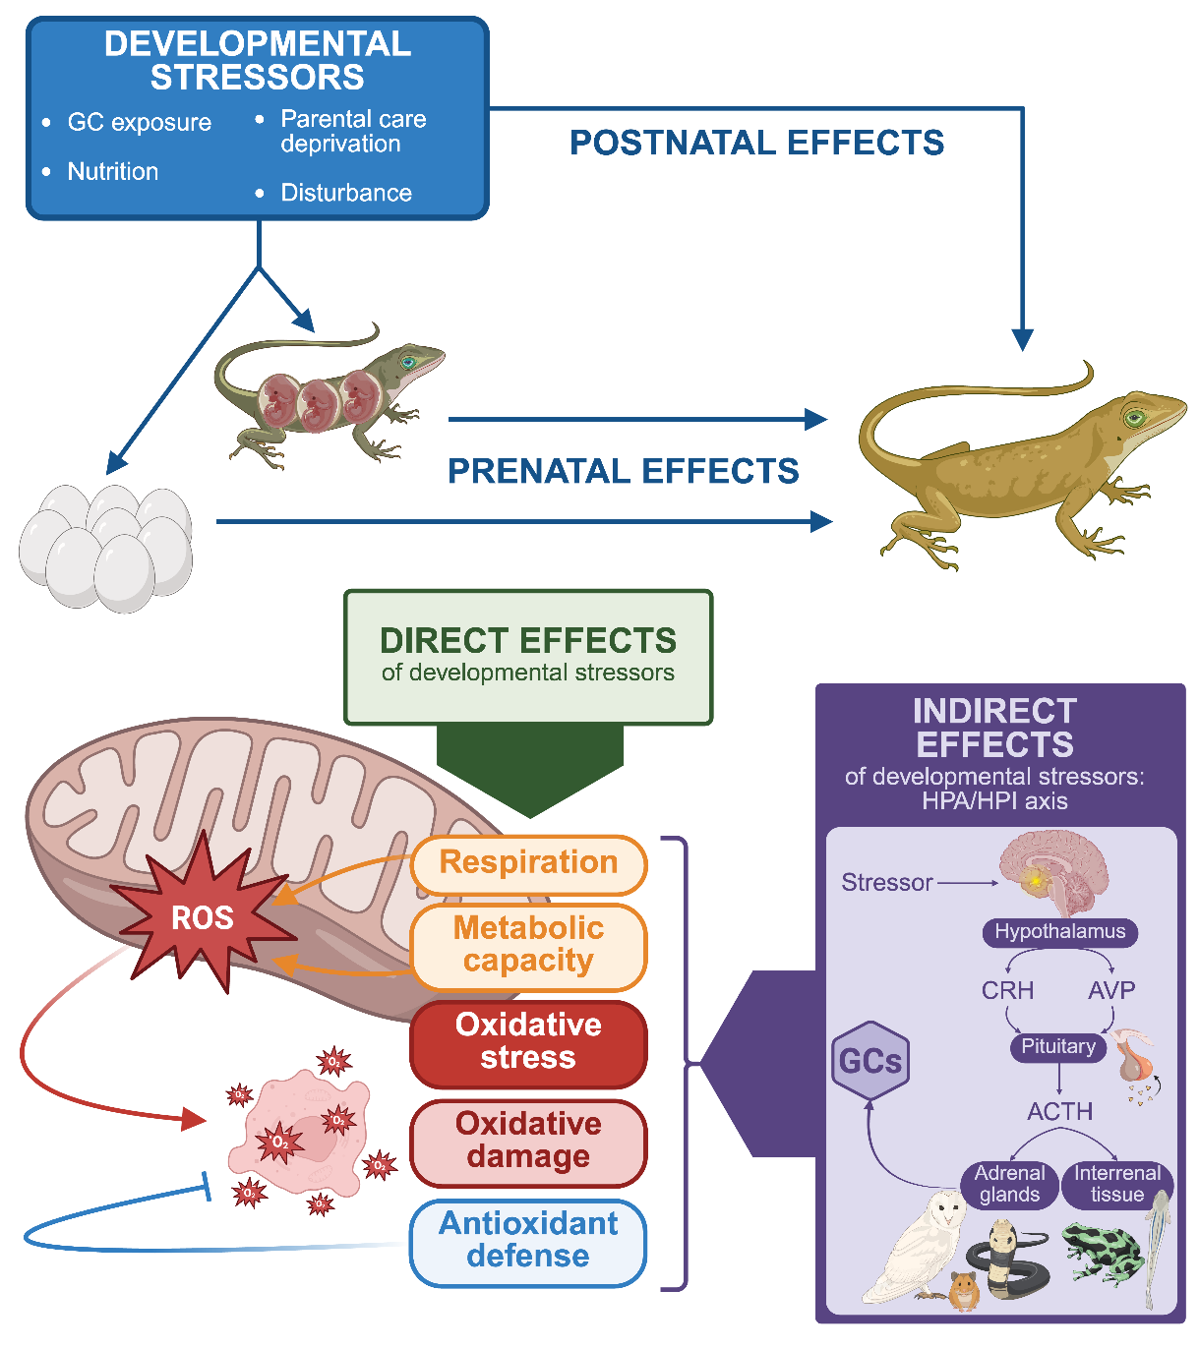
Figure 1 – Developing animals can be exposed to stressors both prenatally (during gestation or in ovo) and postnatally though direct exposure to environmental conditions and, in some species, though parental effects including parental care and maternal effects. The term ‘developmental stressors’ is broadly used to refer to conditions that are sub-optimal such as exposure to elevated levels of glucocorticoid (GC) hormones, parental care deprivation, nutritional imbalance (i.e., excessive or insufficient nutrition), and psychological disturbances such as social isolation and exposure to anthropogenic disturbances such as artificial light and noise. Exposure to stressors during development can affect mitochondrial respiratory function through direct effects on traits that affect aerobic respiration, metabolic capacity, oxidative stress, oxidative damage, and antioxidant defenses. Additionally, developmental stressors can indirectly affect mitochondrial respiratory function through programmatic effects on the hypothalamic-pituitary-adrenal/interrenal (HPA/HPI) axis. In vertebrates, the HPA/I axis regulates the release of GCs that play important roles in metabolic responses to energetically demanding or stressful conditions. Exposure to stressors during development can have sustained effects on HPA/I axis function across life and, in this way, indirectly affect mitochondrial respiratory function through changes in GC secretion and regulation.
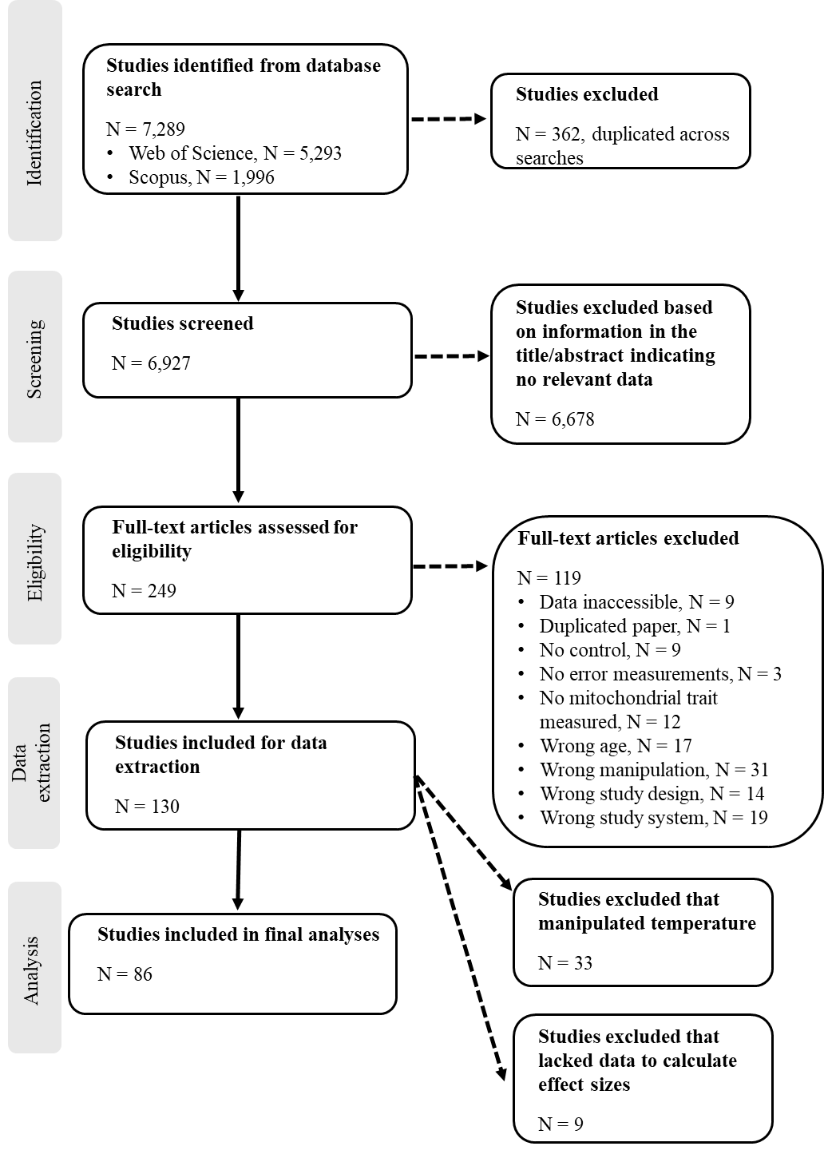
Figure 2 – Flowchart of search results and study selection.

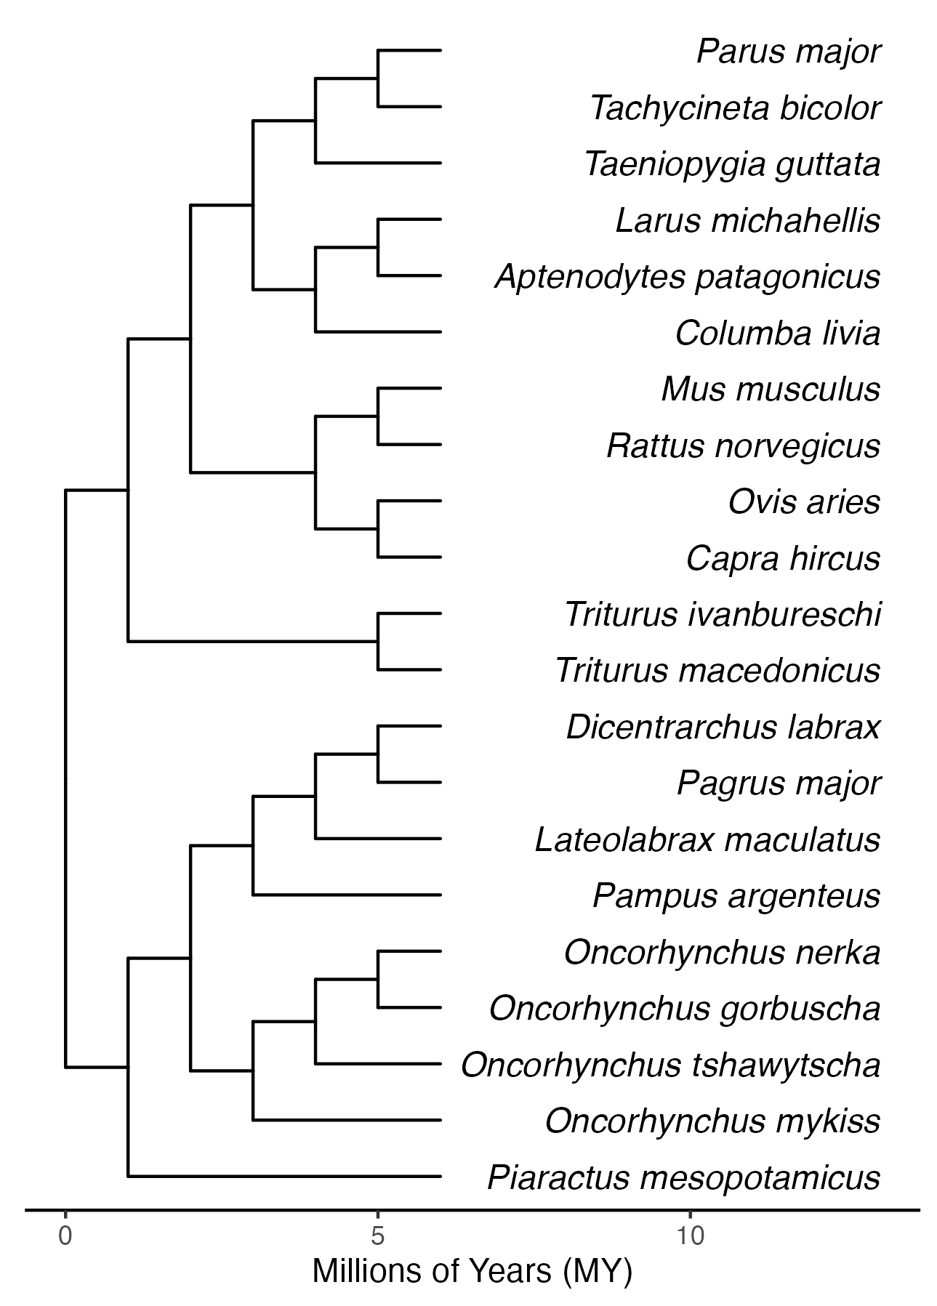





Figure 3 - Phylogeny of species included in the meta-analysis. Phylogenetic relationships and divergence times are based on TimeTree [timetree.org; Kumar et al. (2022)]. The phylogeny was pruned to only include species in the dataset. The animal silhouettes are from PhyloPic (www.phylopic.org) and were contributed by Andy Wilson (2023; CC0 1.0), Mozillian (2024; CC0 1.0), Beth Reinke (2021; CC0 1.0), Denis Lafage (2020; CC0 1.0), and Steven Traver (2012; CC0 1.0).

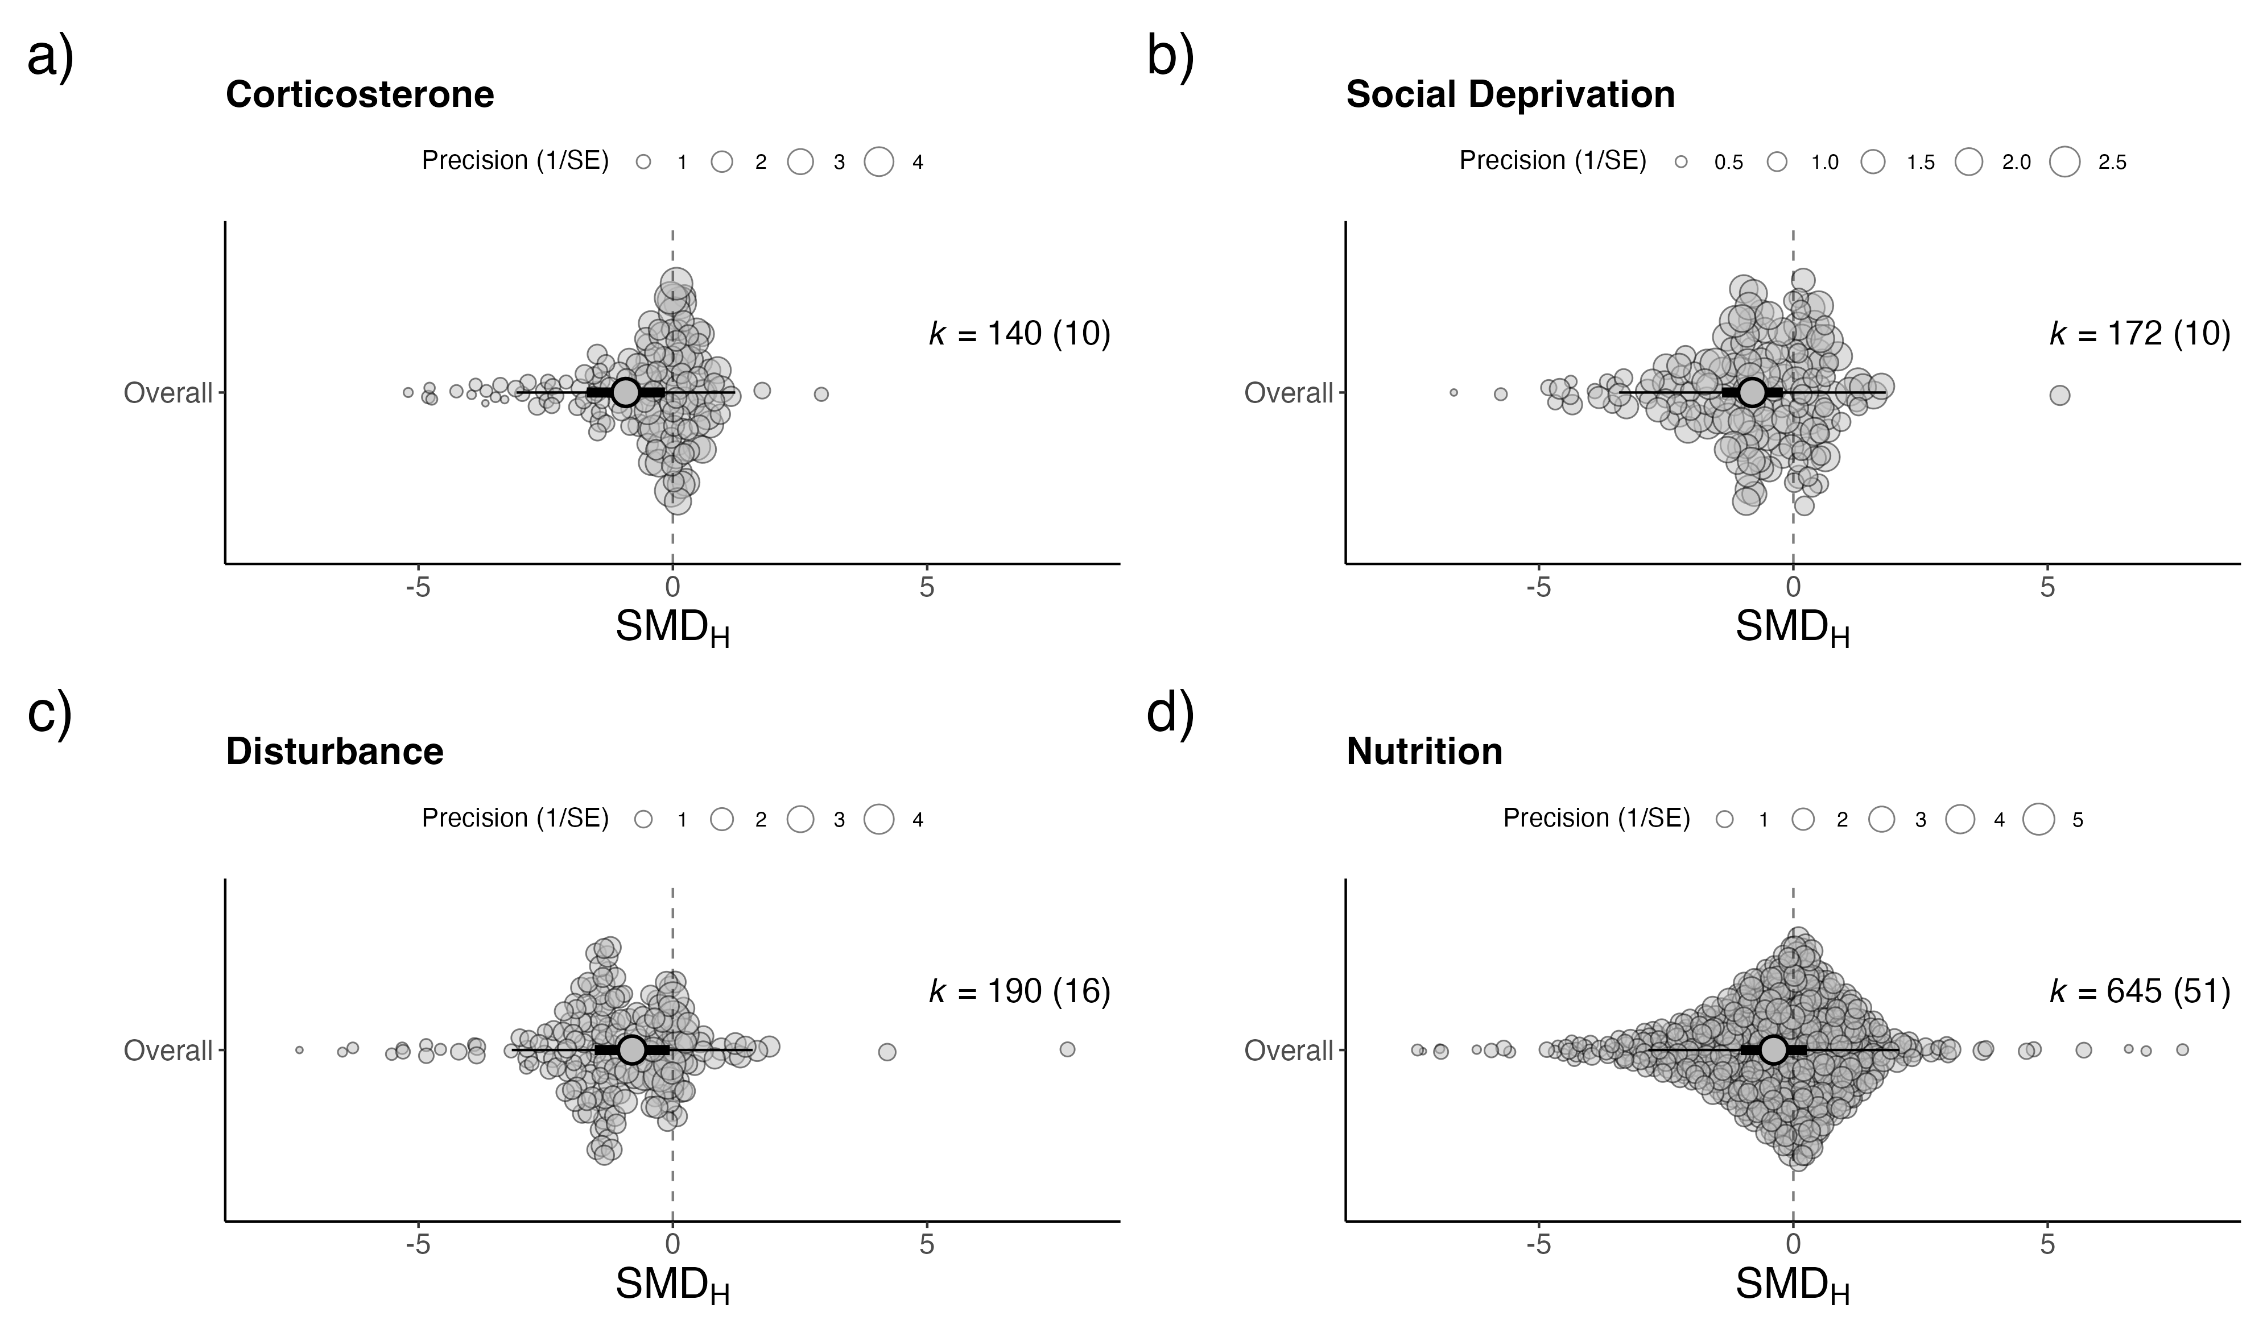
Glucocorticoids
Parental care deprivation
Psychological disturbance
Nutritional imbalance
Figure 4 - Overall meta-analytic mean estimates for each developmental stressor category (a) glucocorticoid exposure, (b) parental care deprivation, (c) psychological disturbance, and (d) nutritional imbalance. Mean estimates are shown as large points, with 95% confidence (thick black bars) and prediction (thin black bars). The number of effects (k) along with the number of studies (in parentheses) are provided for each stressor category. The dashed lines represent no effect where the estimate of the standardized mean difference between the treatment and control groups ( $SMD_{H}$) equals zero. Raw data are also shown and are weighted by their inverse sampling error (precision). Note raw data is truncated for ease of visualisation.

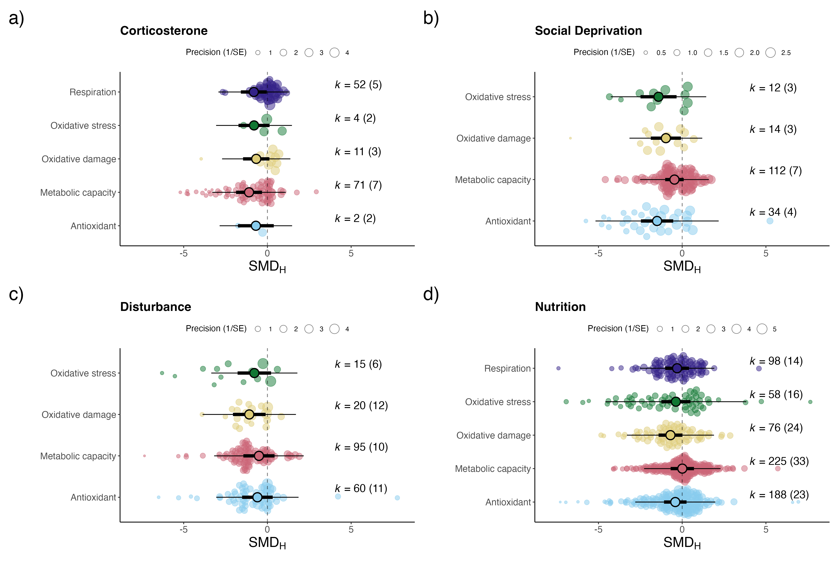
Glucocorticoids
Parental care deprivation
Psychological disturbance
Nutritional imbalance

Figure 5 - Overall meta-analytic mean estimates across each functional trait category for each developmental stressor type (a) glucocorticoid exposure, (b) parental care deprivation, (c) psychological disturbance, and (d) nutritional imbalance. Mean estimates are shown as large points, with 95% confidence (thick black bars) and prediction (thin black bars). The number of effects (k) along with the number of studies (in parentheses) are shown provided for each trait category. The dashed lines represent no effect where the estimate of the standardized mean difference between treatment and control groups ( $SMD_{H}$) equals zero. Raw data are also shown and are weighted by their inverse sampling error (precision). Note raw data is truncated for ease of visualisation.

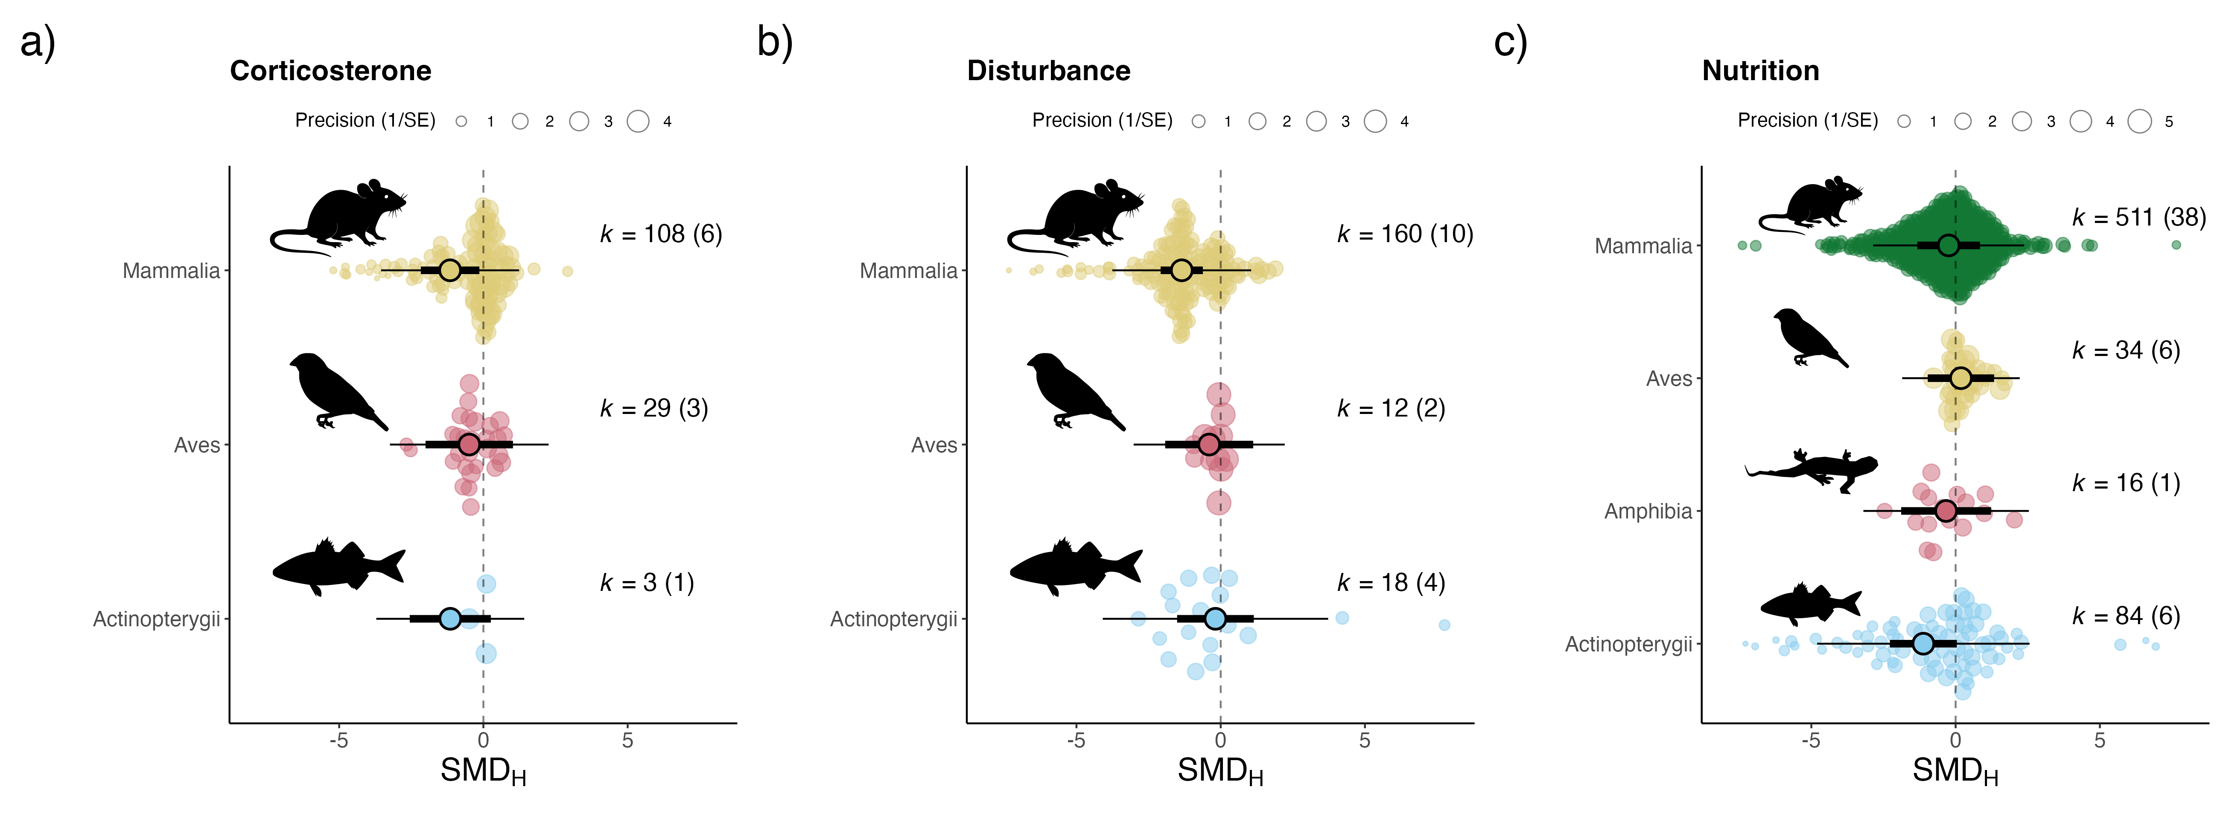
Glucocorticoids
Psychological disturbance
Nutritional imbalance

Figure 6 - Overall meta-analytic mean estimates for each taxonomic group (class) across developmental stressors (a) glucocorticoid exposure, (b) psychological disturbance, and (c) nutritional imbalance. Mean estimates are shown as large points, with 95% confidence (thick black bars) and prediction (thin black bars). The number of effects (k) along with the number of studies (in parentheses) are shown provided for each class. The dashed lines represent no effect where the estimate of the standardized mean difference between treatment and control groups ($SMD_{H}$) equals zero. Raw data are also shown and are weighted by their inverse sampling error (precision). Note raw data is truncated for ease of visualisation.

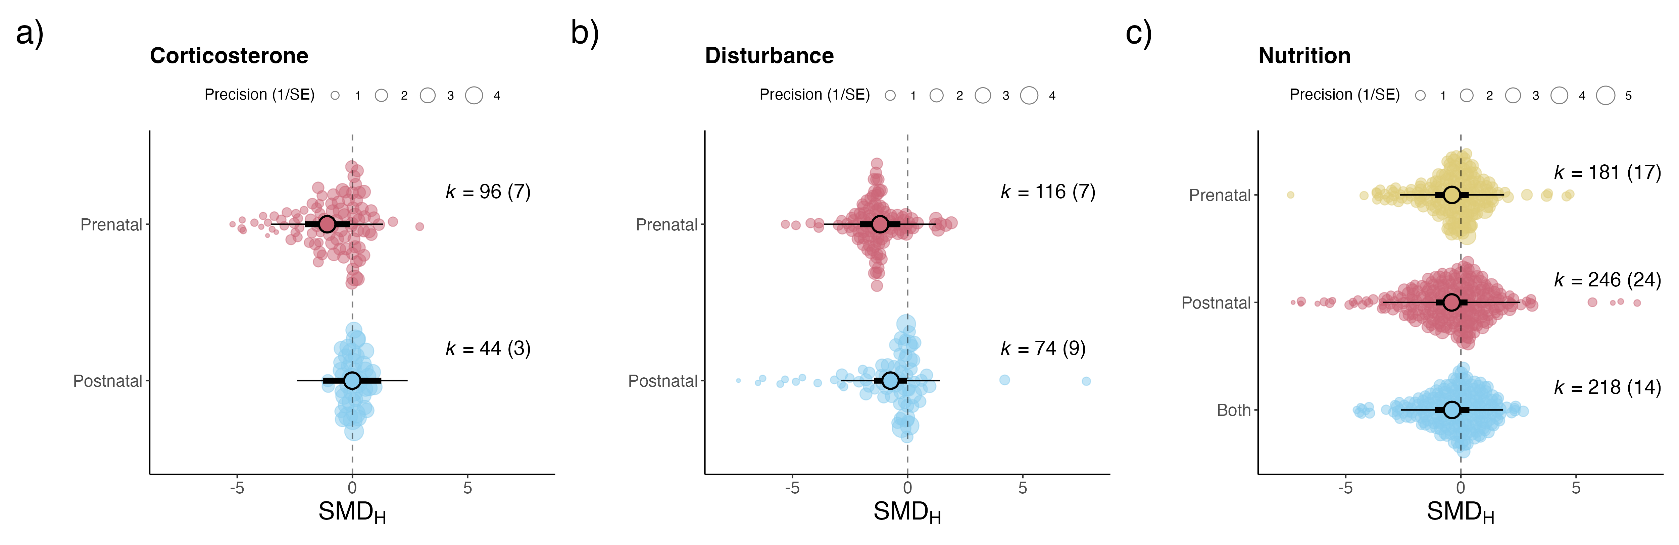
Glucocorticoids
Psychological disturbance
Nutritional imbalance
Figure 7 - Overall meta-analytic mean estimates different stages of manipulation (pre-natal, post-natal or both) across different developmental stressors (a) glucocorticoid exposure, (b) psychological disturbance, and (c) nutritional imbalance. Mean estimates are shown as large points, with 95% confidence (thick black bars) and prediction (thin black bars). The number of effects (k) along with the number of studies (in parentheses) are shown provided for each stage. The dashed lines represent no effect where the estimates of the standardized mean difference between treatment and control groups ($SMD_{H}$) equals zero. Raw data are also shown and are weighted by their inverse sampling error (precision). Note raw data is truncated for ease of visualisation.

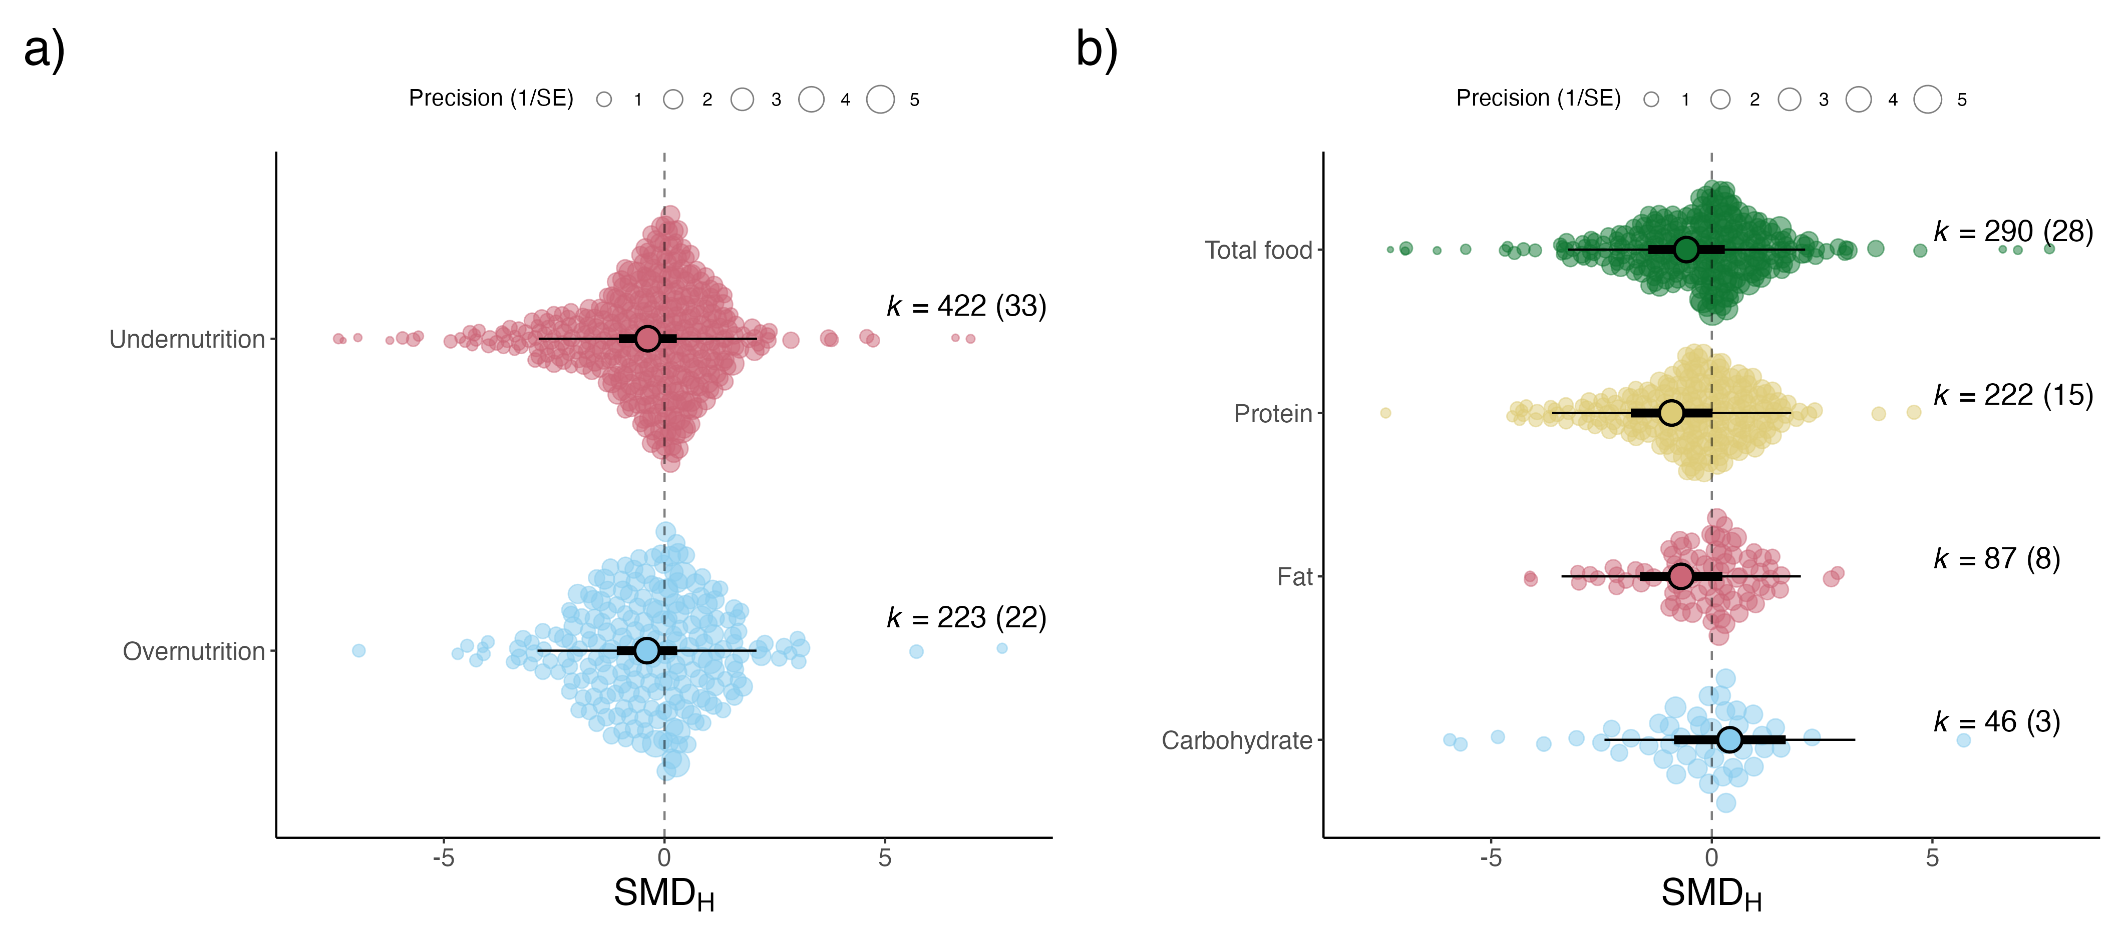

Figure 8 - Overall meta-analytic mean estimates for nutritional stressors (a) under- and over-nutrition and (b) nutrition type. Mean estimates are shown as large points, with 95% confidence (thick black bars) and prediction (thin black bars). The number of effects (k) along with the number of studies (in parentheses) are shown provided for each stressor type. The dashed lines represent no effect where the estimates of the standardized mean difference between treatment and control groups ($SMD_{H}$) equals zero. Raw data are also shown and are weighted by their inverse sampling error (precision). Note raw data is truncated for ease of visualisation.

