**Temperature variability does not influence phenotypic plasticity in ectotherms – a meta-analysis**

Clayton W. Stocker1, Stephanie M. Bamford1, Miki Jahn1, Geoffrey P. F. Mazué1, Amanda K. Pettersen1, Daniel Ritchie1, Alexander Rubin1, Daniel W.A. Noble2,3, Frank Seebacher1,3*

*1School of Life and Environmental Sciences, University of Sydney, NSW 2006, Australia, FS: frank.seebacher@sydney.edu.au; CWS: clayton.stocker@sydney.edu.au*

*2Division of Ecology and Evolution, Research School of Biology, Australian National University, Canberra, Australian Capital Territory, Australia, daniel.noble@anu.edu.au*

*3these authors contributed equally*

*Author contributions:* CWS designed study, collected data, performed analysis, wrote manuscript; SMB designed study and collected data; MJ, GPFM, AKP, DR, AR collected data; DWAN: performed the meta-analysis, wrote the manuscript; FS: designed study, collected data, wrote manuscript.

*Data accessibility statement:* data and code associated with this study have been deposited at: https://github.com/daniel1noble/plasticity_fluc_meta

*Short title:* Variability does not influence plasticity

*Keywords*: developmental plasticity, acclimation, temperature variability, climate change, resilience, ectotherm, animal

*Type of article*: Letter

*Word count*: abstract =

*Number of references*:

Number of Figures: 7, Tables = 0, Text boxes = 0

*Author for correspondence:* Frank Seebacher, School of Life and Environmental Sciences A08, University of Sydney NSW 2006, +61 2 93512779, frank.seebacher@sydney.edu.au

**Abstract**

Phenotypic plasticity can allow individuals to compensate for potentially adverse effects in their thermal environment. It is important, therefore, to understand the impacts of changes in both mean and fluctuations in temperature on plastic responses. Our aim was to establish the current state-of-knowledge regarding the influence of thermal variability on the capacity for phenotypic plasticity in ectothermic vertebrates and invertebrates. We conducted a quantitative synthesis of 46 studies (241 effect sizes across 41 species) to compare the effects of constant and fluctuating temperatures with the same mean on plasticity in biological responses. We compared different traits across different ecosystems (terrestrial and aquatic) and types of phenotypic plasticity (acclimation and developmental plasticity). We found that 98% of studies implemented diel temperature fluctuations, and most data were derived from invertebrates. Our analysis shows that phenotypic plasticity does not differ between constant and fluctuating thermal environments. We conclude that plasticity and its attendant compensation for thermal variability is more likely to be driven by changes in longer-term mean temperatures.

**Introduction**

Climate change is increasing both mean temperatures and the amplitudes of thermal fluctuations (IPCC 2023). Ectotherms are particularly susceptible to thermal fluctuations as their body temperature is closely tied to environmental conditions (Angilletta 2009; Huey *et al.* 2012). The thermal sensitivity of phenotypic traits follows a non-linear thermal performance curve (TPC) as a function of body temperature (Huey and Kingsolver, 1989). TPCs vary between species and traits (Bozinovic *et al.* 2020), but generally incorporate three common features: an initial increase in performance as temperature increases from a minimum critical temperature; a thermal optimum where maximum performance is reached; and a rapid decline in performance to a critical thermal maximum (Huey & Kingsolver 1989). Thermal fluctuations therefore can be both beneficial and detrimental to the performance of an organism depending on their location within the TPCs (Denny 2019; Marshall *et al.* 2021). In a previous meta-analysis, we found that exposure to diel temperature fluctuations in ectotherms had limited overall effects on the means and variances of trait values compared to constant temperature treatments with the same mean and for the same duration (Stocker *et al.* 2024). Increasing fluctuation amplitudes, however, appeared to be stressful and increased heat shock protein expression, reduced longevity, and had negative impacts on populations of aquatic animals. These effects were likely the result of reaching damaging high temperatures as amplitudes increased (Stocker *et al.* 2024). In the special case of egg incubation temperatures in reptiles, the effects of fluctuating temperatures depended on mean temperatures. Compared to constant temperatures, fluctuations increased hatching success and decreased incubation time at cooler mean temperatures, while fluctuations had a negative effect at warmer mean temperatures (Raynal *et al.* 2022). As above, the negative effects of fluctuations at high mean temperatures were likely to be due to reaching damaging high temperatures.

Importantly, ectotherms can exhibit plastic responses that adjust TPCs to at least partially compensate for potentially damaging effects of temperature variation in their environment (Noble *et al.* 2025; Schulte 2014; Seebacher *et al.* 2015). For example, thermal acclimation shifted the temperature at which maximal heart rates occurred from 28oC in 5oC-acclimated fish (*Fundulus heteroclitus*) to 37oC in 33oC-acclimated fish; in the absence of warm acclimation, 5oC-acclimated fish would have suffered heart failure at 37oC (Safi *et al.* 2019).  Acclimation and developmental plasticity are manifestations of phenotypic plasticity that can reduce variance in phenotypic trait values across environmental gradients (Beaman *et al.* 2016; Burggren 2020). Developmental plasticity involves relatively persistent phenotypic changes in response to the thermal environment experienced during early development (Burggren 2018; Loughland *et al.* 2021). Acclimation is a reversible phenotypic shift induced by environmental changes lasting from days to weeks The extent to which phenotypic plasticity is expressed has been tested mainly in response to changes in constant temperatures (Schulte *et al.* 2011). However, in natural environments temperatures fluctuate, calling into question whether constant temperature experiments are representative of natural conditions (Marshall *et al.* 2021).

Fluctuating environmental conditions may dampen plastic responses because they increase the variation in temperatures experienced by organisms and may thereby dilute longer-term signals such as temperature trends during development and seasonal changes. Unpredictable thermal variability can also increase the probability of organisms experiencing damaging temperature extremes, thereby limiting the benefits of plasticity and reduce selection for plastic phenotypes (Dowd & Denny 2020; Jørgensen *et al.* 2021; Vázquez *et al.* 2017). Alternatively, plastic responses could shift TPCs so that fluctuations with increased amplitudes become less damaging, thereby promoting selection for plasticity (Scheuffele *et al.* 2021). In addition, in fluctuating environments phenotypic plasticity can come at the cost of a mismatch between phenotype and environment (Beaman *et al.* 2016) . Plastic responses to short-term variation (e.g., daily variation) could exacerbate that cost, especially if the environment changes rapidly and the lag time between phenotypic and environmental change increases (Beaman *et al.* 2016; Gabriel 2006; Jacob *et al.* 2024). Filtering out frequent short-term environmental signals may render plastic responses more efficient, and compensation for longer-term changes may be the principal benefit of plasticity (Leung *et al.* 2020). At present, empirical evidence is equivocal, leaving the relationship between temperature fluctuations and phenotypic plasticity unresolved (Jacob *et al.* 2024). As we briefly summarised above, temperature fluctuations could promote or constrain plasticity. It is important to understand whether and how short-term fluctuations around mean temperatures influence the expression of phenotypic plasticity to predict the impacts of climate change (Dowd *et al.* 2015).

Here, our aim was to conduct a quantitative synthesis that establishes the current state-of-knowledge regarding the influence of thermal variability on the expression of phenotypic plasticity in ectotherms. The analysis we present here follows from our earlier meta-analyses that considered the impacts of temperature fluctuations on mean trait values (Raynal *et al.* 2022; Stocker *et al.* 2024), and we here make the conceptual advance of investigating the impact of fluctuating temperatures on the *plasticity* of mean trait values. Specifically, we conducted a meta-analysis that tested whether the expression of phenotypic plasticity differed in constant and fluctuating thermal environments with the same mean temperature. Hence, we analysed data from studies that conducted fully factorial experiments with at least two developmental or acclimation temperature treatments crossed with constant and fluctuating conditions. We also analysed the potential impacts of constant and fluctuating thermal environments in subset analyses of (i) ecological levels (individual and population), (ii) ecosystems (aquatic and terrestrial organisms), and (iii) the form of phenotypic plasticity (acclimation or developmental plasticity).

**Materials and Methods**

We followed, as closely as possible, the Preferred Reporting Items for Systematic Reviews and Meta-Analyses (PRISMA) (Moher *et al.* 2015) guidelines, modified for Ecology and Evolution (PRISMA-Eco Evo) (O’Dea *et al.* 2021) (Supplementary Materials Fig. S1 and Table S1). Question formulation, literature searching and screening were performed according to (Foo *et al.* 2021).

*Systematic Literature Search and Screening*

We adhered to the PECO (Population, Exposure, Comparator, Outcome) framework (Morgan *et al.* 2018) in the development of focus questions and the literature search and screening processes (Supplementary Materials Table S2). The initial literature search was conducted on 5 April 2022 in Scopus, Web of Science (Core Collection including Current Contents, BIOSIS Previews, CAB Abstracts, Medline, Agricola and Pubmed) and ScienceDirect databases. A section of the results from this search was published in (Stocker *et al.* 2024), although the data used in the present analysis were not published in the earlier paper. Additionally, we updated the search in Scopus and Web of Science on 17 July 2025. Search terms included synonyms for ‘plasticity’, ‘acclimation’ and ‘developmental effects’ to identify studies that conducted treatments during the lifespan of an individual(Noble *et al.* 2018). To limit the search string to temperature treatments, ‘thermal’ and ‘temperature’ were added as search terms(Noble *et al.* 2018). Synonyms for ‘fluctuating’ or ‘varying’ were added to explicitly look for studies with a fluctuating temperature treatment. The exact search strings used in each database are given in Supplementary Materials Search Strings. All authors (except DWAN) were involved in the search, screening, and data extraction process. We ensured consistency between authors by screening a common set of 100 papers and extracting data collectively from a subset of five papers.

The initial search (2022) returned a total of 13,549 studies after removing duplicates (Supplementary Materials Fig. S1). Of these, we identified a total of 57 studies that fulfilled our inclusion criteria (Supplementary Material Fig. S2). In addition, we used Scopus, Web of Science, ScienceDirect and Google Scholar to conduct a forward (papers citing the original study) and backward (papers that were cited in the original study) search on 19 October 2022, and identified an additional 87 studies. (Michonneau *et al.* 2016)We conducted abstract and full-text screening in Rayyan software (Ouzzani *et al.* 2016) of all identified papers following our exclusion and inclusion criteria (Supplementary Materials Fig. S2). Following full-text screening, 44 studies were included in the final analysis (Supplementary Materials Studies included in the analysis). The updated search (2025) returned an additional 1475 studies after removing duplicates. Following title and abstract screening we identified three studies that met our inclusion criteria and from which we extracted data. Hence, the meta-analysis includes data from a total number of 46 studies, 41 species (20.9% vertebrates, 79.1 % invertebrates), and 241 effect sizes.

*Data Extraction*

All studies included in the analysis had at least four chronic (≥ days) (Seebacher *et al.* 2015) treatments: two constant temperature treatments at a "high" and "low" temperature, and two fluctuating temperature treatments with mean temperatures corresponding to those of the constant treatments (Fig. 1). The acute test temperatures at which phenotypic traits were measured had to coincide with the mean temperatures of the corresponding chronic thermal treatments (Seebacher *et al.* 2015). If there were more than two treatment temperatures, we selected the two experimental temperatures that coincided best with the natural temperature range of each study species to minimise analysis of data from potentially damaging temperature ranges when studies included exposures to relatively extreme temperatures (Seebacher *et al.* 2015; Wilson & Franklin 2002). In experiments that had multiple fluctuating treatments with different amplitudes or types of fluctuations (e.g., sinusoidal, stepwise, alternating, or stochastic), we compared each to the corresponding constant treatment to calculate separate effect size. We extracted data (sample sizes, means, and errors) from these treatments from texts, tables, supplementary materials, and figures (using R package *metaDigitise* version 1.0.1 to extract data from figures)(Pick *et al.* 2019). We used only biological replicates as the sample size, rather than technical replicates from repeated measures using the same samples or animals if they were performed. In addition, we recorded taxonomic information, preferred ecosystems, and life-history stages to include as moderators in subset analyses. We also recorded descriptors of the experimental fluctuations (mean temperature and the fluctuations amplitude, type, and period) that could influence phenotypic trait values (Raynal *et al.* 2022; Stocker *et al.* 2024). None of the screened studies were excluded because of missing information stipulated in our inclusion criteria (Fig. S2), but for one study (Breitenbach *et al.* 2020)  we accessed the published dataset to calculate standard deviations. Phenotypic responses were sorted into trait category and specific phenotypic trait measurement, and we noted details of the experimental design including the type and duration of treatment exposure. Investigators involved in data extraction were not permitted to screen or extract data from studies they had a previous association with.

*Data Processing and Transformations*

Standard errors (SE) and 95% confidence internals (CI) were converted to standard deviations (SD), which were used for effect size calculations () . Bounded data such as proportions (e.g., survival) were transformed before calculating effect sizes (23 effect sizes) to obtain means and variances that were more likely to satisfy normality assumptions :

|  |  |
| --- | --- |
|  | (1) |

|  |  |
| --- | --- |
|  | (2) |

where and are the transformed means and SD, respectively, and are the bounded (proportional) means and SD. We transformed means and variances that were reported as the natural logarithm using Equation 3 and 4 (Higgins *et al.* 2008) :

|  |  |
| --- | --- |
|  | (3) |

|  |  |
| --- | --- |
|  | (4) |

where and are the transformed means and SD, respectively, and are the means and SD on the natural log scale.

Taxonomic information was retrieved from the Open Tree of Life (Michonneau *et al.* 2016). Amphibians were considered aquatic organisms for the analysis.

*Effect Size Calculations*

To quantify changes in plasticity between constant and fluctuation experiments, we derived a standardised effect size called PRRDS (an interaction-based, Plasticity Response Ratio Difference) (Equation 7) and its corresponding sampling variance (Equation 8).

|  |  |
| --- | --- |
|  | (7) |

|  |  |
| --- | --- |
|  | (8) |

PRRDS is derived in the exact same way other interaction-based effect sizes for SMD (See Appendix for Gurevitch et al. 2000) and log response ratios (lnRR) (Macartney et al. 2022) have been calculated for application in other contexts. In our case, we use it to compare the plastic responses to temperature between constant and fluctuating treatments while also standardising the effect by temperature differences across studies. Given PRRDS is a response ratio type effect statistic, following Macartney et al. 2022, we first calculated lnRR within treatments to estimate the change in phenotypic traits following either acclimation or developmental exposure to different temperatures. lnRR within either the constant or fluctuating temperature treatment quantifies the expression of phenotypic plasticity because it measures the change in phenotype across two different temperatures (Figure 1a & b). Unlike, Macartney et al. 2022, we do not focus on within treatment effects as they have been the focus of numerous other studies in different contexts (e.g., Noble at al. 2018, Stocker et al. 2024). Our question was specifically focused on how the plastic response is affected by temperature fluctuations which requires the use of PRRDS. To calculate PRRDs we subtracted the lnRR of the constant from the fluctuating thermal environment (Figure 1c). To control for the fact that temperature gradients differed between studies, the PRRDS standardises the differences in plastic responses to a 1oC change in treatment temperature following approaches described by Noble *et al.* 2022 (see Appendix) and Pottier *et al.* 2021. A PRRDS = 0 indicates that there is no difference in the expression of phenotypic plasticity between constant and fluctuating thermal environments (PRRDS > 0, phenotypic plasticity increases in fluctuating temperatures; PRRDS < 0, phenotypic plasticity increases in constant temperatures, Figure 1c).

*Statistical Analysis*

We used R.4.2.2 in RStudio version 2022.12.0 for all calculations, analyses, and figures (using R Package *ggplot2* version 3.4.2 for figures) (Wickham 2011). All data and code are available at https://github.com/daniel1noble/plasticity_fluc_meta (metadata given in Supplementary Materials Table S3). Data are presented as the mean PRRDS ± 95% CIs. For ease of comparison, the mean PRRDs are transformed (i.e., (exp(meanPRRD)-1)*100%) to give the percentage change of phenotypic plasticity from constant to fluctuating thermal environments (Pustejovsky 2018). We visualised mean and raw effects using orchard and bubble plots (R package *orchard* version 2.0) (Nakagawa *et al.* 2023), which also provide 95% prediction intervals (IntHout *et al.* 2016) . Prediction intervals provide important information about effect heterogeneity by establishing what the expected effect size we would be from future studies 95% of the time (Noble *et al.* 2022).

*Meta-analyses and non-independence*

Multi-level meta-analyses (MLMA) were fitted with frequentist models using restricted maximum likelihood (REML) and an adjusted convergence threshold (1e-8). Inferential tests were done using a t-distribution (Nakagawa *et al.* 2022b). The model was fitted with a modified sampling covariance matrix to account for multiple effect sizes using the same control treatment (Noble *et al.* 2022). We assumed that effect sizes sharing a common control were correlated by r = 0.5, and the shared sampling covariance was calculated using the sampling variances for each effect (Noble *et al.* 2017).

Dependencies in our data set were accounted for by including several random effects in the model (Nakagawa *et al.* 2017). A Study ID random effect was included to account for multiple effect sizes from the same study. A Shared Animal ID random effect was included to account for the same set of animals used for several measured responses. To control for phylogenetic relatedness, a phylogenetic tree was created using the Open Tree of Life database and converted into a correlation matrix that was included in the model when estimating phylogenetic variance. Polytomies were randomly resolved (using R Package *Ape* version 5.8-1) (Paradis & Schliep 2018) and branch lengths were calculated with Grafen’s method (Power = 1) (Grafen 1989). A species-level random effect was included to account for the repeated use of the same species across effect sizes (Cinar *et al.* 2022). To reduce the likelihood of specific traits dominating the analysis, a trait-level random effect was added to the model (except in meta-regressions that analysed specific phenotypic traits as the moderator). Lastly, an observational-level random effect was added to estimate the final ‘residual’ / ‘within-study’ variation (Nakagawa & Santos 2012).

*Multi-level Meta-analytic Models*

MLMA models (using the function *rma.mv* in the R Package *metafor* version 4.8) (Viechtbauer 2010) were implemented to estimate the overall meta-analytic mean on data subsets (population- and individual-level traits) (Figure 2). We took a holistic approach to calculating and presenting heterogeneity statistics following recommendations by Yang *et al*. 2023. In addition to prediction intervals, we report relative heterogeneity (I2 , i.e., *I2Total*) as well as two magnitude measures of heterogeneity (i.e., CVH2 and M2, following Yang *et al.* 2023). CVH2Total expresses the magnitude of heterogeneity relative to the overall meta-analytic mean. While CVH2Total is a useful metric, its interpretation can become problematic when the meta-analytic mean approaches zero. A more robust measure of the magnitude of heterogeneity is therefore to use M2Total (Yang *et al.* 2023). We also decomposed these total measures of heterogeneity into their various partitions/strata corresponding to each of the random effects (e.g., *I2Animal*, *I2Obs*, *I2Phylo*, *I2Species*, *I2Study*, and *I2Trait*). Heterogeneity statistics were calculated from our overall MLMA model.

*Meta-regression Models*

We conducted separate meta-regression models to compare moderators that had the potential to explain effect size variation. Categorical moderators included type of plasticity (acclimation and developmental plasticity), fluctuation type (sinusoidal, alternating, stepwise, and stochastic), phenotypic trait categories (behavioural, biochemical assay, gene expression, life-history, morphological, and physiological), the specific phenotypic trait, and broad taxonomic group (invertebrate vs vertebrate) (see Supplementary Materials Fig. S3 for phylogenetic tree). Levels of a given categorical moderator were only included in MLMR models if the number of effect sizes within the relevant level was > 10 (O’Dea *et al.* 2021). We analysed the amplitude of fluctuations, and the number of fluctuations (treatment exposure duration/period of fluctuations; range = 4 – 546 fluctuations) as continuous moderators.

*Publication Bias and Sensitivity Analysis*

Publication bias was investigated by altering out MLMA model to include z-transformed publication year and precision (inverse of sampling variance) as moderators to assess the presence of a time-lag effect (or decline effect) (Nakagawa *et al.* 2022a). There was no evidence of small-study effects (i.e., no relationship with precision) in our overall data set, however, mean PRRDs, unsurprisingly, did show evidence of time-lag bias where average effects have decreased towards zero through time (Supplementary Materials Publication bias and Sensitivity analysis) coinciding with our overall meta-analytic means for most analyses. Decreasing effect size through time is a common form of publication bias resulting from studies with weaker effects taking longer to be published contributing to a decline in average effect through time (Jennions & Møller 2002).

A sample of effect sizes showed higher than expected precision. We carefully checked these extreme values to ensure that data was correctly extracted. To understand how ‘robust’ our overall MLMA model was to influential data points, we also conducted a Cook’s distance sensitivity analysis (using the function *cooks.distance* in the R Package *metafor* version 4.8). Results suggest that our conclusions are robust and free from significant influential outliers (Supplementary materials Fig. S4). We also confirmed that our results were consistent with robust variance estimators (Nakagawa *et al.* 2022b), which better account for any sources of non-independence within studies that our models may not have accounted for well enough. All results were also largely consistent between our main analyses and those using robust variance estimators.

**Results**

The final data set included 241 effect sizes from 41 species derived from 46 studies. The dataset was dominated by invertebrates but also included vertebrate ectotherms (Fig. 1c). Overall, 98% of the studies used diurnal temperature fluctuations (24 h cycles), with 47% (k = 114) having traits that showed negative slopes with temperature in both the constant and fluctuation treatments, 25% (k = 61) with positive slopes in both treatments and 27% (k = 66) where slopes were opposite directions in the constant and fluctuating thermal treatments.

In the overall MLMA analysis (effect size estimate = -0.0091; 95% CIs = [-0.0177, -0.0044]; p = 0.0378; n = 241, Figure 2a) and individual trait subset analysis (effect size estimate = -0.0093; 95% CIs = [-0.0182, -0.0003]; p = 0.0431; n = 234, Figure 2b), the mean plastic responses were significantly different between constant and fluctuating thermal environments, but effect sizes were small and not robust to non-independence (Figure 2). Total heterogeneity was high overall (*I2Total* rounded to 99.35%, CVTotal = 18.56 and MTotal = 0.95), with substantial between-study (*I2study* =38%, CVstudy = 11.49, Mstudy = 0.59) and within-study heterogeneity (*I2obs* = 52%, *CVobs* = 13.37, *Mobs* = 0.68). Little between-species heterogeneity was identified (see full heterogeneity statistics in Supplementary Materials Table S14).

We explored a priori factors which we expected would explain the high heterogeneity. There were no significant differences in phenotypic plasticity between fluctuating and constant thermal environments across broad trait categories (Figure 3a), but specific trait categories where enough data existed did explain a substantial amount of variation (R2 = 0.30) (Figure 3b). More specifically, plasticity in development time increased in fluctuating environments. In contrast, plasticity in body mass was greater in constant environments (Figure 3b, Supplement Table S8). In each case, however, effect size magnitude was still small despite being significant (0.97-1.57% change) and the upper and lower bound of the 95% prediction intervals still predict small effects (~9 – 10%). Constant and fluctuating temperatures did not influence phenotypic plasticity differently between aquatic or terrestrial species or vertebrates and invertebrates (Figure 4). Neither the fluctuation type (Figure 5), plasticity type (Figure 6) or the amplitude of fluctuating temperature regimes (Figure 7) explained differences in phenotypic plasticity between fluctuating and constant temperature conditions (Supplementary Materials Tables S4-S13).

**Discussion**

Our meta-analysis shows that experiencing constant or fluctuating environmental conditions does not generally impact the expression of phenotypic plasticity in ectothermic organisms. It is important to note, however, that there was substantial heterogeneity in effects overall. Our estimates of *I2Total*, *CVTotal* and *MTotal* all fall well above the 75th percentile of empirically derived heterogeneity estimates (Yang et al. 2023), with most variation explained by within and between study factors. However, our findings were consistent across species with low species-level heterogeneity in effects, which suggests that the small overall effects we observed is similar across species when between- and within-study sources of variation have been controlled (Yang et al. 2023). We note, however, that the number of species and studies were very similar in our dataset (i.e., each study tended to use a unique species) so that we may not be able to disentangle study- and species-specific effects very robustly. Additionally, the data in the analysis stem from a relatively small number of species that are unevenly distributed phylogenetically so that the generality of the current state-of-knowledge is not well established. Taxonomic coverage is likely to be correlated with geographic coverage, and many habitats - particularly biodiverse areas outside Europe and North America - are poorly represented by physiological studies (White *et al.* 2021). Future work is needed to extend understanding of how temperature fluctuations affect plasticity to a broader taxonomic and geographic range of animals, with particular emphasis on those taxa that are likely to be affected by climate change-induced increases in fluctuations (Cooke *et al.* 2021).

Analyses of key moderators predicted to drive between- and within-study variation (e.g., type of plasticity measured, fluctuation type and amplitude) mostly failed to explain variability aside from the specific trait being measured (marginal R2 = 30%). Importantly, even though there were differences in plasticity between constant and fluctuating temperatures for development time and body mass (in opposite directions), these average effects were still small overall. Trait variation is likely to reflect how thermal fluctuations impact traits with different thermal performance curves differently. For example, development time exhibited a non-linear exponential decline with increasing temperature (Fischer *et al.* 2011) while heart rate followed a Gaussian (inverted U-shape) curve as temperature increased (Safi *et al.* 2019) . Fluctuating or constant temperatures are therefore likely to have different impacts on mean trait values and the magnitude of plastic responses. The decrease in plasticity of body mass in fluctuating environments we show here is paralleled by decreases in mean mass in fluctuating relative to constant environments (Stocker *et al.* 2024). Body mass may be sensitive to temperature fluctuations because non-linear increases in metabolic rates at high temperatures could substantially increase energy expenditure. However, in both analyses the effects were very small biologically so that we hesitate to overinterpret these results. The findings of our study overall indicate that there is little support in the current literature that phenotypic plasticity is influenced by regular diel fluctuations around mean temperatures.

Plasticity can be beneficial by allowing organisms to compensate for potentially negative environmental effects (Loughland *et al.* 2021; Schulte 2014). However, the remodelling of phenotypes can be detrimental if inducing environments do not match current environmental conditions (Beaman *et al.* 2016). A mismatch cost can arise from a lag in the time to complete the compensatory response relative to the frequency of the variation in temperature (Pfab *et al.* 2016). Phenotype-environment mismatches occur for some time after the environment changes because environments induce phenotypes so that there necessarily is a lag between environmental and phenotypic change (Gabriel 2005; Nilsson-Örtman & Brönmark 2022). The occurrence of such mismatches would increase if phenotypic plasticity was induced by short term temperature fluctuations that would cause increasing frequencies of lag periods (Ghalambor *et al.* 2007). Our analysis instead indicates that short-term (diel) fluctuations in temperatures do not impact plastic responses, and we suggest that plastic responses are driven by mean temperatures across more than one day.

An interesting question that remains unresolved, is what the characteristics of the inducing environment are that lead to plastic responses (O’Connor *et al.* 2019; Zimmer *et al.* 2022). Our analysis indicates that diel fluctuations do not induce plasticity. However, in the natural environment, animals experience thermal fluctuations around the mean at different spatial- and temporal scales (e.g., diurnal, seasonal, and annual) (Marshall *et al.* 2021). The ability to filter frequent, short-term thermal signals could be an advantageous mechanism that increases the efficacy of plastic responses. A ‘band-pass filter’ could explain this phenomenon, in which regular thermal noise around the mean is filtered out and does not contribute to plasticic responses (Lattin & Kelly 2020). The efficient compensation for the effects of long-term changes in mean temperature could be the primary benefit of phenotypic plasticity that increases the resilience and persistence of ectotherms to future climate changes (Leung *et al.* 2020).

Increases in the amplitude of thermal fluctuations can have detrimental impacts on phenotypic trait values by reaching extreme ranges that damage cellular function and structures (Raynal *et al.* 2022; Stocker *et al.* 2024; Stoks *et al.* 2017). Our meta-analysis indicates that increases in the magnitude of diel fluctuations do not impact plasticity and are therefore unlikely to affect the vulnerability of ectotherms. However, we do not know whether the fluctuation reported in the studies analysed here were actually damaging, and frequent damaging temperature spikes could alter the molecular mechanisms underlying plasticity (Murray *et al.* 2022). These dynamics are important in assessing the impact of climate change-induced increases in mean temperature and heat waves, but require more experimental studies. With that caveat in mind, our findings support the validity of experiments using different constant temperature treatments to assess thermal plasticity and suggest that findings from such experiments are transferable to environments with diel temperature variation. However, the data available in the literature provide a very limited picture of how fluctuations in environmental affect plastic responses. Diel variations are ubiquitous in natural environments but, in addition, temperatures also vary at different time and spatial scales. Very little is known about the impact of these more complex environments, and it will be important in future work to determine the periodicity at which fluctuations become sufficient to induce or impact plastic responses. Additionally, oWe suggest that future research should explore the impacts of transgenerational thermal variability at different temporal scales on phenotypic plasticity.

**Acknowledgements**

FS was supported by Australian Research Council Discovery Grant DP250101953. DWAN was supported by Australian Research Council Future Fellowship FT220100276.

**References**

Angilletta, M.J. (2009). *Thermal adaptation*.

Beaman, J.E., White, C.R. & Seebacher, F. (2016). Evolution of plasticity: Mechanistic link between development and reversible acclimation. *Trends Ecol. Evol.*, 31, 237–249.

Bozinovic, F., Cavieres, G., Martel, S.I., Alruiz, J.M., Molina, A.N., Roschzttardtz, H., *et al.* (2020). Thermal effects vary predictably across levels of organization: empirical results and theoretical basis. *Proc Royal Soc B*, 287, 20202508.

Breitenbach, A.T., Carter, A.W., Paitz, R.T. & Bowden, R.M. (2020). Using naturalistic incubation temperatures to demonstrate how variation in the timing and continuity of heat wave exposure influences phenotype. *Proc. R. Soc. B*, 287, 20200992.

Burggren, W. (2018). Developmental phenotypic plasticity helps bridge stochastic weather events associated with climate change. *J. Exp. Biol.*, 221, jeb161984.

Burggren, W.W. (2020). Phenotypic Switching Resulting From Developmental Plasticity: Fixed or Reversible? *Frontiers in Physiology*, 10, 107–13.

Cinar, O., Nakagawa, S. & Viechtbauer, W. (2022). Phylogenetic multilevel meta‐analysis: A simulation study on the importance of modelling the phylogeny. *Methods Ecol. Evol.*, 13, 383–395.

Cooke, S.J., Bergman, J.N., Madliger, C.L., Cramp, R.L., Beardall, J., Burness, G., *et al.* (2021). One hundred research questions in conservation physiology for generating actionable evidence to inform conservation policy and practice. *Conserv Physiol*, 9, coab009-.

Denny, M. (2019). Performance in a variable world: Using Jensen’s inequality to scale up from individuals to populations. *Conserv. Physiol.*, 7, coz053.

Dowd, W.W. & Denny, M.W. (2020). A series of unfortunate events: characterizing the contingent nature of physiological extremes using long-term environmental records. *Proc Royal Soc B*, 287, 20192333.

Dowd, W.W., King, F.A. & Denny, M.W. (2015). Thermal variation, thermal extremes and the physiological performance of individuals. *J. Exp. Biol.*, 218, 1956–1967.

Fischer, K., Kölzow, N., Höltje, H. & Karl, I. (2011). Assay conditions in laboratory experiments: is the use of constant rather than fluctuating temperatures justified when investigating temperature-induced plasticity? *Oecologia*, 166, 23–33.

Foo, Y.Z., O’Dea, R.E., Koricheva, J., Nakagawa, S. & Lagisz, M. (2021). A practical guide to question formation, systematic searching and study screening for literature reviews in ecology and evolution. *Methods Ecol. Evol.*, 12, 1705–1720.

Gabriel, W. (2005). How stress selects for reversible phenotypic plasticity. *J. Evol. Biol.*, 18, 873–883.

Gabriel, W. (2006). Selective advantage of irreversible and reversible phenotypic plasticity. *Arch. Hydrobiol.*, 167, 1–20.

Ghalambor, C.K., McKay, J.K., Carroll, S.P. & Reznick, D.N. (2007). Adaptive versus non‐adaptive phenotypic plasticity and the potential for contemporary adaptation in new environments. *Funct. Ecol.*, 21, 394–407.

Grafen, A. (1989). The phylogenetic regression. *Philos. Trans. R. Soc. Lond. B, Biol. Sci.*, 326, 119–157.

Guderley, H. (2004). Metabolic responses to low temperature in fish muscle. *Biol. Rev.*, 79, 409–427.

Higgins, J.P.T., White, I.R. & Anzures‐Cabrera, J. (2008). Meta‐analysis of skewed data: Combining results reported on log‐transformed or raw scales. *Stat. Med.*, 27, 6072–6092.

Huey, R.B., Kearney, M.R., Krockenberger, A., Holtum, J.A.M., Jess, M. & Williams, S.E. (2012). Predicting organismal vulnerability to climate warming: Roles of behaviour, physiology and adaptation. *Philos. Trans. R. Soc. B: Biol. Sci.*, 367, 1665–1679.

Huey, R.B. & Kingsolver, J.G. (1989). Evolution of thermal sensitivity of ectotherm performance. *Trends Ecol. Evol.*, 4, 131–135.

IntHout, J., Ioannidis, J.P.A., Rovers, M.M. & Goeman, J.J. (2016). Plea for routinely presenting prediction intervals in meta-analysis. *BMJ Open*, 6, e010247.

IPCC. (2023). *Climate Change 2023: Synthesis Report. Contribution of Working Groups I, II and III to the Sixth Assessment Report of the Intergovernmental Panel on Climate Change*. IPCC, Geneva, Switzerland.

Jacob, S., Dupont, L., Haegeman, B., Thierry, M., Campana, J.L.M., Legrand, D., *et al.* (2024). Phenotypic plasticity and the effects of thermal fluctuations on specialists and generalists. *Proc R Soc*, 291, 20240256.

Jørgensen, L.B., Malte, H., Ørsted, M., Klahn, N.A. & Overgaard, J. (2021). A unifying model to estimate thermal tolerance limits in ectotherms across static, dynamic and fluctuating exposures to thermal stress. *Sci. Rep.*, 11, 12840.

Lattin, C.R. & Kelly, T.R. (2020). Glucocorticoid negative feedback as a potential mediator of trade-offs between reproduction and survival. *Gen. Comp. Endocrinol.*, 286, 113301.

Leung, C., Rescan, M., Grulois, D. & Chevin, L.M. (2020). Reduced phenotypic plasticity evolves in less predictable environments. *Ecol. Lett.*, 23, 1664–1672.

Loughland, I., Little, A. & Seebacher, F. (2021). DNA methyltransferase 3a mediates developmental thermal plasticity. *BMC Biol.*, 19, 11.

Macartney, E.L., Lagisz, M. & Nakagawa, S. (2022). The relative benefits of environmental enrichment on learning and memory are greater when stressed: A meta-analysis of interactions in rodents. *Neurosci. Biobehav. Rev.*, 135, 104554.

Marshall, K.E., Anderson, K.M., Brown, N.E.M., Dytnerski, J.K., Flynn, K.L., Bernhardt, J.R., *et al.* (2021). Whole-organism responses to constant temperatures do not predict responses to variable temperatures in the ecosystem engineer,Mytilus trossulus. *Proc. R. Soc. B-Biol. Sci.*, 288, 20202968.

Michonneau, F., Brown, J.W. & Winter, D.J. (2016). rotl: an R package to interact with the Open Tree of Life data. *Methods Ecol. Evol.*, 7, 1476–1481.

Moher, D., Shamseer, L., Clarke, M., Ghersi, D., Liberati, A., Petticrew, M., *et al.* (2015). Preferred reporting items for systematic review and meta-analysis protocols (PRISMA-P) 2015 statement. *Syst. Rev.*, 4, 1–9.

Morgan, R.L., Whaley, P., Thayer, K.A. & Schünemann, H.J. (2018). Identifying the PECO: A framework for formulating good questions to explore the association of environmental and other exposures with health outcomes. *Environ. Int.*, 121, 1027–1031.

Murray, K.O., Clanton, T.L. & Horowitz, M. (2022). Epigenetic responses to heat: From adaptation to maladaptation. *Exp Physiol*, 107, 1144–1158.

Nakagawa, S., Lagisz, M., Jennions, M.D., Koricheva, J., Noble, D.W.A., Parker, T.H., *et al.* (2022a). Methods for testing publication bias in ecological and evolutionary meta‐analyses. *Methods Ecol. Evol.*, 13, 4–21.

Nakagawa, S., Lagisz, M., O’Dea, R.E., Pottier, P., Rutkowska, J., Senior, A.M., *et al.* (2023). orchaRd 2.0: An R package for visualising meta‐analyses with orchard plots. *Methods Ecol. Evol.*, 14, 2003–2010.

Nakagawa, S., Noble, D.W.A., Senior, A.M. & Lagisz, M. (2017). Meta-evaluation of meta-analysis: Ten appraisal questions for biologists. *BMC Biol.*, 15, 18.

Nakagawa, S. & Santos, E.S.A. (2012). Methodological issues and advances in biological meta-analysis. *Evol. Ecol.*, 26, 1253–1274.

Nakagawa, S., Senior, A.M., Viechtbauer, W. & Noble, D.W.A. (2022b). An assessment of statistical methods for non-independent data in ecological meta-analyses: Comment. *Ecology*, 103, e03490.

Nilsson-Örtman, V. & Brönmark, C. (2022). The time course of metabolic plasticity and its consequences for growth performance under variable food supply in the northern pike. *Proc. R. Soc. B*, 289, 20220427.

Noble, D.W.A., Lagisz, M., O’dea, R.E. & Nakagawa, S. (2017). Non-independence and sensitivity analyses in ecological and evolutionary meta‐analyses. *Mol. Ecol.*, 26, 2410–2425.

Noble, D.W.A., Pottier, P., Lagisz, M., Burke, S., Drobniak, S.M., O’Dea, R.E., *et al.* (2022). Meta-analytic approaches and effect sizes to account for ‘nuisance heterogeneity’in comparative physiology. *J. Exp. Biol.*, 225, jeb243225.

Noble, D.W.A., Stenhouse, V. & Schwanz, L.E. (2018). Developmental temperatures and phenotypic plasticity in reptiles: A systematic review and meta‐analysis. *Biol. Rev.*, 93, 72–97.

O’Connor, M.I., Pennell, M.W., Altermatt, F., Matthews, B., Melián, C.J. & Gonzalez, A. (2019). Principles of Ecology Revisited: Integrating Information and Ecological Theories for a More Unified Science. *Front. Ecol. Evol.*, 7, 219.

O’Dea, R.E., Lagisz, M., Jennions, M.D., Koricheva, J., Noble, D.W.A., Parker, T.H., *et al.* (2021). Preferred reporting items for systematic reviews and meta‐analyses in ecology and evolutionary biology: a PRISMA extension. *Biol. Rev.*, 96, 1695–1722.

Ouzzani, M., Hammady, H., Fedorowicz, Z. & Elmagarmid, A. (2016). Rayyan - A web and mobile app for systematic reviews. *Syst. Rev.*, 5, 210.

Paradis, E. & Schliep, K. (2018). ape 5.0: an environment for modern phylogenetics and evolutionary analyses in R. *Bioinformatics*, 35, 526–528.

Pfab, F., Gabriel, W. & Utz, M. (2016). Reversible phenotypic plasticity with continuous adaptation. *J. Math. Biol.*, 72, 435–466.

Pick, J.L., Nakagawa, S. & Noble, D.W.A. (2019). Reproducible, flexible and high‐throughput data extraction from primary literature: The metaDigitise r package. *Methods Ecol. Evol.*, 10, 426–431.

Pottier, P., Burke, S., Drobniak, S.M., Lagisz, M. & Nakagawa, S. (2021). Sexual (in) equality? A meta‐analysis of sex differences in thermal acclimation capacity across ectotherms. *Funct. Ecol.*, 35, 2663–2678.

Pustejovsky, J.E. (2018). Using response ratios for meta-analyzing single-case designs with behavioral outcomes. *J. Sch. Psychol.*, 68, 99–112.

Quinn, G.P. & Keough, M.J. (2002). *Experimental design and data analysis for biologists*. Cambridge University Press, Cambridge, UK.

Raynal, R.S., Noble, D.W.A., Riley, J.L., Senior, A.M., Warner, D.A., While, G.M., *et al.* (2022). Impact of fluctuating developmental temperatures on phenotypic traits in reptiles: A meta-analysis. *J. Exp. Biol.*, 225.

Safi, H., Zhang, Y., Schulte, P.M. & Farrell, A.P. (2019). The effect of acute warming and thermal acclimation on maximum heart rate of the common killifish Fundulus heteroclitus. *Journal of Fish Biology*, 95, 1441–1446.

Scheuffele, H., Rubio-Gracia, F. & Clark, T.D. (2021). Thermal performance curves for aerobic scope in a tropical fish (Lates calcarifer): flexible in amplitude but not breadth. *J. Exp. Biol.*, 224, jeb243504.

Schulte, P.M. (2014). What is environmental stress? Insights from fish living in a variable environment. *J. Exp. Biol.*, 217, 23–34.

Schulte, P.M., Healy, T.M. & Fangue, N.A. (2011). Thermal performance curves, phenotypic plasticity, and the time scales of temperature exposure. *Integr. Comp. Biol.*, 51, 691–702.

Seebacher, F., White, C.R. & Franklin, C.E. (2015). Physiological plasticity increases resilience of ectothermic animals to climate change. *Nat. Clim. Chang.*, 5, 61–66.

Sterne, J.A.C., Becker, B.J. & Egger, M. (2005). The funnel plot. In: *Publication Bias in Meta-Analysis: Prevention, Assessment and Adjustments*, Publication Bias in Meta‐Analysis: Prevention, Assessment and Adjustments (eds. Rothstein, H.R., Sutton, A.J. & Borenstein, M.). John Wiley & Sons, pp. 73–98.

Stocker, C.W., Bamford, S.M., Jahn, M., Mazué, G.P.F., Pettersen, A.K., Ritchie, D., *et al.* (2024). The Effect of Temperature Variability on Biological Responses of Ectothermic Animals—A Meta‐Analysis. *Ecol. Lett.*, 27, e14511.

Stoks, R., Verheyen, J., Dievel, M.V. & Tüzün, N. (2017). Daily temperature variation and extreme high temperatures drive performance and biotic interactions in a warming world. *Curr. Opin. Insect Sci.*, 23, 35–42.

Vázquez, D.P., Gianoli, E., Morris, W.F. & Bozinovic, F. (2017). Ecological and evolutionary impacts of changing climatic variability. *Biol. Rev.*, 92, 22–42.

Viechtbauer, W. (2010). Conducting meta-analyses in R with the metafor package. *J. Stat. Softw.*, 36, 1–48.

White, C.R., Marshall, D.J., Chown, S.L., Clusella‐Trullas, S., Portugal, S.J., Franklin, C.E., *et al.* (2021). Geographical bias in physiological data limits predictions of global change impacts. *Funct Ecol*, 35, 1572–1578.

Wickham, H. (2011). ggplot2. *Wiley Interdiscip. Rev.-Comput. Stat.*, 3, 180–185.

Wilson, R.S. & Franklin, C.E. (2002). Testing the beneficial acclimation hypothesis. *Trends Ecol Evol*, 17, 66–70.

Zimmer, C., Woods, H.A. & Martin, L.B. (2022). Information theory in vertebrate stress physiology. *Trends Endocrinol. Metab.*, 33, 8–17.

Yang, Y., Noble, D.W.A., Spake, R., Senior, A. M., Lagisz, M., Nakagawa, S. (2023). A pluralistic framework for measuring and stratifying heterogeneity in meta-analyses. EcoEvoRxiv, 2023.

**Figures**

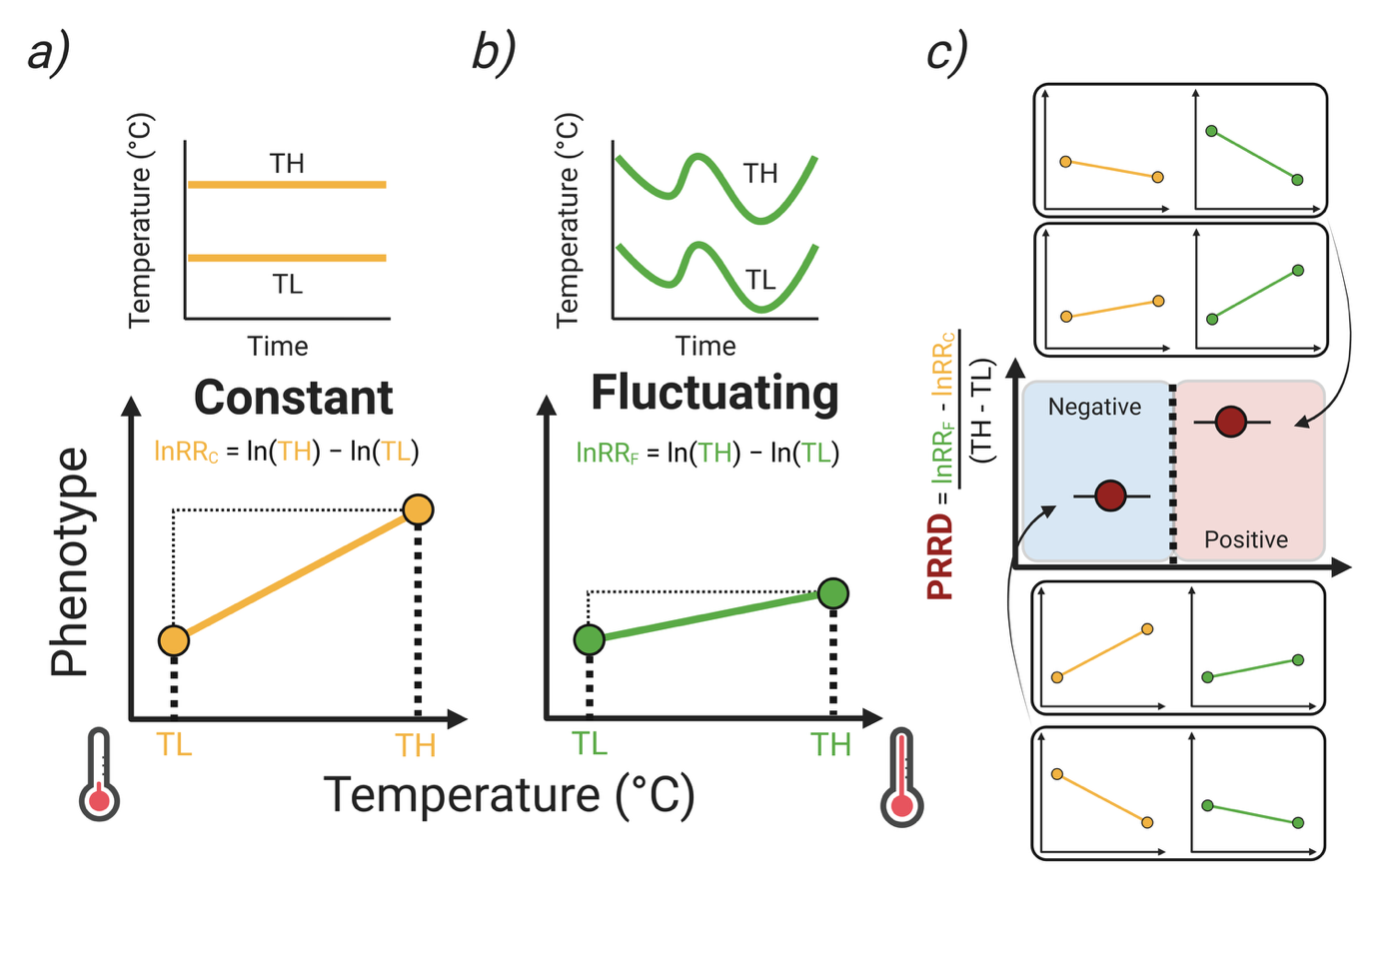

**Fig. 1**

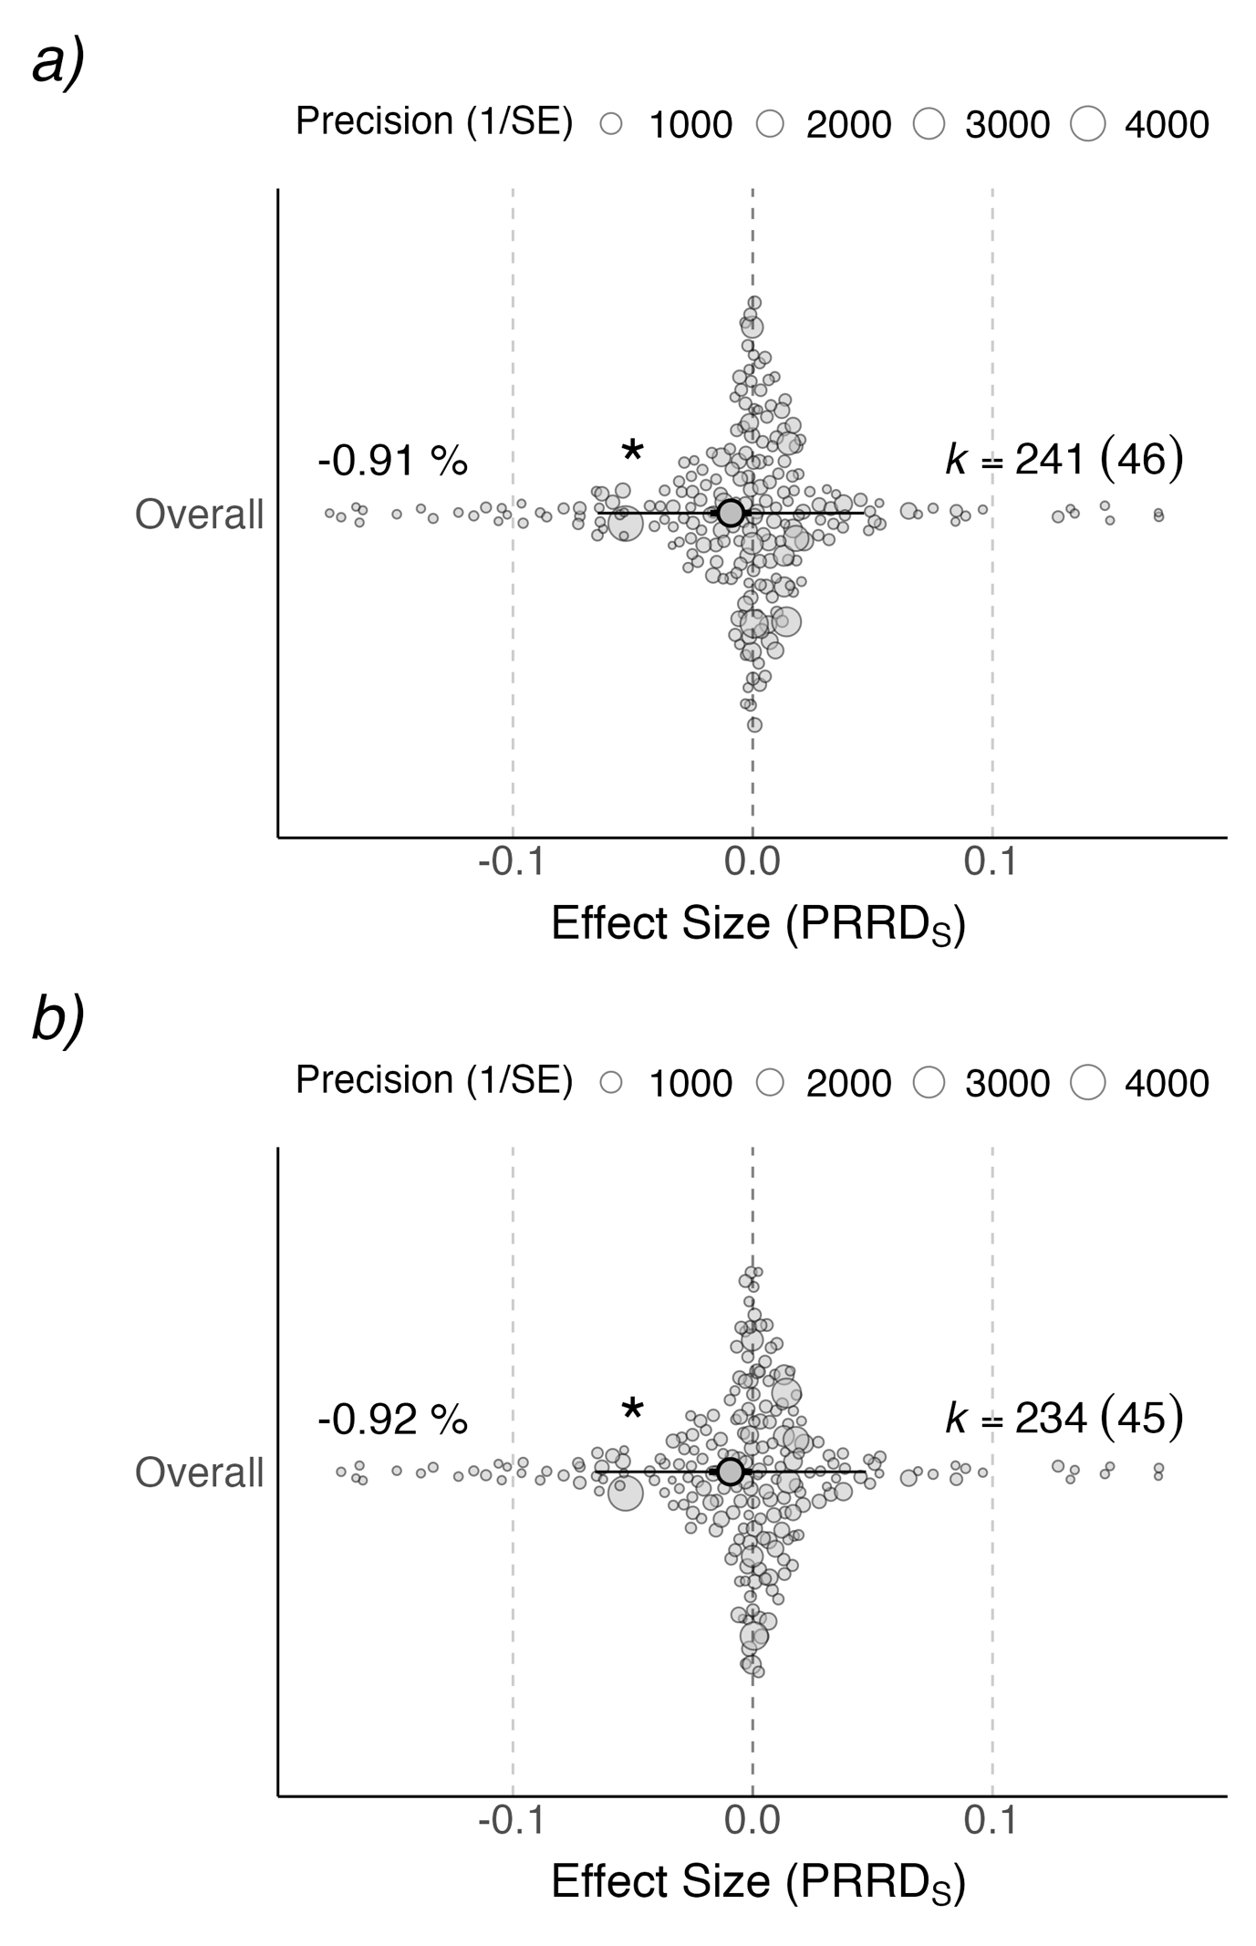

**Fig. 2**

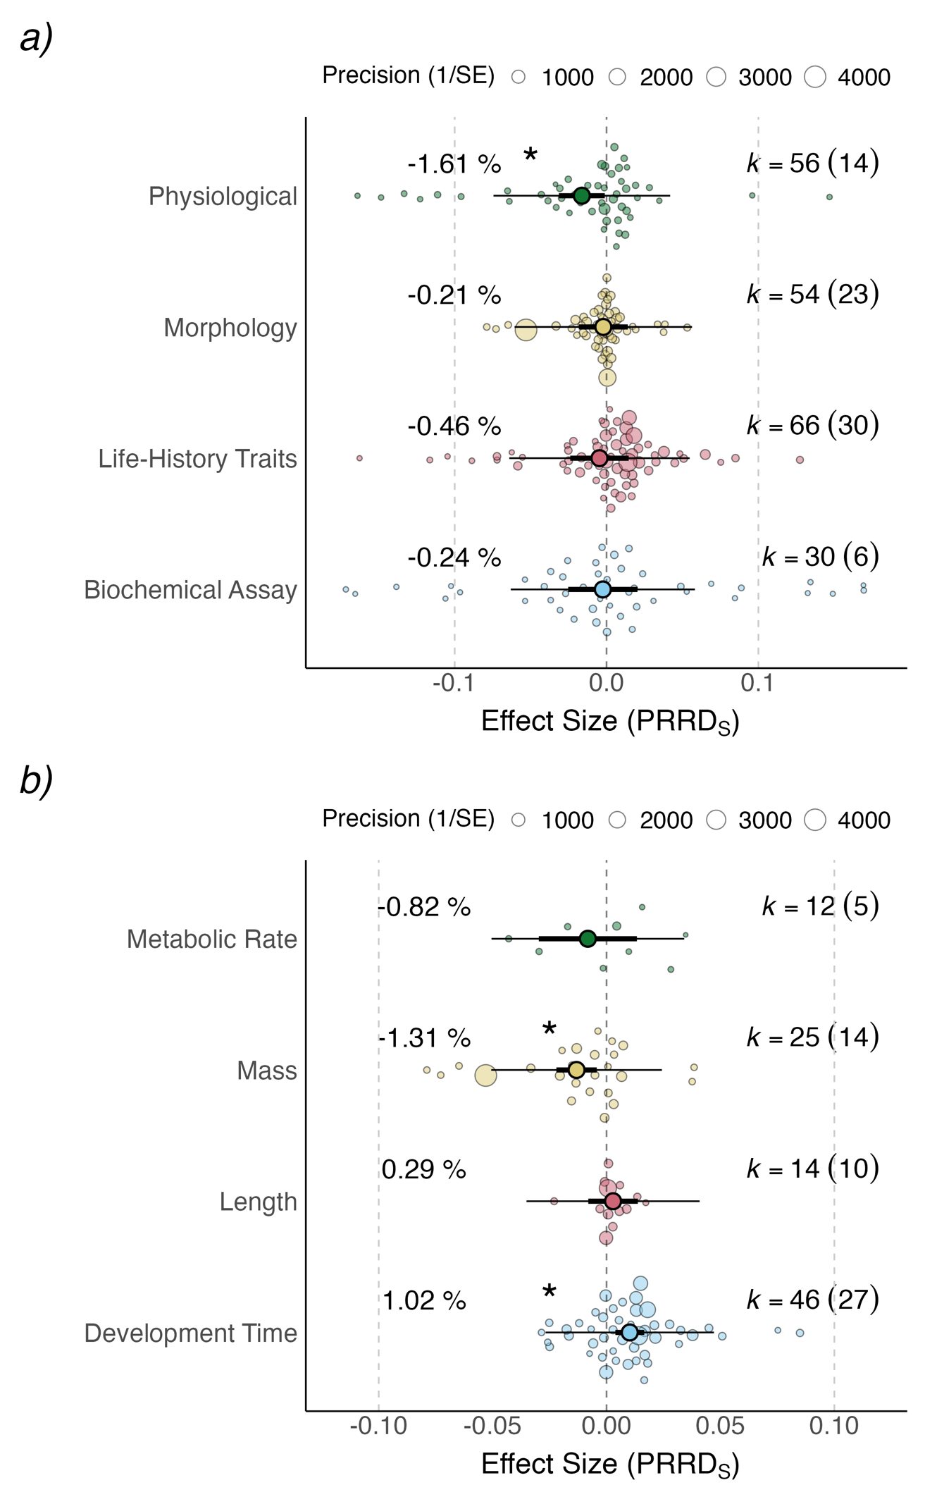

**Fig. 3**

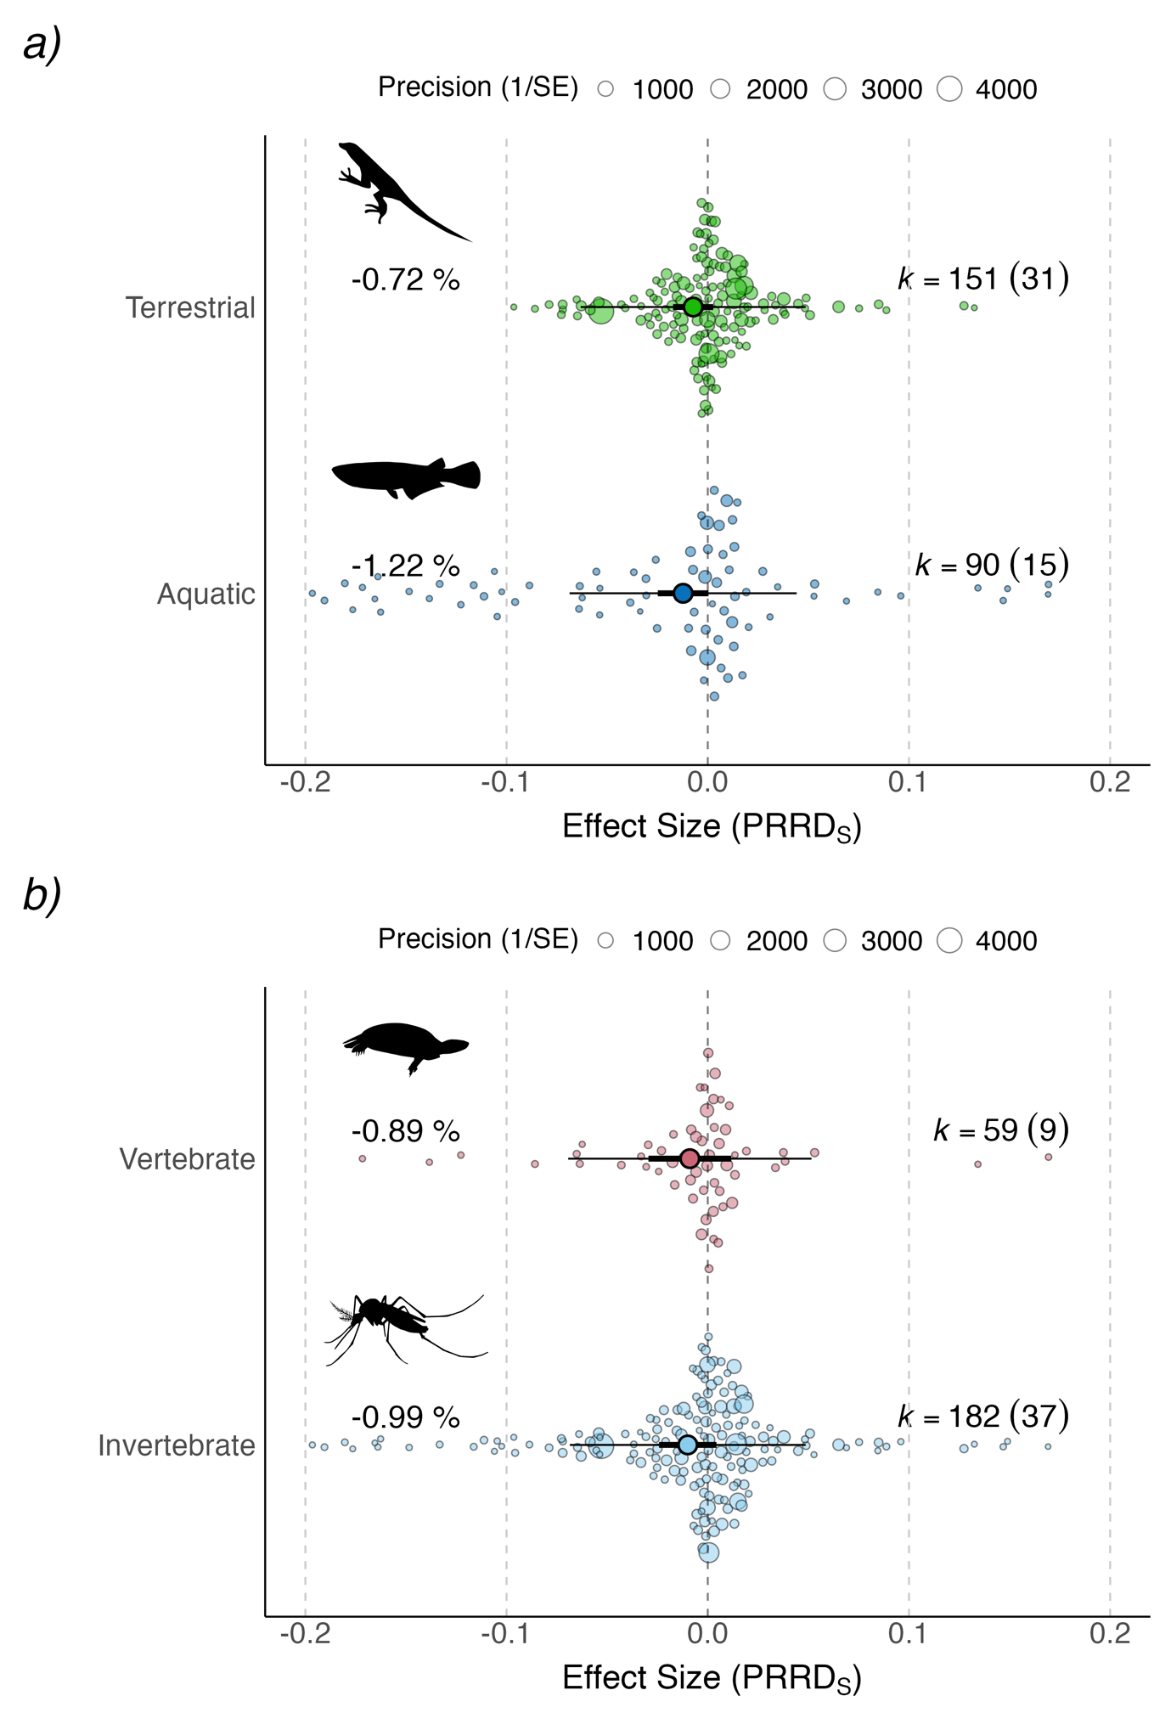

**Fig. 4**

**Fig. 5**

**Fig. 6**

**Fig. 7**

**Figure captions**

**Figure 1 Quantifying changes in plasticity resulting from acclimation to a constant or thermally fluctuating environment.** a) Measurement temperatures taken for two samples of organisms at low temperature (TL) and high temperature (TH) when each group is acclimated at a constant temperature. Calculating the plastic log-response ratio for the constant treatment (lnRRC) can be done by subtracting the natural logarithm of the sample means for the two measurement temperatures. b) Treatment groups where the temperatures fluctuated through the course of acclimation. The plastic log-response ratio for the fluctuating treatment (lnRRF)can also be computed by subtracting the natural logarithm of the sample means for the two measurement temperatures in the fluctuating treatment. c) From these response ratios the effect size (plasticity response ratio difference; PRRD) can be calculated according to equation 7 and 8. Note that there is no a priori assumption that phenotypic responses are higher at TH. Traits where temperature results in either negative or positive plastic responses can result in the same effect size (both in direction and magnitude) if their slopes are the same, as demonstrated with hypothetical examples c) Proportions of different phyla represented in the data set. Arthropods (particularly insects) dominate the data-set (79.1%), followed by Chordates (particulalry reptiles; 20.9%). Created in https://BioRender.com

**Figure 2 Multi-level meta-analytic results for the overall data set (a) and only studies measuring at the individual level (b).** There were no significant differences in phenotypic plasticity between the constant and fluctuating temperature treatments (indicated by 95% CIs crossing zero). Orchard plots depict mean effect size (plasticity response ratio difference; PRRDS) estimates ± 95% CIs (solid circles and horizontal bars, respectively) as well as distributions of individual effect sizes. Effect sizes are weighted (sized) by their precision which is inverse of their sampling error (1/SE). Percentage labels are the mean PRRDS estimates transformed to show a proportional difference between the fluctuating and stable temperature treatments. K = number of effect sizes with the number of studies in brackets. x-axis limits are cropped for presentation.

**Figure 3 Meta-regression results for the overall data set with broad (a) and specific (b) phenotypic trait category as the moderator**. There were no significant differences in phenotypic plasticity between the constant and fluctuating temperature treatments (indicated by 95% CIs crossing zero). Presentation and abbreviations as in Figure 2.

**Figure 4 Meta-regression results for the overall data set across major habitat types (a) and broad taxonomic group (b) as the moderator.** There were no significant differences in the phenotypic plasticity between the constant and fluctuating temperature treatments (indicated by 95% CIs crossing zero). Presentation and abbreviations as in Figure 2.

**Figure 5 Meta-regression results for the overall data set with fluctuation type as the moderator.** There were no significant differences in phenotypic plasticity between the constant and fluctuating temperature treatments (indicated by 95% CIs crossing zero). Presentation and abbreviations as in Figure 2.

**Figure 6** **Meta-regression results for the individual subset data set with plasticity type as the moderator.** There were no significant differences in phenotypic plasticity between the constant and fluctuating temperature treatments (indicated by 95% CIs crossing zero). Presentation and abbreviations as in Figure 2.

**Figure 7 Relationship between effect size and the amplitude of fluctuation.** There were no significant relationships between the amplitudes of fluctuations and the difference in phenotypic plasticity between the constant and fluctuating temperature treatments. Dashed line = PRRDS estimate from the MLMA models. Solid line = model prediction. Sample sizes are those used to calculate each individual effect size. X-axis and Y-axis limits are cropped for presentation.