Box 1 - TDT Curves

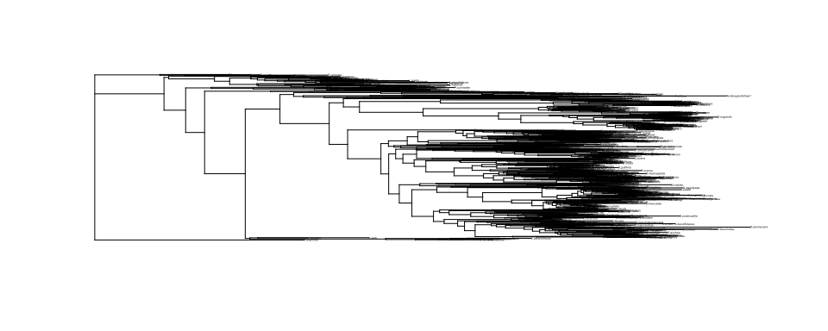

[1] FALSE

***************************************************************  
* Note: *  
* force.ultrametric does not include a formal method to *  
* ultrametricize a tree & should only be used to coerce *  
* a phylogeny that fails is.ultramtric due to rounding -- *  
* not as a substitute for formal rate-smoothing methods. *  
***************************************************************

$SpeciesNumbers  
 Numbers  
Species in data: 112  
Species in tree: 112  
  
$Species_InTree_But_NotData  
character(0)  
  
$Species_InData_But_NotTree  
character(0)

Markov Chain Monte Carlo (MCMC) output:  
Start = 1001   
End = 1031   
Thinning interval = 5   
 traittdt_z.animal.D.nannoptera traittdt_z.animal.D.buzzatii  
[1,] -0.356 -0.49  
[2,] -0.022 -0.70  
[3,] -0.381 -0.64  
[4,] -0.103 -0.13  
[5,] -0.394 -0.29  
[6,] -0.240 -0.22  
[7,] 0.296 -0.36  
 traittdt_z.animal.D.mojavensis traittdt_z.animal.D.arizonae  
[1,] -1.02 -0.86  
[2,] -0.72 -0.40  
[3,] -0.64 -0.30  
[4,] -0.67 -0.52  
[5,] -0.49 -0.63  
[6,] 0.20 -0.17  
[7,] -0.43 -0.95  
 traittdt_z.animal.D.navojoa traittdt_z.animal.D.aldrichi  
[1,] -1.20 -1.20  
[2,] -0.72 -0.42  
[3,] -1.09 -0.47  
[4,] -0.91 -0.30  
[5,] -0.22 0.43  
[6,] -0.17 0.12  
[7,] -0.19 -0.63  
 traittdt_z.animal.D.hydei traittdt_z.animal.D.eohydei  
[1,] -0.50 -1.17  
[2,] -1.11 -1.42  
[3,] -0.25 -0.88  
[4,] -0.40 -0.58  
[5,] -0.58 -0.84  
[6,] -0.69 -0.39  
[7,] -0.65 -1.54  
 traittdt_z.animal.D.anceps traittdt_z.animal.D.mercatorum  
[1,] -1.1224 0.2946  
[2,] -0.9090 0.0664  
[3,] -0.6785 0.3636  
[4,] -0.6533 0.2448  
[5,] -0.4296 0.2204  
[6,] 0.0665 0.0071  
[7,] -0.0027 -0.2205  
 traittdt_z.animal.D.repleta traittdt_z.animal.D.paranaensis  
[1,] -0.675 -1.15  
[2,] -0.292 -1.38  
[3,] -0.892 -0.11  
[4,] -0.097 -0.21  
[5,] -0.721 -0.24  
[6,] -0.254 -0.43  
[7,] -0.223 -0.84  
 traittdt_z.animal.D.ellisoni traittdt_z.animal.D.gaucha  
[1,] 0.39 -0.788  
[2,] -0.26 -0.653  
[3,] -1.14 -0.770  
[4,] -0.47 -0.346  
[5,] -0.23 0.524  
[6,] -0.52 -0.076  
[7,] -0.53 -0.882  
 traittdt_z.animal.D.montana traittdt_z.animal.D.lacicola  
[1,] -0.71 0.39  
[2,] -0.70 -0.88  
[3,] -0.90 -0.63  
[4,] -0.68 -0.77  
[5,] -0.81 -0.17  
[6,] -0.81 -0.35  
[7,] -0.77 -0.59  
 traittdt_z.animal.D.flavomontana traittdt_z.animal.D.borealis  
[1,] -0.84 -0.278  
[2,] -0.77 -0.592  
[3,] -0.89 0.035  
[4,] -0.40 -1.334  
[5,] -0.99 -0.622  
[6,] -0.24 -0.227  
[7,] -0.63 -0.683  
 traittdt_z.animal.D.novamexicana traittdt_z.animal.D.americana  
[1,] -0.513 -0.359  
[2,] -0.174 -0.573  
[3,] -0.245 -0.068  
[4,] 0.087 -0.139  
[5,] -0.731 -0.508  
[6,] -0.046 -0.449  
[7,] -0.537 -0.319  
 traittdt_z.animal.D.lummei traittdt_z.animal.D.virilis  
[1,] -0.92 -0.663  
[2,] -1.12 -1.307  
[3,] -0.32 -0.158  
[4,] -0.45 0.092  
[5,] -0.80 -0.231  
[6,] -0.51 -0.476  
[7,] -0.29 -0.260  
 traittdt_z.animal.D.ezoana traittdt_z.animal.D.littoralis  
[1,] -1.24 -1.63  
[2,] -0.96 -1.22  
[3,] -1.45 -0.84  
[4,] -0.93 -0.19  
[5,] -0.85 -0.80  
[6,] 0.17 -0.40  
[7,] -0.35 -0.48  
 traittdt_z.animal.D.kanekoi traittdt_z.animal.D.melanica  
[1,] -0.74 -0.44  
[2,] -0.63 0.15  
[3,] -0.72 0.94  
[4,] -0.76 1.16  
[5,] -1.26 0.73  
[6,] -0.21 0.42  
[7,] -0.78 0.54  
 traittdt_z.animal.D.micromelanica traittdt_z.animal.D.robusta  
[1,] -1.390 -1.47  
[2,] -0.527 -1.21  
[3,] -0.657 -0.88  
[4,] 0.790 -0.87  
[5,] 0.535 -0.13  
[6,] -0.086 -0.40  
[7,] 0.242 -0.97  
 traittdt_z.animal.D.sordidula traittdt_z.animal.D.daruma  
[1,] -0.7085 -0.26  
[2,] -0.7010 -0.82  
[3,] 0.0012 -0.47  
[4,] 1.2182 0.11  
[5,] 0.3068 0.27  
[6,] -0.2951 0.50  
[7,] -0.6566 0.34  
 traittdt_z.animal.D.latifshahi traittdt_z.animal.D.busckii  
[1,] -0.755 -0.941  
[2,] -1.112 -0.156  
[3,] -0.849 -0.538  
[4,] -0.043 0.723  
[5,] 0.492 0.076  
[6,] -0.339 0.542  
[7,] -0.160 0.021  
 traittdt_z.animal.D.cardini traittdt_z.animal.D.mediopunctata  
[1,] 0.21 0.52  
[2,] 0.92 0.40  
[3,] 0.76 0.36  
[4,] 0.71 -0.21  
[5,] -0.42 0.17  
[6,] 0.68 0.37  
[7,] 0.04 0.13  
 traittdt_z.animal.D.funebris traittdt_z.animal.D.brachynephros  
[1,] -0.638 0.092  
[2,] -0.604 0.693  
[3,] -0.321 0.185  
[4,] 0.123 0.183  
[5,] -0.412 0.484  
[6,] 0.309 0.326  
[7,] -0.063 -0.184  
 traittdt_z.animal.D.phalerata traittdt_z.animal.D.guttifera  
[1,] 0.0901 0.443  
[2,] 0.2488 1.021  
[3,] 0.3382 0.535  
[4,] -0.3258 0.500  
[5,] 0.0023 0.038  
[6,] 0.4913 0.582  
[7,] 0.4954 0.380  
 traittdt_z.animal.D.nigromaculata traittdt_z.animal.D.limbata  
[1,] 0.29 1.06  
[2,] 0.51 0.78  
[3,] 0.85 0.49  
[4,] 0.43 0.25  
[5,] 0.50 0.65  
[6,] 0.35 0.96  
[7,] -0.18 0.68  
 traittdt_z.animal.D.immigrans traittdt_z.animal.D.formosana  
[1,] -0.170 0.205  
[2,] -0.345 0.666  
[3,] -0.260 -0.373  
[4,] 0.292 0.023  
[5,] 0.087 -0.136  
[6,] 0.244 0.464  
[7,] -0.158 0.202  
 traittdt_z.animal.D.nasuta traittdt_z.animal.D.albomicans  
[1,] 0.83 0.69  
[2,] 1.44 0.59  
[3,] 0.87 0.15  
[4,] 0.84 0.56  
[5,] 0.37 0.30  
[6,] 0.87 0.66  
[7,] 0.92 0.76  
 traittdt_z.animal.D.sulfurigaster traittdt_z.animal.D.ruberrima  
[1,] 0.45 -0.0281  
[2,] 0.14 0.3964  
[3,] 0.81 0.1208  
[4,] 0.61 0.8663  
[5,] 0.69 0.4319  
[6,] 0.30 0.9582  
[7,] 0.52 -0.0097  
 traittdt_z.animal.D.repletoides traittdt_z.animal.Z.vittiger  
[1,] 1.20 0.671  
[2,] 1.01 0.125  
[3,] 0.55 0.144  
[4,] 0.76 0.934  
[5,] 0.89 0.072  
[6,] 0.33 0.053  
[7,] -0.32 0.114  
 traittdt_z.animal.Z.camerounensis traittdt_z.animal.Z.davidi  
[1,] 0.40 0.382  
[2,] 0.22 -0.055  
[3,] 0.47 0.117  
[4,] 0.58 0.498  
[5,] 0.42 -0.237  
[6,] 0.17 -0.299  
[7,] -0.53 -0.137  
 traittdt_z.animal.Z.indianus traittdt_z.animal.Z.taronus  
[1,] -0.147 -0.745  
[2,] -0.056 0.026  
[3,] 0.620 -0.239  
[4,] 0.931 0.223  
[5,] -0.063 0.204  
[6,] -0.247 -0.070  
[7,] -0.433 -0.567  
 traittdt_z.animal.Z.mascariensis traittdt_z.animal.Z.sepsoides  
[1,] 0.187 0.51  
[2,] 0.332 0.32  
[3,] -0.070 0.11  
[4,] 0.015 0.30  
[5,] -0.051 -0.59  
[6,] -0.123 0.17  
[7,] -0.243 -0.30  
 traittdt_z.animal.Z.tuberculatus traittdt_z.animal.Z.kolodkinae  
[1,] 0.0074 0.55  
[2,] -0.0749 -0.26  
[3,] 0.2283 -0.24  
[4,] -0.0086 0.20  
[5,] -0.6962 0.15  
[6,] 0.2418 0.67  
[7,] 0.3493 0.13  
 traittdt_z.animal.Z.burlai traittdt_z.animal.Z.ghesquierei  
[1,] -0.862 -0.220  
[2,] 0.185 -0.006  
[3,] 0.454 0.125  
[4,] -0.036 0.411  
[5,] -0.281 -0.736  
[6,] -0.032 0.368  
[7,] -0.163 -0.385  
 traittdt_z.animal.Z.bogoriensis traittdt_z.animal.D.chauvacae  
[1,] 0.251 -0.48  
[2,] 0.051 -0.50  
[3,] -0.295 -0.40  
[4,] 0.549 0.20  
[5,] -0.603 0.24  
[6,] 0.333 0.55  
[7,] -0.352 0.44  
 traittdt_z.animal.D.diplacantha traittdt_z.animal.D.nikananu  
[1,] 0.1501 0.150  
[2,] 0.0015 -0.070  
[3,] -0.0339 0.073  
[4,] -0.1429 0.453  
[5,] -0.5731 0.154  
[6,] 0.6510 0.261  
[7,] 0.2630 0.521  
 traittdt_z.animal.D.malagassya traittdt_z.animal.D.vulcana  
[1,] 0.30 -0.53  
[2,] -0.15 -0.21  
[3,] 0.18 0.36  
[4,] 0.48 0.19  
[5,] 0.29 0.10  
[6,] 0.43 0.40  
[7,] 0.22 0.50  
 traittdt_z.animal.D.greeni traittdt_z.animal.D.birchii  
[1,] 0.0294 -0.354  
[2,] -0.1062 -0.592  
[3,] 0.0658 0.082  
[4,] 0.3778 -0.322  
[5,] -0.0087 -0.232  
[6,] 0.4144 0.230  
[7,] 0.4498 0.170  
 traittdt_z.animal.D.nagarholensis traittdt_z.animal.D.serrata  
[1,] -0.33 0.0317  
[2,] 0.57 -0.1498  
[3,] 0.54 0.0097  
[4,] 0.78 0.4794  
[5,] 0.35 -0.4308  
[6,] 0.47 0.4422  
[7,] -0.11 0.3714  
 traittdt_z.animal.D.bunnanda traittdt_z.animal.D.leontia  
[1,] 0.135 0.062  
[2,] 0.343 0.291  
[3,] 0.294 0.644  
[4,] 0.329 0.230  
[5,] -0.143 0.202  
[6,] -0.089 0.713  
[7,] -0.648 0.891  
 traittdt_z.animal.D.kikkawai traittdt_z.animal.D.rufa  
[1,] -0.039 -0.138  
[2,] 0.410 0.291  
[3,] 0.182 -0.023  
[4,] 0.596 0.281  
[5,] 0.145 0.019  
[6,] 0.569 -0.073  
[7,] 0.817 -0.053  
 traittdt_z.animal.D.auraria traittdt_z.animal.D.triauraria  
[1,] -0.3949 -0.9591  
[2,] 0.0097 -0.4660  
[3,] -0.3057 -0.0609  
[4,] 0.2969 0.0747  
[5,] 0.4049 0.3360  
[6,] -0.0874 0.0544  
[7,] 0.0469 -0.0089  
 traittdt_z.animal.D.melanogaster traittdt_z.animal.D.mauritiana  
[1,] -0.031 0.099  
[2,] 0.229 0.454  
[3,] 0.243 0.314  
[4,] 0.640 0.898  
[5,] 0.137 0.454  
[6,] 0.693 0.685  
[7,] 0.642 0.404  
 traittdt_z.animal.D.sechellia traittdt_z.animal.D.simulans  
[1,] 0.32 0.051  
[2,] 0.37 -0.680  
[3,] 0.43 0.113  
[4,] 0.53 0.146  
[5,] 0.26 0.365  
[6,] 0.65 0.723  
[7,] 0.43 0.254  
 traittdt_z.animal.D.erecta traittdt_z.animal.D.orena  
[1,] 0.58 0.4820  
[2,] 0.34 0.1187  
[3,] 0.50 0.1669  
[4,] 0.60 0.3893  
[5,] -0.18 -0.0022  
[6,] 0.47 0.5401  
[7,] 0.56 0.8231  
 traittdt_z.animal.D.santomea traittdt_z.animal.D.yakuba  
[1,] 0.393 0.531  
[2,] 0.600 0.119  
[3,] 0.021 0.067  
[4,] 0.921 0.601  
[5,] 0.363 0.116  
[6,] 0.518 0.277  
[7,] 0.589 0.417  
 traittdt_z.animal.D.teissieri traittdt_z.animal.D.nepalensis  
[1,] 0.65 -0.016  
[2,] 0.39 -0.123  
[3,] 0.33 0.325  
[4,] 0.63 1.269  
[5,] 0.36 -0.230  
[6,] 0.44 0.563  
[7,] 0.69 0.183  
 traittdt_z.animal.D.lutescens traittdt_z.animal.D.takahashii  
[1,] 0.107 -0.28  
[2,] -0.032 0.49  
[3,] 0.488 0.40  
[4,] 0.974 1.04  
[5,] -0.212 0.48  
[6,] 0.656 0.28  
[7,] -0.289 -0.11  
 traittdt_z.animal.D.biarmipes traittdt_z.animal.D.suzukii  
[1,] -0.156 -0.1523  
[2,] 0.339 0.0639  
[3,] 0.674 0.0205  
[4,] 0.568 0.4199  
[5,] 0.089 0.2277  
[6,] 0.468 -0.0089  
[7,] -0.016 -0.1135  
 traittdt_z.animal.D.eugracilis traittdt_z.animal.D.ananassae  
[1,] -1.05 0.251  
[2,] -0.22 -0.029  
[3,] -0.21 0.424  
[4,] 0.37 1.289  
[5,] 0.67 0.594  
[6,] 0.68 0.762  
[7,] 0.50 -0.113  
 traittdt_z.animal.D.pallidosa traittdt_z.animal.D.bipectinata  
[1,] 0.04 0.55  
[2,] 0.17 0.55  
[3,] 0.62 0.61  
[4,] 0.98 0.57  
[5,] 0.58 0.29  
[6,] 0.46 0.72  
[7,] 0.44 -0.13  
 traittdt_z.animal.D.parabipectinata traittdt_z.animal.D.malerkotliana  
[1,] 0.57 0.31  
[2,] 0.55 0.35  
[3,] 0.79 0.54  
[4,] 1.04 0.98  
[5,] 0.57 0.29  
[6,] 0.87 0.68  
[7,] 0.55 0.15  
 traittdt_z.animal.D.pseudoananassae traittdt_z.animal.D.merina  
[1,] 0.02 0.025  
[2,] 0.36 0.028  
[3,] 0.51 -0.059  
[4,] 0.70 0.726  
[5,] 0.62 -0.186  
[6,] 1.14 1.221  
[7,] 0.20 0.539  
 traittdt_z.animal.D.varians traittdt_z.animal.D.pseudoobscura  
[1,] 1.184 0.65  
[2,] 0.131 0.77  
[3,] 0.694 0.90  
[4,] 0.719 0.67  
[5,] 0.150 0.62  
[6,] 0.985 1.52  
[7,] 0.048 0.77  
 traittdt_z.animal.D.persimilis traittdt_z.animal.D.affinis  
[1,] 0.17 0.67  
[2,] -0.41 0.70  
[3,] 0.44 0.71  
[4,] 0.53 0.49  
[5,] 0.87 0.48  
[6,] 1.04 0.62  
[7,] 0.60 0.67  
 traittdt_z.animal.D.azteca traittdt_z.animal.D.obscura  
[1,] 0.476 0.19  
[2,] 0.290 -0.11  
[3,] -0.092 0.92  
[4,] 0.619 0.37  
[5,] 0.465 0.55  
[6,] 0.615 0.76  
[7,] 0.529 0.32  
 traittdt_z.animal.D.madeirensis traittdt_z.animal.D.subobscura  
[1,] 0.70 0.52  
[2,] -0.56 0.28  
[3,] 0.19 0.62  
[4,] 0.17 0.63  
[5,] 0.50 0.52  
[6,] 0.67 0.45  
[7,] 1.10 1.02  
 traittdt_z.animal.D.bifasciata traittdt_z.animal.D.imaii  
[1,] 0.46 -0.22  
[2,] -0.34 0.62  
[3,] 0.06 0.25  
[4,] 0.38 0.53  
[5,] 0.67 0.14  
[6,] 0.61 0.72  
[7,] 1.02 0.70  
 traittdt_z.animal.D.emarginata traittdt_z.animal.D.saltans  
[1,] -0.62 0.187  
[2,] -0.95 0.119  
[3,] -0.58 -0.075  
[4,] -0.64 -0.203  
[5,] -0.64 -0.883  
[6,] -0.52 0.183  
[7,] -1.23 -1.112  
 traittdt_z.animal.D.willistoni traittdt_z.animal.D.equinoxialis  
[1,] -1.00 -0.853  
[2,] -1.20 -0.821  
[3,] -0.67 -0.471  
[4,] -0.33 -0.189  
[5,] -0.22 -0.837  
[6,] 0.54 -0.034  
[7,] -0.60 -0.529  
 traittdt_z.animal.D.paulistorum traittdt_z.animal.D.tropicalis  
[1,] -0.66 -1.04  
[2,] -0.76 -1.33  
[3,] -0.43 -0.62  
[4,] -0.47 -0.49  
[5,] -0.48 -0.38  
[6,] -0.14 -0.32  
[7,] -0.56 -0.56

var1   
0.38

lower upper  
var1 0.15 0.59  
attr(,"Probability")  
[1] 0.95

var1   
0.66

lower upper  
var1 0.3 0.84  
attr(,"Probability")  
[1] 0.95

var1   
0.86

lower upper  
var1 0.56 0.97  
attr(,"Probability")  
[1] 0.95

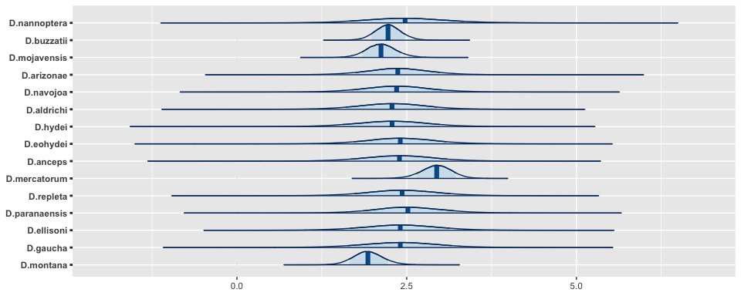

## References