A systems-modelling approach to predict biological responses to extreme heat
Daniel W.A. Noble¹ $‡$, Margaret Mayfield² $†$, Ary Hoffmann² $†$, Zhong-Hua Chen^{3,4} $†$, Steven J. Lade^{5,6} $†$, Xuemei Bai⁵ $†$, Danielle Way⁷ $†$, Belinda Medlyn³ $†$, Owen K. Atkin^{7,8} $†$, Adrienne Nicotra^{1,7} $†$, James M. Cook³, Brajesh Singh³, Alison Bentley⁷, Ian Wright³, Michael R. Kearney² $‡$
Affiliations:
¹ Division of Ecology and Evolution, Research School of Biology, The Australian National University, Canberra ACT 2601, Australia
² School of BioSciences, The University of Melbourne, Australia ³ Hawkesbury Institute for the Environment, Western Sydney University, Australia ⁴ School of Agriculture, Food and Wine, Waite Research Institute, University of Adelaide, Glen Osmond, SA 5064, Australia ⁵ Fenner School of Environment and Society, The Australian National University, Canberra ACT 2602, Australia ⁶ Stockholm Resilience Centre, Stockholm University, Stockholm, Sweden
⁷ Division of Plant Sciences, Research School of Biology, The Australian National University, Canberra ACT 2602, Australia
⁸ Agrifood Innovation Institute, Australian National University, Canberra, ACT 2601, Australia
¹ $‡$ Correspondence: daniel.noble@anu.edu.au & m.kearney@unimelb.edu.au
$†$ These authors contributed equally to this work.

Keywords: plant-animal interactions, microclimate, biophysical models, thermal load sensitivity, dynamic energy budget models, coexistence theory, ecological modelling, population dynamic models

Abstract
Anthropogenic climate change is leading to more frequent and extreme heat waves. These large-scale events are radically re-shaping interactions among organisms – impacting biodiversity, community composition and ecosystem services crucial to natural systems and food security. Predicting heat wave impacts on interacting species requires an understanding of the processes driving differential exposure and sensitivity of organisms to extreme heat events in a life-cycle context. To achieve this predictive capacity, we need to integrate models across scales while capturing species-specific responses at the individual level. We review and demonstrate how existing models in disparate fields can be linked to achieve an increased understanding of how individuals and communities will respond to extreme heat, now and into the future.

A systems-modelling approach to modelling biotic impacts of heatwaves
Climate change is leading to warmer and more variable thermal environments globally [1,2]. Greater thermal variability is resulting in organisms experiencing extreme heat waves that lead to thermal stress impacting organismal growth, survival and reproduction, with cascading effects on population dynamics, species interactions, community composition and ecosystem structure and function [3,4]. Climate variability has already been linked to dramatic global declines in pollinator abundance [5] and crop yields [6–8], but the causes underlying such declines, and their ramifications through communities and society, are not fully understood. The impacts of extreme heat on species and communities are driven by a combination of direct effects of heat stress on the physiology and fitness of organisms within a given species [9–11] and indirect effects on interactions (both positive and negative) among species [e.g., 12]. Understanding the dynamic interplay between direct and indirect effects of extreme heat, and how these are mediated by environmental factors (e.g., water and food availability, microbes), has been hampered by inadequate coupling of models that predict the cumulative damage to physiological function from extreme heat, which impacts fitness of populations, with community dynamic models across species [13]. Predicting how extreme heat impacts population dynamics and communities requires a stronger coupling of biophysical, physiological, population and community ecology models. Currently, siloing of these fields has resulted in disjunction of these models. In addition, most biophysical, physiological, and population studies focus on a single or a very small number of species making it impossible to begin modelling the dynamic feedbacks and interactions between species that matter for responses at community scales [14,15]. A systems-thinking approach is now needed to better capture the multifaceted nature with which extreme heat manifests within in a community (e.g., capturing non-linearities and interactions) – an approach we argue will better capture the dynamic feedbacks within and between species to improve predictions.
Using plants and insects as examples, we review broad classes of models across subfields of ecology and evolution and discuss how they can be linked to effectively model the biotic impacts of heatwaves from individuals to communities (Figure 1). We focus on plant and insect communities given the strong interconnections between them, the ease with which they can and have been studied, and their importance to socioecological systems. Physiological models can now be seamlessly integrated with biophysical models to characterize temperatures experienced by organisms and simulate the effects of extreme heat events on the entire life cycle of species within ecological communities [16–19] (Figure 1). Physiological models that incorporate estimates of thermal sensitivity across species can capture the delicate balance between damage and repair of physiological systems [10,11,20,21], yielding predictions of the immediate and cumulative impacts of extreme heat on growth, survival and reproduction. Importantly, mechanistic physiological models provide outputs at the individual level (e.g., energy and water requirements, waste production, activity constraints, vital rates) that can be integrated into population and community ecology models to capture how extreme heat events perturb interactions among species and across whole, complex communities [22,23]. We demonstrate how such a coupling can be made within and across species and highlight the opportunities it presents to develop a greater understanding of the ways in which extreme heat stress manifests across species. We also discuss the challenges of coupling models across diverse species in communities along with capturing the eco-evolutionary feedbacks that will be necessary for accurate predictions in the future.
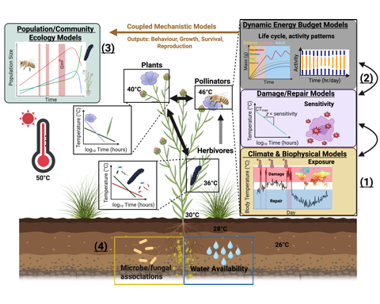
Figure 1- A coupled systems modelling framework for predicting the effects of extreme heat on ecological communities. The modelling approach we develop here integrates (1) climate/biophysical models to predict the different microclimates species experience. (2) Microclimates experienced by organisms then provide inputs for physiological models that integrate temperature exposure with explicit physiological processes that simulate development, behaviour, survival and reproduction in response to microclimate dynamics across life history stages. Physiological models can be built around the unique life cycles of the diverse species in communities, capturing lagged responses to extreme heat, phenological mismatches and mechanistically informed responses to extreme heat for species of the system in question. Outputs (behaviour, growth rate, biomass accumulation, survival and reproduction) from physiological models of individual organisms can then be integrated into (3) population and community ecology models (such as those developed with in the Modern Coexistence Theory Framework – see text) to predict population growth and community composition under a specific type of change (either to the environment or suite of interacting organisms). Environment-mediated feedback loops (4) influence organism thermal exposure and sensitivity (e.g., water availability, microbiota), which can vary across different life stages and organs. Coupling existing models will allow for quantitative predictions to be made on how extreme heatwaves perturb biological systems and allow for the development and implementation of strategies to enhance biological system resilience to extreme heat. Created with BioRender.com.

From weather to microclimates: predicting community wide exposure to extreme heat
Extreme weather events are predicted by Global Circulation Models (GCMs), typically at large spatial scales (e.g. 0.5 $​^{∘}$ grid cells). Yet, species across communities experience these heatwaves differently because of the varied microhabitats they occupy. For example, while air temperature may be 50°C, an organism a metre below the soil surface may be exposed to temperatures ~20°C cooler (Figure 1). Therefore, to understand how extreme heat impacts on a community of organisms, we must characterize the ‘microclimates’ experienced by individuals of different species under a given atmospheric event. Predicting microhabitats often involves taking the atmospheric conditions as independent forcing variables and combining them with detailed information on terrain (slope, aspect, hill shade), vegetation [plant-area index (PAI), stomatal behaviour, leaf reflectance] and soil hydrothermal properties to predict how radiation, wind speed, air temperature, humidity, soil temperature and soil moisture vary on small spatial scales [24–30]. Microclimate models, which typically make predictions at fine spatial and temporal resolutions, offer huge potential in capturing the impacts of past weather conditions which can also determine how a given heat wave manifests. The same atmospheric heat wave can have different implications for microclimatic conditions depending on the recent history of rainfall and temperature. Importantly, downscaling to microclimate conditions does require additional variables for a given location than typically used in climate models (e.g., % shade, soil characteristics, surface albedo), however, many of the additional variables are readily available. In addition, depending on the organism and question of interest, not all input variables are needed to parameterize a given microclimate. Indeed, guides for helping choose what microclimate variables to include and the spatial and temporal resolution needed exist to help decision-making [e.g., 31,32].
Beyond parameterization, the benefit of a systems-thinking approach in the context of microclimate modelling is its ability to capture vegetation and soil dynamics which can dramatically shape microclimate conditions within and between species dynamically across time. For example, plant water use dynamics during heatwaves can amplify or reduce high temperatures via effects on photosynthetic capacity, stomatal decoupling, cuticular conductance, leaf damage and plant mortality [18,33]. These impacts are important for the plants themselves, but also for thermal regimes available to other organisms. Forecasting future thermal regimes is challenging because it involves forecasting future vegetation dynamics, including changes in key vegetation properties such as leaf area index, as a function of plant growth, plant population dynamics and shifts in community composition. Despite the complexity and non-linearity of these interactions across the soil-plant-atmosphere continuum, there is existing capacity, and growing potential, to model them and determine individual-specific exposure to extreme heat. For example, a wide range of vegetation models is available for this purpose, from crop growth models that simulate growth and yield of crops over a season (e.g. Agricultural Production Systems sIMulator (APSIM), [34]) up to the dynamic global vegetation models (DGVMs) that simulate vegetation function and distribution at local to global scales [35].

Translating exposure to organism temperature: biophysics to the rescue!
Once microclimates are quantified, it is crucial to estimate the heat and water budgets of organisms to determine how microclimate variability within a system translates to realized organismal temperatures and hydration states. Heat and water budgets can be computed using a combination of species functional traits (e.g., body mass, metabolic rate, surface area, integument emissivity) along with how heat energy and water are exchanged with the environment – dependent on the microclimate experienced. Such biophysical models have a long history[18, 36,37] but have become more widely applied in ecology in the past 20 years, facilitated by developments in environmental datasets, microclimate modelling, and the emergence of high-level programming languages such as R [19]. Biophysical models of ectothermic animals make use of equations for energy and mass exchange between an organism and its environment and can account for complex radiative heat transfer and the role of evaporative water loss across surfaces [19,24,38]. Equivalent models of leaves incorporate the dynamic role of stomata [18, 39] (Box 1). Biophysical models are powerful because, by translating microclimate conditions to organism body temperature and hydric states, simple regulatory decision-making models can be used [40,41]. For example, given an understanding of an organism’s thermal activity windows, thermal optima, and critical thermal limits we can determine what microclimates should be chosen to get as close as possible to its preferred body temperature [e.g., 40,41]. Incorporating such behavioural thermoregulatory decision making is crucial for mitigating the negative impacts of extreme heat and can inherently capture the trade-offs such a strategy entails through reduced foraging time [19,40]. In addition, incorporating stomatal behaviour can mitigate or exacerbate the extreme temperatures leaf tissue experiences while simultaneously shaping the microclimate conditions for other organisms [18,42] (Box 1). Future developments in biophysical modelling of organismal temperature under extreme heat will involve understanding the nuances of plastic physiological and behavioral responses. For example, lizards may pant when exposed to high temperatures [43], birds may ‘wind surf’ or seek thermal micro-refugia [44], and stomata can enact emergency cooling, departing from the typical responses to vapor pressure and light intensity [33], though this response may depend on prior soil moisture conditions [45]. While biophysical models require many variables for parameterization they can be tailored to the question and organism of interest [19]. Many traits can be assumed, or traits of similar species can be used to construct basic models which can be validated and updated. The application of biophysical models in concert with microclimate models can thus be used to infer the thermal conditions to which members of the same ecological community are exposed with different degrees of detail. Realised thermal exposure can then be linked to physiological models.

Capturing both physiological damage and repair to predict multi-species thermal sensitivity
Translating how heat waves impact plants and animals not only depend on modelling temperature exposure but also the varying sensitivity of organisms to extreme heat [20,46]. Sensitivity to extreme heat can be captured by thermal load sensitivity (TLS) / thermal death time (TDT) models that explicitly account for how heat stress depends on both the temperature experienced and and its duration [20,21]. TLS models predict the relative accumulation of damage to cellular and sub-cellular systems that compromise physiological function. Without periods of recovery, where damage can be repaired, organisms accumulate damage over time reducing growth and impacting survival and reproduction. Typically, TLS models focus on endpoints that include survival (e.g., lethal temperatures, $LT_{50}$ or $LT_{80}$) or some measure of reduced fertility, but this need not be the case [21]. Endpoints are predicted by assuming the effect of time at a given temperature decreases survival and/or fertility exponentially and have been shown to have high predictive power [10,11,20,46]. For example, Ørsted et al. [11] show that both mortality and fecundity follow a clear exponential relationship with time in the Spotted Wing Drosophila (Drosophila suzuki), with survival and fecundity being compromised most for long thermal exposures at high temperatures. Importantly, Ørsted et al. [11] show that reproductive sensitivity can be higher than mortality, with heat injury accumulating faster to impact productivity earlier than survival. TLS theory also applies well to photosynthetic function in plants [47,48], highlighting the potential generality of the TLS framework and its capacity to explore plastic responses (e.g., acclimation and priming) of organisms. TLS models are crucial for predicting how heat waves affect organisms because accumulated damage to physiological systems can result in lagged responses to heat stress or exacerbate future stress (i.e., future heat waves / droughts) – a common feature of extreme heat events [21,49].
Environmental factors known to impact thermal sensitivity, such as water and drought stress [e.g., 50,51] along with nutritional and dietary changes [e.g., 52,53] can also be incorporated into systems modelling approaches through their impacts on thermal sensitivity and tolerance [21] (Figure 1). Indeed, an exciting potential application of a systems-modelling approach is to explore how microclimatic conditions mediate changes to interactions between plant and animal microbial communities. Interactions between plants and microorganisms, such as plant growth-promoting rhizobacteria (PGPR), arbuscular mycorrhizal fungi (AMF), and bacterial or fungal endophytes are known to enhance growth, defense, and heat tolerance in plants [54,55], and gut microbiota can improve heat tolerance in animals [56]. Additionally, modelling the intricate balance between damage and repair for a suite of different species can help identify susceptible species, life stages and tissues that are most at risk from extreme heat events due to direct sensitivity to extreme heat, which should allow for more accurate predictions of the varying levels of species sensitivity within a community [21].
Box 1: Building a systems modelling approach to capture multi-species exposure to extreme heat
Using a simple hypothetical community (Figure I) we outline how a systems-modelling approach can be developed. In Box 1 we focus on how climate, microclimate, and biophysical models can predict the differential exposure to extreme heat events across species, how species can alter each other’s microclimates and incorporate ‘behavioural’ responses of species in response to temperature (e.g., stomatal behaviour, thermoregulation). In Box 2, we then demonstrate how we can use the predicted organismal temperatures from these models to predict life-cycles for species, incorporate differences in thermal sensitivity, and use the output from physiological models to estimate vital rates for population and community ecology models.
To begin, we use natural climate data collected during a heatwave event in January 2018/19 at Renmark, South Australia (Calperum Station). Briefly, we use the micro_silo function in NicheMapR [18,57] in conjunction with microclima [25,26] in the R statistical language. micro_silo uses climate data from 1889 to present (https://www.longpaddock.qld.gov.au/silo/) to compute microclimates. By default, micro_silo computes microclimates at various heights above ground (20cm-1.2m, relevant to our plants and insects) and soil depths (for burrowers) with varying levels of shade (we use 40% and 80%). Simulating these varied conditions allows us to capture the diversity of microclimates that different species in a community might experience and provides opportunities to build in behavioural plasticity.
With available microclimates predicted, we can compute leaf and body temperatures using biophysical models. Plant temperatures will impact temperatures experienced by our grasshopper species because plant stoma change in response to extreme heat events. We first model leaf temperatures that capture stomatal behaviour with the help of the plantecophys package [39]. Here, we define traits of the leaf and use the ectotherm function in NicheMapR to compute realistic leaf temperatures as stoma open and close in response to temperature and vapor pressure deficit (Figure I). The combination of microclimate, leaf traits (e.g., shape, leaf conductance, emissivity) and stomatal behaviour allows us to compute realistic leaf temperatures during the heatwave event which varies across the plant.
Once we have leaf temperatures, we can assume these now form part of the microclimate for our insect species (Figure I). Using the ectotherm function in NicheMapR again, we use the temperatures in the vicinity of the plants, along with insect traits to compute insect body temperatures. One grasshopper species (Species B - Figure I) moves to cooler parts of the plant when it gets too hot and we can capture this thermoregulatory behaviour using information on their thermal preferences to minimize thermal stress when possible (i.e., keep body temperature within thermal limits). All code to demonstrate this process is available at: https://daniel1noble.github.io/thermal_tol_interactions/.
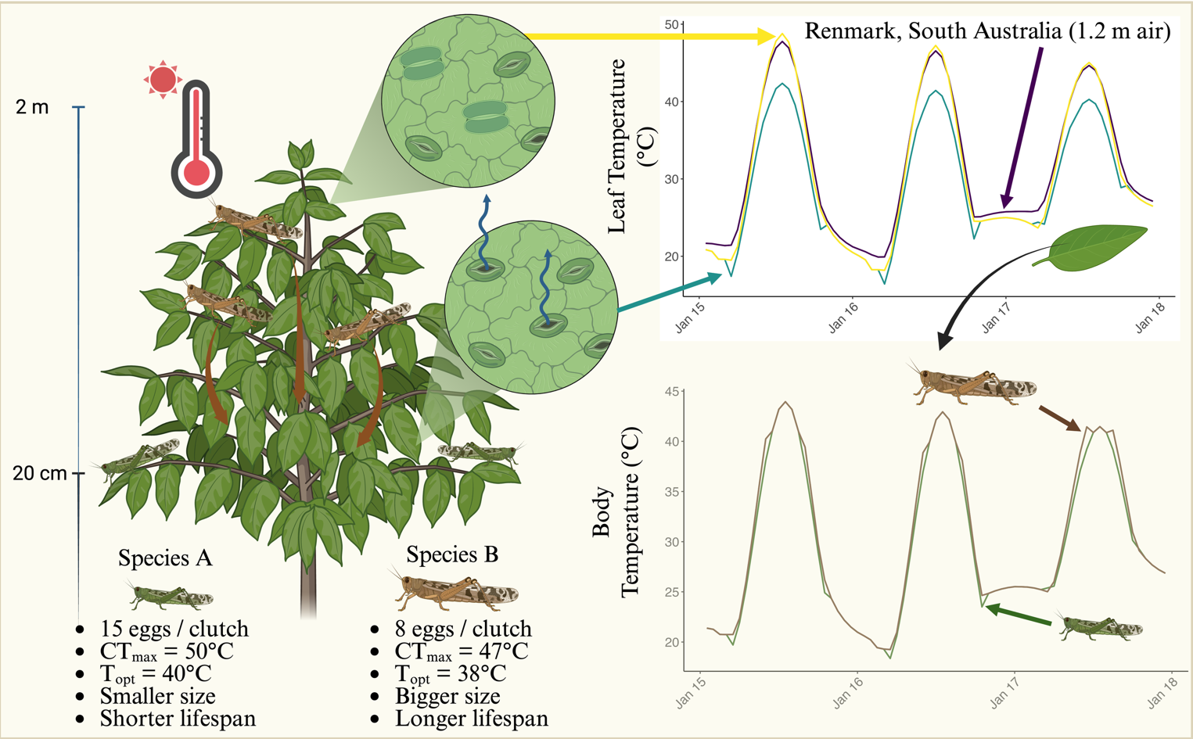
Figure I: Predicting and coupling microclimate and biophysical models of plants and insects. Created with BioRender.com.

Glossary
Coexistence: Coexistence occurs when populations of two or more species are able to persist in each other’s presence indefinitely under constant, equilibrium conditions.
Modern Coexistence Theory: A theoretical framework derived from population ecology describing the conditions under which species can coexist mathematically. It has resulted in the development of population growth models using criteria based on niche and fitness differences, mutual invasibility and feasibility domains.
Microclimate: Microclimates are the local atmospheric conditions experienced by organisms, which can differ substantially from the broader atmospheric conditions. Microclimates are influenced by factors such as vegetation cover, soil properties, and topography, and can significantly affect the thermal environment experienced by organisms
Functional traits: Functional traits are the measurable characteristics of organisms that influence their performance and fitness, such as body size, reproductive output, and metabolic rates. In the context of extreme heat, functional traits can be used to categorize species based on their responses to thermal stress
Biophysical models: Biophysical models capture the balances of heat, water, and other aspects of energy and mass exchange between organisms and their microclimatic environmment to predict how organisms function, survive, and behave in varying environments.
Thermal load sensitivity (TLS) / thermal death time (TDT) models: Models that use biophysical models to predict organism temperature and calculate thermal load that captures lethal and sublethal impacts on tissues, organs and whole organisms.
Vital rates: Demographic parameters that determine how populations change over time. They include measures of birth, death, growth, and reproduction.

Physiological models that capture the effects of extreme heat across life
Dynamic Energy Budget (DEB) models are physiologically-explicit life-cycle models of energy and mass uptake and conversion that predict key life-history transitions, growth, reproduction and survival (senescence) through time [16,58]. DEB models consider organisms as a thermodynamic system (adhering to energy-mass balance) capturing the exchange of food, water, respiratory gases and metabolic waste throughout the life cycle [19]. DEB models can translate short-term (hours) variation in factors such as temperature, toxins (e.g., toxicants, [59]) and resource availability (nutrients) [60,61] into long-term (days, months, years) effects on development, growth, reproduction and survival [17,19]. DEB theory, when combined with biophysical models more generally, allows the full water budget to be computed to account for heat stress impacts of a hydric nature [19]. Perhaps most importantly, DEB theory calculates the life cycle trajectory of an organism and so can account for the effects of timing of heat wave impacts relative to life stage. Applied to multi-species assemblages, DEB models can capture how different species’ life cycles are impacted by heat and interact with each other to predict how traits such as birth, age at maturity, reproductive events, energy flow and lifespan vary across species (Box 2). DEB models integrate many fundamental physiological processes, and necessary parameters have been estimated for > 6000 species already (although there are taxonomic biases) [62,63]. New analytical approaches using phylogenetic imputation methods show promise for calculating energy budgets for species without data. Such methods have, for instance, already been used to predict DEB parameters for over 1.3 million animal species [see, 64]. In addition, software packages such as NicheMapR [24,57] allow for simulations of life-cycles using parameters for diverse species. DEB model outputs, such as body mass and size, reproductive success and timing, and survival, can be used to parameterize vital rates needed for population and community models, with additional options to incorporate eco-evolutionary feedbacks (see Box 3).
Analogously, physiologically-based vegetation models simulate plant growth over time as a function of carbon, water and nutrient uptake and use, following mass balance principles [65]. Model drivers typically include incident radiation, humidity, rainfall, and soil properties as well as air temperature. The models capture the direct effects of temperature on key physiological processes, such as photosynthesis, respiration and phenology, as well as the indirect effects via feedbacks on the vegetation water balance and soil nutrient availability. Short-term responses to temperature are captured well in these models through representations of enzyme kinetics, but representation of longer-term responses remains challenging because plants show high flexibility in their ability to acclimate to ambient temperatures [66]. Another area under active research is capturing plant damage and death from hot-dry weather extremes. Considerable progress has been made by representing the plant hydraulic system explicitly, enabling the risk of hydraulic failure to be predicted under conditions of low rainfall and high evaporative demand [67]. Direct damage to plant tissue from extreme heat has yet to be represented in such models, but the thermal death time framework outlined above offers a promising way forward.

Mechanistic approaches that ‘speak’ to population and community ecology under extreme heat
Modelling tools developed as part of Modern Coexistence Theory [MCT, 15] offer a promising suite of approaches for combining biophysical, physiological, and population ecology models to predict whole community responses to extreme heat events. Population growth models are core to predicting species coexistence within this framework. In their most recent applications, these simple pairwise population growth models have been used to underpin horizontal network models that allow one to examine how species in a community interact and create stable communities [14,68]. Other extensions of MCT tools have integrated environmental variation [23], traits [69] and cross-trophic dynamics [70,71] in predicting the outcomes of species interactions in community contexts. Fundamentally, this approach relies on simple two-species individual-based population growth models [72,73] but key extensions involve the use of whole communities as one “species” [74,75] or the grouping species to simplify interaction matrices while accounting for a small number of dominant species [71].
Population dynamic models that are used as part of MCT can calculate the individual fitness effect of interactions in relation to environments experienced by organisms [22,71,76] (Box 2). As these models use the same fitness measures as DEB models, they offer a population modelling framework to add thermal biology to community diversity predictions. This is because population dynamical models can be combined, for example as networks [14], and compared between microsites with different biophysical properties and composed of species with different thermal responses to their microenvironment. For example, Bimler et al [14] used this approach to determine which species were keystone species under shady and sunny portions of the same plant communities.
Modified vital rate functions (which can be used with any measure of fitness) can be used in population growth models to compare population growth predictions for individuals in areas with different biophysical properties and/or thermal tolerances. Indeed, the predicted traits from DEB models could be used to directly parameterise growth rate models or used to predict functional traits, which at a community scale can be used to categorize species with different response and effect profiles. Horizontal interaction networks can then be used to determine how important microclimates with different biophysical properties are for species interactions (defined by their fitness responses to their thermal environment) within the context of whole communities. These networks can also be made to target particular types of interaction effects or responses to extreme heat events, or used to compare how species interact in areas with different thermal landscapes. The limitation of these methods is that they are data hungry, but even this can be handled by categorizing species by ‘traits’ or shared phylogenetic relationships, which are simplifications shown to be effective at reducing model complexity without sacrificing model accuracy [77].

Box 2: Scaling up extreme heat effects from impacts on individuals of species to communities
We use predicted organismal temperatures (Box 1) to take stock of how thermal heat stress accumulation impacts survival probability and simulate life cycles for two interacting grasshopper species under their respective microclimates.
To start, using existing parameters for a dynamic energy budget (DEB) model for a grasshopper [78] we can use the ectotherm function in NicheMapR, to simulate life cycles for each of the two species. We assume that both species have similar DEB parameters but vary in their life-history, thermal physiology, size and reproduction, which we include in our DEB model (see Figure I in Box 1).
DEB models incorporate a simple Gompertz mortality function to capture senescence, but do not integrate the effects of thermal load accumulation in response to extreme heat events into survival functions. We assume reproduction is not impacted by heat for simplicity, but thermal load on reproduction can also be incorporated in a similar way [11]. By using thermal sensitivity parameters for mortality endpoints from TLS models (i.e. $z$, slope and $α$ = critical thermal limit), they can be used to predict the accumulation of damage during stressful temperatures experienced under realistic conditions for each species by calculating heat injury (HI) accumulated between time point $t_{i}$ and $t_{i+1}$ across life (using an $LT_{50}$ threshold)(Equation 1) (‘red lines’ in Fig IIA) [10,11,21,46].
$$HI=\sum_{i=1}^{T_{e}>T_{c}}{\frac{100⋅\left(t_{i+1}-t_{i}\right)}{{10}^{\left(-\frac{1}{z}⋅max\left(T_{i};T_{i+1}\right)+α\right)}}} \left(1\right)$$
After calculating HI accounting for repair [21], and converting to the probability of mortality through time, we can calculate the total probability of survival (i.e., from senescence, thermal stress, and activity-based mortality) for each age/stage class. In combination with the DEB model outputs on total reproduction across life, we can build a simple age/stage-structured population matrix (day of life or developmental stage) (Fig IIB) to estimate population growth rate [$r_{max}$ = ln($λ$)] for each species under their respective microclimates. $r_{max}$ can then be included in a two-species, density dependent Ricker model (a model commonly used as a the basis for coexistence modelling in the MCT framework) to predict their population growth under competition (Equation 2).
Nt+1i=Nti⋅exp​rmax,i1-Nti+j≠i​αijNtjKi 2
where $N_{t}^{i}$ is the population size of species $i$ at time $t$, r_{max_i} is the intrinsic growth rate of species $i$, $K_{i}$ is the carrying capacity of species $i$, and $α_{ij}$ is the competition coefficient that describes how much species $j$ affects species $i$. Given mechanistic physiological models are used, the population matrix can be updated each generation to reflect changes in vital rates (survival and reproduction) under different microclimates in the future.
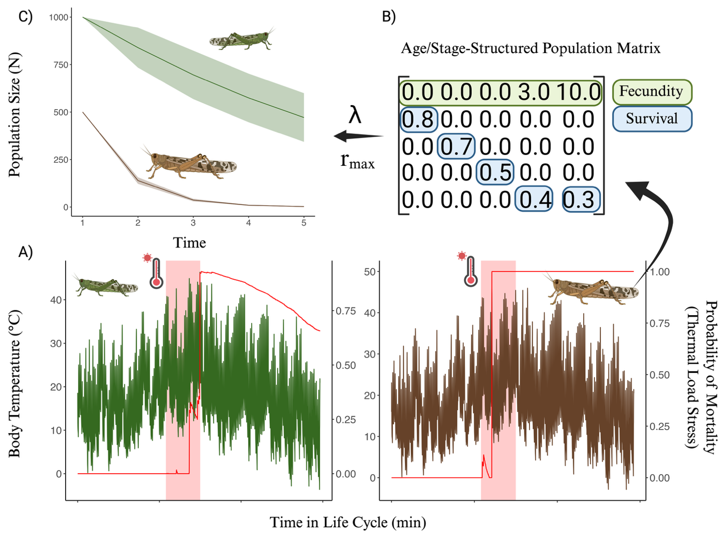
Figure II: A systems approach to using mechanistic physiological models to capture life-cycle vital rates and thermal load stress on survival to scale up to multi-species population dynamics. Created with BioRender.com.

‘Hot’ solutions for a changing world
Extreme heat will have dramatic and widespread effects on biological and socioecological systems that humans rely upon. For example, under current global climate change scenarios, each degree Celsius increase in global mean temperature is estimated to reduce the global yield of wheat by 6.0% and soybean by 3.1% [79], exacerbating food shortages. A systems-modelling approach can help us develop suitable interventions, predict the varied consequences of such interventions, and allow for adjustments that can improve decision making for mitigating the impacts of extreme heat in real world situations. As a simple example (Figure 4A), a systems modelling approach can allow for informed predictions about how to mitigate heat stress to crops while also considering the potential for pest outbreaks. In essence, we want to add a minimal amount of water to a system to cool leaves while avoiding depleting limited water supplies and creating microclimate conditions from becoming more optimal for pests. Making use of real weather data to predict microclimates and organism temperatures we can assess how adding 2, 5, 10, or 20 mm d⁻¹ of water to a system affects leaf temperatures and the life-cycle for a grasshopper species that is a known pest (Figure 4). We can see that adding 2-5 mm d⁻¹ of water can result in as much as a 3.63°C decrease in leaf temperature (Figure 4B), but adding more water does not result in significant gains in cooling. In addition, 2-5 mm of water added each day to avoid extreme heat impacts results in grasshopper populations being suppressed over time whereas not adding water at all results in grasshopper population growth, leading to potential heatwave associated outbreaks. Here, the optimal solution is adding 2-5 mm d⁻¹ of water to both cool plants and protect them from pests. Identifying and/or modifying the thermal suitability of landscapes, such as in our simple example, may dramatically benefit plants and animals under extreme heat and is a promising feature of a systems-thinking approach [19]. Additionally, as our understanding of the mechanisms associated with heat tolerance improve, genetic tools, environmental manipulations (e.g., promoting beneficial microbes) and artificial breeding can be used to enhance thermal tolerance creating more resilience to extreme heat events [e.g., 55].
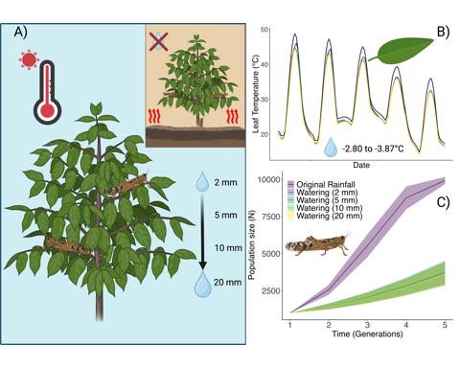
Figure 4- How a systems modelling approach to extreme heat can be used to inform solutions. Heat stress to crops can result in foliage loss and crop failure, but also weaken crops to pests. Using a hypothetical case study of a crop and associated pest, we explore how different watering regimes impact plant temperatures and the flow on effects such regimes have for pest dynamics (A). Using a site near Renmark, South Australia, we use microclimate and biophysical models to estimate leaf temperatures. We see that, compared to original rainfall conditions, certain watering regimes can significantly reduce leaf temperatures by as much as 3.87°C, providing protection to leaves (B). Modelling how these changed microclimate conditions translate to grasshopper body temperatures, we can then estimate changes to grasshopper life cycles and use the vital rates to predict population dynamics, showing, in this case, that even small amounts of water can supress pest growth (C). Created with BioRender.com.
Box 3: An important frontier: integrating eco-evolutionary feedback within a systems-modelling framework
Extreme climactic events, such as heatwaves and droughts, are known to result in intense episodes of selection which can lead to rapid evolutionary change when traits are heritable [80]. In addition, given the intensity of selection associated with extreme climatic events, they have the potential to radically alter the phenotypic and genetic variability available to selection in the future [81], potentially impacting population resilience to future events. Predicting evolutionary responses from extreme heat events is challenging because of their rarity and stochasticity which makes quantifying the strength of selection difficult as it often can only be opportunistically measured [80].
Predicting evolutionary responses also relies on our ability to predict heatwaves and how organisms experience them in the future – a task that is becoming more feasible with new climate models [e.g., 82,83]. Evolutionary consequences of extreme heat events will depend on their characteristics (e.g., frequency, timing, exposure intensity and duration), the traits under selection and their levels of genetic (co)variation, as well as the demographic and ecological context in which the event occurs [84–86]. Considering various forms of plastic responses (e.g., behavioural, developmental, and physiological plasticity) as environments change through time is also crucial because it can dampen selection and shelter genetic variation while also promoting persistence [87,88]. Many of these processes can now be incorporated into a systems modelling framework (e.g, behavioural plasticity), to capture well known environment-phenotype feedback.
A more complete systems modelling approach that captures eco-evolutionary dynamics needs to think about ‘traits’ more broadly than those typically thought of by evolutionary ecologists (e.g., body mass). For example, ‘traits’ can include the parameters within models that establish functional traits within a population (e.g., DEB parameters)[89,90], which may provide predictions for suites of resulting traits that emerge from such parameters. Furthermore, it needs to consider the evolution of suites of traits which can be done using the multivariate breeders equation [91]:
$$Δ\overset{‾}{z}=G⋅β \left(3\right)$$
where $Δ\overset{‾}{z}$ is the vector of changes in the mean trait values, $G$ is the genetic covariance matrix and $β$ is the vector of standardised selection gradients that regress each trait on relative fitness (i.e., $ω=α+β^{T}⋅z+e$; [92]). Plasticity can be captured by mapping trait development to the environment and incorporating environmental variability into the Breeders equation [see also, 93]. While the multivariate breeders equation can be useful for predicting short term evolutionary responses (i.e., one or a few generations) it likely has limited predictive power over longer timespans because of changes in heritability and selection through time, which is a future challenge [86,92].

Outstanding Questions
- How effective is using parameters of closely related species for predicting the impacts of extreme heat for data deficient species?
- How can we capture rapid and longer-term evolutionary responses of interacting species to extreme heat in a systems-modelling framework?
- Can we use thermal load sensitivity models to describe heat damage to plant tissues?
- Can we build and couple dynamic energy budget models for plant species to predict how extreme heat will impact tissue and life cycle dynamics more accurately?
- How do multiple stressors in anthropogenically modified environments interact with extreme heat to impact organisms, populations and communities?
- How will extreme heat impact species coexistence and functional trait diversity in natural and agricultural systems?
- How can we quantify microhabitat complexity to robustly and accurately capture the heat responses of animal, plants and microbes and their interactions?
- How do we model lagged impacts of extreme heat events on whole communities?
- How will thermal stress to natural ecosystems and food production systems impact people?

Concluding Remarks
Implementing a systems-modelling approach will no doubt be challenging, particularly for complex communities, and knowledge gaps remain (see Outstanding Questions). However, more mechanistic approaches that encapsulate key biological processes (physiology, behaviour, phenology, species interactions and eco-evolutionary dynamics - Box 3) are needed now, more than ever, to better predict biological responses to extreme heat [49,94]. Coupled mechanistic models within and across species are expected to have improved predictive power when extrapolated to new conditions and can help better integrate interacting processes [19,94]. Nonetheless, a systems modelling approach will require a solid foundation of species natural history, diverse modelling expertise, and a concerted effort to collect and collate trait and environmental data for model building and validation. However, there are exciting new tools and data that are making overcoming these challenges more feasible [25], and careful consideration of the key processes important to a system can help alleviate these challenges [19]. For example, large databases of physiological traits for both plants and animals now exist [e.g., 95,96] and advanced missing data approaches can help estimate likely parameters for data deficient species [64,68,97]. In addition, ever more sophisticated and powerful computational pipelines (e.g. NicheMapR, TrenchR, mcera5, terra in R) make it easier to implement and connect models. Model selection and validation are important steps in any modelling process and will be more complicated when applied to entire systems. However, starting with a simpler model, validating predictions with empirical data and then adding complexity as needed can make building systems models more tractable [19]. Even simple models that compare counterfactual scenarios may provide important quantitative insights into the impacts of extreme heat on organisms, populations and communities [98–100]. Such insights can form the basis for prediction-driven solutions to mitigate the impacts of extreme heat on biodiversity. By working collaboratively and integratively we can develop a more quantitative and predictive understanding of the impacts that extreme heat will have on organisms, populations, and communities along with how to mitigate these impacts to preserve diverse systems now and into the future.

Acknowledgements
We would like to thank Pieter Arnold, Joel Treutlein and Patrice Pottier for helpful comments on previous versions of this manuscript. We would also like to thank the Editor and three anonymous reviewers who provided very constructive feedback on earlier versions of our manuscript. DWAN and S.J.L. are supported by an ARC Future Fellowship (FT220100276 to DWAN and FT200100381 to S.J.L.). We would also like to thank The Australian National University, the University of Melbourne and Western Sydney University for funding to support workshops that helped develop this manuscript.

Data and Code
Link to the data and code used to for examples in Box 1 and 2 can be found here: https://daniel1noble.github.io/thermal_tol_interactions/ with the full set of files being located on our GitHub repository at https://github.com/daniel1noble/thermal_tol_interactions.

References

1. Barriopedro, D. et al. (2023) Heat waves: Physical understanding and scientific challenges. Rev. Geophys. 61, e2022RG000780
2. Perkins‐Kirkpatrick, S. and Lewis, S.C. (2020) Increasing trends in regional heatwaves. Nat. Commun. 11, 3357
3. Evans, M.E.K. et al. (2025) Scaling plant responses to heat: From molecules to the biosphere. Science 388, 1167–1173
4. Margalef-Marrase, J. et al. (2020) Relationship between heatwave-induced forest die-off and climatic suitability in multiple tree species. Global Change Biology 26, 3134–3146
5. Kazenel, M.R. et al. (2024) Heat and desiccation tolerances predict bee abundance under climate change. Nature 628, 342–348
6. Zhao, C. et al. (2017) Temperature increase reduces global yields of major crops in four independent estimates. Proc. Natl. Acad. Sci. U. S. A. 114, 9326–9331
7. Tito, R. et al. (2018) Global climate change increases risk of crop yield losses and food insecurity in the tropical andes. Global change biology 24, e592–e602
8. Bernacchi, C.J. et al. (2025) Safeguarding crop photosynthesis in a rapidly warming world. Science 388, 1153–1160
9. Martinez, L.D. et al. (2023) Effect of simulated heat waves on the behaviour of two mirid predators. J. Appl. Entomol. 147, 486–498
10. Rezende, E.L. et al. (2020) Predicting temperature mortality and selection in natural drosophila populations. Science 369, 1242–1245
11. Ørsted, M. et al. (2024) Thermal limits of survival and reproduction depend on stress duration: A case study of drosophila suzukii. Ecol. Lett. 27, e14421
12. López-Goldar, X. et al. (2024) Heat waves induce milkweed resistance to a specialist herbivore via increased toxicity and reduced nutrient content. Plant Cell Environ. 47, 4530–4542
13. Trivedi, P. et al. (2022) Plant–microbiome interactions under a changing world: Responses, consequences and perspectives. New Phytol. 234, 1951–1959
14. Bimler, M.D. et al. (2024) Plant interaction networks reveal the limits of our understanding of diversity maintenance. Ecol. Lett. 27, e14376
15. Chesson, P. (2000) General theory of competitive coexistence in spatially-varying environments. Theor. Popul. Biol. 58, 211–237
16. Kooijman, S.A.L.M. (2010) Dynamic energy budget theory for metabolic organisation, Cambridge university press
17. Kearney, M. and Porter, W. (2009) Mechanistic niche modelling: Combining physiological and spatial data to predict species’ ranges. Ecol. Lett. 12, 334–350
18. Kearney, M.R. and Leigh, A. (2024) Fast, accurate and accessible calculations of leaf temperature and its physiological consequences with NicheMapR. Methods Ecol. Evol. 15, 1516–1531
19. Briscoe, N.J. et al. (2023) Mechanistic forecasts of species responses to climate change: The promise of biophysical ecology. Global Change Biology 29, 1451–1470
20. Rezende, E.L. et al. (2014) Tolerance landscapes in thermal ecology. Funct. Ecol. 28, 799–809
21. Arnold, P.A. et al. (2025) A framework for modelling thermal load sensitivity across life. Glob. Chang. Biol. 31, e70315
22. Bimler, M.D. et al. (2018) Accurate predictions of coexistence in natural systems require the inclusion of facilitative interactions and environmental dependency. J. Ecol. 106, 1839–1852
23. Bowler, C.H. et al. (2022) Accounting for demographic uncertainty increases predictions for species coexistence: A case study with annual plants. Ecol. Lett. 25, 1618–1628
24. Kearney, M.R. and Porter, W.P. (2017) NicheMapR – an R package for biophysical modelling: The microclimate model. Ecography (Cop.) 40, 664–674
25. Maclean, I.M.D. et al. (2019) Microclima: An r package for modelling meso‐ and microclimate. Methods Ecol. Evol. 10, 280–290
26. Kearney, M.R. et al. (2020) A method for computing hourly, historical, terrain‐corrected microclimate anywhere on earth. Methods Ecol. Evol. 11, 38–43
27. Maclean, I.M.D. et al. (2021) On the measurement of microclimate. Methods Ecol. Evol. 12, 1397–1410
28. Buckley, L.B. et al. (2023) TrenchR: An R package for modular and accessible microclimate and biophysical ecology. PLOS Clim 2, e0000139
29. Bramer, I. et al. (2018) Advances in monitoring and modelling climate at ecologically relevant scales. 58, 101–161
30. Levy, O. et al. (2016) A dynamically downscaled projection of past and future microclimates. Ecology 97, 1888–1888
31. De Frenne, P. et al. (2024) Ten practical guidelines for microclimate research in terrestrial ecosystems. Methods Ecol. Evol. DOI: 10.1111/2041-210x.14476
32. Meyer, A.V. et al. (2023) A guide and tools for selecting and accessing microclimate data for mechanistic niche modeling. Ecosphere 14
33. Drake, J.E. et al. (2018) Trees tolerate an extreme heatwave via sustained transpirational cooling and increased leaf thermal tolerance. Glob. Chang. Biol. 24, 2390–2402
34. Holzworth, D. et al. (2018) APSIM next generation: Overcoming challenges in modernising a farming systems model. Environ. Model. Softw. 103, 43–51
35. Medlyn, B.E. et al. (2011) Reconciling the optimal and empirical approaches to modelling stomatal conductance: RECONCILING OPTIMAL AND EMPIRICAL STOMATAL MODELS. Glob. Chang. Biol. 17, 2134–2144
36. Porter, W.P. et al. (1973) Behavioral implications of mechanistic ecology : Thermal and behavioral modeling of desert ectotherms and their microenvironment. Oecologia 13, 1–54
37. Porter, W.P. and Gates, D.M. (1969) Thermodynamic equilibria of animals with environment. Ecol. Monogr. 39, 227–244
38. Riddell, E.A. et al. (2017) Physical calculations of resistance to water loss improve predictions of species range models. Ecol. Monogr. 87, 21–33
39. Duursma, R.A. (2015) Plantecophys–an R package for analysing and modelling leaf gas exchange data. PLoS One 10, e0143346
40. Wild, K.H. et al. (2025) Climate change and the cost-of-living squeeze in desert lizards. Science 387, 303–309
41. Briscoe, N.J. et al. (2022) Too hot to hunt: Mechanistic predictions of thermal refuge from cat predation risk. Conserv. Lett. 15
42. Duursma, R.A. et al. (2019) On the minimum leaf conductance: Its role in models of plant water use, and ecological and environmental controls. New Phytol. 221, 693–705
43. Loughran, C.L. and Wolf, B.O. (2020) The functional significance of panting as a mechanism of thermoregulation and its relationship to the critical thermal maxima in lizards. J. Exp. Biol. 223, jeb224139
44. Sharpe, L.L. et al. (2022) In the hot seat: Behavioral change and old-growth trees underpin an australian songbird’s response to extreme heat. Front. Ecol. Evol. 10
45. Posch, B.C. et al. (2024) Intensive leaf cooling promotes tree survival during a record heatwave. Proc. Natl. Acad. Sci. U. S. A. 121, e2408583121
46. Ørsted, M. et al. (2022) Finding the right thermal limit: A framework to reconcile ecological, physiological and methodological aspects of CTmax in ectotherms. J. Exp. Biol. 225, jeb244514
47. Jagadish, S.V.K. et al. (2021) Plant heat stress: Concepts directing future research. Plant Cell Environ. 44, 1992–2005
48. Faber, A.H. et al. (2024) Application of the thermal death time model in predicting thermal damage accumulation in plants. J. Exp. Bot. 75, 3467–3482
49. Martínez-De León, G. and Thakur, M.P. (2024) Ecological debts induced by heat extremes. Trends Ecol. Evol.
50. Marchin, R.M. et al. (2022) Extreme heat increases stomatal conductance and drought-induced mortality risk in vulnerable plant species. Glob. Chang. Biol. 28, 1133–1146
51. Youngblood, J.P. et al. (2025) Dehydration worsens heat tolerance of locusts and amplifies predicted impacts of climate change. Funct. Ecol. DOI: 10.1111/1365-2435.70038
52. Mengutay, M. et al. (2013) Adequate magnesium nutrition mitigates adverse effects of heat stress on maize and wheat. Plant Soil 368, 57–72
53. Andersen, L.H. et al. (2010) Protein and carbohydrate composition of larval food affects tolerance to thermal stress and desiccation in adult drosophila melanogaster. J. Insect Physiol. 56, 336–340
54. Chouhan, D. et al. (2023) Plant-microbe interaction and their role in mitigation of heat stress. In Rhizosphere biology, pp. 127–147, Springer Nature Singapore
55. Márquez, L.M. et al. (2007) A virus in a fungus in a plant: Three-way symbiosis required for thermal tolerance. Science 315, 513–515
56. Hoang, K.L. et al. (2019) The effects of bacillus subtilis on caenorhabditis elegans fitness after heat stress. Ecol. Evol. 9, 3491–3499
57. Kearney, M.R. and Porter, W.P. (2020) NicheMapR – an R package for biophysical modelling: The ectotherm and dynamic energy budget models. Ecography (Cop.) 43, 85–96
58. Nisbet, R. et al. (2000) From molecules to ecosystems through dynamic energy budget models. Journal of Animal Ecology 69, 913–926
59. Jager, T. (2020) Revisiting simplified DEBtox models for analysing ecotoxicity data. Ecol. Modell. 416, 108904
60. Kearney, M.R. et al. (2013) Balancing heat, water and nutrients under environmental change: A thermodynamic niche framework. Funct. Ecol. 27, 950–966
61. Kearney, M. et al. (2010) Modelling the ecological niche from functional traits. Philos. Trans. R. Soc. Lond. B Biol. Sci. 365, 3469–3483
62. Marques, G.M. et al. (2018) The AmP project: Comparing species on the basis of dynamic energy budget parameters. PLoS Comput. Biol. 14, e1006100
63. Kooijman, S.A.L.M. et al. (2021) Multidimensional scaling for animal traits in the context of dynamic energy budget theory. Conserv. Physiol. 9, coab086
64. Bruggeman, J. et al. (2009) PhyloPars: Estimation of missing parameter values using phylogeny. Nucleic Acids Research 37, W179–W184
65. Bonan, G. (2019) Climate change and terrestrial ecosystem modeling, Cambridge University Press
66. Kumarathunge, D.P. et al. (2019) Acclimation and adaptation components of the temperature dependence of plant photosynthesis at the global scale. New Phytol. 222, 768–784
67. De Kauwe, M.G. et al. (2020) Identifying areas at risk of drought-induced tree mortality across south-eastern australia. Glob. Chang. Biol. 26, 5716–5733
68. Bimler, M.D. et al. (2023) Estimating interaction strengths for diverse horizontal systems using performance data. Methods Ecol. Evol. 14, 968–980
69. Kraft, N.J.B. et al. (2015) Plant functional traits and the multidimensional nature of species coexistence. Proc. Natl. Acad. Sci. U. S. A. 112, 797–802
70. Buche, L. et al. (2024) Multitrophic higher-order interactions modulate species persistence. Am. Nat. 203, 458–472
71. Buche, L. et al. (2025) A continuum from positive to negative interactions drives plant species’ performance in a diverse community. Ecol. Lett. 28, e70059
72. Ricker, W.E. (1954) Stock and recruitment. J. Fish. Res. Board Can. 11, 559–623
73. Beverton, R.J.H. and Holt, S. (2012) On the dynamics of exploited fish populations, Springer
74. Levine, J.M. and HilleRisLambers, J. (2009) The importance of niches for the maintenance of species diversity. Nature 461, 254–257
75. Wainwright, C.E. et al. (2019) Distinct responses of niche and fitness differences to water availability underlie variable coexistence outcomes in semi‐arid annual plant communities. J. Ecol. 107, 293–306
76. Mayfield, M. and Stouffer, D.B. (2017) Higher-order interactions capture unexplained complexity in diverse communities. Nature Ecology &Evolution 1, 0062
77. Martyn, T.E. et al. (2021) Identifying “useful” fitness models: Balancing the benefits of added complexity with realistic data requirements in models of individual plant fitness. Am. Nat. 197, 415–433
78. Llandres, A.L. et al. (2015) A dynamic energy budget for the whole life-cycle of holometabolous insects. Ecol. Monogr. 85, 353–371
79. Shekhawat, K. et al. (2022) Beat the heat: Plant- and microbe-mediated strategies for crop thermotolerance. Trends Plant Sci. 27, 802–813
80. Baeckens, S. and Donihue, C.M. (2025) Evolutionary consequences of extreme climate events. Current Biology 35, R850–R864
81. Urban, M.C. (2024) Climate change extinctions. Science 386, 1123–1128
82. Muñoz-Sabater, J. et al. (2021) ERA5-land: A state-of-the-art global reanalysis dataset for land applications. Earth system science data 13, 4349–4383
83. Eyring, V. et al. (2016) Overview of the coupled model intercomparison project phase 6 (CMIP6) experimental design and organization. Geosci. Model Dev. 9, 1937–1958
84. Chevin, L.-M. and Hoffmann, A.A. (2017) Evolution of phenotypic plasticity in extreme environments. Philos. Trans. R. Soc. Lond. B Biol. Sci. 372
85. Hoffmann, A.A. and Bridle, J. (2022) The dangers of irreversibility in an age of increased uncertainty: Revisiting plasticity in invertebrates. Oikos 2022
86. Hoffmann, A.A. and Sgrò, C.M. (2011) Climate change and evolutionary adaptation. 470, 479–485
87. Catullo, R.A. et al. (2019) The potential for rapid evolution under anthropogenic climate change. 29, R996–R1007
88. Ghalambor, C. et al. (2015) Non-adaptive plasticity potentiates rapid adaptive evolution of gene expression in nature. Nature 525, 372–375
89. Sousa, T. et al. (2010) Dynamic energy budget theory restores coherence in biology. Philos. Trans. R. Soc. Lond. B Biol. Sci. 365, 3413–3428
90. Kearney, M. et al. (2009) Integrating biophysical models and evolutionary theory to predict climatic impacts on species’ ranges: The dengue mosquito aedes aegypti in australia. Funct. Ecol. 23, 528–538
91. Lande, R. (1979) Quantitative genetic analysis of multivariate evolution, applied to brain:body size allometry. Evolution 33
92. Walsh, B. and Lynch, M. (2018) Evolution and selection of quantitative traits, Oxford University Press
93. McGlothlin, J. and Galloway, L. (2014) The contribution of maternal effects to selection response: An empirical test of competing models. Evolution 68
94. Urban, M.C. et al. (2016) Improving the forecast for biodiversity under climate change. Science 353, aad8466–aad8466
95. Kattge, J. et al. (2020) TRY plant trait database - enhanced coverage and open access. Glob. Chang. Biol. 26, 119–188
96. Leiva, F.P. et al. (2025) ShareTrait: Towards interoperable and reusable individual trait‐based data in ectotherms. Funct. Ecol. DOI: 10.1111/1365-2435.70147
97. Weiss-Lehman, C.P. et al. (2022) Disentangling key species interactions in diverse and heterogeneous communities: A bayesian sparse modelling approach. Ecol. Lett. 25, 1263–1276
98. Dudney, J. et al. (2025) A causal inference framework for climate change attribution in ecology. Ecol. Lett. 28, e70192
99. Carroll, T. et al. (2023) Biodiversity change under adaptive community dynamics. Glob. Chang. Biol. 29, 3525–3538
100. Dornhaus, A. et al. (2022) How can we fully realize the potential of mathematical and biological models to reintegrate biology? Integr. Comp. Biol. 61, 2244–2254

