Dear Editor,

We would like to submit a paper entitled: “A systems-modelling approach to predict biological responses to extreme heat” for consideration as an Opinion article in Trends in Ecology and Evolution.

Heatwaves are rapidly increasing in intensity and frequency globally. Extreme heatwaves will impact diverse taxa within communities with large-scale effects on community assembly, ecosystem productivity and the people that rely on these ecosystems [1–3]. Understanding the cascading impacts across biological and social systems is essential for enhancing resilience and developing management strategies. However, a major outstanding question that remains is: How can variation in ecological responses of organisms to heat extremes be predicted? [4]. Tackling this question requires greater interoperability among models from diverse fields that each provide important predictive capacity across nested hierarchies of biological scales from the subcellular to the ecosystem. Until now, the development of these models has largely ignored the ways in which they can ‘communicate’ and co-evolve with each other to provide a more robust systems-modelling framework. A systems-modelling approach that integrates the strengths of field-specific models –integrated across spatial and temporal scales – will be better able to capture the diverse ways extreme heat can, and will, perturb ecological communities.

We propose multidisciplinary approaches combining inter-kingdom interactions and co-evolution with explicit consideration of ecophysiology, community, population and ecosystem ecology to tackle this challenge. Our ideas emerged from two workshops held in 2024. Our Opinion piece will discuss our vision for an integrated quantitative modelling framework that uses models from disparate fields to calculate the effects of extreme heat on diverse organisms (microbes, plants and animals). We will show how quantitative predictions that use coupled mechanistic models [biophysical models of heat and mass exchange, Dynamic Energy Budget Theory – 5–7] can be combined with physiological [e.g., thermal death time models – e.g., 8–9] and population / community ecology models [e.g., 10-12] to predict systemwide perturbations of heatwave events. Importantly, we will also identify ways to incorporate recognised biological responses and environmental mediators into our proposed modelling framework (e.g., how thermal sensitivity of plants and animals can be mediated by microbes, water availability, plasticity and evolution). Our approach is unique in that it will provide clear connections between conceptual frameworks [e.g., 4] and the models that make quantitative predictions about how a system responds to extreme heat. Our proposed modelling framework can also be used for developing interventions that maintain resilience of biological and agricultural systems in the face of extreme heat, with the Opinion submission discussing promising applications within that space. Finally, we will discuss how ecological models could be coupled to models of human behaviour and human dominant systems to create social-ecological models that anticipate how impacts of extreme heat on organisms could affect society.

Below, we outline our intended plan in more detail along with the authorship list. While our author list is larger than typical for TREE, this submission has been developed by a large interdisciplinary group who are all actively participating in its development. Because one of the main features of this submission is to illustrate the added value of working across multiple disciplines, it is essential that we include representatives from those fields in our author list. We believe that there are now exciting, un-tapped opportunities to integrate modelling frameworks which will have implications for understanding how extreme heat impacts ecological systems. Such an integration is a first step towards modelling socioecological systems more generally. We hope that you find our proposal as exciting as we do and look forward to hearing your response.

Sincerely,
Daniel Noble (on behalf of all co-authors)

Authors:
Daniel W.A. Noble¹, Micheal R. Kearney², Belinda Medlyn³, Margaret Mayfield², Ary Hoffmann¹, James Cook³, Brajesh Singh³, Adrienne Nicotra^{1,4}, Brendan Choat³, Owen Atkin⁴, Barry Pogson⁴, Danielle Way⁴, Alison Bentley⁴, Ian Wright³, Zhong-Hua Chen³, Steven Lade⁵, Xuemei Bai⁵

Affiliations:
¹ Division of Ecology and Evolution, Research School of Biology, The Australian National University, Canberra ACT 2602, Australia
² School of Biosciences, The University of Melbourne, Australia.
³ Hawksbury Institute for the Environment, Western Sydney University, Australia.
⁴ Division of Plant Sciences, Research School of Biology, The Australian National University, Canberra ACT 2602, Australia.
⁵ Fenner School of Environment and Society, The Australian National University, Canberra ACT 2602, Australia.

Abstract
Anthropogenic climate change is leading to more frequent and extreme heat waves. These short-term but large-scale events are radically re-shaping interactions among organisms, impacting biodiversity, community composition and ecosystem services crucial to natural systems and food security. Predicting heat wave impacts on interacting species requires an understanding of the processes driving differential exposure and sensitivity of organisms to extreme heat events in a life-cycle context. Key to developing this predictive capacity is the formulation of a modelling framework that captures species-specific responses. This includes knowledge of habitat-mediated changes in microclimates, biophysical controls on body temperature, temperature sensitivity of organismal physiology, and how the effects of heatwaves vary depending on thermal history. We show how existing models in disparate fields can be linked to achieve this level of understanding to allow for calculated responses to extreme heat now and into the future with implications for socioecological systems more generally.

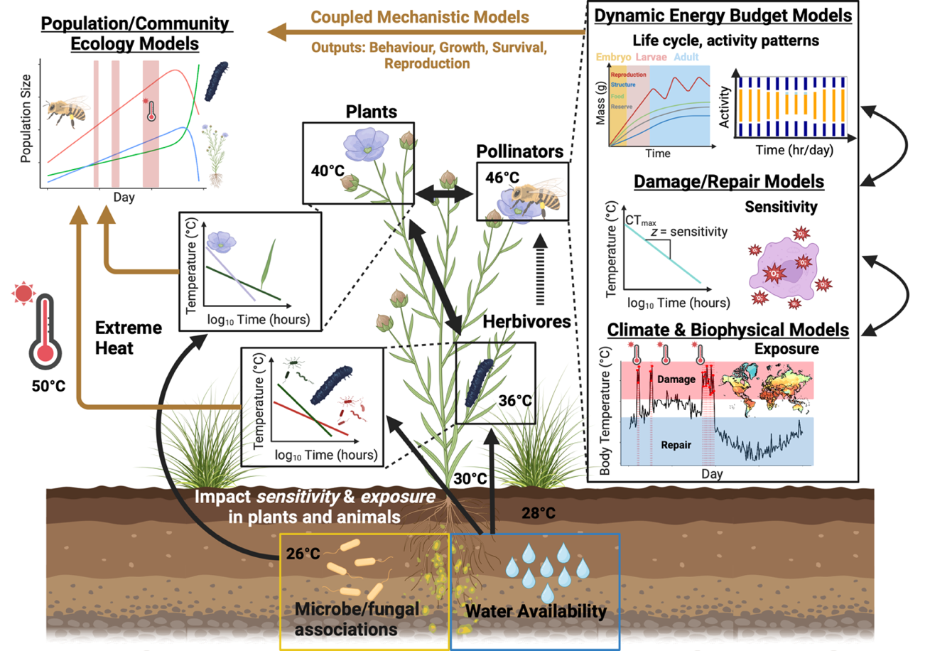
Figure 1: The proposed modelling integration developed in our Opinion submission integrates climate/biophysical models to predict temperatures species experience in their respective microhabitats. Temperatures experienced by organisms provide inputs for damage-repair and dynamic energy budget models that integrate temperature exposure with explicit physiological models that simulate development, behaviour, survival and reproduction in response to temperature across life. Physiological models can be built around the unique life cycles of the diverse species in communities capturing lagged responses to extreme heat, phenological mismatches and mechanistically informed responses to extreme heat for species of the system in question. Outputs (behaviour, growth rate/ biomass accumulation, survival and reproduction) from physiological models of individual organisms can then be integrated into population and community ecology models to predict population growth and community interactions for a given system change. We show how environment mediated feedbacks influence organism thermal exposure and sensitivity (e.g., water availability, microbiota) which can vary across different life stages and organs. The integration of existing models in this novel way will allow simulations at the organismal level to generate emergent predictions for entire communities. In turn, such simulations will allow quantitative predictions to be made on how extreme heatwaves perturb biological systems and allow for the development and implementation of strategies to enhance both biological and socioecological system resilience to extreme heat.

Proposed Outline:
- A need for a mechanistically-informed modelling framework for predicting the effects of extreme heat on community assemblages in natural and managed landscapes
- The next wave of climate models that incorporate feedbacks between biological systems and the atmosphere
- Biophysics to the ‘rescue’: realistic community wide exposure to extreme heat and dynamic energy budget theory
- Capturing the balance between physiological damage and repair to predict multi-species thermal sensitivity
- Mechanistic approaches that ‘speak’ to population and community ecology under extreme heat
- Incorporating environmental feedback to evaluate resilience of biological systems to extreme heat
- ‘Hot’ solutions for a changing world
- Interacting species interacting with people: social-ecological systems
- Future directions: modelling challenges, gaps and possible solutions

We will also have three figures and two boxes as part of the paper that discuss / demonstrate the following:

Figure 1: Broad conceptual overview of different modelling frameworks and how they can be integrated (see above)
Box 1: Box 1 will provide an example of the distinct ways models can be coupled and used to test different scenarios and interventions. We will have a figure within this box.
Box 2: Box 2 will show how to incorporate different environmental contexts and how plasticity of individual organisms and evolution can be integrated into model components. We will have a figure within this box.

References
1. Reichstein, M. et al. (2007) Reduction of ecosystem productivity and respiration during the European summer 2003 climate anomaly: A joint flux tower, remote sensing and modelling analysis. Global Change Biology 13, 634–651

2. Bastos, A. et al. (2014) Analysing the spatio-temporal impacts of the 2003 and 2010 extreme heatwaves on plant productivity in Europe. Biogeosciences 11, 3421–3435

3. Margalef-Marrase, J. et al. (2020) Relationship between heatwave-induced forest die-off and climatic suitability in multiple tree species. Global Change Biology 26, 3134–3146

4. Martı́nez-De León, G. and Thakur, M.P. (2024) Ecological debts induced by heat extremes. Trends in Ecology & Evolution, https://doi.org/10.1016/j.tree.2024.07.002.

5. Kooijman, S.A.L.M. (2010) Dynamic energy budget theory for metabolic organisation, Cambridge University Press.

6. Kearney, M.R. and Leigh, A. (2024) Fast, accurate and accessible calculations of leaf temperature and its physiological consequences with NicheMapR. Methods in Ecology and Evolution

7. Briscoe, N.J. et al. (2023) Mechanistic forecasts of species responses to climate change: The promise of biophysical ecology. Global Change Biology 29, 1451–1470

8. Rezende, E.L. et al. (2020) Predicting temperature mortality and selection in natural drosophila populations. Science 369, 1242–1245

9. Ørsted, M. et al. (2024) Thermal limits of survival and reproduction depend on stress duration: A case study of Drosophila suzukii. Ecology Letters 27, e14421

10. Delmas, E. et al. (2019) Analysing ecological networks of species interactions. Biological Reviews 94, 16–36

11. Carrara, F. et al. (2015) Inferring species interactions in ecological communities: A comparison of methods at different levels of complexity. Methods in Ecology and Evolution 6, 895–906

12. Weiss-Lehman, C.P. et al. (2022) Disentangling key species interactions in diverse and heterogeneous communities: A bayesian sparse modelling approach. Ecology Letters 25, 1263–1276

