Empowering the use of preprints in ecology and evolution: an exploration of the first 1000 EcoEvoRxiv preprints
Authors: Daniel W.A. Noble, Malgorzata Lagisz, Hackathon Participants, Shinichi Nakagawa

Introduction
Publishing preprints – papers communicating non-peer-reviewed research findings – is now an entrenched practice across a multitude of scientific disciplines¹. While preprint use in biology has had a slower uptake², in ecology and evolution, new discipline specific preprint servers, such as EcoEvoRxiv, provide a means by which ecologists and evolutionary biologists can disseminate research findings. Such practices promote open science (e.g., ensuring papers are open access) and facilitate the rapid sharing of new discoveries that can have significant impacts on fundamental and applied knowledge globally (e.g., conservation outcomes).
Preprints attempt to break down barriers to scientific publishing by: 1) increasing the speed, visibility and output of research findings; 2) encouraging constructive and critical feedback from a research community; 3) helping establish precedence of research findings; and 4) removing financial barriers to publication^{e.g., 3}. Importantly, EcoEvoRxiv is a community driven preprint server that has paved the way for new initiatives, including accepting multilingual preprints, recognising and accepting registered reports and non-traditional research reports, and promoting peer review and community discussion to improve the quality of preprints and speed up their peer-reviewed publication (e.g., Peer Community In – PCI).
Preprint servers, such as EcoEvoRxiv, can empower researchers to make their findings more accessible, open and transparent but only if they are used well. Significant barriers to preprint use still exist globally – from lack of clarity around preprint policies at journals⁴ to a stigma that preprints are viewed by a research community to be of poor quality⁵ (but see⁶). Nonetheless, we lack a systematic understanding of the factors that influence preprint use in ecology and evolution which can help inform future initiatives and allow us to begin to break down barriers to their use in our field.
Here, we explore the first preprints uploaded to EcoEvoRxiv to understand preprint practices and use in our field, focusing our attention on understanding: 1) how long it takes for a preprint to become published, and how many preprints remain unpublished; 2) what countries make use of preprints; 3) how career stage and gender impact preprint use; 4) whether data and code are more likely to be shared in preprints; and 5) the extent to which authors make use of preprint servers for registered reports and community driven peer review.
We downloaded metadata on the 1216 preprints currently available on EcoEvoRxiv (as of the 2023-09-30), after removing 5 duplicate titles suggesting a few authors created multiple submissons for the same preprint rather than simply updated an existing submission.
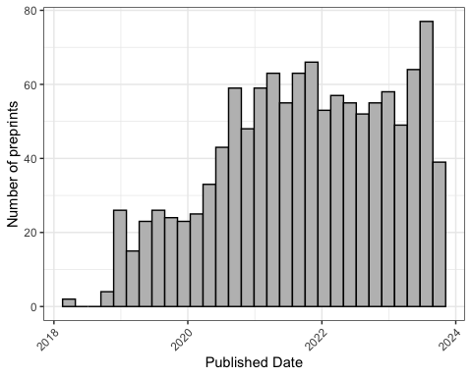
Figure 1- Number of preprints publihsed on EcoEvoRxiv across the years.

References
1. Ginsparg, P. ArXiv at 20. Nature 476, 145–147 (2011).
2. Berg, J. M. et al. Preprints for the life sciences. Science 352, 899–901 (2016).
3. Desjardins-Proulx, P., White, E. P., Adamson, J. J., Ram, K. & Gravel, T. P. D. The case for open preprints in biology. PLoS Biology 11, e1001563 (2013).
4. Klebel, T. et al. Peer review and preprint policies are unclear at most major journals. PLoS ONE 15, e0239518 (202AD).
5. Chiarelli, A., Johnson, R., Pinfield, S. & Richens, E. Preprints and scholarly communication: An exploratory qualitative study of adoption, practices, drivers and barriers. F1000 Research 8, 971, https://doi.org/10.12688/f1000research.19619.2 (2019).
6. Fraser, N., Mayr, P. & Peters, I. Motivations, concerns and selection biases when posting preprints: A survey of bioRxiv authors. PLoS ONE 17, e0274441 (2022).

