A systems-modelling approach to predict biological responses to extreme heat
Daniel W.A. Noble¹ $‡$, Margaret Mayfield² $†$, Ary Hoffmann² $†$, Zhong-Hua Chen^{3,4} $†$, Steven J. Lade^{5,6} $†$, Xuemei Bai⁵ $†$, Danielle Way⁷ $†$, Belinda Medlyn³ $†$, Owen K. Atkin^{7,8} $†$, Adrienne Nicotra^{1,7} $†$, James M.Cook³, Brajesh Singh³, Alison Bentley⁷, Ian Wright³, Michael R. Kearney² $‡$
Affiliations:
¹ Division of Ecology and Evolution, Research School of Biology, The Australian National University, Canberra ACT 2601, Australia
² School of Biosciences, The University of Melbourne, Australia ³ Hawkesbury Institute for the Environment, Western Sydney University, Australia ⁴ School of Agriculture, Food and Wine, Waite Research Institute, University of Adelaide, Glen Osmond, SA 5064, Australia ⁵ Fenner School of Environment and Society, The Australian National University, Canberra ACT 2602, Australia ⁶ Stockholm Resilience Centre, Stockholm University, Stockholm, Sweden
⁷ Division of Plant Sciences, Research School of Biology, The Australian National University, Canberra ACT 2602, Australia
⁸ Agrifood Innovation Institute, Australian National University, Canberra, ACT 2601, Australia
¹ $‡$ Correspondence: daniel.noble@anu.edu.au & m.kearney@unimelb.edu.au
$†$ These authors contributed equally to this work.

Keywords: plant-animal interactions, microclimate, biophysical models, thermal load sensitivity, dynamic energy budget models, coexistence theory, ecological modelling

Highlights
- Recent advances in climate and ecological modelling are converging to enable a predictive understanding of how extreme heat affects ecological communities.
- Heatwaves increasingly drive complex biological responses, yet existing models rarely integrate the direct and indirect effects of heat across scales.
- Mechanistic biophysical and physiological models now allow estimation of thermal exposure, damage, and repair at the individual level. These outputs can be used to predict population and community dynamics, enabling species-specific and community wide forecasting under climate extremes.
- A systems-modelling framework offers a more calculated understanding of the impacts that extreme heat will have on organisms, populations, and communities along with how to mitigate these impacts to preserve diverse systems now and into the future

Abstract
Anthropogenic climate change is leading to more frequent and extreme heat waves. These short-term but large-scale events are radically re-shaping interactions among organisms – impacting biodiversity, community composition and ecosystem services crucial to natural systems and food security. Predicting heat wave impacts on interacting species requires an understanding of the processes driving differential exposure and sensitivity of organisms to extreme heat events in a life-cycle context. To achieve this predictive capacity, we need to integrate models across scales while capturing species-specific responses at the level of individuals. We show how existing models in disparate fields can be linked to achieve a level of understanding necessary for calculated responses to extreme heat from individuals to socioecological systems, now and into the future.

Heat waves within a multidisciplinary modelling framework
Climate change is leading to warmer and more variable thermal environments globally [1,2]. Greater thermal variability is resulting in organisms experiencing extreme heat waves that lead to thermal stress impacting organismal growth, survival and reproduction, with cascading effects on population dynamics, species interactions, community composition and ecosystem structure and function [3,4]. Climate variability has already been linked to dramatic declines in pollinator abundance [5] and crop yields globally [6–8], but the causes underlying such declines, and their ramifications through communities and society, are not fully understood. The impacts of extreme heat on species and communities are driven by a combination of direct effects of heat stress on the physiology and fitness of organisms [9–11] and indirect effects on interactions (both positive and negative) among species [e.g., 12]. For instance, direct effects of heat stress on microbial communities can resulting in compounding effects on associated plant species [13]. Understanding the dynamic interplay between direct effects and indirect species interactions, and how these are mediated by environmental factors, has been hampered by the complexity of community interactions and the lack of an integrated modelling framework that translates short-term physiological damage into changes in fitness and population growth across species [13]. Predicting how extreme heat impacts population dynamics and communities requires the coupling of biophysical, physiological, population and community ecology models.
Here we argue that such a feat is becoming increasingly tangible and will provide powerful new ways of predicting how extreme heat shapes community dynamics. Physiological models can now be seamlessly integrated with biophysical models of heat and mass exchange to characterize temperatures experienced by organisms and simulate the effects of extreme heat events on the entire life cycle of species within ecological communities [14–18]. Physiological models that incorporate estimates of thermal sensitivity across species can capture the delicate balance between damage and repair in physiological systems [10,11,19,20], yielding predictions of the immediate and cumulative impacts of extreme heat on growth, survival and reproduction. Importantly, mechanistic physiological models provide outputs at the individual level (e.g., energy and water requirements, waste production, activity constraints, vital rates) that can be integrated into population and community ecology models to capture how extreme heat events perturb interactions among species [21,22].
We bring together modelling approaches across diverse fields as a first step towards establishing a new, integrative framework for predicting how extreme heat will affect ecological communities and society. We focus on plants, insects and microbes given the strong interconnections between them, the relative ease with which they can be studied, and their significance to natural ecosystem health and agricultural productivity. Importantly, ‘extreme heat’ can take on a different meaning for these diverse organisms. For example, plants and animals have different thermal tolerances or can exploit microthermal environments in different ways to offset the effects of extreme atmospheric heat events. Thermal tolerances also vary among life cycle stages/developmental processes of individual organisms; for example, in plants, vegetative tissues generally exhibit greater tolerance to high temperatures than pollen [23]. As such, ‘extreme’ will be relative to the biology of the organism in question. Our modelling framework can capture these complexities and be extended to incorporate other, diverse interactions including the socioecological systems in which ecological communities and production systems are embedded.

A systems-modelling approach to modelling biotic impacts of heatwaves
We propose a systems-modelling approach to model biotic impacts of heatwaves (Figure 1), starting with the assumption that the impacts of extreme heat events on an ecological community are driven by responses of individuals, which then cascade upwards to other levels. Ultimately, the impacts of extreme heat events on a community are driven by responses of individuals. Therefore, to understand extreme heat impacts on a community of organisms, we must characterize the proximal thermal environments – the ‘microclimates’ – experienced by individuals of different species under a given atmospheric event. These microclimates must then be translated into physiological and behavioral responses, including the processes of thermal damage and repair, and how individuals mitigate their exposure to extreme heat through habitat selection and other avoidance strategies. Finally, dynamic energy budgets translate these individual responses into growth and reproduction trajectories across life cycles to drive population and community models of the resulting interactions.
In the next sections, we outline new developments to model all components in Figure 1, such that a truly systems-based approach to modelling biotic impacts of heatwaves is now possible. We highlight the opportunities such an integration may provide through a greater understanding of the ways in which extreme heat stress manifests across species. Integration will help elucidate how and why interactions among species can change, with implications for natural and agricultural systems, food security and ecosystem services. We discuss the challenges of applying such an integrated modelling framework and how it can incorporate other critical features that capture evolutionary change and plasticity.
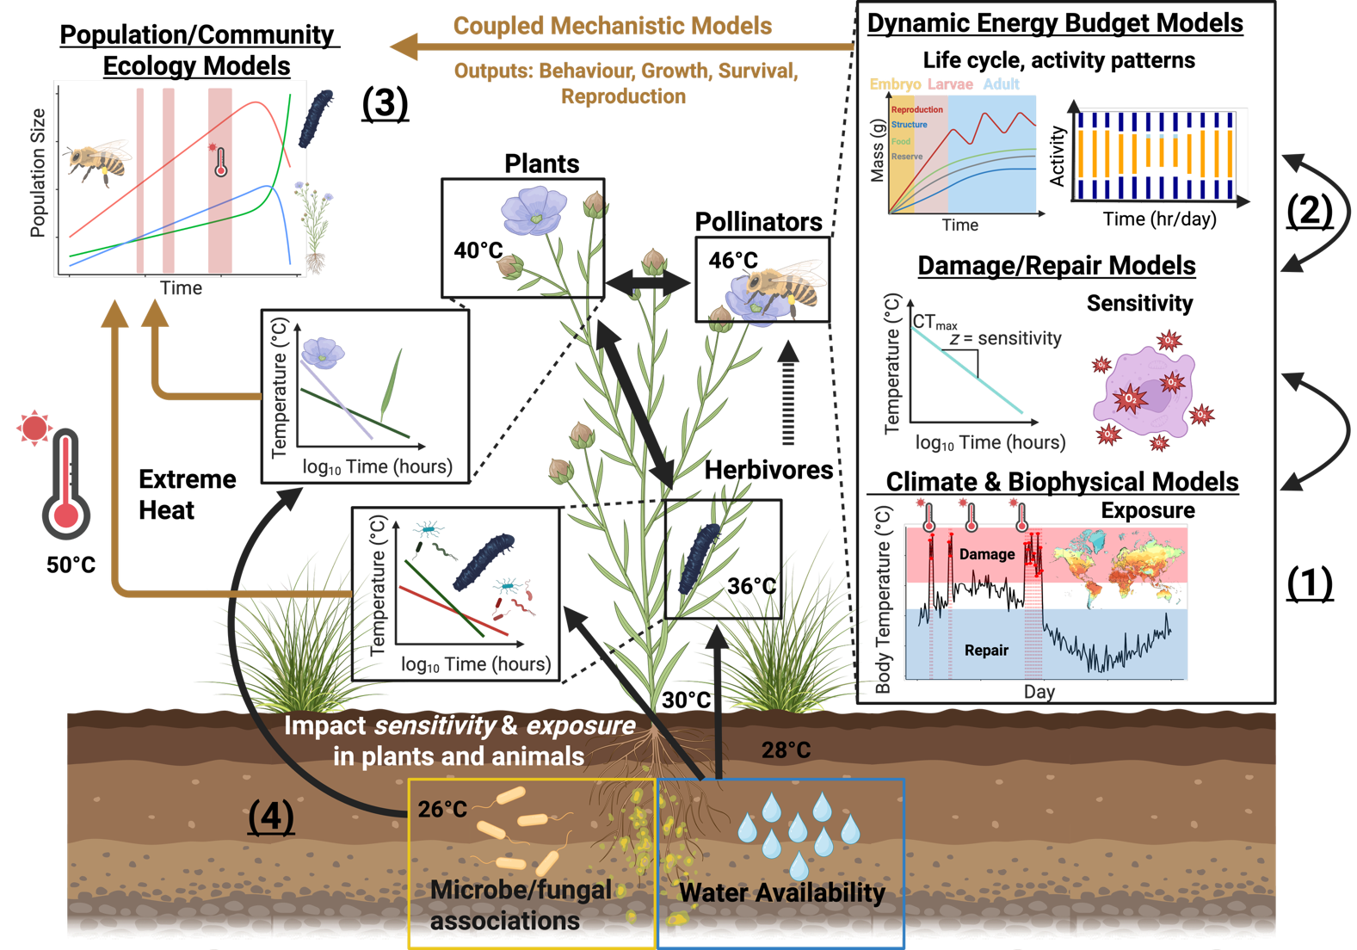
Figure 1- A new, integrative framework for predicting the effects of extreme heat on ecological communities. The modelling approach developed here integrates (1) climate/biophysical models to predict the different temperatures species experience in their respective microhabitats. (2) Temperatures experienced by organisms then provide inputs for damage-repair and vegetation growth or animal dynamic energy budget models that integrate temperature exposure with explicit physiological models that simulate development, behavior, survival and reproduction in response to temperature dynamics across life history stages. Physiological models can be built around the unique life cycles of the diverse species in communities, capturing lagged responses to extreme heat, phenological mismatches and mechanistically informed responses to extreme heat for species of the system in question. Outputs (behavior, growth rate, biomass accumulation, survival and reproduction) from physiological models of individual organisms can then be integrated into (3) population and community ecology models to predict population growth and community composition under a specific type of change (either to the environment or suite of interacting organisms). We then discuss how (4) environment-mediated feedback loops influence organism thermal exposure and sensitivity (e.g., water availability, microbiota), which can vary across different life stages and organs. This novel integration of existing models in this novel way will allow simulations at the organismal level to generate emergent predictions for entire communities. In turn, such simulations will allow quantitative predictions to be made on how extreme heatwaves perturb biological systems and allow for the development and implementation of strategies to enhance both biological and socioecological system resilience to extreme heat. Created with BioRender.com.

The current state of extreme weather modelling
An understanding of heatwave impacts on biology requires environmental inputs about weather conditions. These data may come from weather stations or climate models. Weather station observations of air temperature, radiation, wind speed, cloud cover and humidity are readily available as raw timeseries from the stations themselves, and as interpolated products such as WorldClim [24].
Weather stations can only document past heat wave events at their specific locations. Climate modelling and weather event forecasting is achieved through General Circulation Models (GCMs) – large partial differential equation networks of atmospheric, oceanic and biospheric energy and mass exchange processes. Future climate change scenarios are generally produced at monthly timescales but can be superimposed on historical weather patterns to infer the nature of future heatwaves. Historical analyses are facilitated by GCMs via ‘reanalysis’ datasets produced by calibrating GCMs with observations to produce continuous gridded weather data, including ‘surface’ temperatures, soil temperatures and profiles of temperature, pressure, wind speed and humidity at different levels in the atmosphere [25–29]. The most state-of-the-art of these are ECMWF (European Centre for Medium-Range Weather Forecasts) Reanalysis v5 (ERA5), hourly products at ~31km and ~9km resolutions, respectively.
Historically, GCMs were coded in fast but inflexible languages like Fortran and C. The emergence of the Julia language [30] for scientific computing has created an opportunity to rebuild climate models in a more modular manner, allowing easier interfacing between discipline-specific models. The translation of GCMs and associated land-surface models into more accessible and modular languages opens new opportunities for collaboration between biologists and earth scientists to better integrate processes in the atmosphere and the biosphere to improve predictions of weather events and their biological impacts.

From weather to microclimates: predicting community wide exposure to extreme heat
Extreme weather events are experienced differently across species in a community. For example, while air temperature may be 50°C, an organism a metre below the soil surface may be exposed to temperatures 25°C cooler (Figure 1). Exactly how much the soil lags and dampens the atmospheric dynamics depends on the soil properties, especially its moisture level. Conditions above ground depend on the nature of the vegetation, especially through shading, changes in wind profiles and evaporative cooling (transpiration rates). Vegetation and soil also interact strongly. Past soil moisture regimes and heat wave events can lead to leaf loss and hence increased radiation exposure of the soil surface, while stomatal behavior alters transpiration rate and hence soil moisture. Past weather conditions can determine how a given heat wave manifests, so the same atmospheric heat wave can have different implications for microclimatic conditions depending on the recent history of rainfall and temperature. Despite the complexity and non-linearity of these interactions across the soil-plant-atmosphere continuum, there is existing capacity, and growing potential, to model them and determine individual-specific exposure to extreme heat.
To some extent, and at large spatial scales (e.g. 0.5 $​^{∘}$ grid cells), GCMs have these dynamics built into them via modules called ‘land-surface models’ (LSMs), which aim to capture feedbacks between the land surface and associated vegetation. LSMs will at minimum represent air, soil and canopy temperatures. LSMs that represent multiple layers of the plant canopy will represent the change in leaf temperature with canopy depth; models may also represent thermal gradients through the soil [31]. Land surface schemes will typically do this using energy balance approaches. Early generations of LSMs assumed vegetation was static, with fixed plant functional types (PFTs) and leaf area index (LAI), but most LSMs are moving towards dynamic representations of vegetation properties, allowing large-scale feedbacks between vegetation and climate to be represented [32].
The primary role of LSMs is to better understand overall atmospheric dynamics rather than resolve the details of microclimates to which organisms are exposed. Thus, agronomists and ecologists have developed microclimate models that can provide more detailed inferences of environmental exposure. These microclimate models take the atmospheric conditions as independent forcing variables, together with detailed information on terrain (slope, aspect, hill shade), vegetation [plant-area index (PAI), stomatal behaviour, leaf reflectance] and soil properties (thermal and hydraulic) to predict how radiation, wind speed, air temperature, humidity, soil temperature and soil moisture vary on small scales. The available models vary in the physical processes they incorporate yet can be powerful in predicting relevant microclimates to organisms [33–39]. Our Supplementary Online Material provides a tutorial on how to predict microclimates from climate data using existing open access software and datasets [33,35,36].
Advancements in microclimate modelling have created opportunities to more closely couple the dynamics of the atmosphere and vegetation. In particular, plant water use dynamics during heatwaves can amplify or reduce high temperatures via effects on photosynthetic capacity, stomatal decoupling, cuticular conductance, leaf damage and plant mortality [17,40]. These impacts are important for the plants themselves, but also for thermal regimes within the plant canopy. Forecasting future thermal regimes is challenging because it involves forecasting future vegetation dynamics, including changes in key vegetation properties such as leaf area index, as a function of plant growth, plant population dynamics and shifts in community composition. A wide range of vegetation models is available for this purpose, from crop growth models that simulate growth and yield of crops over a season (e.g. APSIM, [41]) up to the dynamic global vegetation models (DGVMs) that simulate vegetation function and distribution at local to global scales [42].

Translating exposure to organism temperature: biophysics to the rescue!
Once microclimates are quantified, heat budgets of organisms can be computed as a function of their traits using the principles of biophysical ecology. Biophysical models have a long history [17,e.g. 43,44] but have become more widely applied in ecology in the past 20 years, facilitated by developments in environmental datasets, microclimate modelling, and the emergence of high-level programming languages such as R [18]. Biophysical models of ectothermic animals can account for complex radiative heat transfer and the role of evaporative water loss across surfaces [33,45]. Equivalent models of leaves incorporate the dynamic role of stomata [17,46], while models of endotherms can account for the role of insulation and metabolic heat production [47]. Future developments in biophysical modelling of organismal temperature under extreme heat will involve understanding the nuances of plastic physiological and behavioral responses. For example, lizards may pant when exposed to high temperatures [48], birds may ‘wind surf’ or seek thermal micro-refugia [49], and stomatal behavior may depart from the typical responses to vapor pressure and light intensity to allow emergency cooling [40], though this response may depend on prior soil moisture conditions [50]. The application of biophysical heat budget models in concert with microclimate models can thus be used to infer the thermal conditions to which members of the same ecological community are exposed with different degrees of detail. Realised thermal exposure can then be linked to physiological models of damage and repair.

Capturing both physiological damage and repair to predict multi-species thermal sensitivity
Translating how heat waves impact plants and animals not only depends on modelling temperature exposure but also the varying sensitivity of organisms to extreme heat [19,51]. Sensitivity to extreme heat can be captured by thermal load sensitivity (TLS) / thermal death time (TDT) models that explicitly account for how heat stress depends on both the temperature experienced and and its duration [19,20]. Typically, these models focus on endpoints that include survival (e.g., lethal temperatures, $LT_{50}$ or $LT_{80}$) or some measure of reduced fertility, but this need not be the case [20]. Endpoints are predicted by assuming the effect of time at a given temperature decreases survival or fertility exponentially [10,11,19,51]. For example, Ørsted et al. [11] show that both mortality and fecundity follow a clear exponential relationship with time in Drosophila suzuki, with survival and fecundity being compromised most for long thermal exposures at high temperatures. Importantly, Ørsted et al. [11] show that reproductive sensitivity can be higher than mortality, with heat injury accumulating faster to impact productivity earlier than survival. TLS theory also applies well to photosynthetic function in plants [52,53], highlighting the potential generality of the TLS framework and its capacity to explore plastic responses (e.g., acclimation and priming) of organisms. TLS models explicitly acknowledge that thermal sensitivity depends on the relative accumulation of damage to cellular and sub-cellular systems that compromise physiological function. Without periods of recovery, where damage can be repaired, organisms accumulate damage over time that reduces growth, and impacts survival and reproduction.
The concept of damage and repair is important for understanding how heat waves affect organisms because both processes can result in lagged responses to heat stress – a common feature of extreme heat events [20,54]. Once the thermal sensitivity (i.e., the slope $z$, Figure 1) for a particular endpoint has been quantified it can be used to predict the accumulation of damage during stressful temperatures experienced under realistic conditions [10,11,20,51]. Several approaches can be used to capture the accumulation of damage [10,11,51], but a simplistic way follows Ørsted et al. [11]:
$$HI=\sum_{i=1}^{T_{e}>T_{c}}{\frac{100⋅\left(t_{i+1}-t_{i}\right)}{{10}^{\left(-\frac{1}{z}⋅max\left(T_{i};T_{i+1}\right)+α\right)}}} \left(1\right)$$
Equation 1 summarizes heat injures (HI) sustained across time, $t$, during heat stress events (i.e., when body temperatures are greater than the critical temperatures, $T_{e}>T_{c}$) using information about the maximum temperature, $T$, experienced between time point $t_{i}$ and $t_{i+1}$ and the thermal sensitivity (i.e., $z$ and $α$). Once an organism accumulates damage to reach a given threshold the endpoint has been reached. Arnold et al [20] recently proposed a framework for integrating repair processes into these models more explicitly.
Environmental factors that impact thermal sensitivity can also be incorporated into TLS models (Box 1, see also [20]). Modelling the intricate balance between damage and repair for a suite of different species can help identify susceptible species, life stages and tissues that are most at risk from extreme heat events due to direct sensitivity to extreme heat, which allows for more accurate predictions of the varying levels of species sensitivity within a community under particular types of climate events.
Box 1: Sensitivity to extreme heat is mediated by environmental feedbacks
Natural and anthropogenic environments shape thermal sensitivity and should be considered in any systems modelling approach to assessing community responses to extreme heat [20]. Some of the biotic and abiotic interactions likely to mediate plant and animal community responses include:
Microbial Interactions: Heat tolerance of animals and plants can be increased and decreased through changes in the gut microbiome and/or through associated microbes within or around tissues. Interactions between plants and microorganisms, such as plant growth-promoting rhizobacteria (PGPR), arbuscular mycorrhizal fungi (AMF), and bacterial or fungal endophytes are known to impact growth, defense, and heat tolerance in plants [55,56] (Figure 2A). These interactions are usually achieved by provision and priming of the production of essential phytohormones, secondary metabolites, organic acids, amino acids and osmolytes that help the plant to mitigate heat stress [57]. Heat tolerance in animals can also be influenced by gut microbiota or other associated symbiotes. For example, Bacillus subtilis residing in the gut of the nematode Caenorhabditis elegans provides protection against heat shock as reflected by effects on fecundity [58] (Figure 2B).
Drought and Water Stress: Drought, often associated with periods of extreme heat, can reduce thermal tolerance in plants by triggering stomata closure, impacting plants’ ability to cool through transpiration, leading to leaf damage from excessive heat [59] (Figure 2C). Drought and water stress also have impacts on nectar flow with cascading effects on nectivores. Impact of drought on plants can be mitigated by plant signaling which enriches microbial supply of osmolytes [60]. Extended periods of water stress (e.g., several days or more) have also been shown to increase thermal sensitivity in insects, reducing tolerance of extreme heat [61] (Figure 2D).
Nutrition and Diet: Nutritional composition of a diet has been shown to affect the heat tolerances of insects and plants. Possible mechanisms of this feedback include the modification of lipid membranes, substrate availability for ATP synthesis, availability of key amino acids and the alleviation of oxidative stress. For example, a key mineral, magnesium (Mg), is crucial for photosynthesis with Mg deficiency in plants leading to increased oxidative cellular damage. Mengutay et al [62] show how supplementation of Mg can improve heat tolerance in maize and wheat, with visual leaf damage being aggravated in both species under heat stress when Mg supply is low (Figure 2E). Similar examples have been identified in insects. For example, in Drosophila melanogaster larvae fed a high protein diet were able to withstand higher temperatures compared to those fed a high carbohydrate diet [63] (Figure 2F).
The above list is not exhaustive. Many environmental stressors, such as pollution and salinity, along with interactions between environmental stressors and cross-trophic interactions among species exposed to those stressors can also impact thermal sensitivity can also impact thermal sensitivity [20,54]. The point we make here is that to fully model heat sensitivity, it is important to account for the abiotic and biotic environment in which an organism experiences heat stress where possible.
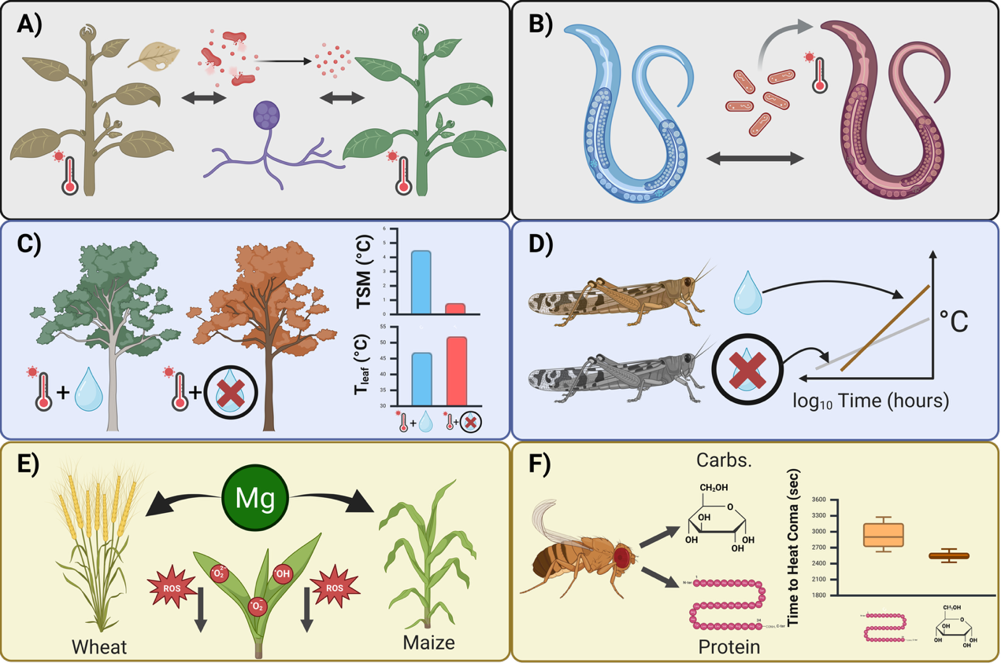
Figure 2- Examples of environmental factors impacting thermal sensitivty in plants and animals. A & B) microbial interactions. C & D) drought and water stress. E & F) nutrition and diet. See text for more explanation. Created with BioRender.com.

Glossary
Coexistence: Coexistence occurs when two populations of two species are able to persist in each other’s presence indefinitely under constant, equilibrium conditions. Coexistence can be defined by differences in how species compete or through the ability of species to invade environments successfully when the other species is present at low abundances. The majority of known models of coexistence rely on equilibrium conditions. A condition at odds with extreme heat events and directional climate change. However, the emphasis of many coexistence models on the importance of species interactions in variable environments makes coexistence models and associated frameworks for understanding community assembly and diversity maintenance are potentially useful for exploring whole community responses to extreme events.
Microclimate: Microclimates are the local atmospheric conditions experienced by organisms, which can differ substantially from the broader atmospheric conditions. Microclimates are influenced by factors such as vegetation cover, soil properties, and topography, and can significantly affect the thermal environment experienced by organisms
Functional traits: Functional traits are the measurable characteristics of organisms that influence their performance and fitness, such as body size, reproductive output, and metabolic rates. In the context of extreme heat, functional traits can be used to categorize species based on their responses to thermal stress
Biophysical models: Biophysical models capture the balances of heat, water, and other aspects of energy and mass exchange between organisms and their microclimatic environmment to predict how organisms function, survive, and behave in varying environments.
Thermal load sensitivity (TLS) models: Models that use biophysical principles to quantify thermal exposure and thermal load and integrate them with physiological models that capture the dynamics of damage and repair processes in driving lethal and sublethal impacts on tissues, organs and whole organisms.
Vital rates: Demographic parameters that determine how populations change over time. They include measures of birth, death, growth, and reproduction.

Physiological models that capture the effects of extreme heat across life
Dynamic Energy Budget (DEB) models are physiologically explicit life-cycle models of energy and mass uptake and conversion that predict key life-history transitions, growth, reproduction and survival (senescence) through time [14,64]. DEB models consider organisms as a thermodynamic system (adhering to energy-mass balance) capturing the exchange of food, water, respiratory gases and metabolic waste throughout the life cycle [18]. DEB models can translate short-term (hourly) variation in factors such as temperature, toxins (e.g., toxicants, [65]) and resource availability (nutrients) [66,67] into long-term (days, months, years) effects on development, growth, reproduction and survival [15,18]. DEB theory, when combined with biophysical models more generally, allows the full water budget to be computed to account for heat stress impacts of a hydric nature [18]. Perhaps most importantly, DEB theory calculates the life cycle trajectory of an organism and so can account for the effects of timing of heat wave impacts relative to life stage. Applied to multi-species assemblages, DEB models can capture how different species’ life cycles are impacted by heat and interact with each other to predict how traits such as birth, age at maturity, reproductive events, energy flow and lifespan vary across species. DEB models integrate many processes in a parameter-sparse manner, and necessary parameters have been estimated for > 6000 species already (although there are taxonomic biases) [68,69]. New analytical approaches using phylogenetic imputation methods show promise for calculating energy budgets for species without data. Such methods have, for instance, already been used to predict DEB parameters for over 1.3 million animal species [see, 70]. In addition, software packages such as NicheMapR [33,71] allow for simulations of life-cycles using parameters for diverse species. DEB model outputs, such as body mass and size, reproductive success and timing, and survival, can be used to parameterize vital rates needed for population and community models, with additional options to incorporate eco-evolutionary feedbacks (see Box 2).
Analogously, physiologically-based vegetation models simulate plant growth over time as a function of carbon, water and nutrient uptake and use, following mass balance principles [31]. Model drivers typically include incident radiation, humidity, rainfall, and soil properties as well as air temperature. The models capture the direct effects of temperature on key physiological processes, such as photosynthesis, respiration and phenology, as well as the indirect effects via feedbacks on the vegetation water balance and soil nutrient availability. Short-term responses to temperature are captured well in these models through representations of enzyme kinetics, but representation of longer-term responses remains challenging because plants show high flexibility in their ability to acclimate to ambient temperatures [72]. Another area under active research is capturing plant damage and death from hot-dry weather extremes. Considerable progress has been made by representing the plant hydraulic system explicitly, enabling the risk of hydraulic failure to be predicted under conditions of low rainfall and high evaporative demand [73]. Direct damage to plant tissue from extreme heat has yet to be represented in such models, but the thermal death time framework outlined above offers a promising way forward.

Mechanistic approaches that ‘speak’ to population and community ecology under extreme heat
Coexistence frameworks offer an intriguing approach that can bring the many elements discussed above together to understand whole community responses to extreme climate events. Modern coexistence theory [MCT; [74]] uses simple two-species individual-based population growth models, such as Beverton-Holt or Ricker models [75,76], to determine how interactions between species at the individual level lead to “coexistence”.
Population dynamic models calculate the individual fitness effect of interactions [77]. These models can incorporate variation in the environment [21] and in the outcome of interactions themselves [78]. As these models use the same fitness measures as DEB models they offer a population modelling framework to add thermal biology to community diversity predictions. This is because population dynamical models can be combined, for example as networks [79], and compared between microsites with different biophysical properties and composed of species with different thermal responses to their microenvironment. For example, Bimler et al [79] used this approach to determine which species were keystone species under shady and sunny portions of the same plant communities.
Modified vital rate functions (which can be used with any measure of fitness) can be used in population growth models to compare population growth predictions for individuals in areas with different biophysical properties and/or thermal tolerances. The outcomes from DEB models could be used to directly parameterise growth rate models or used to predict functional traits, which at a community scale can be used to categorize species with different response and effect profiles. Horizontal interaction networks can then be used to determine how important microclimates with different biophysical properties are for species interactions (defined by their fitness responses to their thermal environment) within the context of whole ecologocial communities. These networks can also be made to target particular types of interaction effects or responses to extreme heat events, or used to compare how species interact in areas with different thermal landscapes. The limitation of these methods is that they are data hungry, but even this can be handled by categorizing species by ‘trait’ or shared phylogenetic relationships, which are simplifications shown to be effective at reducing model complexity without sacrificing model accuracy [80].
Population growth models used in coexistence frameworks are best suited to sessile organisms as there is no mechanism within them to capture the effects of individuals moving to different environments or changing who they interact with. Recent advances of coexistence modelling have resulted in the development of coexistence models that incorporate variance in interaction outcomes and intrinsic fitness within the context of heterogeneous environments [e.g., 22].
Box 2: Integrating eco-evolutionary feedback within a systems-modelling framework
Extreme environments can act as a potent selective force triggering evolutionary change in populations [81–83]. Evolutionary responses will depend on the amount of phenotypic and genetic variation present in a population and exposed to natural selection along with the strength of selection on phenotypes. Extreme environments pose unique challenges for predicting evolutionary change because they are, by definition, rare events. Adaptive evolution will therefore depend on the frequency of extreme environments and the underlying genetic correlation between traits expressed across environments and other conditions [81]. In addition, phenotypic plasticity can result in both maladaptive and adaptive outcomes by either shielding selection on genetic variation or by facilitating persistence and selection, making it difficult to predict the long term effects of plasticity and adaptive evolution in building population resilience [82,84–87].
Plasticity and evolution can be incorporated into a systems modelling framework by allowing environments to govern ‘trait’ development (plasticity) and by incorporating selection and genetic (co)variance estimates for ‘traits’ within these models (evolution). We speak of ‘traits’ broadly here because these need not be traits typically thought of by evolutionary ecologists (e.g., body mass, vital rates). Rather, ‘traits’ can include the parameters within models that establish functional traits within a population (e.g., DEB parameters)[88]. Plasticity can be captured by mapping trait development to the environment. In contrast, evolutionary change takes place in multivariate trait space where genetic variance and covariance between traits (i.e., constraints) along with varying patterns of selection can be used to predict trait changes across generations. One simple way to make such predictions is by using the multivariate breeders equation [89]:
$$Δ\overset{‾}{z}=G⋅β \left(2\right)$$
where $Δ\overset{‾}{z}$ is the vector of changes in the mean trait values, $G$ is the genetic covariance matrix and $β$ is the vector of standardised selection gradients that regress each trait on relative fitness (i.e., $ω=α+β^{T}⋅z+e$; [90]). While the multivariate breeders equation can be useful for predicting short term evolutionary responses (i.e., one or a few generations) it likely has limited in predictive power over longer timespans because of changes in heritability and selection through time [83,90].
Measuring and incorporating both plasticity and evolution into our proposed systems modelling framework is challenging because such models usually focus on one or a few ‘traits’. Studies that have attempted to measure plasticity and evolutionary potential in traits demonstrate how such processes can shape outcomes in important ways [61,91–95]. For example, applying a TDT framework to isogenic lines of Drosophila melanogaster, Leiva et al [95] show evidence for genetic (co)variation in both upper thermal limits ($CT_{max}$) and also thermal sensitivity (i.e, $z$, slope from TDT curves). Thermal sensitivity in Drosophila species is also known to respond plastically to temperature [91]. In the alpine plant Wahlenbergia ceracea there is little genetic variation in plasticity, despite ample plasticity in response to warming. Thus adaptive evolution of plasticity is unlikely in this species [96]. Beyond these examples, few studies have attempted to quantify genetic variation in plastic responses to warming effects including extreme heat events, and among those that have, evidence that such plasticity is adaptive remains elusive [96,97]. One challenge in assessing the adaptive evolution of plasticity is that trait values themselves are also under selection in the different environments that elicit a plastic response; thus, selection on plasticity reflects both selection on trait means in a given environment and selection on the full range of phenotypes across environments [89,96].

Box 3: Interacting species interacting with people: social-ecological systems
Extreme heat may threaten the services that natural and agricultural ecosystems provide to people [98]. For example, loss of output from production ecosystems will have substantial economic consequences for a local area. Degradation of natural ecosystems may affect their regulating services, such as flood mitigation. Impacts on cultural services may be severe for communities that are closely connected to a landscape Figure 3.
People may respond to the impacts of extreme heat on ecosystems in a variety of ways. Farmers or ecosystem managers may introduce new species, alter management practices or farm remaining unaffected areas more intensively. Thermal stress may ultimately result in people leaving areas, potentially making remaining human communities more vulnerable through loss of resources, services and community [99]. Thermal risks to ecosystems may also precipitate declines in individual wellbeing, and these consequences may accrue differently across regions and peoples [100]. Many of these impacts and responses, however, are poorly understood.
Thermal stress on ecosystems can affect not only local communities but also human dominated systems, such as cities, far away from affected ecosystems. Cities are intrinsically connected to and rely on other regions to maintain their functionality [101,102]. For example, extreme heat stress may affect essential ecosystem services, such as food production [103], which can in turn affect price and access to food for people living in urban centers, with financial, economic and health consequences. The impacts on local agricultural communities could lead to loss of livelihood, pushing people in rural areas to migrate to cities [104]. These external pressures will interact with a system that is already constrained by multiple stressors, including direct impacts imposed by extreme heat and other aspects of climate change such as extreme rainfall and flooding. If sufficiently widespread, economic and political destabilisation may occur as has already been observed in some parts of the world [105].
Understanding the relationships between people and nature requires adopting a social-ecological systems perspective, where people and nature are interdependent and intertwined [106]. Social-ecological models aim to capture social and natural systems along with their interactions [107]. They are conventionally built using process-based modelling frameworks such as agent-based models, dynamical systems models or state-and-transition models [108]. Process-based approaches are critical to understanding how emergent social-ecological phenomena develop [109], such as tipping points, traps or other dynamics. Such models can display complex emergent behavior resulting from interactions within the social-ecological system. For example, responding to decreased productivity from extreme heat by farming more intensively could lead to a maladaptation or ‘lock-in’ from which it is difficult to escape [110].
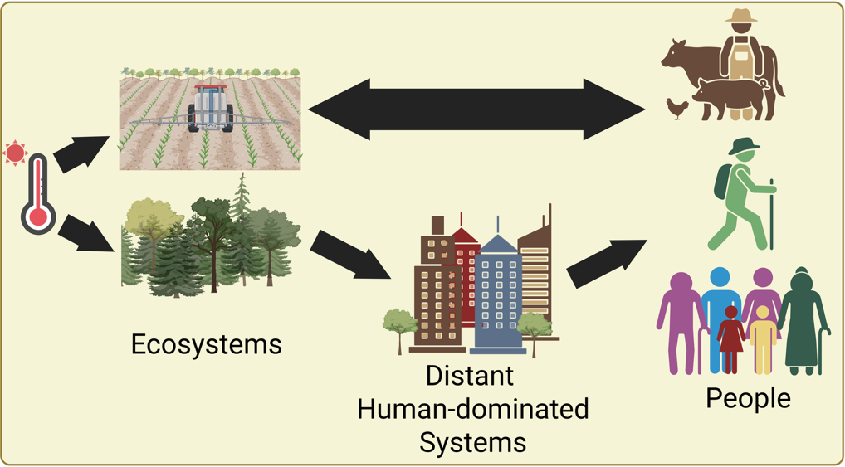
Figure 3- Impacts of extreme heat on natural and production ecosystems will cascade to affect people, both locally and in distant human-dominated systems such as cities. Decisions made by people in these communities in response to these changes will affect the ecosystems on which they rely, creating an interdependent social-ecological system. Created with BioRender.com.

‘Hot’ solutions for a changing world
Extreme heat will have dramatic and widespread effects on the socioecological systems that humans rely upon (Box 3). For example, under current global climate change scenarios, each degree Celsius increase in global mean temperature is estimated to reduce the global yield of wheat by 6.0% and soybean by 3.1% [103], exacerbating food shortages. A systems modelling approach can provide us with quantitative tools to make informed predictions, plan interventions and evaluate various scenarios for mitigating the impacts of extreme heat. For example, microclimate and biophysical models can allow for informed predictions about how to mitigate heat stress to crops (e.g. with irrigation interventions), while also considering how such interventions impact pests and beneficial insects (see Figure 4 and Case Study 4 & 5 in the Supplementary Online Material). Identifying and/or modifying the thermal suitability of landscapes to benefit plants and animals under extreme heat shows immense promise [18]. Additionally, as our understanding of the mechanisms associated with heat tolerance improve, genetic tools, environmental manipulations and artificial breeding can be used to enhance thermal tolerance creating more resilience to extreme heat events [e.g., 56], although the extent to which resilience can be actively manipulated remains unknown in many species. Integrating these solutions into a systems modelling framework will then allow for a calculated understanding of the viability of such approaches in real world situations.
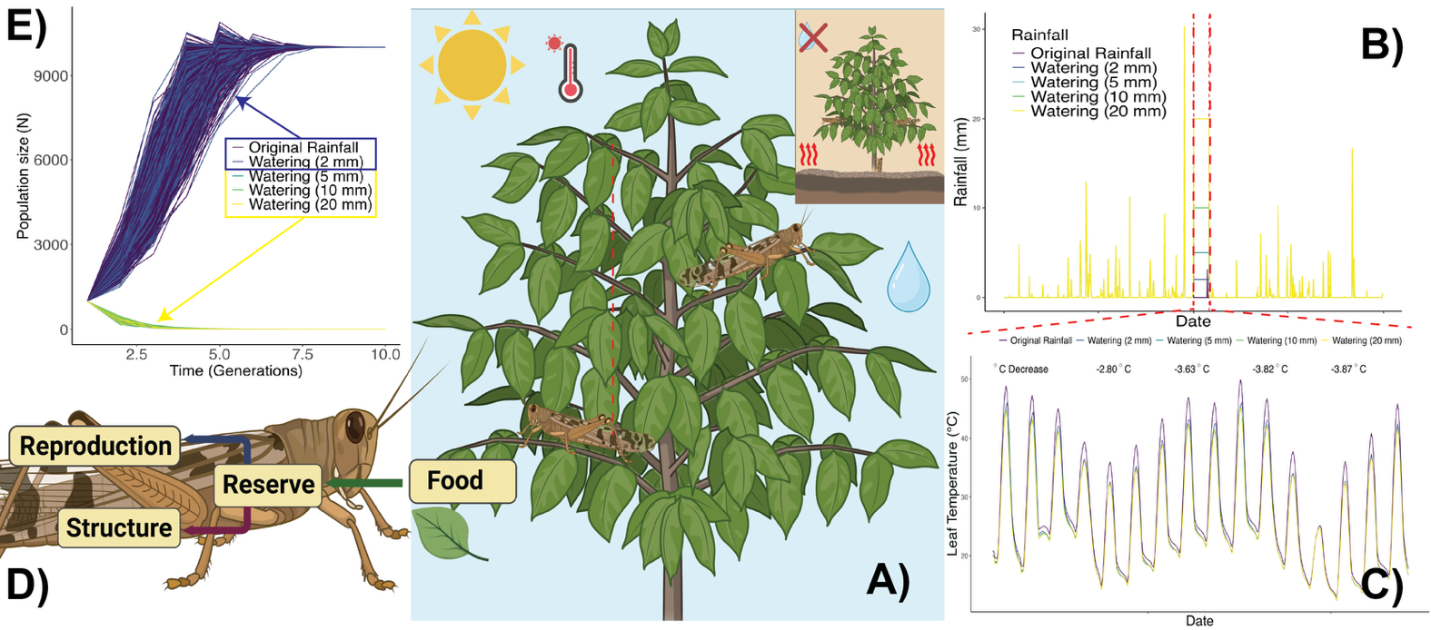
Figure 4- How a systems modelling approach to extreme heat can be used to inform solutions. A hypothetical example of an insect-plant interaction. (A) To counteract an extreme heat wave event, different watering scenarios to cool plants of agricultural importance during heat stress could be applied. Of critical importance is understanding how much water to apply to a system to keep plants cool while minimizing: 1) water use, given that heat waves are often associated with extreme drought conditions and 2) pest outbreaks, given watering may create more ideal conditions for pest insects. (B) We can obtain actual or predicted future climate data from weather stations or climate models for rainfall and create alternative scenarios where rainfall layers are manipulated by modifying the watering regimes during a heatwave event. We could then assess how adding 2, 5, 10, or 20 mm d⁻¹ of water and compares to original rainfall. (C) Adding water during an extreme heat event should result in cooling effects and by using microclimate and biophysical models we can quantify how much cooling would occur by calculating leaf temperature across all scenarios. Adding 5 mm of water can result in a 3.63°C decrease in leaf temperature. Adding more water does not result in significant gains in cooling. Note, in this simple example, we have assumed vegetation properties to remain constant; by linking in a crop growth model we could also estimate how the additional water would affect plant growth and yield, enabling the trade-offs between plant shading, leaf temperatures, crop health and yield to be explored. (D) We can then use the microclimatic conditions created by the plant to better understand how these different microclimates impact grasshopper pest body temperatures using biophysical models in combination with dynamic energy budget models that simulate the entire life-cycle of the grasshopper keeping tabs on how energy and mass flow between growth (struture) and (reproduction) during adult stages. These models also include survival estimates through time (senesence) using hazards functions allowing us to estimate an intrinsic growth rate parameter (i.e., $r_{max}$) for the pest under the different watering scenarios. (E) Using estimates of intrinsic growth rate we can then estimate the population growth rate of grasshoppers using a simple Ricker’s population growth model applied to the different scenarios. Assuming we would add 5 mm d⁻¹ each season during heatwave events, grasshopper populations would be suppressed over time whereas adding 2 mm d⁻¹ results in grasshopper population growth, leading to heatwave associated outbreaks. Here, the optimal solution is thus 5 mm d⁻¹ of water added to both 1) cool plants to protect them during a heat wave and 2) supress pest outbreaks. Created with BioRender.com.
Outstanding Questions
- For data deficient species, can we use parameters of closely related species at predicting the impacts of extreme heat for species lacking data?
- How can we capture rapid and longer-term evolutionary responses of interacting species to extreme heat in a systems-modelling framework?
- Can we use thermal load sensitivity models to describe heat damage to plant tissues?
- For plant species, can we build and couple dynamic energy budget models to predict how extreme heat will impact tissue and life cycle dynamics more accurately?
- How do multiple stressors in anthropogenically modified environments interact with extreme heat to impact organisms, populations and communities?
- How will extreme heat impact species coexistence and functional trait diversity in natural and agricultural systems?
- How can we quantify microhabitat complexity to robustly and accurately capture the heat responses of animal, plants and microbes and their interactions?
- How will thermal stress to natural ecosystems and food production systems impact people?

Concluding Remarks
We have discussed ways in which a better understanding of the impacts of extreme heat on plant and animal systems can be captured through the coupling of models from diverse research fields – models that translate the effects of atmospheric conditions to the biophysical experiences of organisms and how this then scales up to impact individuals, populations and communities. As part of demonstrating the ways in which these models can be coupled, we have developed a series of case studies to show how a systems modelling framework can be approached (see Supplementary Online Material). While our case studies are necessarily hypothetical, they move us one step closer to implementing a systems modelling approach in real-world systems. However, many challenges and gaps remain (see Outstanding Questions). Developing a systems modelling framework will require collaboration between different research fields, including biophysics, physiology, ecology and evolutionary biology as well as collaboration with socio-ecologists. Nonetheless, by working collaboratively and integratively we can develop a more quantitative and predictive understanding of the impacts that extreme heat will have on organisms, populations, and communities along with how to mitigate these impacts to preserve diverse systems now and into the future.

Acknowledgements
We would like to thank Pieter Arnold, Joel Treutlein and Patrice Pottier for helpful comments on previous versions of this manuscript. DWAN and S.J.L. are supported by an ARC Future Fellowship (FT220100276 to DWAN and FT200100381 to S.J.L.). We would also like to thank The Australian National University, the University of Melbourne and Western Sydney University for funding to support workshops that helped develop this manuscript.

Supplement and Code
Link to the supplement can be found here: https://daniel1noble.github.io/thermal_tol_interactions/ with the full set of files being located on our GitHub repository at https://github.com/daniel1noble/thermal_tol_interactions.

References

1. Barriopedro, D. et al. (2023) Heat waves: Physical understanding and scientific challenges. Rev. Geophys. 61, e2022RG000780
2. Aglas-Leitner, P. et al. (2024) Recent extreme heatwaves dwarfed by projected future events, Copernicus Meetings
3. Evans, M.E.K. et al. (2025) Scaling plant responses to heat: From molecules to the biosphere. Science 388, 1167–1173
4. Margalef-Marrase, J. et al. (2020) Relationship between heatwave-induced forest die-off and climatic suitability in multiple tree species. Global Change Biology 26, 3134–3146
5. Kazenel, M.R. et al. (2024) Heat and desiccation tolerances predict bee abundance under climate change. Nature
6. Zhao, C. et al. (2017) Temperature increase reduces global yields of major crops in four independent estimates. Proc. Natl. Acad. Sci. U. S. A. 114, 9326–9331
7. Tito, R. et al. (2018) Global climate change increases risk of crop yield losses and food insecurity in the tropical andes. Global change biology 24, e592–e602
8. Bernacchi, C.J. et al. (2025) Safeguarding crop photosynthesis in a rapidly warming world. Science 388, 1153–1160
9. Martinez, L.D. et al. (2023) Effect of simulated heat waves on the behaviour of two mirid predators. J. Appl. Entomol.
10. Rezende, E.L. et al. (2020) Predicting temperature mortality and selection in natural drosophila populations. Science 369, 1242–1245
11. Ørsted, M. et al. (2024) Thermal limits of survival and reproduction depend on stress duration: A case study of drosophila suzukii. Ecol. Lett. 27, e14421
12. López-Goldar, X. et al. (2024) Heat waves induce milkweed resistance to a specialist herbivore via increased toxicity and reduced nutrient content. Plant Cell Environ.
13. Trivedi, P. et al. (2022) Plant–microbiome interactions under a changing world: Responses, consequences and perspectives. New Phytol. 234, 1951–1959
14. Kooijman, S.A.L.M. (2010) Dynamic energy budget theory for metabolic organisation, Cambridge university press
15. Kearney, M. and Porter, W. (2009) Mechanistic niche modelling: Combining physiological and spatial data to predict species’ ranges. Ecol. Lett. 12, 334–350
16. Jusup, M. and Kearney, M.R. (2024) The untapped power of a general theory of organismal metabolism. arXiv preprint arXiv:2408. 13998
17. Kearney, M.R. and Leigh, A. (2024) Fast, accurate and accessible calculations of leaf temperature and its physiological consequences with NicheMapR. Methods Ecol. Evol. 15, 1516–1531
18. Briscoe, N.J. et al. (2023) Mechanistic forecasts of species responses to climate change: The promise of biophysical ecology. Global Change Biology 29, 1451–1470
19. Rezende, E.L. et al. (2014) Tolerance landscapes in thermal ecology. Funct. Ecol. 28, 799–809
20. Arnold, P.A. et al. (2025) A framework for modelling thermal load sensitivity across life. Glob. Chang. Biol. 31, e70315
21. Bimler, M.D. et al. (2018) Accurate predictions of coexistence in natural systems require the inclusion of facilitative interactions and environmental dependency. J. Ecol. 106, 1839–1852
22. Bowler, C.H. et al. (2022) Accounting for demographic uncertainty increases predictions for species coexistence: A case study with annual plants. Ecol. Lett. 25, 1618–1628
23. Tushabe, D. and Rosbakh, S. (2025) Patterns and drivers of pollen temperature tolerance. Plant Cell Environ. 48, 1366–1379
24. Fick, S.E. and Hijmans, R.J. (2017) WorldClim 2: New 1‐km spatial resolution climate surfaces for global land areas: NEW CLIMATE SURFACES FOR GLOBAL LAND AREAS. Int. J. Climatol. 37, 4302–4315
25. Kalnay, E. et al. (2018) The NCEP/NCAR 40-year reanalysis project. In Renewable energy, pp. 146–194, Routledge
26. Hersbach, H. et al. (2020) The ERA5 global reanalysis. Quart. J. Roy. Meteor. Soc. 146, 1999–2049
27. Klinges, D.H. et al. (2022) mcera5 : Driving microclimate models with ERA5 global gridded climate data. Methods Ecol. Evol. 13, 1402–1411
28. Meyer, A.V. et al. (2023) A guide and tools for selecting and accessing microclimate data for mechanistic niche modeling. Ecosphere 14
29. Muñoz-Sabater, J. et al. (2021) ERA5-land: A state-of-the-art global reanalysis dataset for land applications. Earth system science data 13, 4349–4383
30. Bezanson, J. et al. (2012) Julia: A fast dynamic language for technical computing. arXiv [cs.PL]
31. Bonan, G. (2019) Climate change and terrestrial ecosystem modeling, Cambridge University Press
32. Argles, A.P.K. et al. (2022) Dynamic global vegetation models: Searching for the balance between demographic process representation and computational tractability. PLOS Clim. 1, e0000068
33. Kearney, M.R. and Porter, W.P. (2017) NicheMapR – an R package for biophysical modelling: The microclimate model. Ecography (Cop.) 40, 664–674
34. Maclean, I.M.D. et al. (2019) Microclima: An r package for modelling meso‐ and microclimate. Methods Ecol. Evol. 10, 280–290
35. Kearney, M.R. et al. (2020) A method for computing hourly, historical, terrain‐corrected microclimate anywhere on earth. Methods Ecol. Evol. 11, 38–43
36. Maclean, I.M.D. et al. (2021) On the measurement of microclimate. Methods Ecol. Evol. 12, 1397–1410
37. Buckley, L.B. et al. (2023) TrenchR: An R package for modular and accessible microclimate and biophysical ecology. PLOS Clim 2, e0000139
38. De Frenne, P. et al. (2024) Ten practical guidelines for microclimate research in terrestrial ecosystems. Methods Ecol. Evol.
39. Levy, O. et al. (2016) A dynamically downscaled projection of past and future microclimates. Ecology 97, 1888–1888
40. Drake, J.E. et al. (2018) Trees tolerate an extreme heatwave via sustained transpirational cooling and increased leaf thermal tolerance. Glob. Chang. Biol. 24, 2390–2402
41. Holzworth, D. et al. (2018) APSIM next generation: Overcoming challenges in modernising a farming systems model. Environ. Model. Softw. 103, 43–51
42. Medlyn, B.E. et al. (2011) Reconciling the optimal and empirical approaches to modelling stomatal conductance: RECONCILING OPTIMAL AND EMPIRICAL STOMATAL MODELS. Glob. Chang. Biol. 17, 2134–2144
43. Porter, W.P. et al. (1973) Behavioral implications of mechanistic ecology : Thermal and behavioral modeling of desert ectotherms and their microenvironment. Oecologia 13, 1–54
44. Porter, W.P. and Gates, D.M. (1969) Thermodynamic equilibria of animals with environment. Ecol. Monogr. 39, 227–244
45. Riddell, E.A. et al. (2017) Physical calculations of resistance to water loss improve predictions of species range models. Ecol. Monogr. 87, 21–33
46. Duursma, R.A. (2015) Plantecophys–an R package for analysing and modelling leaf gas exchange data. PLoS One 10, e0143346
47. Briscoe, N.J. et al. (2022) Too hot to hunt: Mechanistic predictions of thermal refuge from cat predation risk. Conserv. Lett. 15
48. Loughran, C.L. and Wolf, B.O. (2020) The functional significance of panting as a mechanism of thermoregulation and its relationship to the critical thermal maxima in lizards. J. Exp. Biol. 223, jeb224139
49. Sharpe, L.L. et al. (2022) In the hot seat: Behavioral change and old-growth trees underpin an australian songbird’s response to extreme heat. Front. Ecol. Evol. 10
50. Posch, B.C. et al. (2024) Intensive leaf cooling promotes tree survival during a record heatwave. Proc. Natl. Acad. Sci. U. S. A. 121, e2408583121
51. Ørsted, M. et al. (2022) Finding the right thermal limit: A framework to reconcile ecological, physiological and methodological aspects of CTmax in ectotherms. J. Exp. Biol. 225, jeb244514
52. Jagadish, S.V.K. et al. (2021) Plant heat stress: Concepts directing future research. Plant Cell Environ. 44, 1992–2005
53. Faber, A.H. et al. (2024) Application of the thermal death time model in predicting thermal damage accumulation in plants. J. Exp. Bot. 75, 3467–3482
54. Martínez-De León, G. and Thakur, M.P. (2024) Ecological debts induced by heat extremes. Trends Ecol. Evol.
55. Chouhan, D. et al. (2023) Plant-microbe interaction and their role in mitigation of heat stress. In Rhizosphere biology, pp. 127–147, Springer Nature Singapore
56. Márquez, L.M. et al. (2007) A virus in a fungus in a plant: Three-way symbiosis required for thermal tolerance. Science 315, 513–515
57. Dastogeer, K.M.G. et al. (2022) Microbe-mediated thermotolerance in plants and pertinent mechanisms- a meta-analysis and review. Front. Microbiol. 13, 833566
58. Hoang, K.L. et al. (2019) The effects of bacillus subtilis on caenorhabditis elegans fitness after heat stress. Ecol. Evol. 9, 3491–3499
59. Marchin, R.M. et al. (2022) Extreme heat increases stomatal conductance and drought-induced mortality risk in vulnerable plant species. Glob. Chang. Biol. 28, 1133–1146
60. Li, J. et al. (2025) Drought-induced plant microbiome and metabolic enrichments improve drought resistance. Cell Host Microbe 33, 882–900.e7
61. Youngblood, J.P. et al. (2025) Dehydration worsens heat tolerance of locusts and amplifies predicted impacts of climate change. Funct. Ecol.
62. Mengutay, M. et al. (2013) Adequate magnesium nutrition mitigates adverse effects of heat stress on maize and wheat. Plant Soil 368, 57–72
63. Andersen, L.H. et al. (2010) Protein and carbohydrate composition of larval food affects tolerance to thermal stress and desiccation in adult drosophila melanogaster. J. Insect Physiol. 56, 336–340
64. Nisbet, R. et al. (2000) From molecules to ecosystems through dynamic energy budget models. Journal of Animal Ecology 69, 913–926
65. Jager, T. (2020) Revisiting simplified DEBtox models for analysing ecotoxicity data. Ecol. Modell. 416, 108904
66. Kearney, M.R. et al. (2013) Balancing heat, water and nutrients under environmental change: A thermodynamic niche framework. Funct. Ecol. 27, 950–966
67. Kearney, M. et al. (2010) Modelling the ecological niche from functional traits. Philos. Trans. R. Soc. Lond. B Biol. Sci. 365, 3469–3483
68. Marques, G.M. et al. (2018) The AmP project: Comparing species on the basis of dynamic energy budget parameters. PLoS Comput. Biol. 14, e1006100
69. Kooijman, S.A.L.M. et al. (2021) Multidimensional scaling for animal traits in the context of dynamic energy budget theory. Conserv. Physiol. 9, coab086
70. Bruggeman, J. et al. (2009) PhyloPars: Estimation of missing parameter values using phylogeny. Nucleic Acids Research 37, W179–W184
71. Kearney, M.R. and Porter, W.P. (2020) NicheMapR – an R package for biophysical modelling: The ectotherm and dynamic energy budget models. Ecography (Cop.) 43, 85–96
72. Kumarathunge, D.P. et al. (2019) Acclimation and adaptation components of the temperature dependence of plant photosynthesis at the global scale. New Phytol. 222, 768–784
73. De Kauwe, M.G. et al. (2020) Identifying areas at risk of drought-induced tree mortality across south-eastern australia. Glob. Chang. Biol. 26, 5716–5733
74. Chesson, P. (2000) General theory of competitive coexistence in spatially-varying environments. Theor. Popul. Biol. 58, 211–237
75. Ricker, W.E. (1954) Stock and recruitment. J. Fish. Res. Board Can. 11, 559–623
76. Beverton, R.J.H. and Holt, S. (2012) On the dynamics of exploited fish populations, Springer
77. Mayfield, M. and Stouffer, D.B. (2017) Higher-order interactions capture unexplained complexity in diverse communities. Nature Ecology &Evolution 1, 0062
78. Buche, L. et al. (2025) A continuum from positive to negative interactions drives plant species’ performance in a diverse community. Ecol. Lett. 28, e70059
79. Bimler, M.D. et al. (2024) Plant interaction networks reveal the limits of our understanding of diversity maintenance. Ecol. Lett. 27, e14376
80. Martyn, T.E. et al. (2021) Identifying “useful” fitness models: Balancing the benefits of added complexity with realistic data requirements in models of individual plant fitness. Am. Nat. 197, 415–433
81. Chevin, L.-M. and Hoffmann, A.A. (2017) Evolution of phenotypic plasticity in extreme environments. Philos. Trans. R. Soc. Lond. B Biol. Sci. 372
82. Urban, M.C. et al. (2024) When and how can we predict adaptive responses to climate change? Evolution Letters 8, 172–187
83. Hoffmann, A.A. and Sgrò, C.M. (2011) Climate change and evolutionary adaptation. 470, 479–485
84. Hoffmann, A.A. and Bridle, J. (2022) The dangers of irreversibility in an age of increased uncertainty: Revisiting plasticity in invertebrates. Oikos 2022
85. Ghalambor, C. et al. (2015) Non-adaptive plasticity potentiates rapid adaptive evolution of gene expression in nature. Nature 525, 372–375
86. Oostra, V. et al. (2018) Strong phenotypic plasticity limits potential for evolutionary responses to climate change. Nat. Commun. 9, 1005
87. Noble, D.W.A. et al. (2019) Plastic responses to novel environments are biased towards phenotype dimensions with high additive genetic variation. Proc. Natl. Acad. Sci. U. S. A. 116, 13452–13461
88. Sousa, T. et al. (2010) Dynamic energy budget theory restores coherence in biology. Philos. Trans. R. Soc. Lond. B Biol. Sci. 365, 3413–3428
89. Lande, R. (1979) Quantitative genetic analysis of multivariate evolution, applied to brain:body size allometry. Evolution 33
90. Walsh, B. and Lynch, M. (2018) Evolution and selection of quantitative traits, Oxford University Press
91. Baeza Icaza, A. et al. (2025) Warm acclimation reduces the sensitivity of drosophila species to heat stress at ecologically relevant scales. J. Anim. Ecol. 94, 896–907
92. Kearney, M. et al. (2009) Integrating biophysical models and evolutionary theory to predict climatic impacts on species’ ranges: The dengue mosquito aedes aegypti in australia. Funct. Ecol. 23, 528–538
93. Ellner, S.P. et al. (2011) Does rapid evolution matter? Measuring the rate of contemporary evolution and its impacts on ecological dynamics: How much does rapid evolution matter? Ecol. Lett. 14, 603–614
94. Pottier, P. et al. (2022) Developmental plasticity in thermal tolerance: Ontogenetic variation, persistence, and future directions. Ecol. Lett. 25, 2245–2268
95. Leiva, F.P. et al. (2024) Genetic variation of heat tolerance in a model ectotherm: An approach using thermal death time curves
96. Arnold, P.A. et al. (2019) Sparse evidence for selection on phenotypic plasticity in response to temperature. Philos. Trans. R. Soc. Lond. B Biol. Sci. 374, 20180185
97. Arnold, P.A. et al. (2024) Testing the evolutionary potential of an alpine plant: Phenotypic plasticity in response to growth temperature outweighs parental environmental effects and other genetic causes of variation. J. Exp. Bot. 75, 5971–5988
98. Assessment, M.E. (2005) Opportunities and challenges for business and industryunioviedo.es
99. Dandy, J. et al. (2019) Leaving home: Place attachment and decisions to move in the face of environmental change. Reg. Environ. Change 19, 615–620
100. Leviston, Z. et al. (2018) Linkages between ecosystem services and human wellbeing: A nexus webs approach. Ecol. Indic. 93, 658–668
101. Bai, X. et al. (2016) Defining and advancing a systems approach for sustainable cities. Curr. Opin. Environ. Sustain. 23, 69–78
102. Grimm, N.B. et al. (2008) Global change and the ecology of cities. Science 319, 756–760
103. Shekhawat, K. et al. (2022) Beat the heat: Plant- and microbe-mediated strategies for crop thermotolerance. Trends Plant Sci. 27, 802–813
104. Black, R. et al. (2011) The effect of environmental change on human migration. Glob. Environ. Change 21, S3–S11
105. Neil Adger, W. (1999) Social vulnerability to climate change and extremes in coastal vietnam. World Dev. 27, 249–269
106. Folke, C. et al. (2016) Social-ecological resilience and biosphere-based sustainability science. Ecology and Society 21
107. Schlüter, M. et al. (2012) New horizons for managing the environment: A review of coupled social‐ecological systems modeling: Social-ecological systems modeling. Nat. Resour. Model. 25, 219–272
108. Biggs, R. et al. (2021) The routledge handbook of research methods for social-ecological systems, Taylor & Francis
109. Brown, C. and Rounsevell, M. (2021) How can social–ecological system models simulate the emergence of social–ecological crises? People Nat. (Hoboken) 3, 88–103
110. Wise, R.M. et al. (2014) Reconceptualising adaptation to climate change as part of pathways of change and response. Glob. Environ. Change 28, 325–336

