A systems-modelling approach to predict biological responses to extreme heat
Daniel W.A. Noble¹ $‡$, Margaret Mayfield² $†$, Ary Hoffmann¹ $†$, Zhong-Hua Chen³ $†$, Steven Lade⁵ $†$, Xuemei Bai⁵ $†$, Danielle Way⁴ $†$, Belinda Medlyn³ $†$, Owen Atkin⁴ $†$, Adrienne Nicotra^{1,4} $†$, James Cook³, Brajesh Singh³, Brendan Choat³, Barry Pogson⁴, Alison Bentley⁴, Ian Wright³, Micheal R. Kearney² $‡$
Affiliations:
¹ Division of Ecology and Evolution, Research School of Biology, The Australian National University, Canberra ACT 2602, Australia
² School of Biosciences, The University of Melbourne, Australia
³ Hawksbury Institute for the Environment, Western Sydney University, Australia
⁴ Division of Plant Sciences, Research School of Biology, The Australian National University, Canberra ACT 2602, Australia
⁵ Fenner School of Environment and Society, The Australian National University, Canberra ACT 2602, Australia
¹ $‡$ Correspondance: daniel.noble@anu.edu.au & m.kearney@unimelb.edu.au
$†$ These authors contributed equally to this work.

Abstract
Anthropogenic climate change is leading to more frequent and extreme heat waves. These short-term but large-scale events are radically re-shaping interactions among organisms, impacting biodiversity, community composition and ecosystem services crucial to natural systems and food security. Predicting heat wave impacts on interacting species requires an understanding of the processes driving differential exposure and sensitivity of organisms to extreme heat events in a life-cycle context. To achieve this predictive capacity, we need to integrate models across scales while capturing species-specific responses at the level of individuals. We show how existing models in disparate fields can be linked to achieve a level of understanding necessary for calculated responses to extreme heat from individuals to socioecological systems, now and into the future.

A need for a mechanistically informed modelling framework for interpreting and predicting the effects of extreme heat on community assemblages
Climate change is leading to warmer and more variable thermal environments globally [1,2]. Greater thermal variability will result in organisms experiencing extreme heat waves that result in thermal stress that impacts organismal growth, survival and reproduction with cascading effects on population dynamics, community composition and ecosystem structure and function [3,4]. Climate variability has already been linked to dramatic declines in plant and animal performance, resulting in reduced pollinator abundance [5] and in crop yields globally [6–8], but the causes underlying such declines, and their ramifications through communities, are not fully understood. The impacts of extreme heat on species and communities are driven by a combination of direct effects of heat stress on organism physiology and fitness [9–12] and indirect effects on interactions (both positive and negative) among species [e.g., 13,14] – including the microbial communities many species rely upon [15]. Understanding the dynamic interplay between direct and indirect interactions, and how these are mediated by environmental factors, has been hampered by the complexity of community interactions and the lack of an integrated modelling framework that can translate short-term physiological damage into changes in fitness and population growth across species [15].
Predicting how extreme heat impacts population dynamics and community interactions requires the coupling of biophysical, physiological, population and community ecology models. We argue that such a feat is becoming increasingly tangible and will provide powerful new ways of predicting how extreme heat shapes community dynamics. Physiological models can now be seamlessly integrated with biophysical models of heat and mass exchange to characterize temperatures experienced by organisms and simulate the effects of extreme heat events on the entire life cycle of species within communities [16–20]. Physiological models that incorporate estimates of thermal sensitivity across species can capture the delicate balance between damage and repair in physiological systems [11,12,21,22] to translate the immediate and cumulative impacts of extreme heat on growth, survival and reproduction. Importantly, mechanistic physiological models provide common currencies that can be integrated into population and community ecology models to capture how extreme heat events perturb interactions among species [23,24].
Here, we bring together and discuss modelling approaches across diverse fields to establish a bridge for thinking about how we might begin integrating them to predict how extreme heat will affect communities. We focus our discussion on plant, insect and microbial communities given the strong interconnections between them, the ease with which they can be studied, and their significance to natural and agricultural productivity. Importantly, ‘extreme heat’ can take on a different meaning for these diverse organisms. For example, plants and animals have different thermal tolerances or can exploit microthermal environments in different ways to dampen the effects of extreme atmospheric heat events. As such, ‘extreme’ will be relative to the biology of the organism in question. Our framework can capture these complexities and be extended to incorporate other, diverse interactions.

A systems-modelling approach to modelling biotic impacts of heatwaves
We propose a systems-modelling approach to model biotic impacts of heatwaves (Figure 1), scaling from the level of the atmosphere to microclimate, and from individuals to populations and communities. Ultimately, the impacts of extreme heat events on a community are driven by responses of individuals. Therefore, to understand extreme heat impacts on a community of organisms, we must characterize the proximal thermal environments – the ‘microclimates’ – experienced by individuals of different species under a given atmospheric event. These microclimates must then be translated into physiological and behavioral responses, including the processes of thermal damage and repair, and how individuals mitigate their exposure to extreme heat through habitat selection and other avoidance strategies. Finally, dynamic energy budgets translate these individual responses into growth and reproduction trajectories across life cycles to drive population and community models of the resulting interactions.
In the next sections, we outline new developments that enable us to model all the components in Figure 1 such that a truly systems-based approach to modelling biotic impacts of heatwaves is now possible. We highlight the immense opportunities such an integration may provide through a greater understanding of the ways in which extreme heat stress manifests across species. Such an integration will help elucidate how and why interactions among species can change, with implications for natural and agricultural systems, food security and ecosystem services. We discuss the challenges of applying such an integrated modelling framework and how it can incorporate other critical features that capture evolutionary change and plasticity.
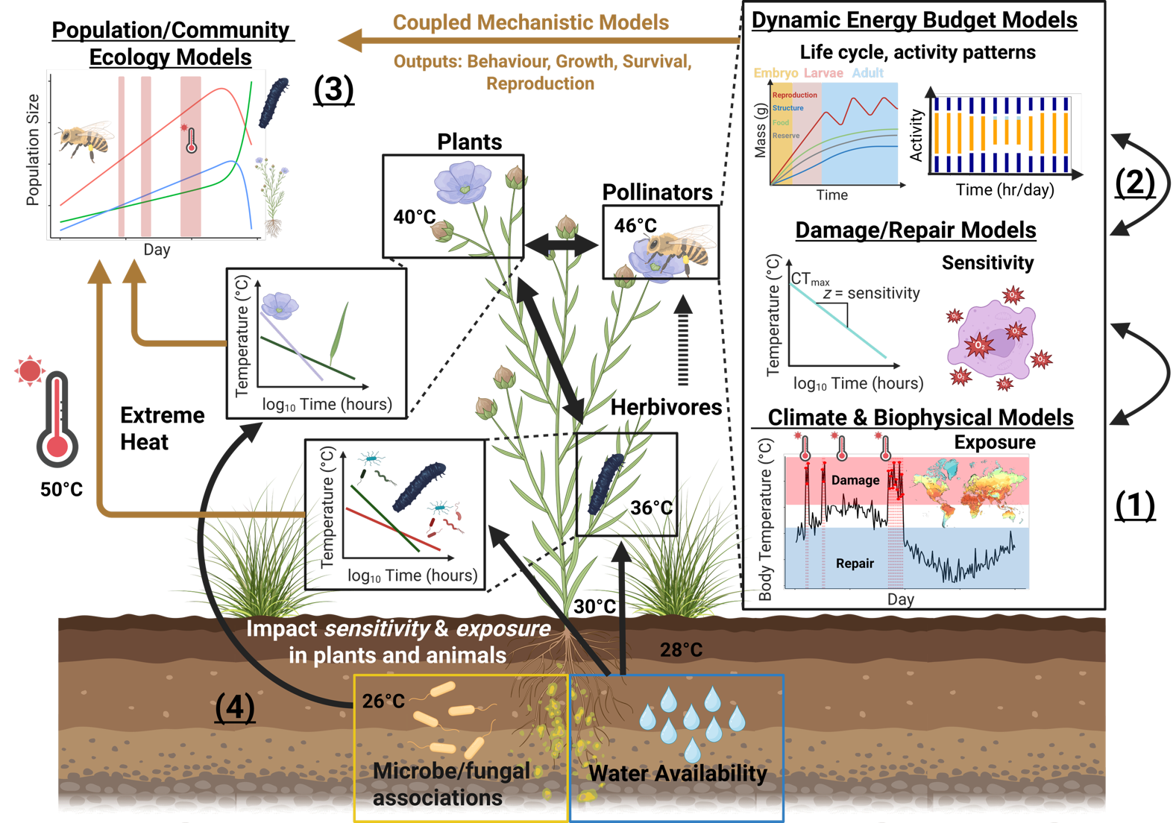
Figure 1- The proposed modelling integration developed here integrates (1) climate/biophysical models to predict the temperatures species experience in their respective microhabitats. (2) Temperatures experienced by organisms provide inputs for damage-repair and dynamic energy budget models that integrate temperature exposure with explicit physiological models that simulate development, behavior, survival and reproduction in response to temperature across life history stages. Physiological models can be built around the unique life cycles of the diverse species in communities, capturing lagged responses to extreme heat, phenological mismatches and mechanistically informed responses to extreme heat for species of the system in question. Outputs (behavior, growth rate/ biomass accumulation, survival and reproduction) from physiological models of individual organisms can then be integrated into (3) population and community ecology models to predict population growth and community composition under a specific type of change. We discuss how (4) environment-mediated feedbacks influence organism thermal exposure and sensitivity (e.g., water availability, microbiota) which can vary across different life stages and organs. The integration of existing models in this novel way will allow simulations at the organismal level to generate emergent predictions for entire communities. In turn, such simulations will allow quantitative predictions to be made on how extreme heatwaves perturb biological systems and allow for the development and implementation of strategies to enhance both biological and socioecological system resilience to extreme heat. Created with BioRender.com.

The current climate of extreme weather modelling
An understanding of heatwave impacts on biology requires environmental inputs about weather conditions. These data may come from weather stations or models. Weather station observations of air temperature, radiation, wind speed, cloud cover and humidity are readily available as raw timeseries from the stations themselves, and as interpolated products such as WorldClim [25].
Weather stations can of course only tell us about past heat wave events. Climate modelling and weather event forecasting is achieved through General Circulation Models (GCMs) – large partial differential equation networks of atmospheric, oceanic and biospheric energy and mass exchange processes. Future climate change scenarios are generally produced at monthly time-scales, but can be superimposed on historical weather patterns to infer the nature of future heatwaves. Historical analyses are facilitated by GCMs via ‘reanalysis’ datasets produced by calibrating GCMs with observations to produce continuous gridded weather data, including ‘surface’ temperatures, soil temperatures and profiles of temperature, pressure, wind speed and humidity at different levels in the atmosphere [26–30]. The most state-of-the-art of these are ERA5 and ERA5-Land, hourly products at ~31km and ~9km resolutions, respectively.
Historically, GCMs were coded in fast but inflexible languages like Fortran and C. The emergence of the Julia language [31] for scientific computing has created an opportunity to rebuild climate models in a more modular manner, allowing easier interfacing between discipline-specific models and easier integration of the massive emerging power of AI for data assimilation and machine learning [32]. The translation of GCMs and associated land-surface models into more accessible and modular languages opens up new opportunities for collaboration between biologists and earth scientists to better integrate the processes in the atmosphere and the biosphere to generate better predictions of weather events and their biological impacts.

From weather to microclimates: predicting community wide exposure to extreme heat
Extreme weather events are experienced differently across species in a community. For example, while air temperature may be 50°C, an organism a metre below the soil surface may be exposed to temperatures 25°C cooler (Figure 1). Exactly how much the soil lags and dampens the atmospheric dynamics depends on the soil properties, especially its moisture level. Conditions above ground depend on the nature of the vegetation, especially through shading, changes in wind profiles and evaporative cooling (transpiration rates). Vegetation and soil also interact strongly. Past soil moisture regimes and heat wave events can lead to leaf loss and hence increased radiation exposure of the soil surface, while stomatal behavior alters transpiration rate and hence soil moisture. ‘Memory’ effects of past weather conditions can determine how a given heat wave manifests, so the same atmospheric heat wave can have different implications for microclimatic conditions depending on the recent history of rainfall and temperature. Despite the complexity and non-linearity of these interactions across the soil-plant-atmosphere continuum (SPAC), there is existing capacity, and growing potential, to model them and determine individual-specific exposure to extreme heat.
To some extent, GCMs have these dynamics built into them via modules called ‘land-surface models’ (LSMs), which aim to capture feedbacks between the land surface and associated vegetation. LSMs will at minimum represent air, soil and canopy temperatures. LSMs that represent multiple layers of the plant canopy will represent the change in leaf temperature with canopy depth; models may also represent thermal gradients through the soil. Land surface schemes will typically do this using energy balance approaches. In contrast dynamic vegetation models may use simpler empirical regression approaches to estimate soil and understory temperatures [e.g. 33].
The primary role of LSMs is to better understand overall atmospheric dynamics rather than resolve the details of microclimates to which organisms are exposed. Thus, agronomists and ecologists have developed microclimate models that can provide more detailed inferences of environmental exposure. These microclimate models take the atmospheric conditions as independent forcing variables, together with detailed information on terrain (slope, aspect, hill shade), vegetation [leaf/plant-area index, leaf area index (LAI) and soil properties (thermal and hydraulic properties)] to predict how radiation, wind speed, air temperature, humidity, soil temperature and soil moisture vary on centimeter scales. The available models vary in the physical processes they incorporate yet can be powerful in predicting relevant microclimates to organisms [34–40]. Our Supplementary Online Material provides a tutorial on how to predict microclimates from climate data using existing open access software and datasets [34,36,37].
Advancements in microclimate modelling have created opportunities to more closely couple the dynamics of the atmosphere and vegetation. In particular, plant water use dynamics during heatwaves can amplify or reduce high temperatures via effects on photosynthetic capacity, stomatal decoupling, cuticular conductance, leaf damage and plant mortality. These impacts are important for the plants themselves, but also for thermal regimes within the plant canopy. Forecasting future thermal regimes also involves forecasting future vegetation dynamics, with interesting challenges that include interactions between high LAI and canopy shading [41].

Translating exposure to organism temperature: biophysics to the rescue!
Once microclimates are quantified, heat-budgets of organisms can be computed as a function of their traits using the principles of biophysical ecology. Biophysical models have a long history [e.g. 42,43] but have become more widely applied in ecology in the past 20 years, facilitated by developments in environmental datasets, microclimate modelling, and the emergence of high-level programming languages such as R [20]. Biophysical models of ectothermic animals can account for complex radiative heat transfer and the role of evaporative water loss from the skin, breath and eyes [34,44]. Equivalent models of leaves incorporate the dynamic role of stomata [19,45], while models of endotherms can account for the role of insulation and metabolic heat production [46]. Future development in biophysical modelling of organismal temperature under extreme heat involves understanding the nuances of plastic physiological and behavioral responses. For example, lizards may pant when exposed to high temperatures [47], birds may ‘wind surf’ or seek thermal micro-refugia [48], and stomatal behavior may depart from the typical responses to vapor pressure and light intensity to allow emergency cooling [49], though this response may depend on prior soil moisture conditions [50]. The application of biophysical heat budget models in concert with microclimate models can thus be used to infer differential exposure of members of a community to specific temperatures to predict relative exposure with different degrees of detail, from rank-order stress exposure to hourly trajectories that can be linked to physiological models of damage and repair.

Capturing the balance between physiological damage and repair to predict multi-species thermal sensitivity
Translating how heat waves impact plants and animals not only depends on modelling temperature exposure but also the varying sensitivity of organisms to extreme heat [21,51]. Sensitivity to extreme heat can be captured by thermal load sensitivity (TLS) / thermal death time (TDT) models that explicitly account for how heat stress depends on both temperature and the duration of time at a given temperature [21,22]. Typically, these models focus on endpoints that include survival (e.g., lethal temperatures, $LT_{50}$ or $LT_{80}$) or some measure of fertility, but this need not be the case [e.g. Table 1 in 52,see 22]. Endpoints are predicted by assuming the effect of time at a given temperature decreases survival or fertility exponentially [11,12,21,51]. For example, Ørsted et al. [12] show that both mortality and fecundity follow a clear exponential relationship with time, with survival and fecundity being compromised most for long thermal exposures at high temperatures in Drosophila suzuki. Importantly, Ørsted et al. [12] also show that reproductive sensitivity can be higher than mortality with heat injury accumulating faster to impact productivity earlier than survival. TLS theory has also been shown to apply well to photosynthetic function in plants [52,53] highlighting the potential generality of the TLS framework. Thermal load sensitivity models explicitly acknowledge that thermal sensitivity depends on the relative accumulation of damage to cellular and sub-cellular systems that compromise physiological function. Without periods of recovery, where damage can be repaired, organisms accumulate damage over time that reduces growth, and impacts survival and reproduction.
The concept of damage/repair is important for understanding how heat waves affect organisms because both processes can result in lagged responses to heat stress – a common feature of extreme heat events [22,54]. Once the thermal sensitivity (i.e., the slope $z$, Figure 1) for a particular endpoint has been quantified it can be used to predict the accumulation of damage during stressful temperatures experienced under realistic conditions [11,12,22,51]. Several approaches can be used to capture the accumulation of damage [11,12,51], but a simplistic way can be computed following Ørsted et al. [12]:
$$HI=\sum_{i=1}^{T_{e}>T_{c}}{\frac{100⋅\left(t_{i+1}-t_{i}\right)}{{10}^{\left(-\frac{1}{z}⋅max\left(T_{i};T_{i+1}\right)+α\right)}}} \left(1\right)$$
Equation 1 summarizes heat injures (HI) sustained across time, $t$, during heat stress events (i.e., when body temperatures are greater than the critical temperatures, $T_{e}>T_{c}$) using information about the maximum temperature, $T$, experienced between time point $t_{i}$ and $t_{i+1}$ and the thermal sensitivity (i.e., $z$ and $α$). Once an organism accumulates damage to reach a given threshold the endpoint has been reached. [22] recently proposed a framework for integrating repair processes into these models more explicitly. Environmental factors that impact thermal sensitivity can also be incorporated into TLS model (Box 1, see also [22]). Modelling the intricate balance between damage and repair for a suite of different species can help identify susceptible species, life stages and tissues that are most at risk from extreme heat events, which allows for more accurate predictions of the varying sensitivity of species across a community.
Box 1: Sensitivity to extreme heat is mediated by environmental feedbacks
Natural and anthropogenic environments shape thermal sensitivity and should be considered in any systems modelling approach [22]. Some examples across plants and animals include:
Microbial Interactions: Heat tolerance of animals and plants can be increased and decreased through changes in the gut microbiome and/or through associated microbes within or around tissues. Interactions between plants and microorganisms, such as plant growth-promoting rhizobacteria (PGPR), arbuscular mycorrhizal fungi (AMF), and bacterial or fungal endophytes are known to impact growth, defense, and heat tolerance in plants [55–57] (Box Figure 2A). These interactions are usually achieved by stimulating the production of essential phytohormones, secondary metabolites, organic acids, and amino acids that helps the plant to mitigate heat stress [58,59]. Heat tolerance in animals can also be influenced by gut mircobiota or other associated symbiotes. For example, Bacillus subtilis residing in the gut of the nematode Caenorhabditis elegans provides protection against heat shock as reflected by effects on fecundity [60] (Box Figure 2B). Moreover, this protective effect can influence the ability of the host to evolve further resistance to the heat shock [61].
Drought and Water Stress: Drought, often associated with periods of extreme heat, can reduce thermal tolerance in plants by impacting their ability to cool through transpiration leading to leaf damage [62] (Box Figure 2C). Extended periods of water stress (e.g., several days or more) have also been shown to increase thermal sensitivity in insects, reducing the time they could deal with extreme heat [63] (Box Figure 2D).
Nutrition and Diet: Nutritional composition of the diet has also been shown to affect heat tolerance in insects and plants, possibly through the modification of lipid membranes, substrate availability for ATP synthesis, availability of key amino acids and/or alleviating oxidative stress. [64] show how supplementation of a key mineral, magnesium (Mg), can improve heat tolerance in maize and wheat, with visual leaf damage being aggravated in both species under heat stress when in low supply of Mg. Damage resulted from increased oxidative cellular damage (Box Figure 2E). In Drosophila melanogaster larvae fed a diet with high protein content were also able to withstand higher temperatures than those fed a high carbohydrate diet, with some evidence for sex-dependent effects [65] (Box Figure 2F).
The above list is not exhaustive, and other environmental stressors, such as pollution and salinity, along with interactions between environmental stressors discussed above, can also impact thermal sensitivity [22,54].
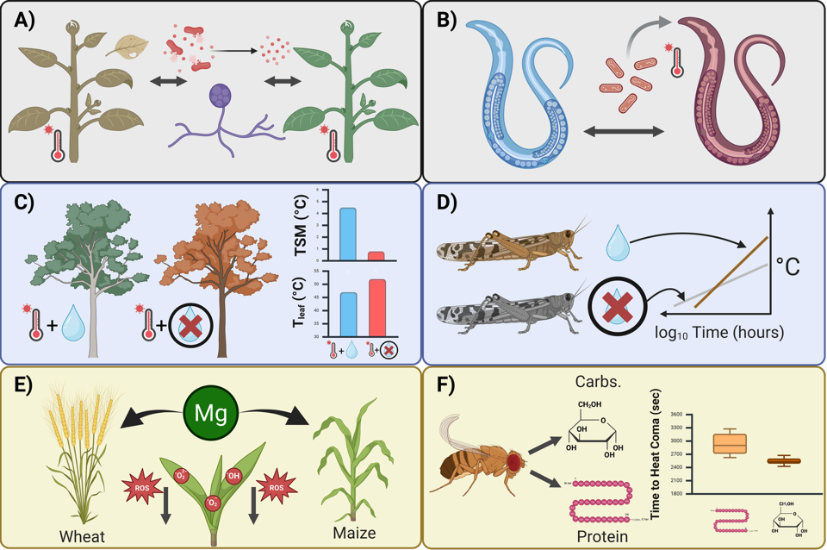
Figure 2- Examples of environmental factors impacting thermal sensitivity in plants and animals. A & B) microbial interactions. C & D) drought and water stress. E & F) nutrition and diet. See text for more explanation. Created with BioRender.com.

Glossary
Coexistence: Coexistence occurs when two species are able to persist in each others presence indefinitely under constant, equilibrium conditions. While highly variable natural environments compromise these assumptions, coexistence models still have a lot of potential as tools for exploring whole community responses to extreme events
Microclimate: Microclimates are the local atmospheric conditions experienced by organisms, which can differ substantially from the broader atmospheric conditions. Microclimates are influenced by factors such as vegetation cover, soil properties, and topography, and can significantly affect the thermal environment experienced by organisms
Functional traits: Functional traits are the measurable characteristics of organisms that influence their performance and fitness, such as body size, reproductive output, and metabolic rates. In the context of extreme heat, functional traits can be used to categorize species based on their responses to thermal stress

Dynamic Energy Budget (DEB) models that capture the effects of extreme heat across life
Dynamic Energy Budget (DEB) models are physiologically explicit life-cycle models of energy and mass uptake and conversion that predict key life-history transitions, growth, reproduction and survival (senescence) through time [16,66]. DEB models consider organisms as a thermodynamic system (adhering to energy-mass balance) capturing the exchange of food, water, respiratory gases and metabolic waste throughout the life cycle [20]. DEB models can translate short-term (hourly) variation in factors, such as temperature, toxins (e.g., toxicants, [68]) and resource availability (nutrients) [69,70] into long-term (days, months, years) effects on development, growth, reproduction and survival [17,20], though they have been applied to plants much less than for animal and microbial systems[71]. DEB theory, when combined with biophysical models more generally, allows the full water budget to be computed to account for heat stress impacts of a hydric nature [20]. Perhaps most importantly, DEB theory calculates the life cycle trajectory of an organism and so can account for the effects of timing of heat wave impacts relative to life stage. Applied to multi-species assemblages, DEB models can capture how different species’ life-cycles are impacted by heat and interact with each other to predict how traits such as birth, age at maturity, reproductive events, energy flow and lifespan vary across species. While DEB models are parameter rich, necessary parameters have been estimated for > 5000 species already [72,73] and approaches for using DEB theory to model plant growth and performance are being developed [71]. New analytical approaches using phylogenetic imputation methods allow for models to be developed independently for all species even when data are lacking. These methods show promise in predicting DEB parameters for over 1.3 million species [see, 74]. In addition, software packages such as NicheMapR [34,75] allow for simulations of life-cycles using parameters for diverse species. From these models key outputs on organisms such as body mass and size, reproductive success and events, along with survival can be used to parameterize vital rates needed for population and community models, with additional options to incorporate eco-evolutionary feedbacks (see Box 2).

Mechanistic approaches that ‘speak’ to population and community ecology under extreme heat
Coexistence frameworks offer an intriguing approach for how to bring the many elements discussed above together to understand whole community responses to extreme climate events. Modern coexistence theory [MCT; [76]] uses simple two-species individual-based population growth models, such as Beverton-Holt or Ricker models [77,78], to determine how interactions between species at the individual level lead to indefinite “coexistence”.
What population dynamic models do is calculate the individual fitness effect of interactions [79]. These models can incorporate variation in the environment [23] and in the outcome of interactions themselves [80]. As these models use the same fitness measures as DEB models they offer a population modelling framework to add thermal biology to community diversity predictions. This is because population dynamical models can be put together, for example as networks [81] and compared between microsites with different biophysical properties and composed of species with different thermal responses to their microenvironment. For example, [81], used this approach to determine which species were keystone species under shady and sunny portions of the same plant communities.
Modified vital rate functions (which can be used with any measure of fitness) can be used in population growth models to compare population growth predictions for individuals in areas with different biophysical properties and/or thermal tolerances. The outcomes from DEB models could be used to directly parameterise growth rate models or used to establish functional traits, which at a community scale can be used to categorize species with different response and effect profiles. Horizontal interaction networks can them be developed for microclimates with different biophysical properties from which plants (defined by their fitness responses to their thermal environment) can be identified that have particularly types of interaction effects or responses during extreme heat events, or areas with particular thermal landscapes. The limitation of these methods is that they are data hungry, but even this can be handled by categorizing species by ‘trait’ which has been shown to be an effective way of reducing model complexity without sacrificing accuracy [82].
The population growth models used in coexistence frameworks are best suited to sessile organisms, like plants, as there is no mechanism within them to capture the effects of individuals moving to different environments or changing who they interact with. Recent advances of coexistence modelling have resulted in the development of coexistence models that incorporate variance in interaction outcomes and intrinsic fitness within the context of heterogeneous environments [e.g., 24]. Another useful advancement is the development of horizontal network models parameterized with outcomes of population dynamical models [81].
Box 2: Integrating eco-evolutionary feedbacks within a systems-modelling framework
Extreme environments both impact trait development and act as a potent selective force triggering evolutionary change in populations [83–85]. Evolutionary responses will depend on the amount of phenotypic and genetic variation exposed to natural selection and the strength of selection on phenotypes. Extreme environments pose unique challenges for predicting evolutionary change because they are, by definition, rare events. Adaptive evolution will therefore depend on the frequency of extreme environments and the underlying genetic correlation between traits expressed across environments [83]. In addition, phenotypic plasticity can result in both maladaptive and adaptive outcomes by either shielding selection on genetic variation or by facilitating persistence and selection making the relative role of plasticity and adaptive evolution to building population resilience complex [84,86–89].
Plasticity and evolution can be incorporated into a systems modelling framework by allowing environments to govern ‘trait’ development (plasticity) and by incorporating selection and genetic (co)variance estimates for ‘traits’ within these models (evolution). We speak of ‘traits’ broadly here because these need not be traits typically thought of by evolutionary ecologists (e.g., body mass, morphology). Rather, ‘traits’ can also include the parameters within models (e.g., DEB parameters) that allow functional traits to emerge [90]. Plasticity can be captured by mapping trait development to the environment. In contrast, evolutionary change takes place in multivariate trait space where genetic variance and covariance between traits (i.e., constraints) along with varying patterns of selection can be used to predict trait change across generations. One way to make such predictions is by using the multivariate breeders equation [91]:
$$Δ\overset{‾}{z}=G⋅β \left(2\right)$$
where $Δ\overset{‾}{z}$ is the vector of changes in the mean trait values, $G$ is the genetic covariance matrix and $β$ is the vector of standardised selection gradients that regress each trait on relative fitness (i.e., $ω=α+β^{T}⋅z+e$; [92]). While the multivariate breeders equation can be useful for predicting short term evolutionary responses (i.e., one or a few generations) it is likely limited in predictive power over longer timespans because of changes in heritability and selection through time [85,92].
Measuring and incorporating both plasticity and evolution into our proposed systems modelling framework is challenging because such models usually focus on one or a few ‘traits’. Studies that have attempted to measure plasticity and evolutionary potential in traits demonstrate how such processes can shape outcomes in important ways [63,93–97]. For example, using isogenic lines of Drosophia melanogaster, Leiva et al [97] show evidence for genetic variation in both upper thermal limits ($CT_{max}$) and thermal sensitivity (i.e, $z$, slope from TDT curves) using a TDT framework. Simulations also show that selection on one parameter will also induce changes in the other. Additionally, thermal sensitivity in Drosophia species is also known to respond plastically to temperature [93]. In the alpine plant Wahlenbergia ceracea despite ample plasticity in response to warming there is little genetic variation in plasticity, thus adaptive evolution of plasticity in response to extreme heat is unlikely [98]. Indeed, few studies have attempted to quantify genetic variation in plasticity in response to warming, never mind extreme heat events, and among those that have there is little evidence that such plasticity is adaptive [98,99]. One challenge in assessing the adaptive evolution of plasticity is that trait values themselves are also under selection in the different environments that elicit the plasticity; thus selection on plasticity reflects both selection on trait means in a given environment and selection on the full range of phenotypes across environments [91,98].

Box 3: Interacting species interacting with people: social-ecological systems
Extreme heat may threaten the services natural and agricultural ecosystems provide to people [100]. For example, loss of output from production ecosystems will have substantial economic consequences for a local area. Degradation of natural ecosystems may also affect their regulating services, such as flood mitigation. Impacts on cultural services may be severe for communities that are closely connected to a landscape (Figure 3).
People may respond to the impacts of extreme heat on ecosystems in a variety of ways. Farmers or ecosystem managers may introduce new species, alter management practices or farm remaining unaffected areas more intensively. Thermal stress may ultimately result in people leaving areas, potentially making remaining communities more vulnerable [101]. Thermal risks to ecosystems may also precipitate declines in individual wellbeing, and these consequences may accrue differently across regions and peoples [102]. Many of these impacts and responses, however, are poorly understood.
Thermal stress on ecosystems can affect not only nearby communities but also human dominant systems, such as cities, far away from affected ecosystems. Cities are intrinsically connected to and rely on other regions to maintain their functionality [103,104]. For example, extreme heat stress may affect essential ecosystem services, such as food production [105], which can in turn affect price and access to food for people living in urban centers, with financial, economic and health consequences. The impacts on local communities could lead to loss of livelihood, pushing people in rural communities to migrate to cities [106]. These external pressures will interact with a system that is already constrained by multiple stressors, including direct impacts imposed by extreme heat and other aspects of climate change. If sufficiently widespread, economic and political destabilisation may occur as has already been observed in other parts of the world [107].
Understanding the relationships between people and nature requires adopting a social-ecological systems perspective, where people and nature are interdependent and intertwined [108]. Social-ecological models aim to capture social and natural systems along with their interactions [109]. They are conventionally built using process-based modelling frameworks such as agent-based models, dynamical systems models or state-and-transition models [110]. Process-based approaches are critical to understanding how emergent social-ecological phenomena develop [111], such as tipping points, traps or other dynamics. Such models can display complex emergent behavior resulting from interactions within the social-ecological system. For example, responding to decreased productivity from extreme heat by farming more intensively could lead to a maladaptation or ‘lock-in’ from which it is difficult to escape [112].
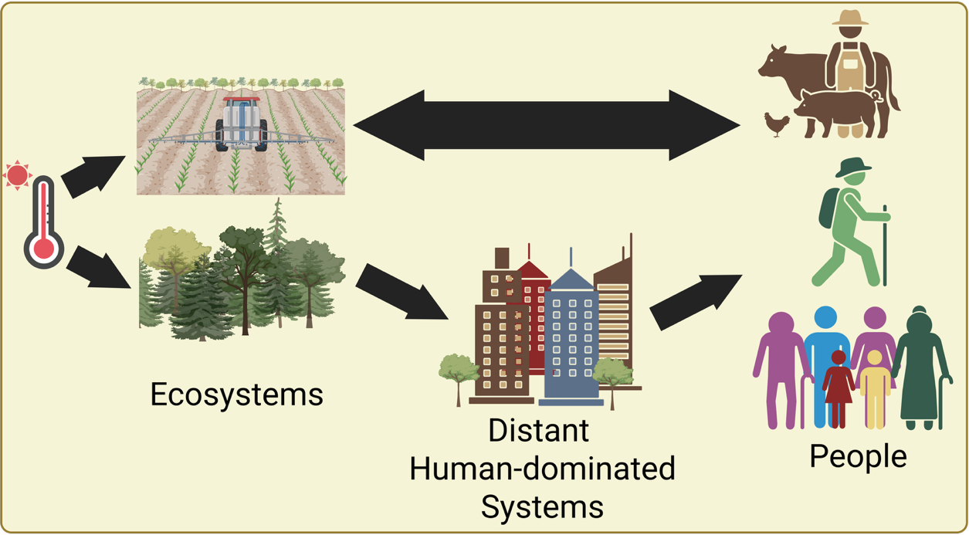
Figure 3 - Impacts of extreme heat on natural and production ecosystems will cascade to affect people, both locally and in distant human-dominated systems such as cities. Decisions made by people in these communities in response to these changes will affect the ecosystems on which they rely, creating an interdependent social-ecological system. Created with BioRender.com

‘Hot’ solutions for a changing world
Extreme heat will have dramatic and widespread effects on the socioecological systems that humans rely upon (Box 3). For example, under current global climate change scenarios, each degree Celsius increase in global mean temperature is estimated to reduce the global yield of wheat by 6.0% and soybean by 3.1% [105] exacerbating food shortages. A systems modelling approach can provide us with quantitative tools to make informed predictions, plan interventions and evaluate various scenarios for mitigating the impacts of extreme heat. For example, microclimate and biophysical models, in combination with watering interventions, can allow us to make informed predictions about how to mitigate heat stress to crops while also considering how such interventions impact pests (See Figure 4 and Case Study 4/5 in the Supplementary Online Material). Identifying and/or modifying the thermal suitability of landscapes to benefit plants and animals under extreme heat shows immense promise [20]. Additionally, as our understanding of the mechanisms associated with heat tolerance improve, genetic tools, environmental manipulations and artificial breeding can be used to enhance thermal tolerance creating more resilience to extreme heat events [e.g., 57]. Integrating these solutions into a systems modelling framework will then allow for a calculated understanding of the viability of such approaches in real world situations.
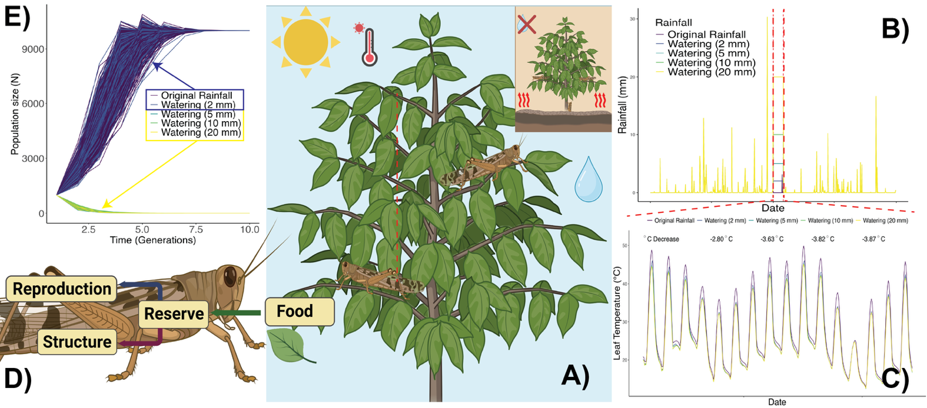
Figure 4- How a systems modelling approach to extreme heat can be used to inform solutions. A hypothetical example of an insect-plant interaction. (A) To counteract an extreme heat wave event different watering scenarios to cool plants of agricultural importance during heat stress could be applied. Of critical importance is understanding how much water to apply to a system to keep plants cool while minimizing: 1) water use, given that heat waves are often associated with extreme drought conditions and 2) pest outbreaks, given watering may create more ideal conditions for pest insects. (B) We can obtain actual or future climate data from weather stations or climate models for rainfall and create alternative scenarios where rainfall layers are manipulated by modifying the watering regimes during a heatwave event. We could add 2, 5, 10, or 20 mm of water and compare this to our original rainfall. (C) Adding water during an extreme heat event should result in cooling effects and using microclimate and biophysical models we can quantify how much cooling would occur by calculating leaf temperature across all scenarios. We can see that adding 5 mm of water can result in a 3.63 Celsius decrease in leave temperature. Adding more water does not resulting in significant gains in cooling. (D) We can then use the microclimatic conditions created by the plant to better understand how these different microclimates impact grasshopper pest body temperatures using biophysical models in combination with dynamic energy budget models that simulate the entire life-cycle of the grasshopper keeping tabs on how energy and mass flow between growth (structure) and (reproduction) during adult stages. These models also include survival estimates through time (senescence) using hazards functions allowing us to estimate an intrinsic growth rate parameter (i.e., $r_{max}$) under the different scenerios. (E) Using our estimate of intrinsic growth rate we can then estimate the population growth rate of grasshoppers using a simple Ricker’s population growth model applied to the different scenerios. We can see that, assuming we would add 5 mm each season during heatwave events, populations would be supressed over time whereas adding 2mm results in population growth, which would lead to outbreaks. Here, the optimal solution is 5mm of water added to both 1) cool plants to protect them during a heat wave and 2) suppress pest outbreaks. Created with BioRender.com.

Outstanding Questions
- How effective are models that use parameters of closely related species at predicting the impacts of extreme heat for species lacking data?
- How can we capture longer-term evolutionary responses to extreme heat in a systems modelling framework?
- For modular plant species, can we build and couple dynamic energy budget models to predict how extreme heat will impact tissue and life cycle dynamics more accurately?
- How do multiple stressors in anthropogenically modified environments interact with extreme heat to impact organisms, populations and communities?
- How will extreme heat impact species coexistence and functional trait diversity in natural and agricultural systems?
- How accurately can we capture animal behavioural responses to extreme heat using biophysical models? How can we quantify microhabitat complexity to most robustly capture these responses?

Concluding Remarks
We have discussed ways in which a better understanding of the impacts of extreme heat on plant and animal systems can be captured through the coupling of models from diverse research fields – models that translate the effects of atmospheric conditions to the biophysical experiences of organisms and how this then scales up to impact individuals, populations and communities. As part of demonstrating the ways in which these models can be coupled, we have developed a series of case studies to show how such a systems modelling framework can be approached (see Supplementary Online Material). While our case studies are necessarily hypothetical in nature they move us one step closer to implementing a systems modelling approach in real-world systems. However, many challenges and gaps remain (see Outstanding Questions). Developing a systems modelling framework will require collaboration between different research fields, including biophysics, physiology, ecology and evolutionary biology as well as with socio-ecologists. Nonetheless, by working collaboratively and integratively we can develop a more calculated understanding of the impacts that extreme heat will have on organisms, populations, and communities along with how to mitigate these impacts to preserve diverse systems now and into the future.

References

1. Barriopedro, D. et al. (2023) Heat waves: Physical understanding and scientific challenges. Rev. Geophys. 61, e2022RG000780
2. Aglas-Leitner, P. et al. (2024) Recent extreme heatwaves dwarfed by projected future events, Copernicus Meetings
3. Reichstein, M. et al. (2007) Reduction of ecosystem productivity and respiration during the european summer 2003 climate anomaly: A joint flux tower, remote sensing and modelling analysis. Global Change Biology 13, 634–651
4. Margalef-Marrase, J. et al. (2020) Relationship between heatwave-induced forest die-off and climatic suitability in multiple tree species. Global Change Biology 26, 3134–3146
5. Kazenel, M.R. et al. (2024) Heat and desiccation tolerances predict bee abundance under climate change. Nature
6. Zhao, C. et al. (2017) Temperature increase reduces global yields of major crops in four independent estimates. Proc. Natl. Acad. Sci. U. S. A. 114, 9326–9331
7. Tito, R. et al. (2018) Global climate change increases risk of crop yield losses and food insecurity in the tropical andes. Global change biology 24, e592–e602
8. Bastos, A. et al. (2014) Analysing the spatio-temporal impacts of the 2003 and 2010 extreme heatwaves on plant productivity in europe. Biogeosciences 11, 3421–3435
9. Hesketh, A.V. and Harley, C.D.G. (2023) Extreme heatwave drives topography-dependent patterns of mortality in a bed-forming intertidal barnacle, with implications for associated community structure. Global Change Biology 29, 165–178
10. Martinez, L.D. et al. (2023) Effect of simulated heat waves on the behaviour of two mirid predators. J. Appl. Entomol.
11. Rezende, E.L. et al. (2020) Predicting temperature mortality and selection in natural drosophila populations. Science 369, 1242–1245
12. Ørsted, M. et al. (2024) Thermal limits of survival and reproduction depend on stress duration: A case study of drosophila suzukii. Ecol. Lett. 27, e14421
13. López-Goldar, X. et al. (2024) Heat waves induce milkweed resistance to a specialist herbivore via increased toxicity and reduced nutrient content. Plant Cell Environ.
14. Huỳnh, T.-H. et al. (2024) Heatwave-induced functional shifts in zooplankton communities result in weaker top-down control on phytoplankton. Ecol. Evol. 14, e70096
15. Trivedi, P. et al. (2022) Plant–microbiome interactions under a changing world: Responses, consequences and perspectives. New Phytol. 234, 1951–1959
16. Kooijman, S.A.L.M. (2010) Dynamic energy budget theory for metabolic organisation, Cambridge university press
17. Kearney, M. and Porter, W. (2009) Mechanistic niche modelling: Combining physiological and spatial data to predict species’ ranges. Ecol. Lett. 12, 334–350
18. Jusup, M. and Kearney, M.R. (2024) The untapped power of a general theory of organismal metabolism. arXiv preprint arXiv:2408. 13998
19. Kearney, M.R. and Leigh, A. (2024) Fast, accurate and accessible calculations of leaf temperature and its physiological consequences with NicheMapR. Methods Ecol. Evol. 15, 1516–1531
20. Briscoe, N.J. et al. (2023) Mechanistic forecasts of species responses to climate change: The promise of biophysical ecology. Global Change Biology 29, 1451–1470
21. Rezende, E.L. et al. (2014) Tolerance landscapes in thermal ecology. Funct. Ecol. 28, 799–809
22. Arnold, P. et al. (2025) A framework for modelling thermal load sensitivity across life. EcoEvoRxiv, https://doi.org/10.32942/X23M0R
23. Bimler, M.D. et al. (2018) Accurate predictions of coexistence in natural systems require the inclusion of facilitative interactions and environmental dependency. J. Ecol. 106, 1839–1852
24. Bowler, C.H. et al. (2022) Accounting for demographic uncertainty increases predictions for species coexistence: A case study with annual plants. Ecol. Lett. 25, 1618–1628
25. Fick, S.E. and Hijmans, R.J. (2017) WorldClim 2: New 1‐km spatial resolution climate surfaces for global land areas: NEW CLIMATE SURFACES FOR GLOBAL LAND AREAS. Int. J. Climatol. 37, 4302–4315
26. Kalnay, E. et al. (2018) The NCEP/NCAR 40-year reanalysis project. In Renewable energy, pp. 146–194, Routledge
27. Hersbach, H. et al. (2020) The ERA5 global reanalysis. Quart. J. Roy. Meteor. Soc. 146, 1999–2049
28. Klinges, D.H. et al. (2022) mcera5 : Driving microclimate models with ERA5 global gridded climate data. Methods Ecol. Evol. 13, 1402–1411
29. Meyer, A.V. et al. (2023) A guide and tools for selecting and accessing microclimate data for mechanistic niche modeling. Ecosphere 14
30. Muñoz-Sabater, J. et al. (2021) ERA5-land: A state-of-the-art global reanalysis dataset for land applications. Earth system science data 13, 4349–4383
31. Bezanson, J. et al. (2012) Julia: A fast dynamic language for technical computing. arXiv [cs.PL]
32. Yatunin, D. et al. (2025) The climate modeling alliance atmosphere dynamical core: Concepts, numerics, and scaling. Authorea Preprints
33. Braziunas, K.H. et al. (2025) Microclimate temperature effects propagate across scales in forest ecosystems. Landsc. Ecol. 40, 37
34. Kearney, M.R. and Porter, W.P. (2017) NicheMapR – an R package for biophysical modelling: The microclimate model. Ecography (Cop.) 40, 664–674
35. Maclean, I.M.D. et al. (2019) Microclima: An r package for modelling meso‐ and microclimate. Methods Ecol. Evol. 10, 280–290
36. Kearney, M.R. et al. (2020) A method for computing hourly, historical, terrain‐corrected microclimate anywhere on earth. Methods Ecol. Evol. 11, 38–43
37. Maclean, I.M.D. et al. (2021) On the measurement of microclimate. Methods Ecol. Evol. 12, 1397–1410
38. Buckley, L.B. et al. (2023) TrenchR: An R package for modular and accessible microclimate and biophysical ecology. PLOS Clim 2, e0000139
39. De Frenne, P. et al. (2024) Ten practical guidelines for microclimate research in terrestrial ecosystems. Methods Ecol. Evol.
40. Levy, O. et al. (2016) A dynamically downscaled projection of past and future microclimates. Ecology 97, 1888–1888
41. Manzoni, S. et al. (2022) Consistent responses of vegetation gas exchange to elevated atmospheric CO 2 emerge from heuristic and optimization models. Biogeosciences 19, 4387–4414
42. Porter, W.P. et al. (1973) Behavioral implications of mechanistic ecology : Thermal and behavioral modeling of desert ectotherms and their microenvironment. Oecologia 13, 1–54
43. Porter, W.P. and Gates, D.M. (1969) Thermodynamic equilibria of animals with environment. Ecol. Monogr. 39, 227–244
44. Riddell, E.A. et al. (2017) Physical calculations of resistance to water loss improve predictions of species range models. Ecol. Monogr. 87, 21–33
45. Duursma, R.A. (2015) Plantecophys–an R package for analysing and modelling leaf gas exchange data. PLoS One 10, e0143346
46. Briscoe, N.J. et al. (2022) Too hot to hunt: Mechanistic predictions of thermal refuge from cat predation risk. Conserv. Lett. 15
47. Loughran, C.L. and Wolf, B.O. (2020) The functional significance of panting as a mechanism of thermoregulation and its relationship to the critical thermal maxima in lizards. J. Exp. Biol. 223, jeb224139
48. Sharpe, L.L. et al. (2022) In the hot seat: Behavioral change and old-growth trees underpin an australian songbird’s response to extreme heat. Front. Ecol. Evol. 10
49. Drake, J.E. et al. (2018) Trees tolerate an extreme heatwave via sustained transpirational cooling and increased leaf thermal tolerance. Glob. Chang. Biol. 24, 2390–2402
50. Posch, B.C. et al. (2024) Intensive leaf cooling promotes tree survival during a record heatwave. Proc. Natl. Acad. Sci. U. S. A. 121, e2408583121
51. Ørsted, M. et al. (2022) Finding the right thermal limit: A framework to reconcile ecological, physiological and methodological aspects of CTmax in ectotherms. J. Exp. Biol. 225, jeb244514
52. Jagadish, S.V.K. et al. (2021) Plant heat stress: Concepts directing future research. Plant Cell Environ. 44, 1992–2005
53. Faber, A.H. et al. (2024) Application of the thermal death time model in predicting thermal damage accumulation in plants. J. Exp. Bot. 75, 3467–3482
54. Martínez-De León, G. and Thakur, M.P. (2024) Ecological debts induced by heat extremes. Trends Ecol. Evol.
55. Chouhan, D. et al. (2023) Plant-microbe interaction and their role in mitigation of heat stress. In Rhizosphere biology, pp. 127–147, Springer Nature Singapore
56. Liu, Y. et al. (2025) Beneficial microorganisms: Regulating growth and defense for plant welfare. Plant Biotechnol. J. 23, 986–998
57. Márquez, L.M. et al. (2007) A virus in a fungus in a plant: Three-way symbiosis required for thermal tolerance. Science 315, 513–515
58. Huang, A.C. et al. (2019) A specialized metabolic network selectively modulates arabidopsis root microbiota. Science 364, eaau6389
59. Dastogeer, K.M.G. et al. (2022) Microbe-mediated thermotolerance in plants and pertinent mechanisms- a meta-analysis and review. Front. Microbiol. 13, 833566
60. Hoang, K.L. et al. (2019) The effects of bacillus subtilis on caenorhabditis elegans fitness after heat stress. Ecol. Evol. 9, 3491–3499
61. Gehman, A.-L.M. and Harley, C.D.G. (2019) Symbiotic endolithic microbes alter host morphology and reduce host vulnerability to high environmental temperatures. Ecosphere 10, e02683
62. Marchin, R.M. et al. (2022) Extreme heat increases stomatal conductance and drought-induced mortality risk in vulnerable plant species. Glob. Chang. Biol. 28, 1133–1146
63. Youngblood, J.P. et al. (2025) Dehydration worsens heat tolerance of locusts and amplifies predicted impacts of climate change. Funct. Ecol.
64. Mengutay, M. et al. (2013) Adequate magnesium nutrition mitigates adverse effects of heat stress on maize and wheat. Plant Soil 368, 57–72
65. Andersen, L.H. et al. (2010) Protein and carbohydrate composition of larval food affects tolerance to thermal stress and desiccation in adult drosophila melanogaster. J. Insect Physiol. 56, 336–340
66. Nisbet, R. et al. (2000) From molecules to ecosystems through dynamic energy budget models. Journal of Animal Ecology 69, 913–926
67. Jager, T. (2020) Revisiting simplified DEBtox models for analysing ecotoxicity data. Ecol. Modell. 416, 108904
68. Haberle, I. et al. (2025) Comparing freshwater mussel responses to stress using life-history and dynamic energy budget theory. Sci. Total Environ. 958, 177664
69. Kearney, M.R. et al. (2013) Balancing heat, water and nutrients under environmental change: A thermodynamic niche framework. Funct. Ecol. 27, 950–966
70. Kearney, M. et al. (2010) Modelling the ecological niche from functional traits. Philos. Trans. R. Soc. Lond. B Biol. Sci. 365, 3469–3483
71. Russo, S.E. et al. (2022) Dynamic energy budget models: Fertile ground for understanding resource allocation in plants in a changing world. Conserv. Physiol. 10, coac061
72. Marques, G.M. et al. (2018) The AmP project: Comparing species on the basis of dynamic energy budget parameters. PLoS Comput. Biol. 14, e1006100
73. Kooijman, S.A.L.M. et al. (2021) Multidimensional scaling for animal traits in the context of dynamic energy budget theory. Conserv. Physiol. 9, coab086
74. Bruggeman, J. et al. (2009) PhyloPars: Estimation of missing parameter values using phylogeny. Nucleic Acids Research 37, W179–W184
75. Kearney, M.R. and Porter, W.P. (2020) NicheMapR – an R package for biophysical modelling: The ectotherm and dynamic energy budget models. Ecography (Cop.) 43, 85–96
76. Chesson, P. (2000) General theory of competitive coexistence in spatially-varying environments. Theor. Popul. Biol. 58, 211–237
77. Ricker, W.E. (1954) Stock and recruitment. J. Fish. Res. Board Can. 11, 559–623
78. Beverton, R.J.H. and Holt, S. (2012) On the dynamics of exploited fish populations, Springer
79. Mayfield, M. and Stouffer, D.B. (2017) Higher-order interactions capture unexplained complexity in diverse communities. Nature Ecology &Evolution 1, 0062
80. Buche, L. et al. (2025) A continuum from positive to negative interactions drives plant species’ performance in a diverse community. Ecol. Lett. 28, e70059
81. Bimler, M.D. et al. (2024) Plant interaction networks reveal the limits of our understanding of diversity maintenance. Ecol. Lett. 27, e14376
82. Martyn, T.E. et al. (2021) Identifying “useful” fitness models: Balancing the benefits of added complexity with realistic data requirements in models of individual plant fitness. Am. Nat. 197, 415–433
83. Chevin, L.-M. and Hoffmann, A.A. (2017) Evolution of phenotypic plasticity in extreme environments. Philos. Trans. R. Soc. Lond. B Biol. Sci. 372
84. Urban, M.C. et al. (2024) When and how can we predict adaptive responses to climate change? Evolution Letters 8, 172–187
85. Hoffmann, A.A. and Sgrò, C.M. (2011) Climate change and evolutionary adaptation. 470, 479–485
86. Hoffmann, A.A. and Bridle, J. (2022) The dangers of irreversibility in an age of increased uncertainty: Revisiting plasticity in invertebrates. Oikos 2022
87. Ghalambor, C. et al. (2015) Non-adaptive plasticity potentiates rapid adaptive evolution of gene expression in nature. Nature 525, 372–375
88. Oostra, V. et al. (2018) Strong phenotypic plasticity limits potential for evolutionary responses to climate change. Nat. Commun. 9, 1005
89. Noble, D.W.A. et al. (2019) Plastic responses to novel environments are biased towards phenotype dimensions with high additive genetic variation. Proc. Natl. Acad. Sci. U. S. A. 116, 13452–13461
90. Sousa, T. et al. (2010) Dynamic energy budget theory restores coherence in biology. Philos. Trans. R. Soc. Lond. B Biol. Sci. 365, 3413–3428
91. Lande, R. (1979) Quantitative genetic analysis of multivariate evolution, applied to brain:body size allometry. Evolution 33
92. Walsh, B. and Lynch, M. (2018) Evolution and selection of quantitative traits, Oxford University Press
93. Baeza Icaza, A. et al. (2025) Warm acclimation reduces the sensitivity of drosophila species to heat stress at ecologically relevant scales. J. Anim. Ecol. 94, 896–907
94. Kearney, M. et al. (2009) Integrating biophysical models and evolutionary theory to predict climatic impacts on species’ ranges: The dengue mosquito aedes aegypti in australia. Funct. Ecol. 23, 528–538
95. Ellner, S.P. et al. (2011) Does rapid evolution matter? Measuring the rate of contemporary evolution and its impacts on ecological dynamics: How much does rapid evolution matter? Ecol. Lett. 14, 603–614
96. Pottier, P. et al. (2022) Developmental plasticity in thermal tolerance: Ontogenetic variation, persistence, and future directions. Ecol. Lett. 25, 2245–2268
97. Leiva, F.P. et al. (2024) Genetic variation of heat tolerance in a model ectotherm: An approach using thermal death time curves
98. Arnold, P.A. et al. (2019) Sparse evidence for selection on phenotypic plasticity in response to temperature. Philos. Trans. R. Soc. Lond. B Biol. Sci. 374, 20180185
99. Arnold, P.A. et al. (2024) Testing the evolutionary potential of an alpine plant: Phenotypic plasticity in response to growth temperature outweighs parental environmental effects and other genetic causes of variation. J. Exp. Bot. 75, 5971–5988
100. Assessment, M.E. (2005) Opportunities and challenges for business and industryunioviedo.es
101. Dandy, J. et al. (2019) Leaving home: Place attachment and decisions to move in the face of environmental change. Reg. Environ. Change 19, 615–620
102. Leviston, Z. et al. (2018) Linkages between ecosystem services and human wellbeing: A nexus webs approach. Ecol. Indic. 93, 658–668
103. Bai, X. et al. (2016) Defining and advancing a systems approach for sustainable cities. Curr. Opin. Environ. Sustain. 23, 69–78
104. Grimm, N.B. et al. (2008) Global change and the ecology of cities. Science 319, 756–760
105. Shekhawat, K. et al. (2022) Beat the heat: Plant- and microbe-mediated strategies for crop thermotolerance. Trends Plant Sci. 27, 802–813
106. Black, R. et al. (2011) The effect of environmental change on human migration. Glob. Environ. Change 21, S3–S11
107. Neil Adger, W. (1999) Social vulnerability to climate change and extremes in coastal vietnam. World Dev. 27, 249–269
108. Folke, C. et al. (2016) Social-ecological resilience and biosphere-based sustainability science. Ecology and Society 21
109. Schlüter, M. et al. (2012) New horizons for managing the environment: A review of coupled social‐ecological systems modeling: Social-ecological systems modeling. Nat. Resour. Model. 25, 219–272
110. Biggs, R. et al. (2021) The routledge handbook of research methods for social-ecological systems, Taylor & Francis
111. Brown, C. and Rounsevell, M. (2021) How can social–ecological system models simulate the emergence of social–ecological crises? People Nat. (Hoboken) 3, 88–103
112. Wise, R.M. et al. (2014) Reconceptualising adaptation to climate change as part of pathways of change and response. Glob. Environ. Change 28, 325–336

