DFT40163 web Design Technology

Week 14

Assessment Lab Task 5: Mobile Web Application Using jQuery Mobile
Instructions:
You are required to develop a simple, mobile-responsive website using the jQuery Mobile framework based on the given reference and the attached design sample (refer to the provided screenshot).
Main Source: https://demos.jquerymobile.com/1.2.0/

Objective
- To creatively apply jQuery Mobile components in building a mobile web application.
- To design a professional landing page for "Jabatan Teknologi Maklumat & Komunikasi (JTMK)".

Task
You must develop a mobile web landing page that includes the following components:

1. Header Section
- Organization logo on the left.
- Navigation bar on the right with links: HOME, ABOUT, PROJECTS, and CONTACT.
- The header must be sticky (fixed at the top) on all pages.

2. Main Content Sections

a) HOME Page
- A large introduction section with:
  - Heading: "HEY, MY NAME IS JTMK"
  - Sub-heading describing JTMK:
"JTMK is the Department of Information and Communication Technology (JTMK) offering DDT courses (Diploma in Information Technology (Digital Technology)) at Seberang Perai Polytechnic (PSP)."
- A button labeled "PROJECTS" that links to the Projects page.

b) ABOUT Page
- Details about all group members, assuming these roles:
  - Head of Department
  - Program Head (Software Track)
  - Program Head (Network Track)
  - Program Head (Data Track)
- Each member's profile must include:
  - Passport-sized photo
  - Full name
  - Position
  - Contact number

c) PROJECTS Page
- Create a list of projects with:
  - Project titles
  - Images
  - Reports in PDF format (clickable and viewable)
- Content must be creative and meaningful.

d) CONTACT Page
- Include functional buttons/links for:
  - Phone call (using tel: link)
  - Email (using mailto: link)
  - WhatsApp messaging (using WhatsApp API link)

3. Footer Section
- At the bottom of every page, display centered text:
"Copyright © DDT4x S2 2024/2025. All rights reserved."

4. Additional: Social Media Sidebar (Floating on Left)
- Display clickable icons vertically for:
  - LinkedIn
  - GitHub
  - Twitter
  - YouTube
  - Instagram
- Dummy links (#) are acceptable.

Requirements
- Apply jQuery Mobile components:
  - Header/Footer
  - Navigation Bar
  - Buttons
  - Listviews
  - Responsive Layouts (Grids)
- Apply Mobile Web Apps Architecture:
  - Use roles, theming, and page management.
- Manipulate Dialogs:
  - Apply dialog boxes where suitable according to creativity and page needs.
- Apply Hosting Resources:
  - Local Hosting: Host all files within the project folder (e.g., using FTP upload to web hosting like 000webhost, InfinityFree, GitHub Pages).
  - CDN Hosting: Use appropriate CDN links for libraries (e.g., jQuery, jQuery Mobile).
- Integrate jQuery Mobile lab activities previously done in class wherever relevant.

Deliverables
- Submit the complete project files:
  - HTML, CSS (if applicable), jQuery Mobile files.
- Must be tested and function correctly in both desktop browser and mobile view.
- Include a brief report containing:
  - URL of the developed website
  - Full source code
  - Screenshots of each page in responsive view (both desktop and mobile)
- Submit as a single compressed ZIP file.
Figure X: Sample Outcome for Homepage (without applying jQuery Mobile components)
This sample shows the homepage layout before integration of jQuery Mobile framework. It lacks mobile responsiveness, theming, and interactive jQuery Mobile elements.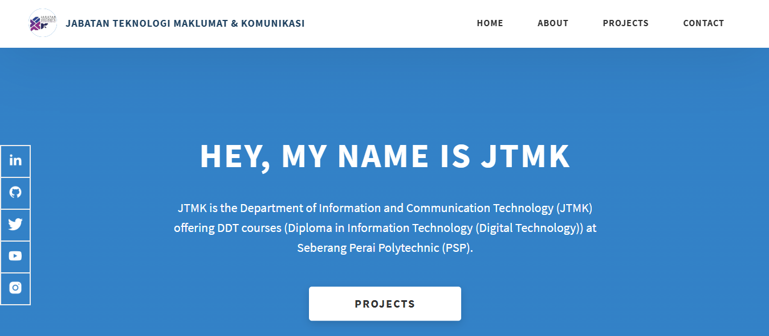
Rubric for Lan Task 5
 | Criteria | 4 | 3 | 2 | 1 | Score
1 | Design & Layout | Excellent, professional layout; fully responsive and visually appealing | Good layout; responsive design with minor flaws | Basic structure; limited responsiveness; lacks polish | Very poor layout; no clear structure; lacks responsiveness | 4
2 | Use of jQuery Mobile Components | Creative and full application of jQuery Mobile components with enhancements | Proper and consistent use of required components | Basic components used correctly, but inconsistent | Minimal or incorrect use of jQuery Mobile components | 4
3 | Navigation Bar | Fully functional, user-friendly navigation. | Functional with minor issues. | Basic structure, links may not work. | Missing or not functional. | 4
4 | Content Completeness (HOME, ABOUT, PROJECTS, CONTACT, Footer, Sidebar) | All sections complete, linked correctly, with rich and meaningful content | All sections present and properly linked with minor errors | Some sections missing or not properly linked | Major sections missing or incomplete | 4
5 | About Us Page Content | Complete, meaningful, professional content. | Complete but lacks some quality details. | Basic information included but incomplete. | Very incomplete or irrelevant. | 4
6 | Project Page Content | Complete, creative, well-documented projects. | Good project list with images/PDFs. | Few projects with basic info. | Very little or no project info. | 4
7 | Footer (Copyright & Alignment) | Footer perfectly formatted and centered. | Footer correct with minor formatting issues. | Footer present but not properly centered. | Footer missing or incorrectly formatted. | 4
8 | Padding and Margin (Navbar, Content, Footer) | Excellent and consistent padding/margin across pages. | Proper padding/margin but slight inconsistency. | Basic padding/margin but inconsistent. | No proper padding/margin settings. | 4
9 | Layout Application | Excellent layout, fully responsive and user-friendly. | Good layout, mostly responsive. | Basic layout, minor responsiveness. | Poor layout, not mobile responsive. | 4
10 | Direct Call, Email & WhatsApp Functions | All three functions correctly implemented. | Two functions work properly. | Only one function works. | None implemented. | 4
11 | CSS Application |  |  | Good CSS, improves layout. | Basic CSS, minimal styling. | 2
12 | Hosting (Project Files Hosted) |  |  | Properly hosted and fully functional project. | Files not hosted or broken hosting. | 2
13 | Use of CDN |  |  | Full and proper use of CDN links. | CDN used correctly but minor errors. | 2
14 | Report Submission (URL, Source Code, Screenshots) |  |  | Full report: URL, complete source code, and all responsive screenshots included properly | Report submitted but incomplete (missing screenshots/code) | 2
15 | Task Completion within Time Allocated |  |  | Completed on time, high-quality submission. | Late submission but acceptable quality. | 2
 |  |  |  |  | TOTAL MARKS | 50

