Punto 1.

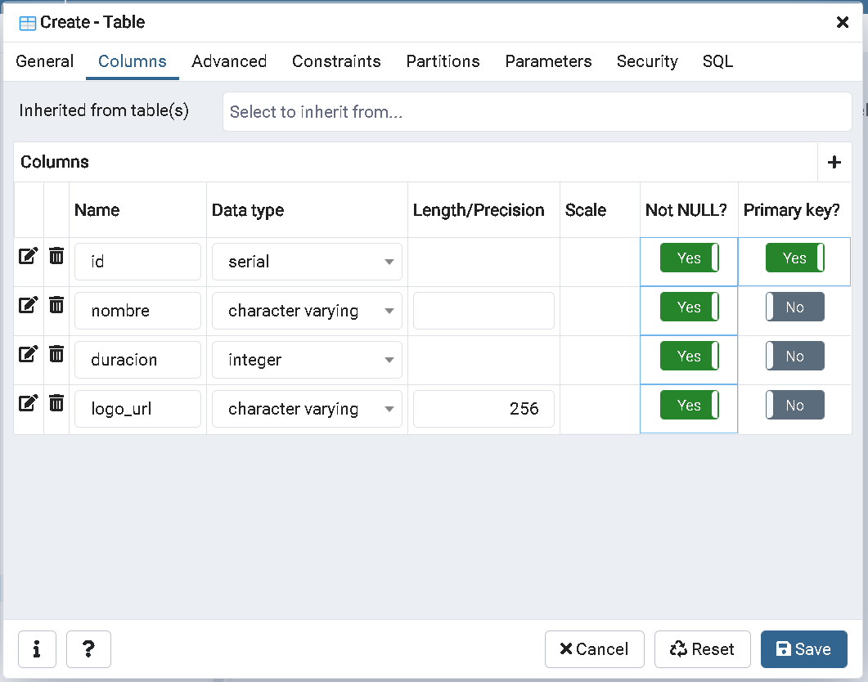

Punto 2.

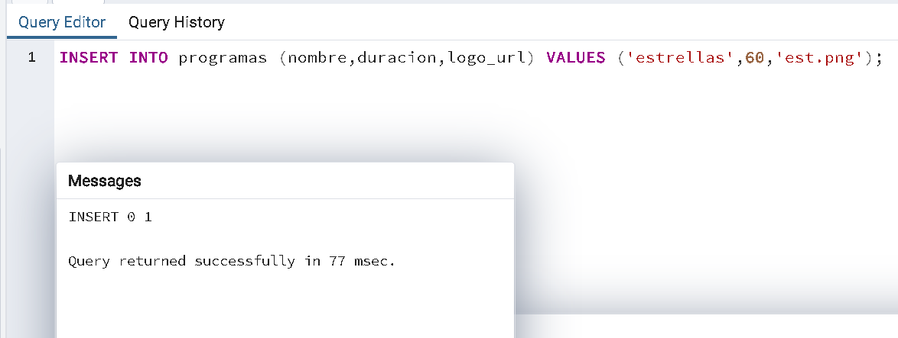

Punto 3.

C:\Program Files\PostgreSQL\13\bin>pg_dump.exe -U postgres -W -x -O -d supertv > dump_file_pg

Password:

C:\Program Files\PostgreSQL\13\bin>

C:\Program Files\PostgreSQL\13\bin>dir dump_file_pg

Volume in drive C is SOE

Volume Serial Number is BA32-D3D1

Directory of C:\Program Files\PostgreSQL\13\bin

05/17/2021 10:04 AM 1,929 dump_file_pg

1 File(s) 1,929 bytes

0 Dir(s) 55,135,043,584 bytes free

C:\Program Files\PostgreSQL\13\bin>

Punto 4.

C:\Program Files\PostgreSQL\13\bin>psql.exe -U postgres -W -h localhost

Password:

psql (13.2)

WARNING: Console code page (437) differs from Windows code page (1252)

8-bit characters might not work correctly. See psql reference

page "Notes for Windows users" for details.

Type "help" for help.

postgres=# CREATE DATABASE supertv_nueva;

CREATE DATABASE

postgres=# \l

List of databases

Name | Owner | Encoding | Collate | Ctype | Access privileges

---------------+----------+----------+----------------------------+----------------------------+-----------------------

postgres | postgres | UTF8 | English_United States.1252 | English_United States.1252 |

prueba | postgres | UTF8 | English_United States.1252 | English_United States.1252 |

supertv | postgres | UTF8 | English_United States.1252 | English_United States.1252 |

supertv_nueva | postgres | UTF8 | English_United States.1252 | English_United States.1252 |

template0 | postgres | UTF8 | English_United States.1252 | English_United States.1252 | =c/postgres +

| | | | | postgres=CTc/postgres

template1 | postgres | UTF8 | English_United States.1252 | English_United States.1252 | =c/postgres +

| | | | | postgres=CTc/postgres

(6 rows)

postgres=#

Punto 5.

C:\Program Files\PostgreSQL\13\bin>psql -U postgres -W -h localhost -d supertv_nueva < dump_file_pg

Password:

SET

SET

SET

SET

SET

set_config

------------

(1 row)

SET

SET

SET

SET

SET

SET

CREATE TABLE

CREATE SEQUENCE

ALTER SEQUENCE

ALTER TABLE

COPY 1

setval

--------

1

(1 row)

ALTER TABLE

C:\Program Files\PostgreSQL\13\bin>

Puntos de verificación:

1. Descripcion de table

C:\Program Files\PostgreSQL\13\bin>psql -U postgres -W -h localhost

Password:

psql (13.2)

WARNING: Console code page (437) differs from Windows code page (1252)

8-bit characters might not work correctly. See psql reference

page "Notes for Windows users" for details.

Type "help" for help.

postgres=#

supertv_nueva=# \d+ programas;

Table "public.programas"

Column | Type | Collation | Nullable | Default | Storage | Stats target | Description

----------+------------------------+-----------+----------+---------------------------------------+----------+--------------+-------------

id | integer | | not null | nextval('programas_id_seq'::regclass) | plain | |

nombre | character varying | | not null | | extended | |

duracion | integer | | not null | | plain | |

logo_url | character varying(256) | | not null | | extended | |

Indexes:

"programas_pkey" PRIMARY KEY, btree (id)

Access method: heap

supertv_nueva=#

1. Revisión de registros

supertv_nueva=# SELECT * FROM programas;

id | nombre | duracion | logo_url

----+-----------+----------+----------

1 | estrellas | 60 | est.png

(1 row)

supertv_nueva=#

1. Abrir contenido
2. SELECT