# Convert i18n json to excel

You need to prepare the json file and then call the excute method of JsonToExcelSplitKey

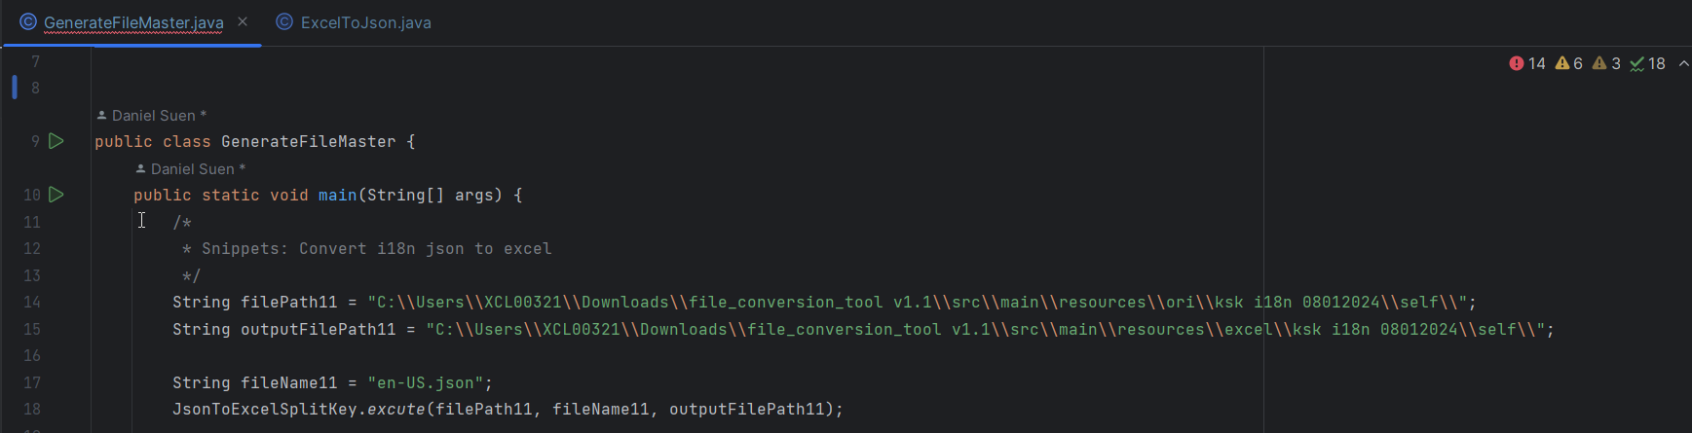

# Convert i18n js to excel

You need to prepare the js file and then call the excute method of JsToExcelSplitKey

importance:

1.If the keys in the js file contain single quotes, you need to remove the single quotes manually before executing the program

e.g.' er_name':'you hava' -> er_name:' you hava '

2. Give the colon where the first key is missing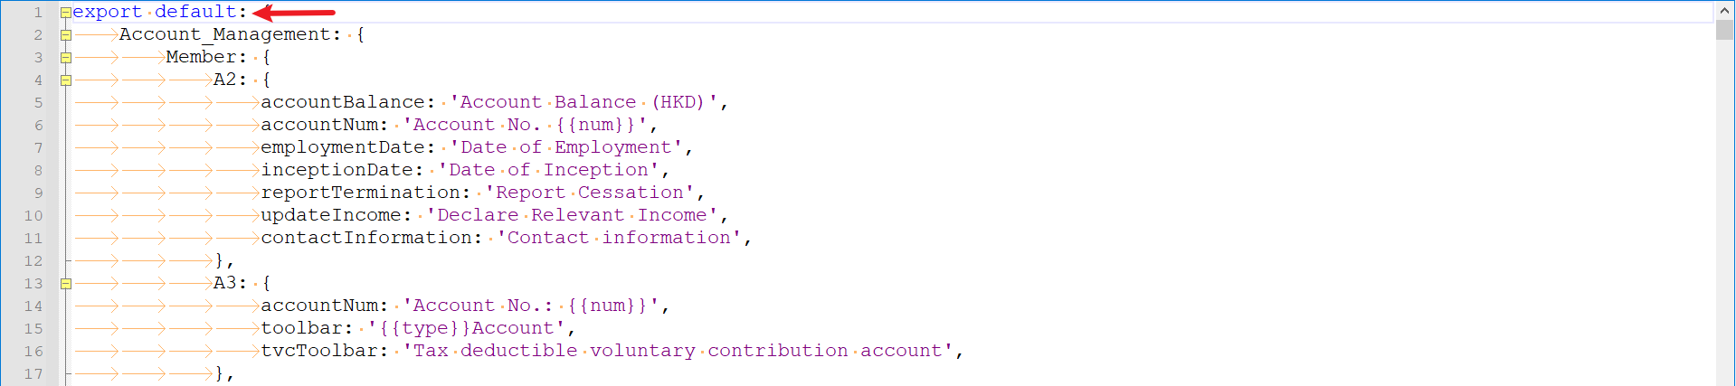

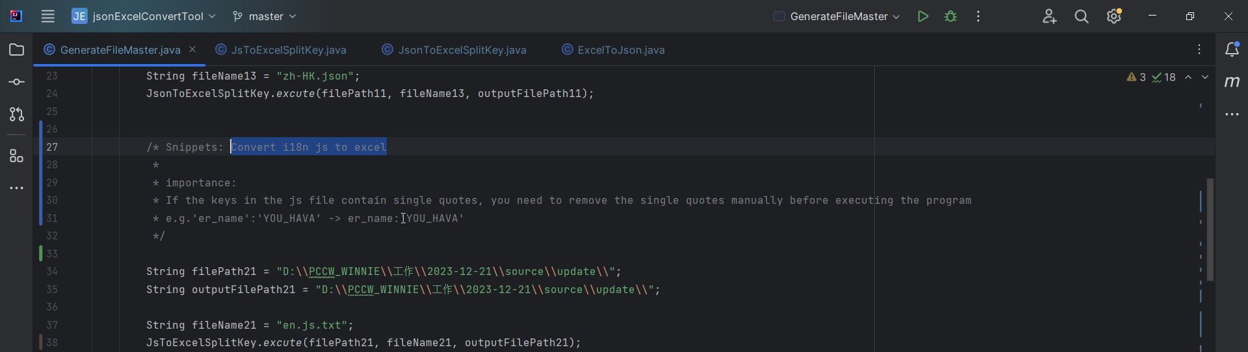

# Convert excel to i18n json

You need to prepare the excel file and then call the excute method of ExcelToJson.

(The format of excel is as follows: The first column is [lookupKey], and the second column is [value].)

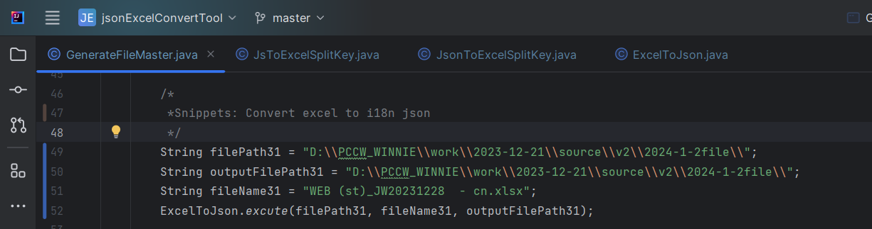

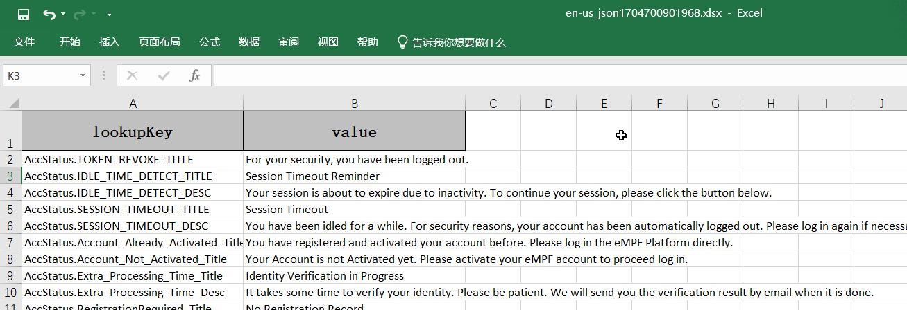

# Convert excel to i18n js

You need to prepare the excel file and then call the excute method of ExcelToJs.

(The format of excel is as follows: The first column is [lookupKey], and the second column is [value].)

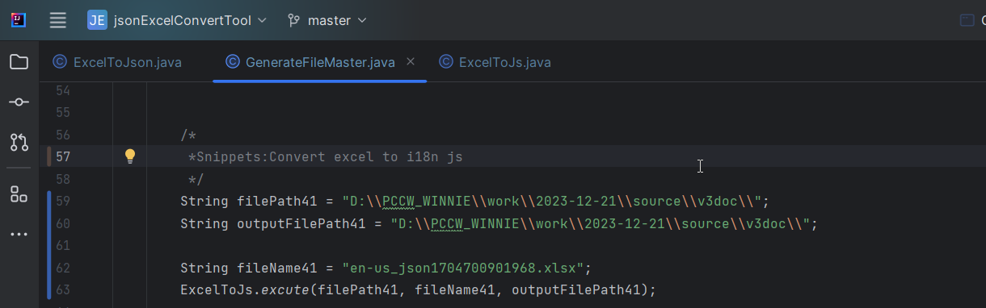



# Remark

At present, the program can achieve: the maximum level of js/json is 7 layers, if more than 7 layers please contact the developer.