Reasons for Error Correction

Background and Development of Shor Error Correction Code
The Shor error correction code was proposed by American physicist Peter Shor in 1995 [1], and it represents the first practical quantum error correction (QEC) scheme. The fundamental idea is to encode the logical information of a single qubit across multiple physical qubits, using redundancy to detect and correct common types of errors—most notably bit flip and phase flip errors.
This method successfully demonstrated the theoretical feasibility of fault-tolerant quantum computation and laid the foundation for subsequent developments in QEC. In 1996, Steane introduced a seven-qubit code [2], while Calderbank and Shor jointly proposed a generalized theoretical framework for quantum error correction [3]. Steane also expanded upon this framework with further theoretical advancements in the same year [4]. These foundational works have become the cornerstones of modern quantum error correction research.

Hardware Constraints and Platform Description
Due to current limitations in quantum hardware—such as the number of available qubits, connectivity architecture, and gate operation stability—the design of quantum error correction algorithms must carefully consider practical implementation constraints.

In this study, we selected the IBM Heron r1 quantum processor [9] as the experimental platform. The median error rate of its controlled-Z (CZ) gate operations is 0.004101. Since excessive gate operations can rapidly accumulate errors, it is essential to adopt strategies that balance implementation cost with correction effectiveness in order to enhance overall computational reliability.

Common Sources of Quantum Errors
According to relevant studies [5]–[8], the most common sources of errors in quantum computation include:
- Bit Flip Errors
A qubit flips from state |0⟩ to |1⟩ or vice versa due to external disturbances during the computation process.
- Phase Flip Errors
The phase information of a qubit is affected by environmental noise, leading to incorrect computational results.
- Gate Operation Errors
Errors arising from imperfect implementation of quantum gates or interference from the surrounding environment during gate execution.
- Qubit Crosstalk Errors
Unintended interactions between neighboring qubits cause the propagation of errors.
- Measurement Errors
Disturbances during the readout phase lead to inaccuracies in the measurement results.

Targeted Error Type in This Study
This study focuses specifically on bit flip errors for analysis and correction, based on the following considerations:
  - Bit-level information forms the core of quantum logical operations.
  - Phase flip errors can be addressed using similar correction strategies by changing the measurement basis.
The main objective of this study is to evaluate the computational capacity of existing quantum hardware under error-prone conditions, rather than optimizing hardware fidelity itself.

Experimental Design, Limitations, and Objectives
To evaluate the effectiveness of a randomized grouping strategy based on the Shor Error Correction Code (SRCC) in correcting bit flip errors, we implemented several experimental configurations using the IBM Heron r1 quantum processor.

The experimental limitations include the number of available qubits, the efficiency of mapping logical to physical qubits, the number of gate operations, and the accumulation of overall system error.

The objectives of this study are as follows:

- To analyze the impact of different randomized grouping strategies on the correction of bit flip errors;

- To assess the improvement in overall computational accuracy achieved through the proposed correction mechanisms;

- To explore the feasibility and potential of applying QEC strategies on physical quantum hardware platforms.

Related Encoding Techniques
- Repetition Code
In this approach, the state of a single logical qubit is encoded into three physical qubits. A majority-voting mechanism is then applied for error correction. The transformation of states is as follows:

Original qubit state:
∣ψ⟩ = α∣0⟩ + β∣1⟩

Encoded state:
∣ψ⟩ = α∣000⟩ + β∣111⟩

- Phase Code
Each physical qubit is further encoded into three additional qubits, resulting in a total of nine physical qubits per logical qubit. Every group of three qubits corresponds to one logical qubit.

Steane [2] proposed a seven-qubit encoding scheme in 1996, and Calderbank and Shor [3] introduced a generalized framework that significantly advanced the development of quantum error correction techniques.

Implementation and Analysis
This chapter provides a detailed description of the experimental methods and observations based on the Shor Error Correction Code. The overall experimental design follows a step-by-step optimization strategy, where each method is developed as an improvement upon the findings of the previous phase. The effectiveness of each approach is verified through both simulation and real-device testing.

Experimental Platform and Parameter Settings
All simulation experiments in this study were conducted using the IBM Qiskit environment. In addition, partial real-device testing was performed on two superconducting quantum processors: IBM Heron r1 and IBM Brisbane.

The IBM Heron r1 processor has a median controlled-Z (CZ) gate error rate of 0.004101. The Brisbane system provides access to 27 qubits, making it suitable for scaling experiments involving larger quantum circuits and multi-qubit configurations.
The simulation parameters are summarized as follows:
- Error model: Bit flip error
- Error rate settings: 0.002 and 0.007
- Gate operation range: Up to 500 controlled-NOT (CNOT) gates

Three-Bit Repetition Code
First, according to the Shor Repetition Code (SRCC), each logical qubit is encoded by repeating its state across three physical qubits. Ideally, all three qubits should maintain identical values. However, due to errors that may occur during operations, inconsistencies can arise among the three qubits. The three-bit repetition code corrects these errors by applying a majority-vote mechanism: the three qubits are processed as inputs to a full adder circuit, and the carry-out bit is used to determine the corrected logical value.

Grouping Error Correction in Circle(shown as Fig.1)
To accommodate the qubit connectivity constraints of the IBM quantum processor, we implemented Shor’s error correction code using a circular grouping structure. As illustrated in Fig. 1, six qubits are arranged in a ring, and error correction is performed by cyclically grouping the qubits into overlapping triplets. Specifically, the groups are formed as qubits [0,1,2], [1,2,3], [2,3,4], and so on, with each group applying the three-bit repetition code for correction.
It should be noted that this circular arrangement is not limited to six qubits; subsequent experiments in this study extend the ring to configurations of up to 20 qubits.
However, the initial results using the six-qubit ring were suboptimal. As shown in Fig. 2, after 100 controlled-NOT (CNOT) gate operations, the correction accuracy drops significantly—falling below 0.6—even under relatively low error rates.
We hypothesize that this degradation is caused by the accumulation of consecutive bit errors. When the intended target state is all-zero, encountering two or more erroneous '1' bits in succession can trigger an infinite error loop. In such cases, repeated application of the correction will fail to restore the correct state, regardless of how many iterations are performed. This type of error pattern is especially prone to occur in circuits dominated by CNOT gates or other two-qubit operations.
To mitigate this infinite loop problem, we propose that the sampling sequence must be randomized or disrupted. The following subsections (C and D) present experimental designs to validate this hypothesis.

Sampling According to Offset: [-2,0,1]
As an initial step, we aimed to determine the optimal sampling configuration using a simulator. Through experimentation, we found that applying a sampling offset of [-2, 0, 1] yielded the best error correction performance. (In this context, the offset [-2, 0, 1] refers to the relative index differences modulo six, where positive and negative signs indicate clockwise and counterclockwise shifts, respectively.)
For example, based on the six-qubit ring shown in Fig. 1, the optimal grouping would be qubits [4, 0, 1]. The corresponding results are presented in Fig. 3.
These results demonstrate that the Shor Repetition Code (SRCC), when combined with an optimized circular sampling structure, can achieve effective error correction at an error rate below 0.002 when the optimal index is used.
However, implementing this approach on a real quantum device remains challenging, as it is impractical to pre-determine the optimal index configuration in an actual hardware environment.
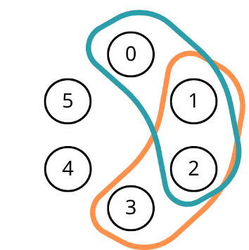
- 6 bits grouping error correction in circle

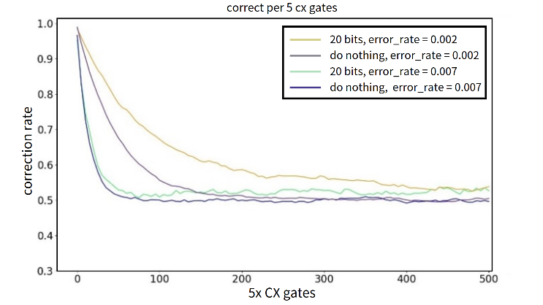
- Results of 6-Bit Grouping Error Correction in Circle. Consider the error rate equal to 0.007 and 0,002 in without error correction (dark blue and green) and SRCC error correction (purple and yellow).
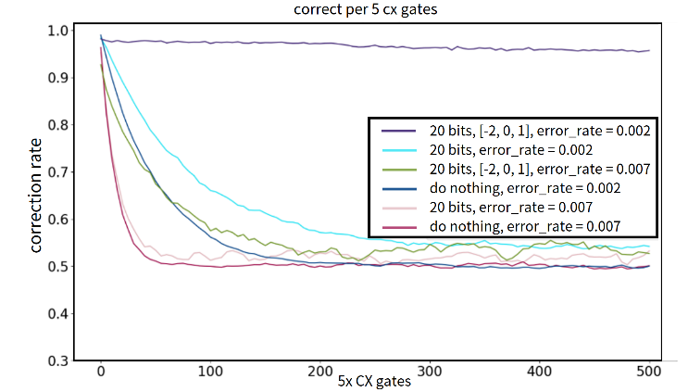
- Results of Sampling according to offset: [-2,0,1]

Delayed Write-Back Strategy
On the other hand, even when the optimal sampling offset is applied and the corrected results are immediately written back to all qubits, errors may persist. It can be observed that the more frequently the qubit states are updated, the more likely errors are to accumulate. For instance, in a worst-case scenario, the state sequence may evolve as follows:
100001 → 110001 → 111001 → …, progressively deviating from the intended state.

This issue arises when the result of the first group’s three-bit repetition code correction is inaccurate. Once the erroneous result is written back (e.g., to qubit 0), it becomes part of the input for the next group’s correction (e.g., [0,1,2]), thereby propagating the error through subsequent operations.

To mitigate this, we propose a delayed write-back strategy, in which each group’s correction result is temporarily stored in a separate set of auxiliary qubits. These auxiliary qubits correspond to the same indices as the original six qubits. Once all groups have completed their correction cycles, the final results are collectively written back to the original qubits.

This method helps isolate each correction cycle, preventing unintended interference between groups. As shown in Fig. 4, this strategy significantly improves the correction accuracy compared to previous methods.

Even under a relatively high error rate of 0.007, the proposed method maintains an accuracy rate above 0.8 after 500 controlled-NOT gate operations. Notably, a temporary accuracy dip is observed around the 100th operation. This is due to the intentional injection of a large disturbance—20 times the regular CNOT gate error rate—at that point. Despite this, the system rapidly recovers, demonstrating the resilience and effectiveness of our correction method.

Despite this, the system rapidly recovers, demonstrating the resilience and effectiveness of our correction method.
However, it is worth noting that when the error rate increases beyond a certain threshold, the overall correction performance declines significantly. This highlights the practical limits of our method and the importance of controlling gate-level error rates in real quantum hardware.

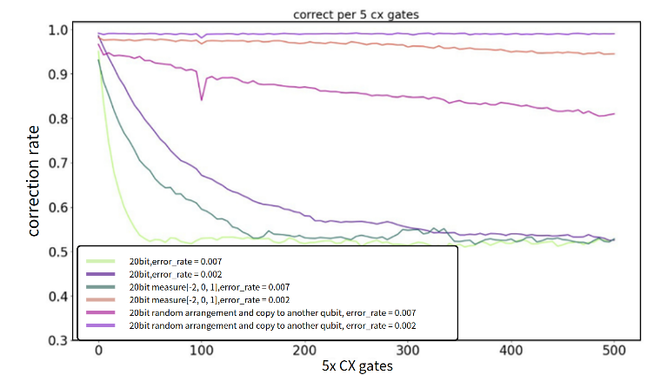
- The results of “write back after all bits are finished”. It is obviously that the correct rate is enhacend. It is should be mention that we give a huge error in 100th controlled-not gates operations in the system. In our method the correct rate will be recovered.

Random Shuffling Strategy
Building on the previous observations, we hypothesize that introducing randomness into the qubit grouping process could further enhance error correction performance. Specifically, if the indices of the qubits to be corrected are randomly shuffled, the likelihood of encountering persistent error propagation patterns may be significantly reduced.

Although random shuffling is currently not feasible in real quantum hardware due to physical layout constraints, we tested this strategy in a simulated environment to evaluate its potential benefits. The results indicate that randomized grouping can indeed improve the robustness of error correction.
To illustrate the process, we use the IBM Brisbane quantum processor as a testbed, with the following setup:

- Initial correction phase
The qubits marked in orange represent the data qubits requiring correction, while the red-marked qubits serve as additional storage for the correction results. For instance, qubits 40, 41, and 42—physically adjacent—are selected as the first group. After applying the majority-vote mechanism (e.g., through a full adder), the corrected result is stored in qubit 60. Similarly, qubits 44, 45, and 46 are grouped and corrected, with the result stored in qubit 64 (as shown in Fig. 5).

- Shuffling and repeated correction
Once the initial correction results are stored (e.g., in qubits 53 and 54), a pairwise exchange of data qubit positions is performed, disrupting the original qubit sequence. The swap pattern follows the scheme illustrated in the blue box in Fig. 6, and the updated positions are reflected in the orange frame in Fig. 6. After this permutation, a new group, e.g., qubits 40, 41, and 42 in their shuffled locations—is selected again for correction, and the process is repeated.

Each correction result is written into a new auxiliary storage qubit until all data has been processed. This shuffling-disruption mechanism is executed iteratively, progressively reducing correlated errors across the system.

The final results (see Fig. 7) confirm that even when scaling up to 21 or 30 qubits, the random shuffling strategy maintains high accuracy—above 95%—under an error rate of 0.002. This demonstrates the strategy’s potential in large-scale quantum circuits and motivates future hardware designs that may enable dynamic qubit reconfiguration.
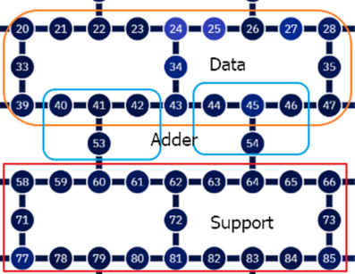
- Step1
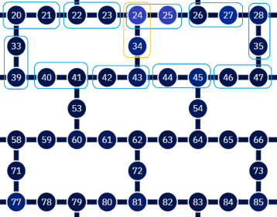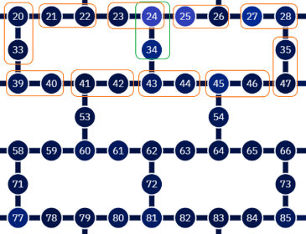
- Step2

Fig.7 shows the results of our work.
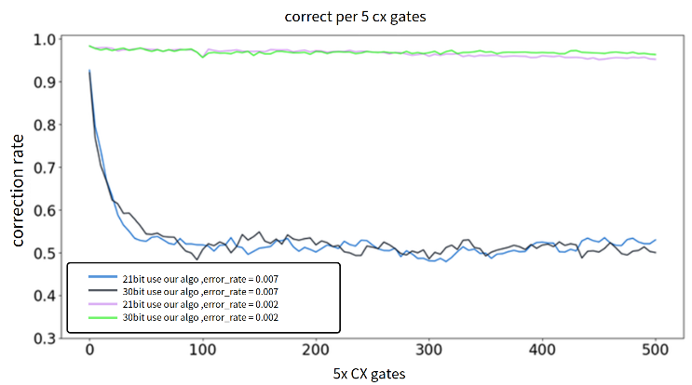
- The results of our algorithm. We can see that even more than 20 bits such as 21 bits and 30 bits can have a good effect when the error rate is 0.002

