The Importance of Randomness to Quantum Error Correction Algorithms and Quantum Error Correction Algorithms Applicable to IBM Quantum Computer

(Feb 2025)
Daniel Tseng^{1,2}, Ting Hsuan Chiang^{1,2}, Tsung-Wei Huang^{2,3}
1. Department of Information and Computer Engineering, Chung Yuan Christian University
2. Department of Intelligent Computing and Big Data, Chung Yuan Christian University
3. Chung Yuan Christian Quantum Information Center
sherrychiang01@gmail.com
Abstract—Until now there is no perfect quantum computer system, and the qubits are always with errors. As a result, error correction becomes extremely challenging, requiring fundamentally different approaches than traditional methods.In our study, we use a simulator to implement Shor’s error correction code (SRCC) and develop Shor’s error correction code with random method (SRCC-R) on bit flip errors problem. We consider the IBM quantum computer system with the error rate 0.007 and 0.002. In our result shows that using SRCC the flip errors can correct less than 25 controlled-not gates with 0.97 correct rate. In our method, SRCC-R the flip errors can correct larger than 500 controlled-not gates with 0.95 correct rate.

Index Terms—Bit Flip error, error rate, three-bit repetition, quantum error correction cord, qubit grid.

Shor's Error Correction Code
S
hor's Error Correction Code is a type of quantum error correction code, which was proposed by American physicist Peter Shor in 1995[1].
Shor error correction code is one of the basic technologies in the field of quantum computing. It distributes the information of one qubit to multiple quantum qubits and uses redundancy to detect and correct common errors in the quantum computing process. Based on this algorithm, the conception of this article was formed. However, it should be mention that in 1996, a general code in 7 qubits code was discovered by Steane [2]. Also the general theory of quantum error correction was shown on papers of Calderbank and Shor [3] and Steane [4].

Reasons for Error Correction
Quantum errors comes from the hardware, including prepare initial state[5], coherence time[6], gate operation error[7], measure errors[8] and so on. There are many kinds of quantum errors. In this study, we focus on the Bit Flip error. There are several reasons. First, the information of bits is the most important calculation information. Second, although the information of phase is also important in quantum computation, it is to use the same error-correction method to correct the information of phase by changing the measure basis. Third we want to find out the ability of the quantum computer with error, so we don’t consider the view of the hardware to decrease the error of enhance the fidelity in the specify quantum computer.

The Arrangement of the Quantum Computer Qubit Grid
The quantum error correction algorithm must not only consider accuracy after error correction, but the two-qubit gate used for error correction must also conform to the arrangement of the quantum computer qubit grid. Therefore, it is necessary to consider the structure of hardware. We chose IBM Heron r1 processor, shown as Fig.1 and developed the quantum error correction cord to correspond to the arrangement of qubits in the system.
CZ-gate is mainly used by this quantum processor. The median error rate is 0.004101. Since quantum errors are not only bit-flip errors, but also phase errors, this error rate of 0.004101 will be too large to get the correct answer after more than a dozen of times of operation.

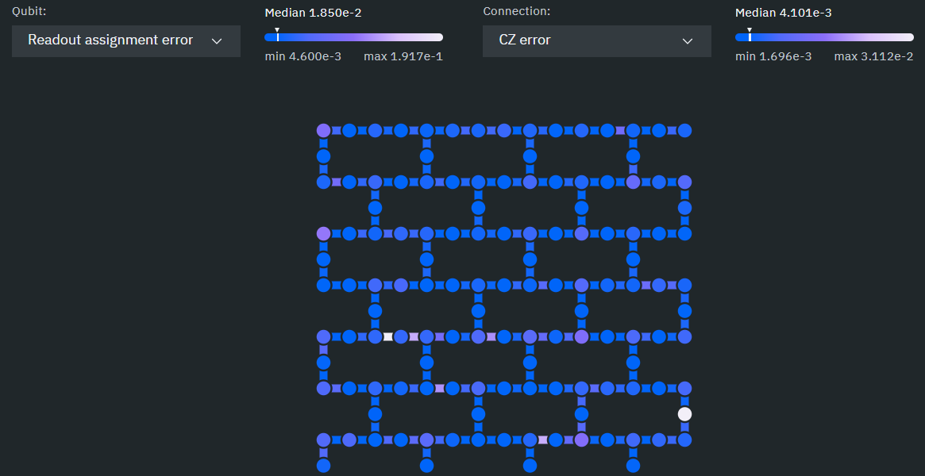
- The arragement of the qubits and the current error rate map of IBM Heron r1 processor

Implementation and Analysis

Three-Bit Repetition Code
First, according to SRCC, repeating a qubit operation three times should result in three identical results. However, errors may occur during the operation, causing the three qubits to be different. The three-bit repetition code is to uniformly correct these three qubits to the majority answer, which means putting these three qubits into the full adder and taking the carry bit. Grouping Error Correction in Circle (shown as Fig.2) Figure 2 demonstrates how six bits are formed into a ring and grouped for error correction. However, it does not necessarily be 6 bits to form a ring, so subsequent experiments will be conducted on 20 bits. the correct rate is almost down below to 0.6 after 100 times of controlled-not gate operations even in lower error rate, shown as Fig.3. We assume that it is caused by consecutive bit errors. That is, if there are continuous errors, there will be no way to correct them. To break the infinite loop, it is necessary to shuffle the sampling sequence. To test this hypothesis, we designed the section below.

Sampling According to Offset: [-2,0,1]
After experiments, we found that sampling according to offset: [-2,0,1] has the best error correction effect (Note that [-2,0,1] here is defined as the remainder difference of three indices divided by six). The results are shown in Figure 4. We can see that the SRCC is useful in circle structure when the error rate is below 0.002 and in the best index.
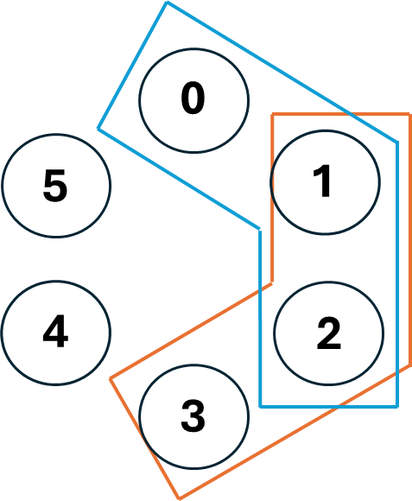
- 6 bits grouping error correction in circle
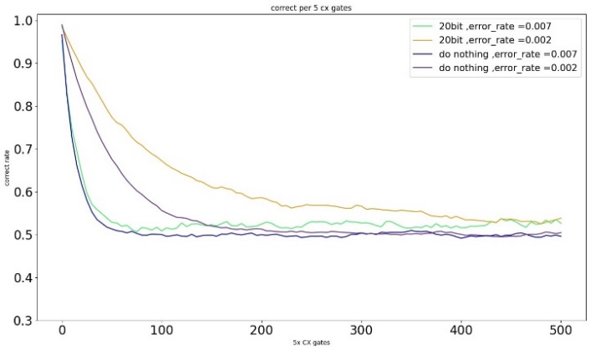
- Results of 6-Bit Grouping Error Correction in Circle. Consider the error rate equal to 0.007 and 0,002 in without error correction (dark blue and green) and SRCC error correction (purple and yellow).
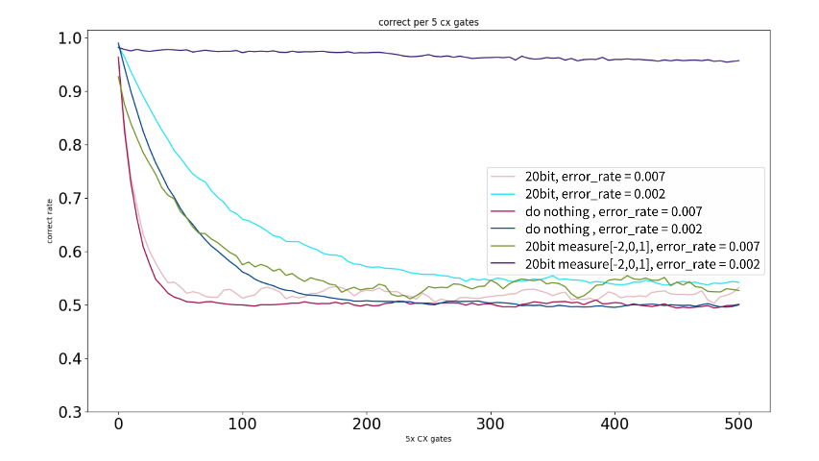
- Results of Sampling according to offset: [-2,0,1]

Conclusion
Although none of the methods we proposed can maintain consistent accuracy at an error rate of 0.007, if we optimistically use the error rate of IBM's latest quantum computer (0.002) for experiments, our method can indeed maintain a certain accuracy. Our error correction method could maintain a certain level of accuracy on IBM's quantum computer. We also understand the importance of random permutation for all error correction algorithms.

References
- Shor P. W., Phys. Rev. A, 52 (1995) R2493-R2496
- Steane A. M., Phys. Rev. Lett., 77 (1996) 793-767.
- Calderbank A. R. and Shor P. W., Phys. Rev. A, 54 (1996) 1098-1105
- Steane A. M., Proc. Roy. Soc. Lond. A, 452 (1996) 2551-2577.
- H. Kim, Noise-resilient preparation of quantum many-body ground states, arXiv:1703.00032 (2017).
- Aaron Somoroff, Quentin Ficheux, Raymond A. Mencia, Haonan Xiong, Roman Kuzmin, and Vladimir E. Manucharyan, Phys. Rev. Lett. 130, 267001
- D. Willsch, M. Nocon, F. Jin, H. De Raedt, and K. Michielsen, Phys. Rev. A 96. 062306
- Lena Funcke, Tobias Hartung, Karl Jansen, Stefan Kühn, Paolo Stornati, and Xiaoyang Wang, Phys. Rev. A 105, 062404

