Name: Daniel Holguin Delgado
CSE 212 Data Structure “Cheat Sheet”

Note: This document should contain your own work. It is a violation of the BYU-Idaho honor code to share this document or copy in whole or in part from another.

Data Structure | Graphic | Purpose and Example | Time Complexity of Common Operations
 |  |  | Insert | Access
Dynamic Array | Boxes in a row [ ] [ ] [ ] connected side by side, showing growth when full.  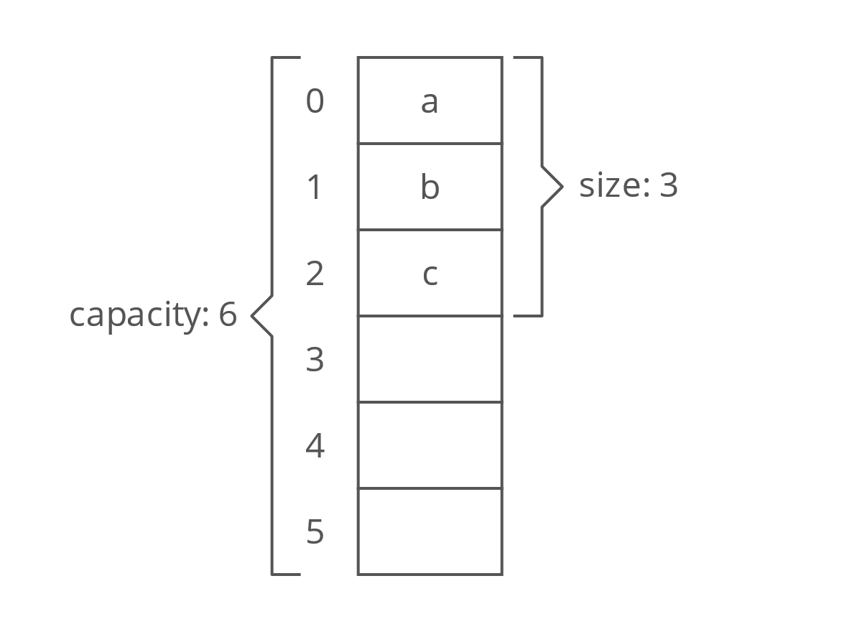 | A dynamic array stores items in order and can grow when needed. It is good when you want fast access by position (index).  Example: A list of usernames in a game lobby where you often add new users to the end and look them up by number. | At the beginning: O(n)  At the end: O(1)* | Find by value: O(n)  Find by index: O(1)
Linked List (Doubly-linked) | Circles for nodes connected by arrows in both directions <-><->.  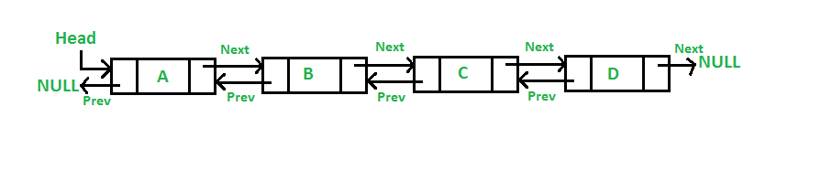 | linked list stores items where each one links to the next and previous. It’s good when you need to add or remove items in the middle quickly, without shifting all others.  Example: A playlist where you move songs up or down easily. | At the beginning: O(1)  At the end: O(1) | Find by value: O(n)  Find by index: O(n)
Stack | A pile of plates with arrows showing "push" on top and "pop" from top.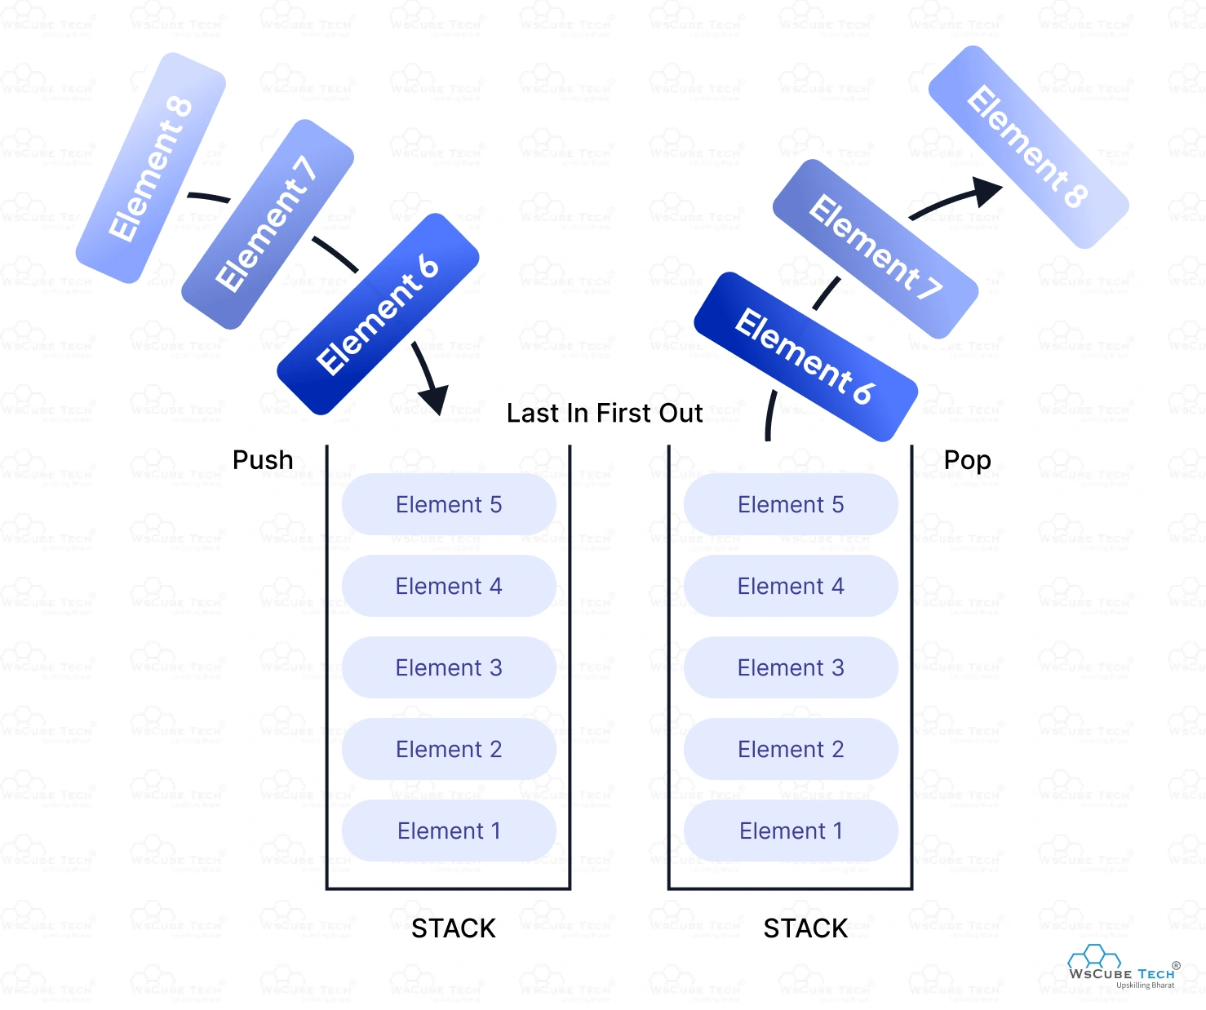 | A stack is “last in, first out” (LIFO). You only work with the top item.  Example: Undo feature in a text editor, where the last change is undone first. | Push: O(1)  Pop: O(1) | The top: O(1)
Queue | A line of people with arrows showing "enqueue" at back and "dequeue" at front.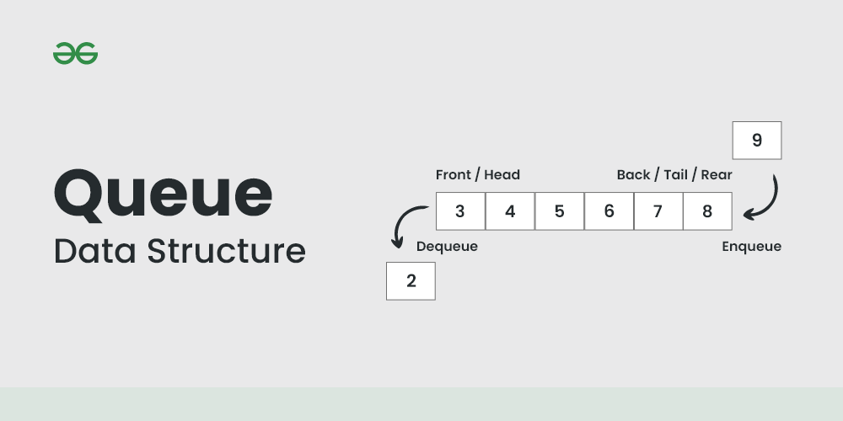 | A queue is “first in, first out” (FIFO). You add at the back and take from the front.  Example: Print jobs sent to a printer are handled in order received. | Enqueue: O(1)  Dequeue: O(1) | The front: O(1)
Map | Key-value pairs stored in buckets.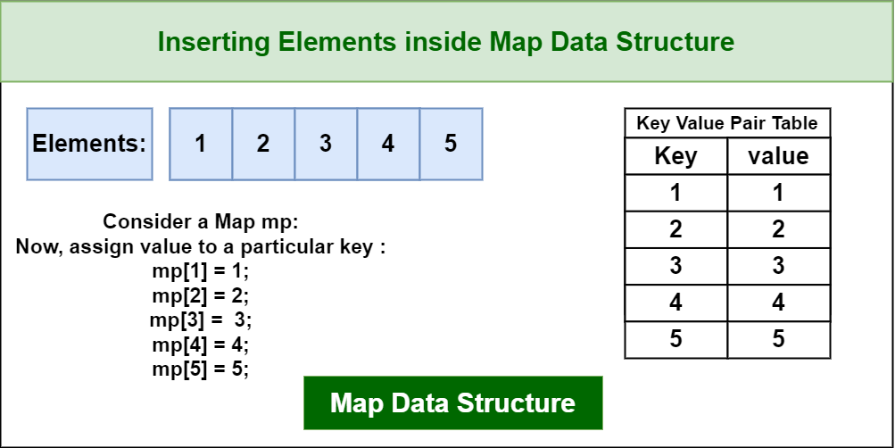 | A map stores data by keys, not positions. You can look up items quickly by their unique key.  Example: Storing phone numbers with names as keys. | O(1) | By key: O(1)
Balanced BST | A tree diagram with each left child smaller, each right child bigger, and height kept balanced. 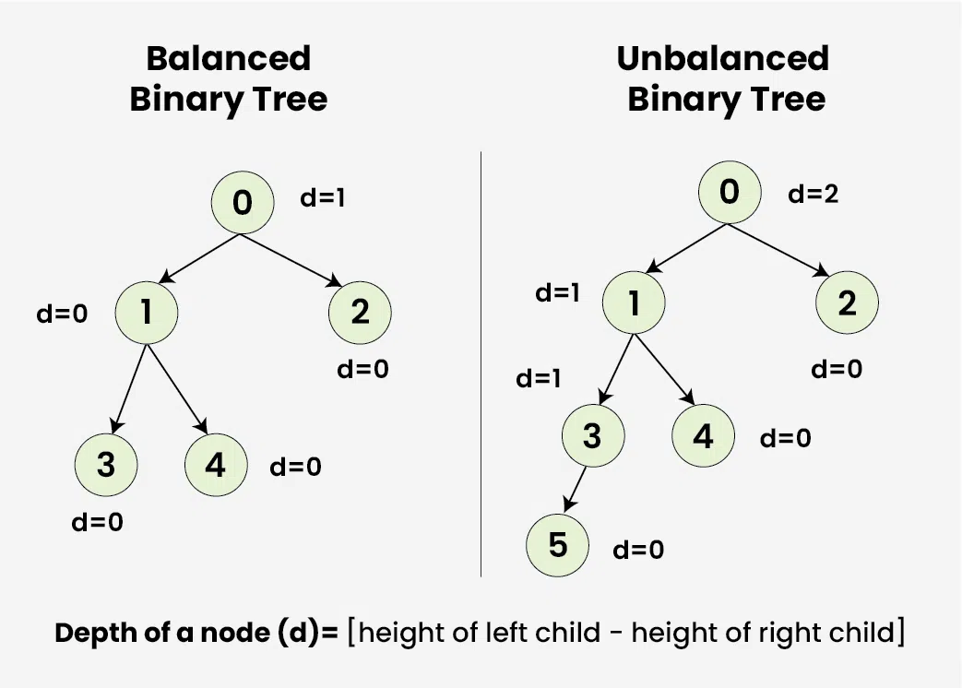 | A balanced BST keeps items in order and allows fast searching, inserting, and deleting.  Example: A database index for movie titles, where you want quick lookup and automatic sorting. | O(log n) | Search: O(log n)

