Video streaming

General information

The AR system is built from three main parts: camera, PC, and phone. These three components communicate between them and transfer data. This data is video streaming.

Implementation

First, we need to capture a frame from the camera as eyes work. Our camera is a stereo camera that works in high resolution and fps. To support the advanced camera, we had to use GPU to receive the camera’s data. We connected the camera to Jetson Xavier by Nvidia with a USB peripheral. A wired network cable connected the Jetson to the PC.

One of the most video compression standards is Advanced Video Coding (AVC), also referred to as H.264. This standard is based on block-oriented, motion-compensated coding. Some main components improve the compression as DCT (As we learned in class), motion compensation, intra prediction (neighborhood prediction, and CABAC.

We implemented a pipeline using the Gstreamer framework to send the compressed camera frames in efficiency compression over UDP protocol to ensure that we will have the lowest latency. The PC received the stream in OpenCV with the Gstreamer plugin, and then we implemented the AR algorithm.

The last part is streaming the content to the phone. We created an Android app with a Gstreamer framework to receive streams from the PC to the phone wireless in UDP protocol.

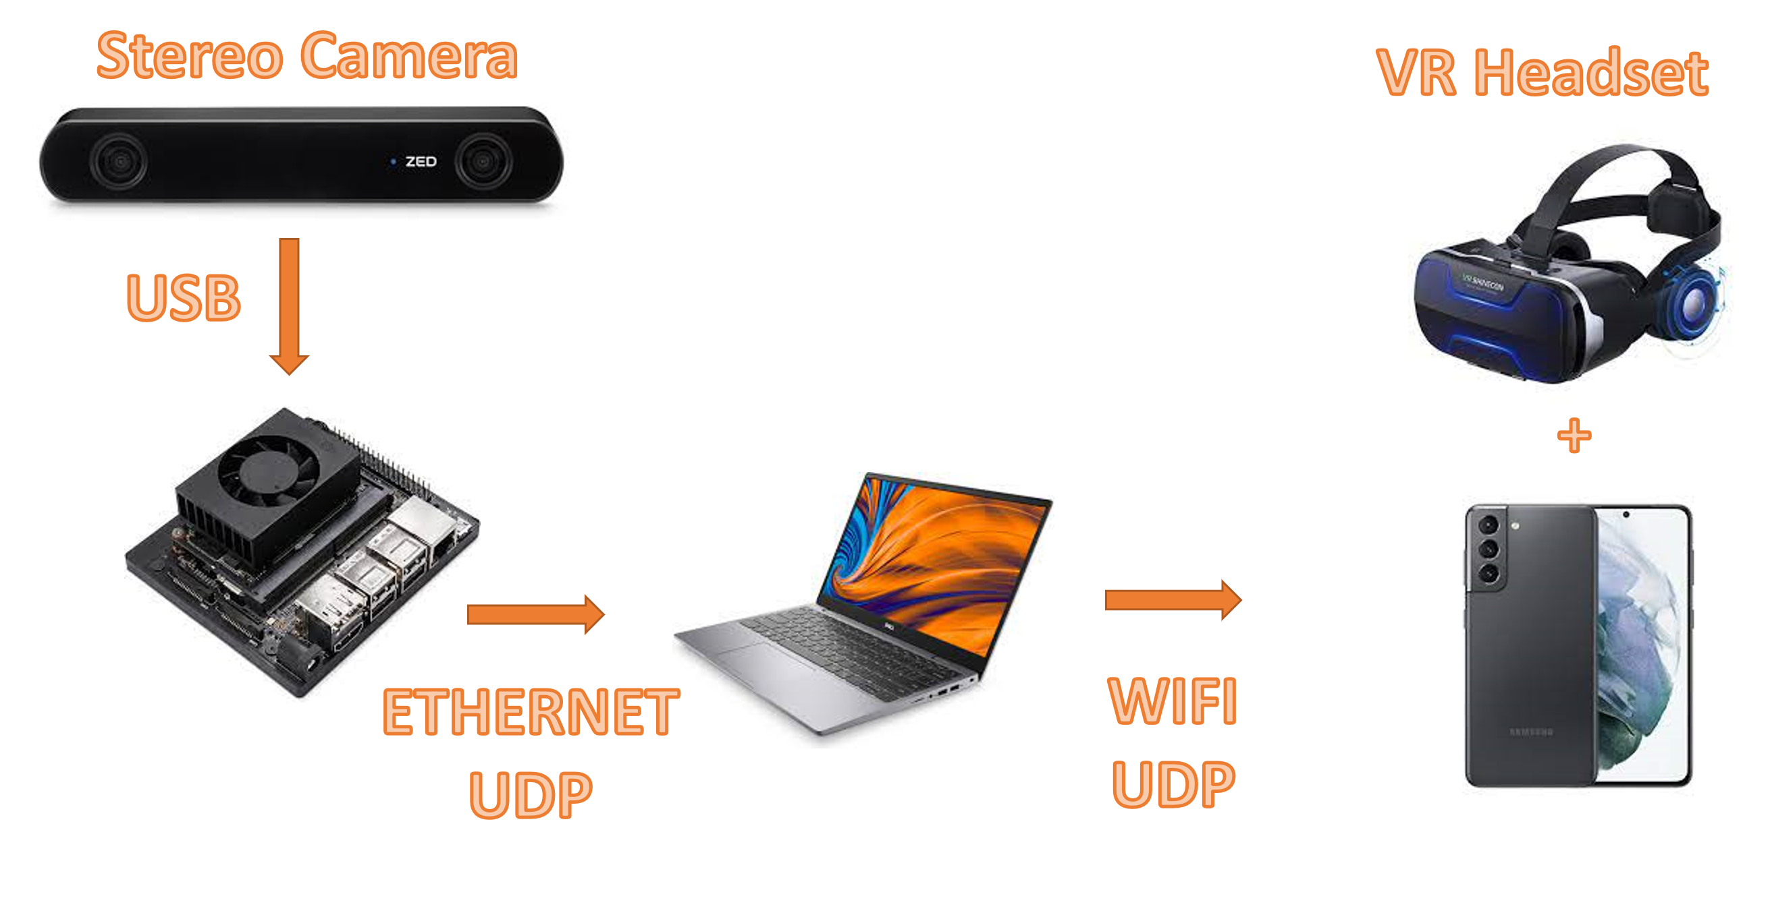

Assumptions and limitations

The problem with H.264 coding is that if the processing time of each frame is too big, the video preview starts to pixelized. To overcome that problem, we had to capture a new frame only when the last frame was processed. That way, we managed to keep low latency and good image resolution but a low frame rate that can interfere with the user experience.

Another limitation is the network bandwidth. While the PC was connected to the GPU wired, the phone was connected with wifi. If the network bandwidth was low, we miss UDP packets, resulting in many bad phone pixels.

Results

[Reshaped image with GUI offset and table content]

# <https://en.wikipedia.org/wiki/Advanced_Video_Coding>