 | Department of Computer Science and Engineering  The Chinese University of Hong Kong
Automatic bibliography field recognition and format conversion

Term 2 2013/14
Final Year Project Report

Project Code: | KY1301
Supervisor: | Professor YIP Yuk Lap Kevin
Students: | Wong Chong Wai (1155000258)
 | Wong Yik Pan (1155000261)

Abstract

Table of contents
1. Introduction 5
1.1 Background 5
1.2 Motivation 9
1.3 Summary of Term 1 2013/14 10
1.4 Project Plan for Term 2 2013/14 13
2. User Specifications 14
2.1 Functional Specifications 14
2.2 Non-functional Specifications 15
3. Design 16
3.1 Programming Languages 16
3.1.1 Java 16
3.1.2 SQL 16
3.2 Development Tools 17
3.2.1 SourceTree 17
3.2.2 Apache Tomcat 18
3.3 Database 19
3.3.1 Meaning of tables 19
3.3.2 Source of data 20
3.3.3 Data dictionary 21
4. Implementation 23
4.1 Approaches 23
4.1.1 Break down the publication entry 23
4.1.2 Regular expression 23
4.1.3 Database 23
4.1.4 Machine learning 23
4.1.5 Web interface 23
4.2 Flow Chart 25
4.3 Running Time 26
4.3 Difficulties and Limitation 27
5. Testing 28
5.1 White-box Testing 28
5.2 Black-box Testing 29
5.3 Load Testing 30
6. Documentation 31
6.1 Javadoc 31
6.2 User Manual 31
7. Conclusion 32
8. Individual Contributions 33
8.1 Division of labor 33
8.2 Reflection (Individual) 35
9. Acknowledgment 36
10. Reference 37
11. Appendix 41
11.1 Progress Schedule 41
11.2 Progress Detail Record 41

1. Introduction

1.1 Background
Research outputs are often formally summarized and published in journal articles or conference proceedings. Many researchers usually have web pages listing all their publications. These publication items usually consist of a few compulsory fields, such as authors and titles, and some optional fields, such as publish date and link to the journal.

Most of these publication lists are made with simple HTML code and their formats vary among the researchers. We found that even within our department, different professors or lecturers adapt different ways to list out their publications. Some even have different formats within one’s own publications page.

For example, below is one of the publications from one of the Assistant Professor in our department, Prof. CHENG James.
James Cheng, Zechao Shang, Hong Cheng, Haixun Wang, and Jeffrey Xu Yu.
KReach: Who is In Your Small World.
In PVLDB, Volume 5, Number 11, Pages 1292-1303, 2012.
This is a very standard publication entry with all the fields can be clearly identified. He uses commas and line separators to separate different fields. However, there are many entries which have different style.

Here is another entry from Prof. Heng Pheng-Ann. The difference from the previous example is that, the author names are abbreviated and the order swapped between authors and journal title. Also, he used double-quotes around the title. These two examples are both separated into multiple lines and use both commas and line separators to identify different fields.
"Binocular Tone Mapping,"
X. Yang, L. Zhang, T. T. Wong and P. A. Heng
ACM Transactions on Graphics (SIGGRAPH 2012 issue), Vol. 31, No. 4, 93:1 - 10.

Here is another entry from Prof. LEE Ho Man Jimmy. In this entry, the last part of the entry contains a few numbers. This may not be understood as clear as in the previous 2 examples since there is no keyword indicating what those numbers means. This one puts all the fields on the same line and uses comma to separate fields.
Y.C. Law, J.H.M. Lee, and M.H.C. Woo. Redundant Modeling in Permutation Weighted Constraint Satisfaction Problems, CONSTRAINTS, 15(3):354-403, 2010

This example is from Prof. LEE Ching-chyi from Department of Decision Sciences and Managerial Economics (Faculty of Business). He alternated the order of the fields by putting the year right after author names. Besides, he uses both short form and full form for the fields “Vol.” (volume) and “Number”.
Kabiraj, Tarun, Lee, Ching-chyi, 2011, Licensing Contracts in Hotelling Structure . Theoretical Economics Letters, Vol. 1, Number 3, pp. 57-62

This is by Prof. Gordon MATHEWS from the Department of Anthropology (Faculty of Arts). On first sight, we can see that he lists the year right at the beginning of the entry. Also, at the last part of the entry, the journal name is placed along with some numbers, which we believe that they are volume, issue and page numbers. This one used full stops and empty space to separate fields.
2012 Gordon Mathews and Yang Yang. "How Africans Pursue Low-end Globalization in Hong Kong and Mainland China." Journal of Current Chinese Affairs 41 (2): 95-120.

This example is by Shu Annie Tse Mei from the Department of Psychology (Faculty of Social Science). She used brackets for the year and placed it between author names and article title. Besides, in each author names, she takes the initials of the first names and added a hyphen between the initials. There is also a number “43” which is ambiguous that whether it is a volume number or an issue number.
Tam, K.-P., Shu, T.-M., Ng, H. K.-S., & Tong, Y.-Y. (2013). Belief about immutability of moral character and punitiveness toward criminal offenders. Journal of Applied Social Psychology, 43, 603-611.

As seen from the above examples, format of publication entries varies even within CUHK, not to mention within HK or even among countries.

1.2 Motivation
Although there are many management software in the market to help users make and organize their publication entries, the file formats and citation styles of these software varies. Moreover, some of the software is free while some others charge users on a monthly or yearly basis. It may take some time for users to find suitable software for themselves.

When we first looked at the project, we have been wondering that would it be nice if there is a software or tool which can take whatever you type in and produce the publication list in a format the user specified. Therefore, our goal of this project is that a user can simply type in all the things he or she needs into a plain text file. No matter what order within a single entry, all the user need to do is type in the details and use our system to “translate” the plain text files into some format which the user wants.

As most researchers have their own personal webpage, we are certain that most of our user would like to use software that can automatically generate publication list in HTML format that can easily be included in their pages. Besides, our system should also be easy to use. Therefore, our group wants to create a system that can offer such kind of “translation”.

1.3 Summary of Term 1 2013/14
(1) Idea come up – Create a system that can automatically separate free-text publication entries into different fields, and provide a web interface for user (if applicable), export to different file format (eg. BibTeX, xls).
(2) Marketing research – Two existing system, RefWorks and EndNote, allow user to organize the publication entries in a systematic way. But not support for uploading publication entries in free-text format.
(3) Sample data collection & processing – Collected 100 publication entries from CUHK’s and CITYU’s professor web pages in August 2013. And manually separated into different publication fields.
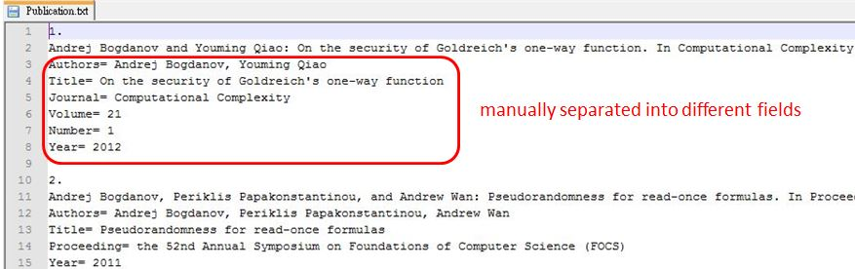
(4) BibTeX – One standard format for publication entry. We knowing that for different entry types, BibTeX will have different required and optional fields. For example, the type “article” has “Journal” in required fields, but the type of “book” doesn’t have.
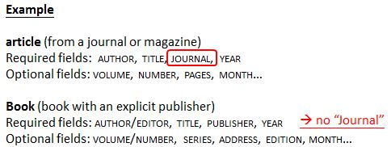

(5) Programming languages – Using Java and SQL.
(6) Development tools – Installed Eclipse and MySQL in our laptop. Eclipse is an IDE for coding, and MySQL is a RDBMS for storing data.
(7) Console program – Created a program run in Eclipse console. We have applied two approaches, matching by regular expression and database, to identity the fields of publication entry. The accuracy about numerical fields is good, but accuracy about string fields needs improvement.
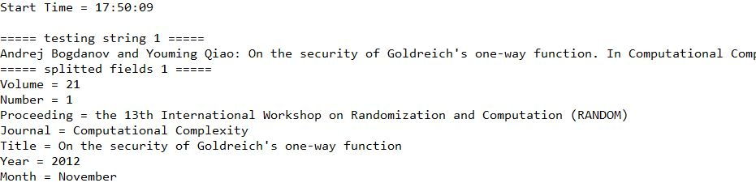
……
(8) Break down the publication entry – First, we check any quoted string in the free-text, if yes, identity those quoted string is title. Second, we split the free-text by commas, then an array of string is created. Finally, we process each element of array matching by regular expression and database.
(9) Regular expression – From the 100 sample publication entries, we recognized some keywords or patterns which may help us identifying the numerical fields. For example, some contains the keyword “vol.”, we just can identify the following number is volume field.
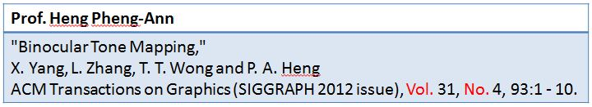
(10) Database – Three tables are created in local MySQL database, “Conference”, “Journal” and “Publication”. Stores the name of conference and journal grabbed from internet. We compared different substrings of the element with the name stored in database. By comparing in substring instead of word by word, we can avoid the chance of mismatching. If we found a match, we can identify that is a conference and journal fields.

1.4 Project Plan for Term 2 2013/14
(1) | Collect journal data (around 11,000 journal names) from ISI because we want to identity different categories of journal, not just Computer Science. ISI is a website contains different categories of journal (Biology, Ecology, Geology etc.).
(2) | Write a program or manually collect more publication entries (different expertise), like over 1,000, to ensure our system is dependable and diversified. We plan to collect from other universities’ professor web page in different professionals, different universities and from other countries.
(3) | Remove bias in testing data set by collecting more publication entries which contain fields that we did not focus on in Term 1.
(4) | Improve the works of Term 1. For example, the algorithm of identify author names and title fields and improve the running time.
(5) | Adopt machine learning techniques to help recognize data fields. We supply our manually separated fields (mainly author names and titles) and train our system with these data to see if it can recognize some useful and interesting patterns in these fields.
(6) | Use version control to maintain the consistency of our source code.
(7) | Store the recognized data fields in standard file format – BibTeX.
(8) | Design a web interface for our system, if applicable.

2. User Specifications

2.1 Functional Specifications
(1) Process-Oriented Requirements
Input free-text publication entries
(1) | Provides a text area for user input the free-text publication entries.
(2) | User can input more than one free-text publication entry at one time.
(3) | No limit length for the free-text publication entries.

Field recognition
(1) | During the process of field recognition, loading image or bar should be displayed.
(2) | Can recognize different fields. (eg. title, journal, proceeding, volume, issue, number, page, year, authors, article, month, thesis, chapter, editors, publisher)
(3) | Records the start time and end time for the field recognition.

Export to different file formats
(1) | User can export the result to different file formats. (eg. BibTeX, xls)
(2) | User can export the result to HTML code, also allow user to choose the order of different fields.

(2) Data-Oriented Requirements
Database
(1) | Creates a database with four tables, storing “Conference”, “Journal”, “Publisher”, and “Publication”.
(2) | Keeps update the database data.

2.2 Non-functional Specifications
 | Specifications
Operational | (1) The system must work on any browser, any operating system.  (2) The system must work on handheld devices, for example, iPad, IPhone, Android.
Performance | (1) The system must allow more than 300 users using it at the same time, perform load test first.  (2) The system should be available for use 24 hours per day, 365 days per year.
Security | (1) Everyone can using the system, no need to log in.
Cultural and  Political | (1) For beta version, the system only provide English version (the world wide language). For further development, can provide Simplified Chinese and Traditional Chinese version.

3. Design

3.1 Programming Languages

3.1.1 Java
Java is an OOP language, also provided with many libraries, for example “Apache POI” (work with Microsoft Office file formats) and “Weka” (work with data mining). Those libraries are needed in this project. Also, we have learnt in CSCI1130, both of us are familiar with Java.

3.1.2 SQL
For connect the local database, we have used SQL statement for search query. Also, we have learnt the basic SQL statement in CSCI3170 and DSME4070.
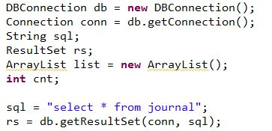

3.2 Development Tools
In Term 1, we have using Eclipse and MySQL for developing the console program. Now, we still use them, also with the following new tools.

3.2.1 SourceTree
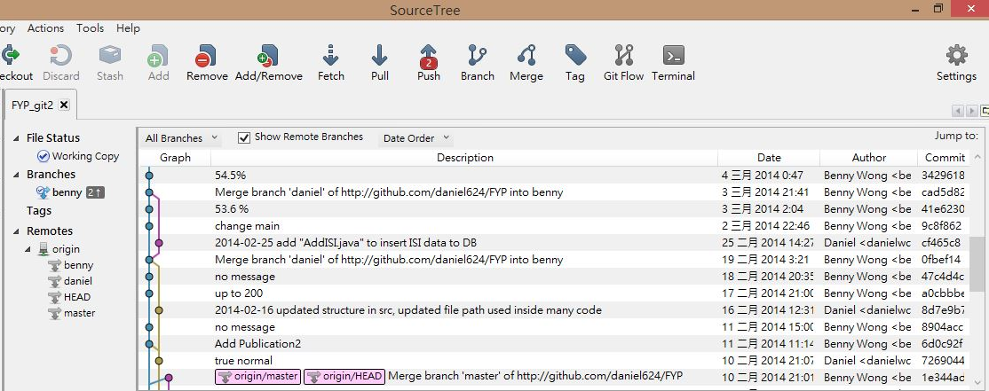

Source control -- lyu1203-spring-jack.pdf

3.2.2 Apache Tomcat

3.3 Database

3.3.1 Meaning of tables
Four tables are created in our local MySQL database.
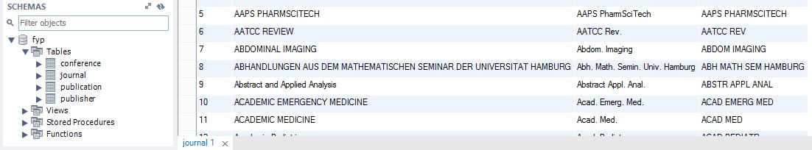

 | Table name | Description | No. of records
1 | Conference | Stores the full name and short name of conference grabbed from internet | 3,970
2 | Journal | Stores the full name and short name of journal grabbed from internet | 12, 445
3 | Publisher | Stores the name of publisher grabbed from internet | 117, 440
4 | Publication | Stores the publication entries in free-text format, with manually separated it into the corresponding fields | 380

3.3.2 Source of data
Conference Data Collection
(1) The DBLP Computer Science Bibliography (DBLP)
(2) AllConferences.com
Journal Data Collection
(1) The DBLP Computer Science Bibliography (DBLP)
(2) PubMed
(3) Web of Knowledge (ISI)
(4) Elsevier B.V.
Publisher Data Collection
(1) Books-By-ISBN
Publication Entries Data Collection
(1) Department of Applied Social Studies, CITYU
(2) Department of Computer Science, CITYU
(3) Department of English, CITYU
(4) Department of Marketing, CITYU
(5) Department of Computer Science and Engineering, CUHK
(6) Division of Social Science, HKUST

3.3.3 Data dictionary
1. Conference Table
Name | Data Type | Data | Key | Field Size | Description
CID | INT | 5234 | PK | 11 | Conference ID (Not Null)
FullName | VARCHAR | Ambient Intelligence Forum |  | 500 | Conference Full Name (Not Null)
ShortName | VARCHAR | AMIF |  | 100 | Conference Short Name

2. Journal Table
Name | Data Type | Data | Key | Field Size | Description
JID | INT | 3838 | PK | 11 | Journal ID (Not Null)
FullName | VARCHAR | Journal in Computer Virology |  | 500 | Journal Full Name (Not Null)
ShortName | VARCHAR | NULL |  | 100 | Journal Short Name

3. Publisher Table
Name | Data Type | Data | Key | Field Size | Description
PubID | INT | 37 | PK | 11 | Publisher ID (Not Null)
PubName | VARCHAR | Science Press |  | 500 | Publisher Name (Not Null)

4. Publication Table
Name | Data Type | Data | Key | Field Size | Description
ID | INT | 1 | PK | 11 | Publication ID (Not Null)
Authors | VARCHAR | Andrej Bogdanov, Youming Qiao |  | 500 | -
Title | VARCHAR | On the security of Goldreich's one-way function |  | 500 | -
Journal | VARCHAR | Computational Complexity |  | 500 | -
Proceeding | VARCHAR | NULL |  | 500 | -
Volume | VARCHAR | 21 |  | 255 | -
Issue | VARCHAR | NULL |  | 255 | -
Number | VARCHAR | 1 |  | 255 | -
Article | VARCHAR | NULL |  | 255 | -
Page | VARCHAR | NULL |  | 255 | -
Month | VARCHAR | NULL |  | 255 | -
Thesis | VARCHAR | NULL |  | 255 | -
Chapter | VARCHAR | NULL |  | 255 | -
Editors | VARCHAR | NULL |  | 500 | -
Publisher | VARCHAR | NULL |  | 500 | -
Year | INT | 2012 |  | 11 | -

4. Implementation

4.1 Approaches

4.1.1 Break down the publication entry

4.1.2 Regular expression

(How did you use this idea? For example, what if two different fields both contain "vol"?)

4.1.3 Database
Hash Table
(Besides using stored data to recognize each entry, you may also use stored data to identify whole records. For example, if you have structured PubMed data stored in your database, you could check if an entry from your list is similar to an entry in the database. If so, you may use the parsed contents in the database directly.)

4.1.4 Machine learning

4.1.5 Web interface
HTML Code, xls, txt, bib
Bibex validation

4.2 Flow Chart

(flow chart for breaking down a text entry into fields, one flow chart for regular-expression-based methods, etc.)

4.3 Running Time

4.3 Difficulties and Limitation

5. Testing

5.1 White-box Testing

5.2 Black-box Testing

5.3 Load Testing

6. Documentation

6.1 Javadoc

6.2 User Manual

7. Conclusion
To conclude, we have achieved ….

8. Individual Contributions

8.1 Division of labor

Name | English Name | Student ID
Wong Chong Wai | Daniel | 1155000258
Wong Yik Pan | Benny | 1155000261

The following table shows a more detailed division of labor
Tasks | Person(s)
Project initiation
Idea come up | Daniel, Benny
Marketing research | Benny
100 sample data collection | Daniel, Benny
User specifications
Functional specifications | Benny
Non-functional specifications | Benny
Design
Choosing development tools | Daniel
Data collection | Daniel
Implementation
Regular expression | Daniel, Benny
Database | Daniel, Benny
Hash table | Daniel
Machine learning | Daniel
Web interface | Daniel, Benny

Tasks | Person(s)
Testing
White-box testing | Benny
Black-box testing | Benny
Documentation
Javadoc | Daniel, Benny
User Manual | Daniel, Benny
Report | Daniel, Benny

8.2 Reflection (Individual)

9. Acknowledgment
We would like to take this opportunity to thank our supervisor, Prof. Kevin Yip. He gives us a great advice and support for our project and spends time for our regular meeting on every other Tuesday in Term 2. Also, he provides us valuable guidelines and comments in doing the report and presentation.

Thanks again that give us opportunity to do this project. In this project, we learnt a lot and applied what we have learned in different courses which it is useful for our future.

10. Reference
Development Tools
(1) Eclipse
https://www.eclipse.org/

(2) MySQL
http://www.mysql.com/

(3) SourceTree
http://www.sourcetreeapp.com/

(4) Apache Tomcat
http://tomcat.apache.org/

Conference Data Collection
(1) The DBLP Computer Science Bibliography (DBLP)
http://www.informatik.uni-trier.de/~ley/db/

(2) AllConferences.com
http://www.allconferences.com/

Journal Data Collection
(1) The DBLP Computer Science Bibliography (DBLP)
http://www.informatik.uni-trier.de/~ley/db/

(2) PubMed
http://www.ncbi.nlm.nih.gov/pubmed

(3) Web of Knowledge (ISI)
http://admin-apps.webofknowledge.com/JCR/JCR?PointOfEntry=Home&SID=V2G9x27vcbJsYSpTIkA

(4) Elsevier B.V.
http://www.elsevier.com/journals/title/a

Publisher Data Collection
(1) Books-By-ISBN
http://www.books-by-isbn.com/

Publication Entries Data Collection
(1) Department of Applied Social Studies, CITYU
http://ssweb.cityu.edu.hk/apss/index.aspx?cid=74

(2) Department of Computer Science, CITYU
http://www.cs.cityu.edu.hk/people/academic_staff.html

(3) - Department of English, CITYU
http://www.english.cityu.edu.hk/en/index.jsp

(4) Department of Marketing, CITYU
http://www.cb.cityu.edu.hk/mkt/people/

(5) Department of Computer Science and Engineering, CUHK
https://www.cse.cuhk.edu.hk/v7/en/people/lec.html

(6) Division of Social Science, HKUST
http://sosc.ust.hk/

BibTeX
(1) BibTeX
http://www.bibtex.org/

(2) Wikipedia
http://zh.wikipedia.org/wiki/BibTeX

(3) Bibtex Templates (Format)
https://www.cs.vassar.edu/people/priestdo/tips/bibtex

(4) Bibtex Format Checker
http://gridtlse.enseeiht.fr/bibtlse/Check.do

Programming
(1) Use WEKA in Java
http://weka.wikispaces.com/Use+WEKA+in+your+Java+code

(2) Data Mining - Practical Machine Learning Tools and Techniques (2nd)
http://www.amazon.com/Data-Mining-Practical-Techniques-Management/dp/0120884070

(3) “Hello World” Java Servlet Example with Apache Tomcat
http://helloworldprograms.blogspot.hk/2010/08/servlet-hello-world.html

(4) Read / Write Excel File In Java Using Apache POI
http://viralpatel.net/blogs/java-read-write-excel-file-apache-poi/

(5) Write To File In Java
http://www.mkyong.com/java/how-to-write-to-file-in-java-bufferedwriter-example/

(6) HTML tutorial (For output a HTML code)
http://www.w3schools.com/html/DEFAULT.asp

(7) HashMap in Java
http://www.ewdna.com/2008/11/hashmap.html

(8) SourceTree Tutorial (Git Flow)
http://www.takobear.tw/12/post/2014/02/bear-git-flow-sourcetreegit-flow.html

(9) Apache Tomcat Tutorial
http://pclevin.blogspot.hk/2013/03/apachetomcat-tomcat.html

11. Appendix

11.1 Progress Schedule

11.2 Progress Detail Record

