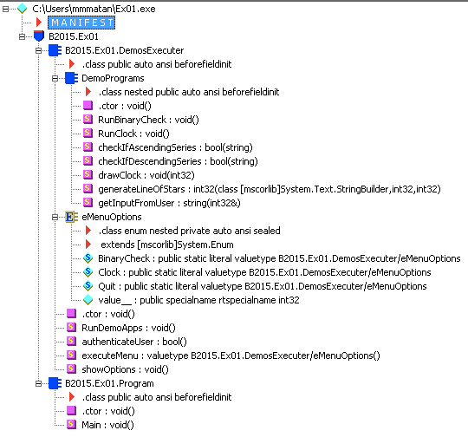**Question 1**

The file is .NET Assembly: **TRUE**

The file is .NET PE: **TRUE**

Explanation:PE is an extension of Assembly it also includes the MSIL, resources, metadata and manifest as possible to view with ildasm and also contains the Header and Unmanaged stub.

a. Assembly Name: B15-Ex01

b. Version: 15:2:1:27368

c. In the **Manifest** part

d. Using also:

* mscorlib, ver: 2.0.0.0
* System.Xml, ver: 2.0.0.0

**Question 2**

| Type | Name | Members |
| --- | --- | --- |
| Class | Program | public Program()  public static void Main() |
| Class | DemosExecuter | public class DemoPrograms()  public class DemosExecuter()  public enum eMenuOptions()  public static void RunDemoApps()  private static bool autenticateUser()  private static eMenuOptions executeMenu()  private static void showOptions() |
| Class | DemoPrograms | public DemoPrograms()  public static void RunBinaryCheck()  public static void RunClock()  private static bool checkIfAscendingSeries(string i_NumberStr)  private static bool checkIfDescendingSeries(string i_NumberStr)  private static void drawClock(int i_NumOfLines)  private static int generateLineOfStars(StringBuilder i_SB, int i_PlaceInText, i_Rows)  private static string getInputFromUser(out int currentNumber) |
| Enum | eMenuOptions | public static int BinaryCheck = 1  public static int Clock = 2  public static int Quit = 0 |

**Question 3**

Username: 15B-Ex01

Password: I love C#

**Screenshots**

**Part1**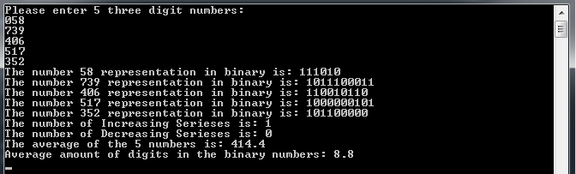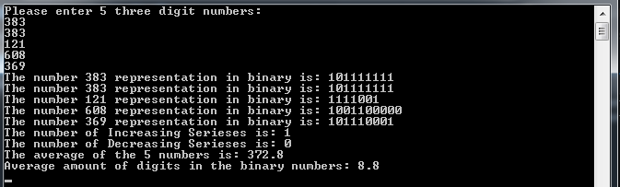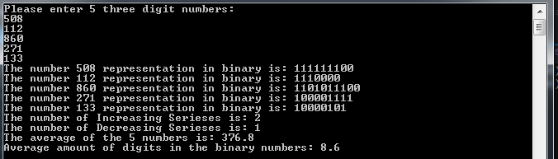

**Part 3**

