Sprint Planning

## Know the end from the beginning

* Sprint ends October 25, 2019
* We Should each spend 3-4 hours working on our assigned issues.
* Fall break is October 18-20
* Jared is gone on 10/16/19 :(
* We should be making 1-2 meaningful pushes on a weekly basis.
* Jared is the Scrum Master.
  + Dickey, Daniel
  + Lambert, Jared
  + Warnock, Garrett
  + Yorgason, Max

## Fill out details for each story

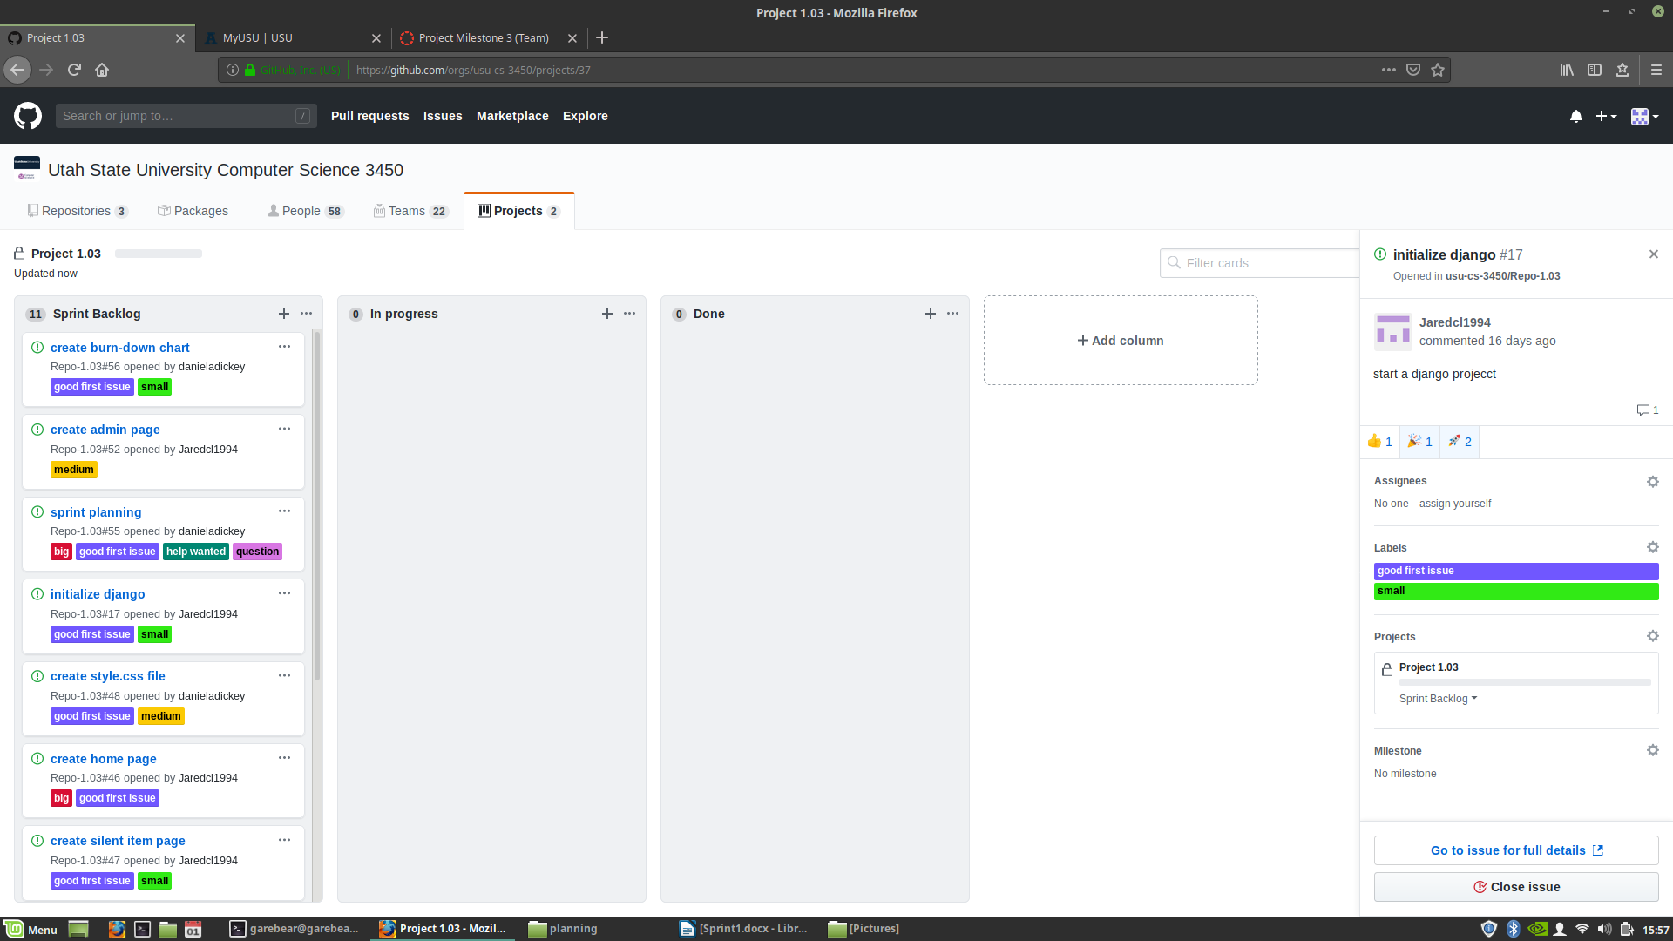

## 

## Artifacts