Sprint Planning 2

## Know the end from the beginning

* Sprint ends Nov 8th
* We each have 3-4 hours to work on the sprint individually.
* Jared will be gone at least one day.
* Complete 1-2 tasks a week.
* Break down stories into smaller tasks to make them more manageable and make sure we get more accomplished.
* Daniel is the Scrum Master
  + Dickey, Daniel
  + Lambert, Jared
  + Warnock, Garrett
  + Yorgason, Max

## Fill out details for each story

* 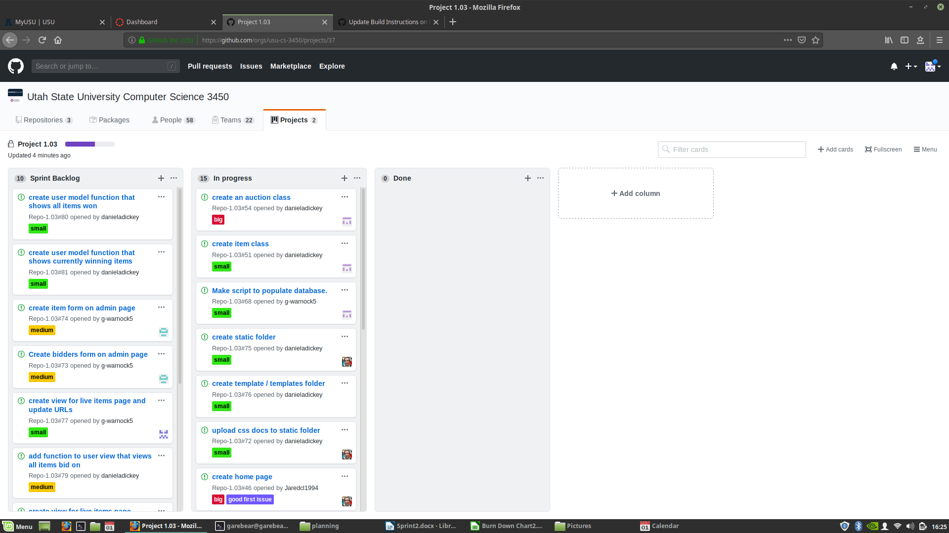

## 

## Artifacts

