Sprint Planning

## Know the end from the beginning

* Sprint Ends November 22nd.
* Each Team member should spend approximately 3-4 hours this sprint.
* Jared will be gone at least one day.(Possibly the 15th)
* Make one meaningful commit a day.
* For sprint 3 we want to be better at breaking down tasks into more manageable tasks. They need to be more specific and better thought out.
* Max Yorgason will be the Scrum Master for this sprint.
  + Dickey, Daniel
  + Lambert, Jared
  + Warnock, Garrett
  + Yorgason, Max

## Fill out details for each story

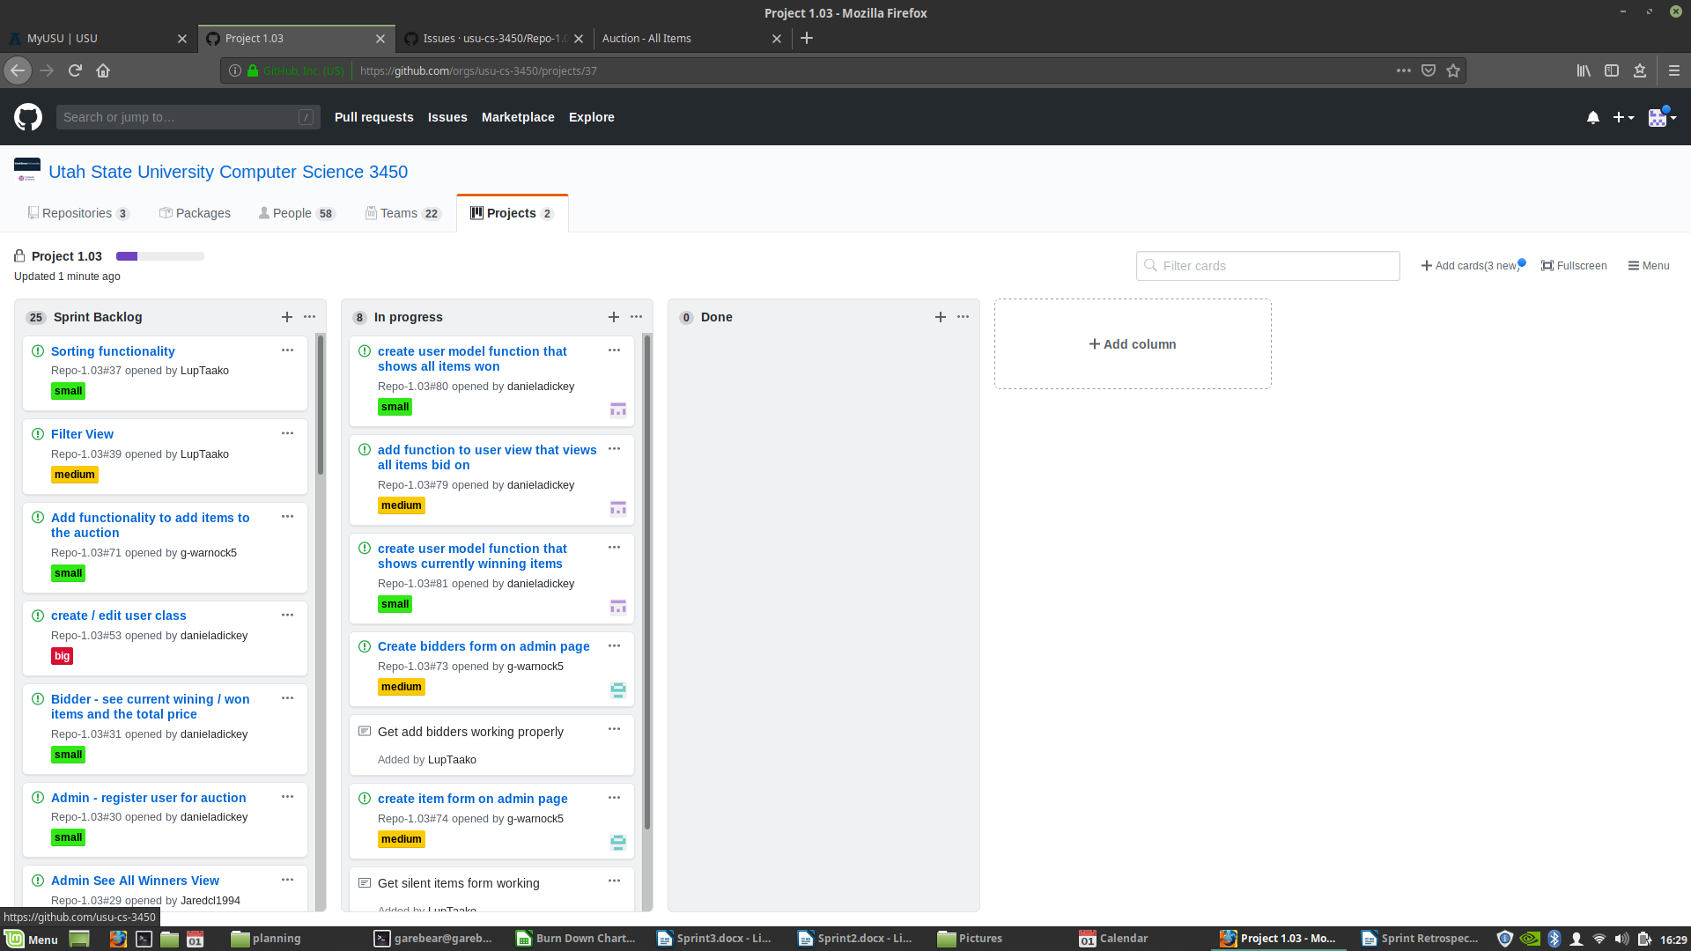

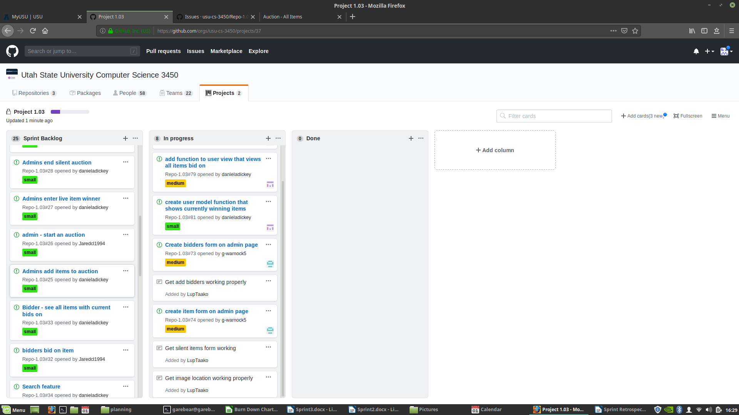

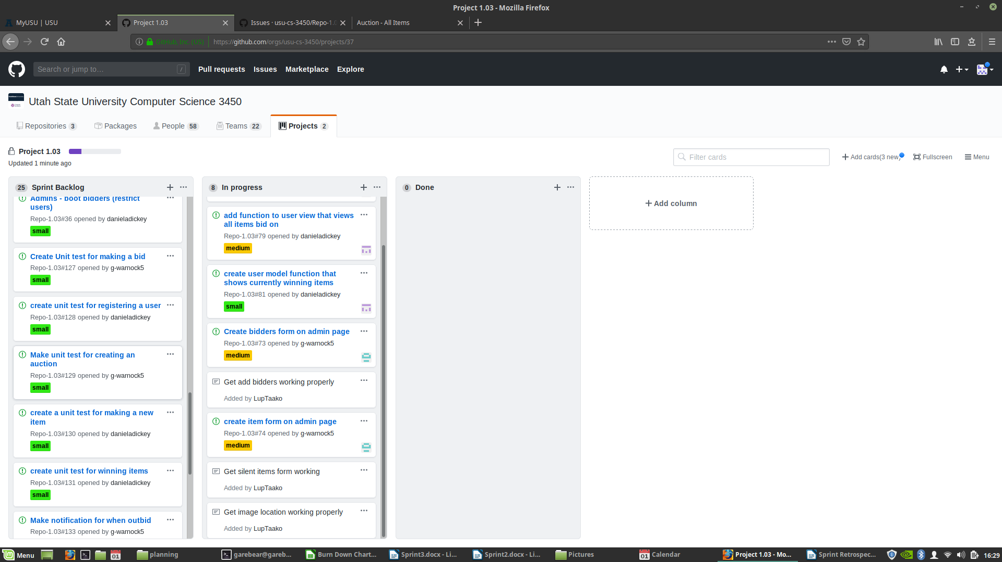

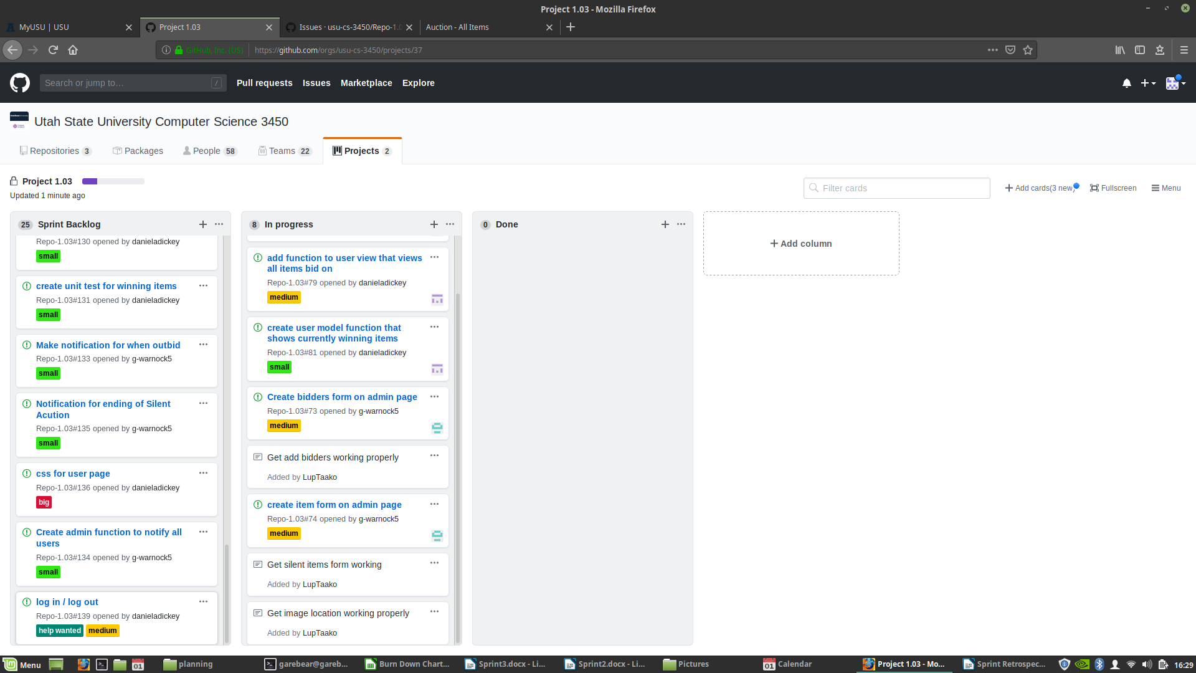

## Artifacts

