**Daily Scrum or Standup Meeting**

Team name: Hopeful Scrubs

Scrum Master: Jared Lambert

Date: 10-16-19

|  |  |  |  |
| --- | --- | --- | --- |
| **Team Member** | **What did you do since the last scrum?** | **What do you plan to do before the next scrum?** | **What obstacles do you have?** |
| Dickey, Daniel | Zippo, nil, nada… | Upload this doc to the repo  Make the homepage html  Look at some files in Django | I’m hungry, like always… |
| Lambert, Jared | Not Present for Meeting (Excused Absence See Sprint Planning Document) | Not Present for Meeting (Excused Absence See Sprint Planning Document) | SLC, cute girls, learning MIPS |
| Warnock,  Garrett | Initialized the planning documents  Made burn down chart | Refamiliarize self with Django  Make silent item page in html  Sprint planning document | Fall Break  Work  Discrete Math |
| Yorgason,  Max | Initialized the Django and pushed it to master *SMH* | Work on the admin html page  Work on the user html page  Update the sprint backlog on github | Work, and going home for fall break |

# Burndown

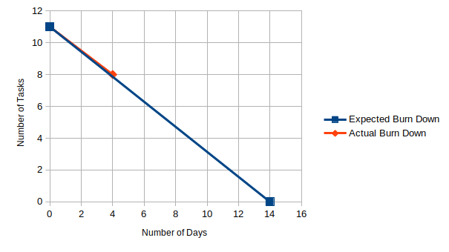

# Screenshot of your project board

