**Daily Scrum or Standup Meeting**

Team name: Hopeful Scrubs

Scrum Master: Jared Lambert

Date: 10-21-19

|  |  |  |  |
| --- | --- | --- | --- |
| **Team Member** | **What did you do since the last scrum?** | **What do you plan to do before the next scrum?** | **What obstacles do you have?** |
| Dickey, Daniel | Nothing | Work on CSS Document  Create navigation bar. | Trying to remember how to do CSS, HTML and Django |
| Lambert, Jared | Considered the future of our project | Create item class and an auction class | Brothers Birthday Party |
| Warnock,  Garrett | Updated some documents | Refamiliarize self with Django  Make silent item page and live item in html | Lack of Sleep  Discrete Math |
| Yorgason,  Max | Sick | Work on the admin html page  Work on the user html page | Large operating systems assignment due. |

# Burndown

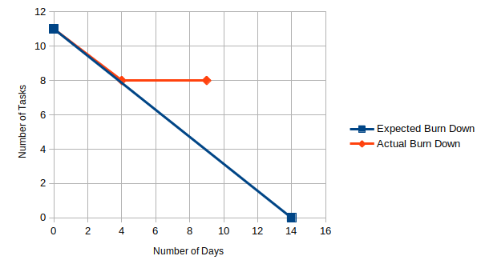

# Screenshot of your project board

