**Daily Scrum or Standup Meeting**

Team name: Hopeful Scrubs

Scrum Master: Daniel Dickey

Date: 10-30-19

|  |  |  |  |
| --- | --- | --- | --- |
| **Team Member** | **What did you do since the last scrum?** | **What do you plan to do before the next scrum?** | **What obstacles do you have?** |
| Dickey, Daniel | nothing | Created base CSS File | All of them, The scrum Master did not remove any obstacles for me…. |
| Lambert, Jared | Created an item class  Created an item class | ??? (not in daily scrum) | Its cold outside and Cant use his skatboard... |
| Warnock,  Garrett | nothing | Work on HTML for both item classes. | Every other class  Work |
| Yorgason,  Max | nothing | Working on User and Admin pages | Work |

# Burndown

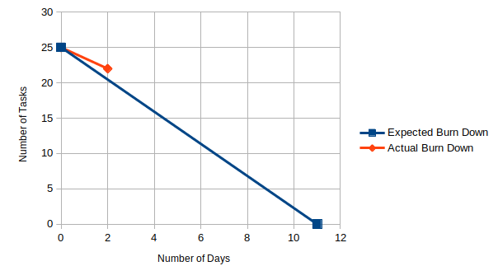

# Screenshot of your project board

