**Daily Scrum or Standup Meeting**

Team name: Hopeful Scrubs

Scrum Master: Daniel Dickey

Date: 11-04-19

|  |  |  |  |
| --- | --- | --- | --- |
| **Team Member** | **What did you do since the last scrum?** | **What do you plan to do before the next scrum?** | **What obstacles do you have?** |
| Dickey, Daniel | Read some Django tutorial | Finish Django tutorial  Created base CSS File | Homework from other classes, personal life, my head hurts |
| Lambert, Jared | Create Models | Make script to populate database | 1. Cost of electricity  2. Life of labtop battery. |
| Warnock,  Garrett | nothing | Work on HTML for both item classes. | Every other class  Work  School makes this developer sad |
| Yorgason,  Max | Made a form for adding a bidder and item | Submit a view that puts item and bidder in database | Work  CS3100 assignment due |

# Burndown

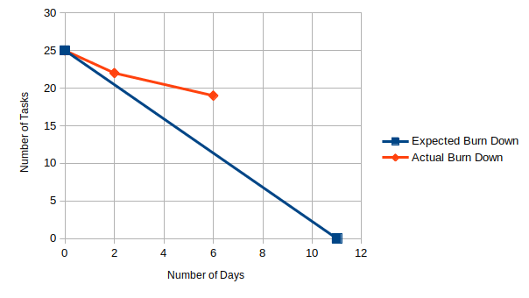

# Screenshot of your project board

