**Daily Scrum or Standup Meeting**

Team name: Hopeful Scrubs

Scrum Master: Daniel Dickey

Date: 11-06-19

|  |  |  |  |
| --- | --- | --- | --- |
| **Team Member** | **What did you do since the last scrum?** | **What do you plan to do before the next scrum?** | **What obstacles do you have?** |
| Dickey, Daniel | Pushed CSS of mobile and desktop  updated read me | Make Nav bar into “template” | Hes just a kid and life is a nightmare!! |
| Lambert, Jared | Created Script to populate database. | Show what a user has won, shows items currently winning, shows all items users bid on | Might develop carpal tunnel syndrome and a soar back from so much work... |
| Warnock,  Garrett | Worked on basic views and html for items pages. | Display Items, Enable bid functionality, Mark as sold. | Nothing |
| Yorgason,  Max | Working on getting item and bidder functions working | Finish bidding options for users | Work  CS3100 assignment due |

# Burndown

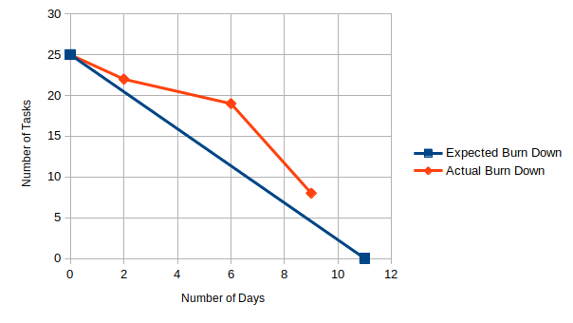

# Screenshot of your project board

