**Daily Scrum or Standup Meeting**

Team name: Hopeful Scrubs

Scrum Master: Max Yorgason

Date: 11-13-19

|  |  |  |  |
| --- | --- | --- | --- |
| **Team Member** | **What did you do since the last scrum?** | **What do you plan to do before the next scrum?** | **What obstacles do you have?** |
| Dickey, Daniel |  | Update CSS for User menu | Other classes  Not enough time |
| Lambert, Jared |  | Implement Search function | Eating too much food.  Too full of energy. |
| Warnock,  Garrett |  | Start working on a filter option | Extracurricular activities. |
| Yorgason,  Max |  | Make sure Admin can add a bidder | Work |

# Burndown

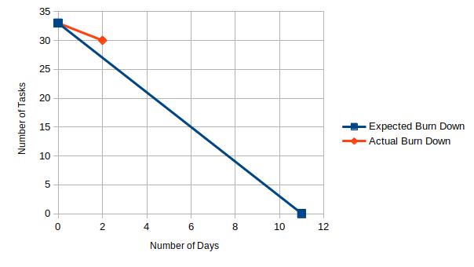

# Screenshot of your project board

