**Daily Scrum or Standup Meeting**

Team name: Hopeful Scrubs

Scrum Master: Max Yorgason

Date: 11-15-19

|  |  |  |  |
| --- | --- | --- | --- |
| **Team Member** | **What did you do since the last scrum?** | **What do you plan to do before the next scrum?** | **What obstacles do you have?** |
| Dickey, Daniel | Made minor changes to CSS (menu) | Change filter button CSS, | His own old CSS is creating problems |
| Lambert, Jared | ... | Implement Search function…  Unit Tests... | His pillow is too soft... |
| Warnock,  Garrett | Created a Filter for All Items page. | Create filter for Silent Item and Live item page.  Enter Live Item Winner  Display All Winners | Weekend Sports. |
| Yorgason,  Max | Add and remove bidders if they are already users | Modify Web pages that he has made. Expand manager and user pages to different URLs | Work |

# Burndown

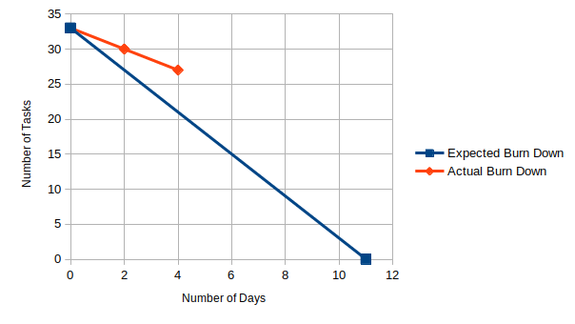

# Screenshot of your project board

