**Daily Scrum or Standup Meeting**

Team name: Hopeful Scrubs

Scrum Master: Max Yorgason

Date: 11-18-19

|  |  |  |  |
| --- | --- | --- | --- |
| **Team Member** | **What did you do since the last scrum?** | **What do you plan to do before the next scrum?** | **What obstacles do you have?** |
| Dickey, Daniel | Made Mobile menu and minor CSS changing. | Update menu for admin and user pages | Sick |
| Lambert, Jared |  | Implement Search function…  Login page |  |
| Warnock,  Garrett | Worked on converting previous CSS filter to using a form | Finish the basic filter  Start working on Enter Live Item Winner  Start working on Display All Winners | Upcoming Tests. |
| Yorgason,  Max | Updated User and Manager URLs. | Finish adding silent Items, Work on passing parameters between web pages | work |

# Burndown

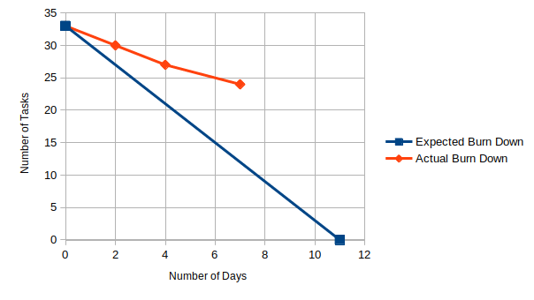

# Screenshot of your project board

