**Daily Scrum or Standup Meeting**

Team name: Hopeful Scrubs

Scrum Master: Max Yorgason

Date: 11-18-19

|  |  |  |  |
| --- | --- | --- | --- |
| **Team Member** | **What did you do since the last scrum?** | **What do you plan to do before the next scrum?** | **What obstacles do you have?** |
| Dickey, Daniel | Update sub-menu for admin and user pages | Style user/manager pages based on user type | Not sure how to style pages based off user |
| Lambert, Jared |  | Implement Search function…  Login page  Unit Tests |  |
| Warnock,  Garrett | Finished basic filter | Start working on Enter Live Item Winner  Start working on Display All Winners  Possibly make a unit test for making a bid | Upcoming Tests. |
| Yorgason,  Max | Cannot view account page without being logged in. | Combining manager and user webpages into one | Work, and operating systems assignment. |

# Burndown

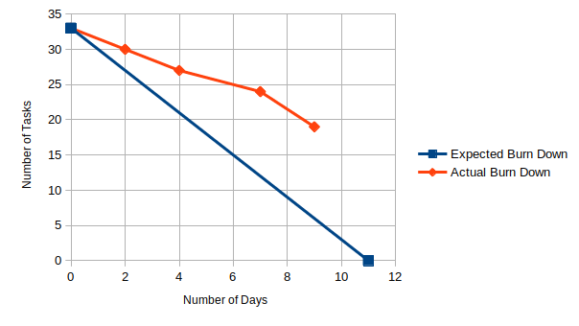

# Screenshot of your project board

