# ADO.NET

* Old, but: consistent, stable
* Was designed to support large loads, security, scalability
* Heart: System.Data namespace
* Compatible with more than just SQL Server (System.Data.OracleClient)
* **Disconnected model**: Open connection, do INSERT/UPDATE whatever, then close immediately
  + Connections are expensive (network, etc)
  + Locks, concurrency issues
  + **Do not forget to close connections (try-finally)**
* **Connection pooling:** not good that we are closing/opening connections willy nilly. Create instead some connections (eg 50)
  + Number of active connections: specified in DB connection string, else default 100
* **Data providers:** components designed for data manipulation + forward/read only access to data
  + DbConnection
  + DbCommand
  + DbDataReader: when speed is needed (forward + read only), similar to Stream
  + DbDataAdapter: to populate DataSet, DataTable
  + DataSet: inmemory copy of RDBMS, collection of DataTables
  + DataTable

**DataSet vs DataReader:** what to use to query: datareader is always used, even with DataAdapter

* DataReader: **async** stuff DataAdapter: **sync**
* DataAdapter fetches tables, rows then hydrate business object collection (slow)
* Both support multiple result sets
* DataAdapter: Fill() only completes when everything’s ready DataReader: HasRows, but it can be incomplete yet (has to manually check)
* DataReader: iterate only once (DataTable: any times)
* DataSets: can be loaded from XML ~serializable

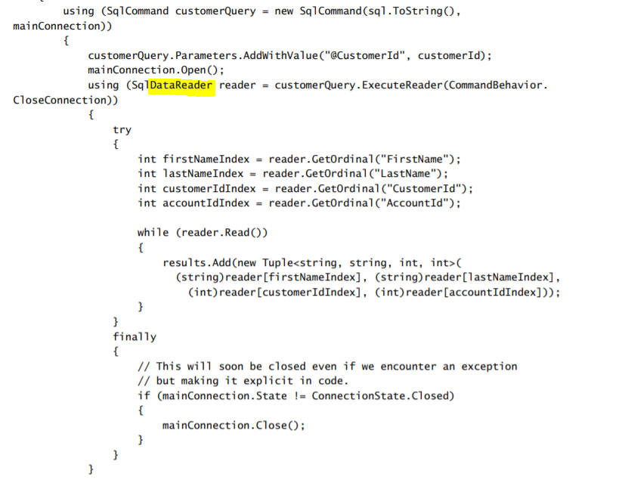

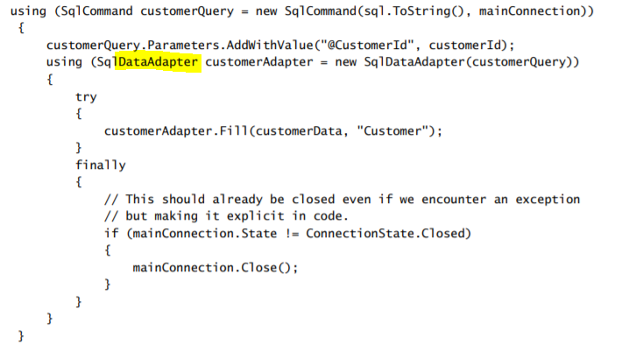

ORMs:

* Linq to Sql
* EF
  + Conceptual model (works in .NET code)
  + Underlaying storage mechanism
  + Mapping between the two

# EF

* **CSDL:** Conceptual Schema Definition Language
* **SSDL:** Store Schema Definition Language
* **MSL:** Mapping Specification Language  
  These days these are all in .edmx file

**Entity Model Designer:** Creates. Edmx  
**Entity Data Model Wizard:** True starting point of **building conceptual model, use existing DB  
Create Database Wizard:** Do opposite of EDM Wizard – start from conceptual model  
**Update Model Wizard**