**Service Fabric:** Kubernetes is nice, but it only solves infrastructure problems. We still have issues like microservices communicating with each other, service discovery, telemetry, provision, upgrade, etc.

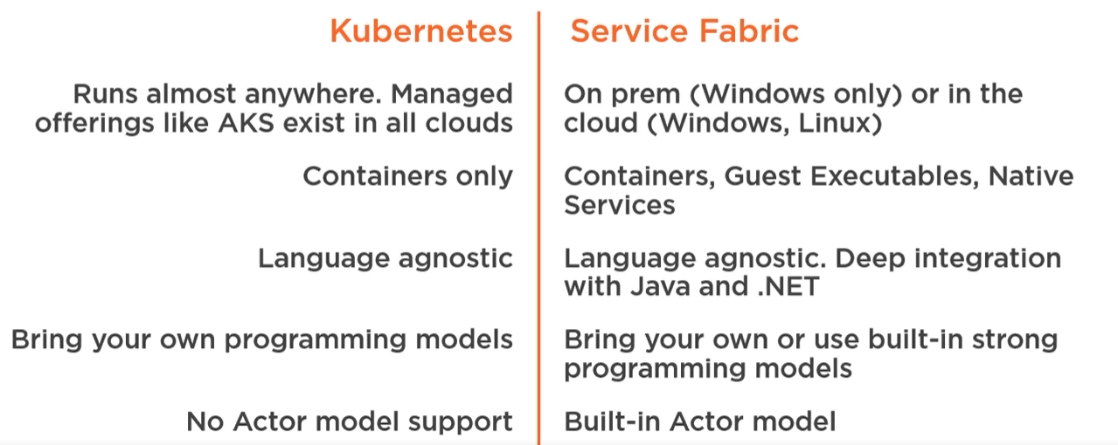

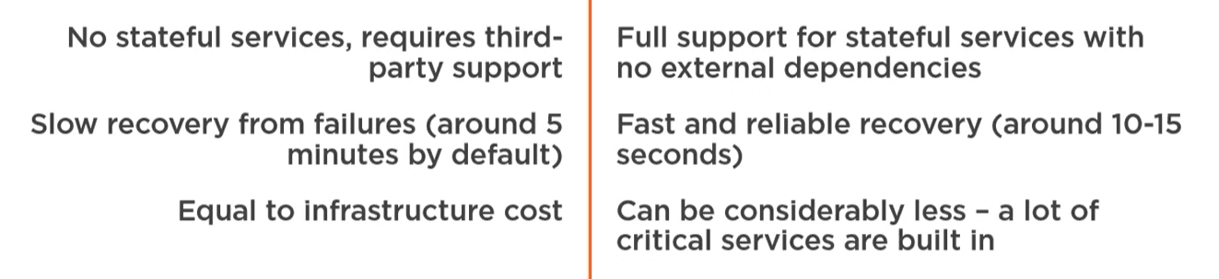

Programming models

**Reliable services:** Like windows services (console apps)  
- stateless  
- stateful (w/ its own transactional replicated storage)

**Reliable actors:** stateful, massive amount of client requests

**Guest executables:** any existing app, wrapped inside Service Fabric

**Containers**