“In Brownsville, Brooklyn's poorest neighborhood, just 38.9% of students scored at or above grade level in math and 31.2% in reading on statewide tests in 2012. The respective citywide numbers were 60% and 46.9%. Test scores are strongly correlated with household income”(Crain’s)

Not only household income but schools food systems could have a high correlation to low test scores. Living in a low income neighborhood means that many families have very little access to nutritious foods or no access at all. Some neighborhoods have access to nutritious food but not a way to afford it. Children are being fed cheap, highly processed food that lead to malnutrition, obesity and disease.

School meals are impacting children's ability to learn in a detrimental way. The foods offered are loaded with sugars, sodium, chemicals, and caffeine. Students are being exposed to high glucose diets which can lower brain function, leaves kids tired, sick, unfocused. As a result students experience problems in academic learning as well as psychological behavior.

What would constitute a good solution? Local farms and schools to work together in order to change food purchasing habits and education practices. The goals of this system would be for the students and low income families to have access to free, healthy local foods. To provide education opportunities in the classroom and hands on experience in the kitchen and agricultural activities. This system could be sustainable with the help of the community, the children and volunteers. This would not only strengthen the local economy but it could also create new job.

This system sounds promising but is it feasible? How many farms can we currently find in Brooklyn, NY and how much food are they producing? Could they produce enough food to sustain these low income communities and institutions? If not, how many more farms do we need? And do we have enough land or rooftop space to produce more food?

**Sources:**

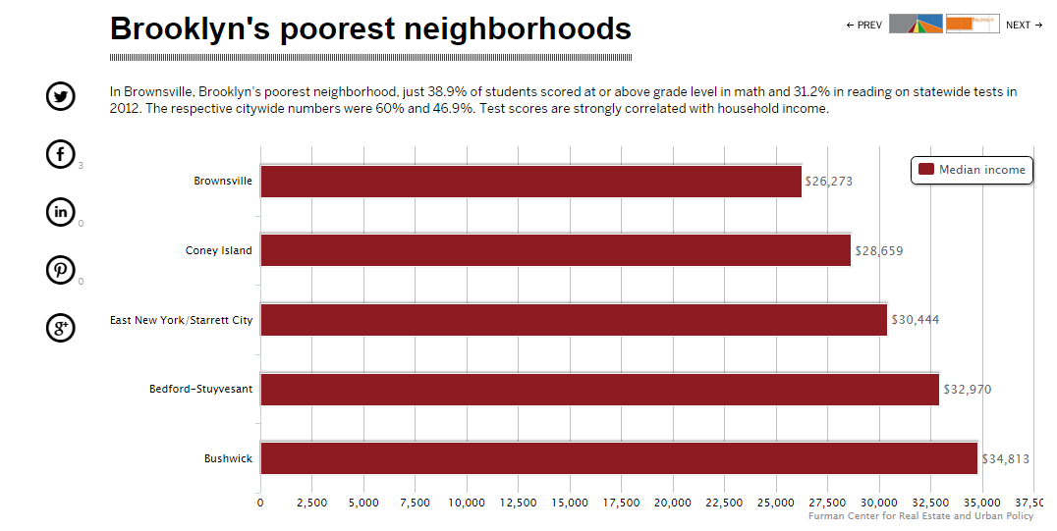

Crain’s <http://mycrains.crainsnewyork.com/stats-and-the-city/2013/brooklyn/brooklyns-poorest-neighborhoods>

