Bug1:
Signin:
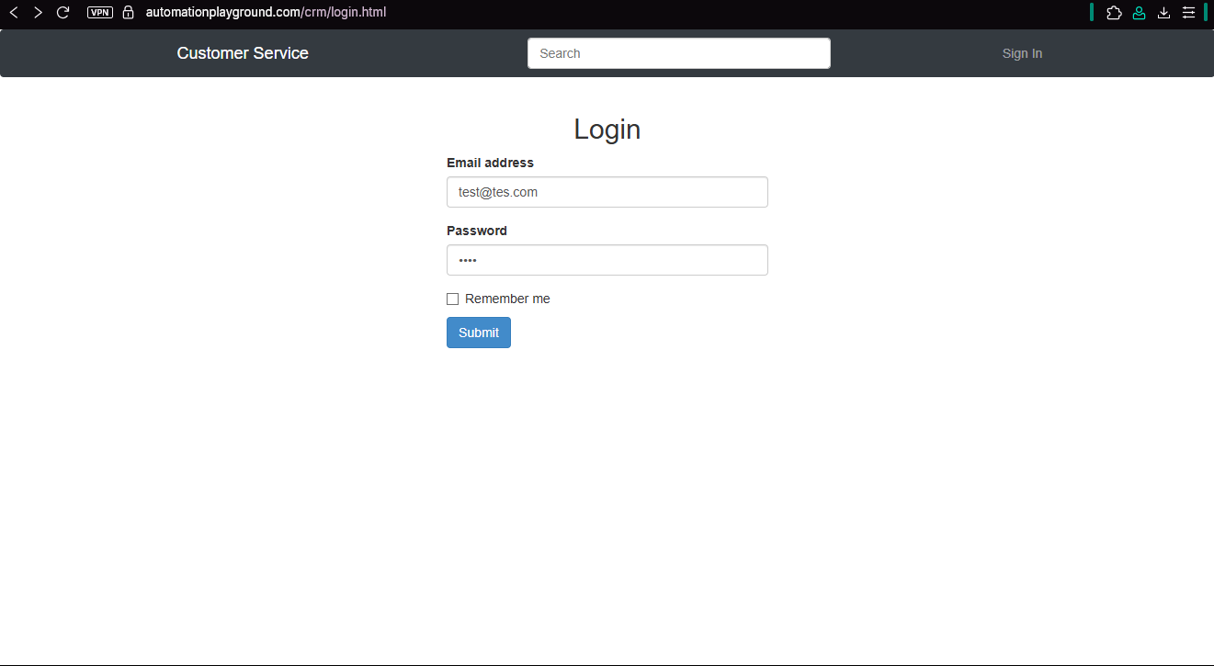
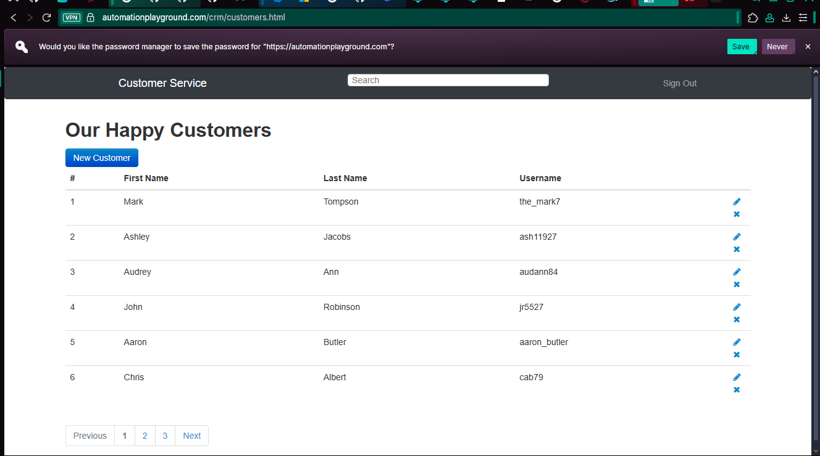
I added a dummy credentials and I got signed in
Steps to reproduce:
1-go to login
2- add test@tes.com as a username
3- add 123 as password
4- click submit
Expected vs Actual behavior
Expected: error message for invalid credentials
Actual: signed in
Severity: Critical

Bug 2:
Edit Customer:
I tried to edit a customer and it couldn’t be edited
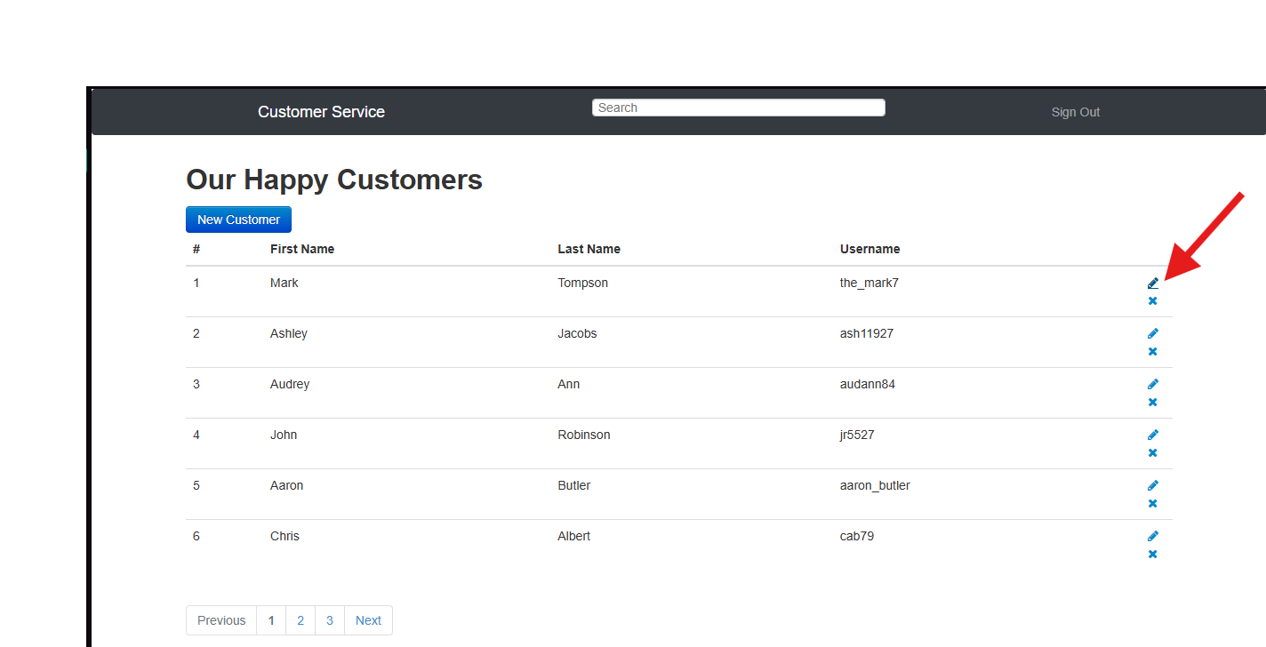

Steps to reproduce:
1-go to Customer
2- Press on the edit button
Expected vs Actual behavior
Expected: a form should be opened to edit the entered data

Actual: User profile
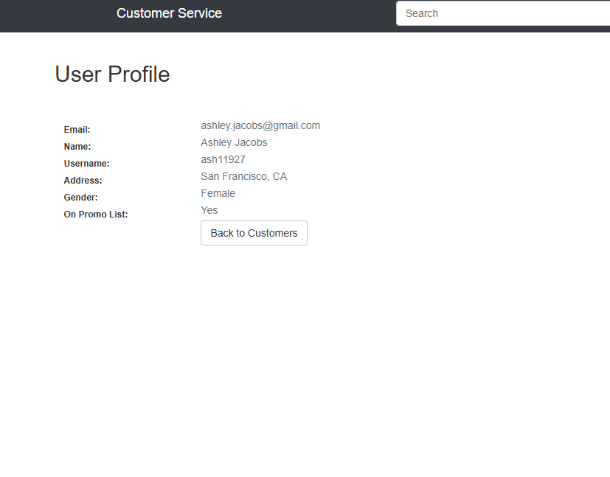

Severity: High

Bug 3:
Delete Customer
I tried to delete a customer and it couldn’t be deleted

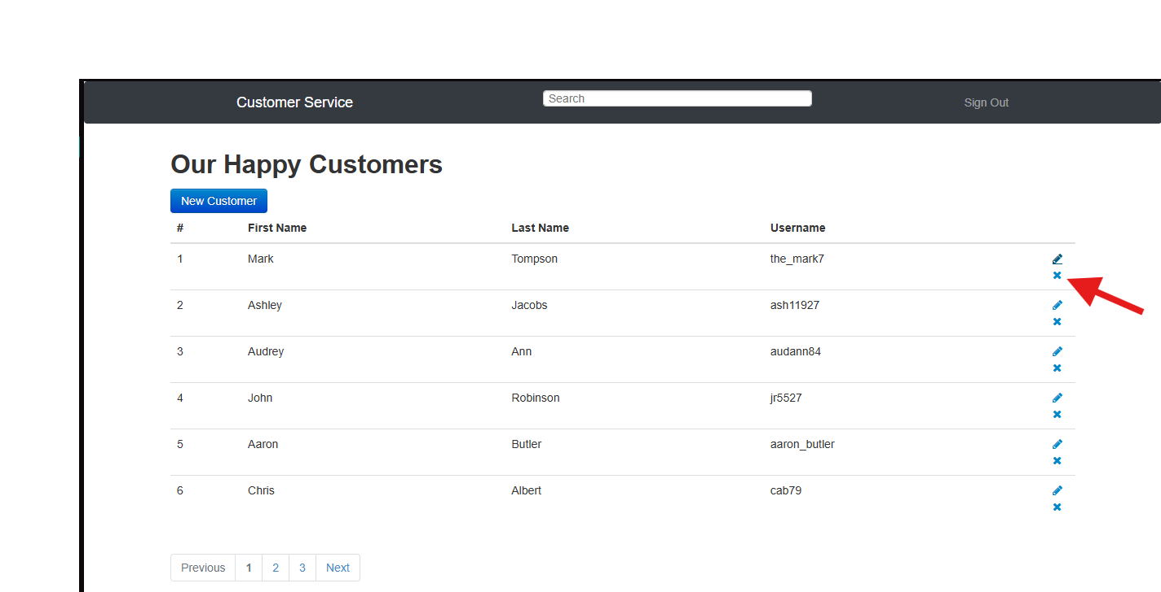
Steps to reproduce:
1-go to Customer
2- Press on the Delete button
Expected vs Actual behavior
Expected: Customer should be removed from the table
Actual: Customer was not removed from the table
Severity: High

Bug 4:
Creating new Customer
I tried to create a customer and it couldn’t be Created

Steps to reproduce:
1-go to Customer
2- Press on the New Customer button
3- add the credentials
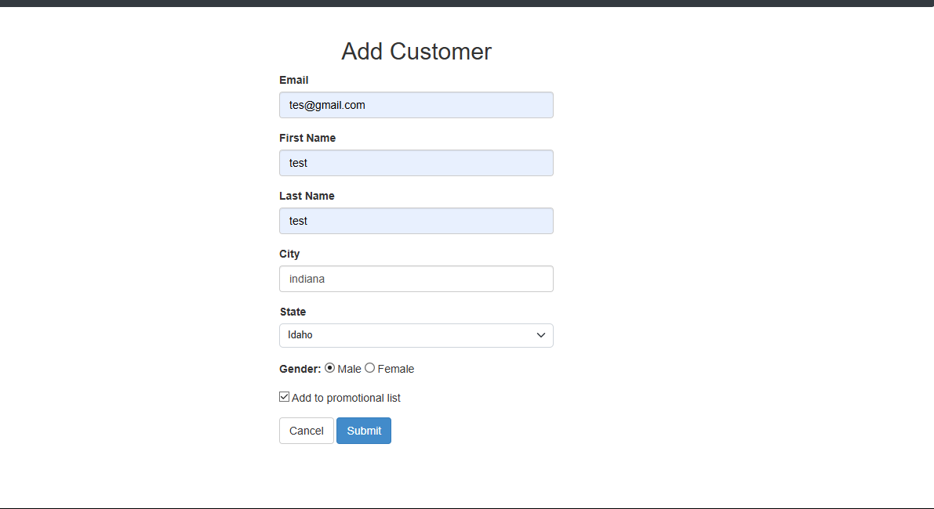
4- click on submit
Expected vs Actual behavior
Expected: Customer should be added to the table
Actual: Customer was not added to the table
Severity: Critical
Bug 5
Data in the table
I tried to check the data in the table and switch between pages I got the same data in all three pages
Steps to reproduce:
1-go to Customer
2- Press on the pagination button to switch in the table
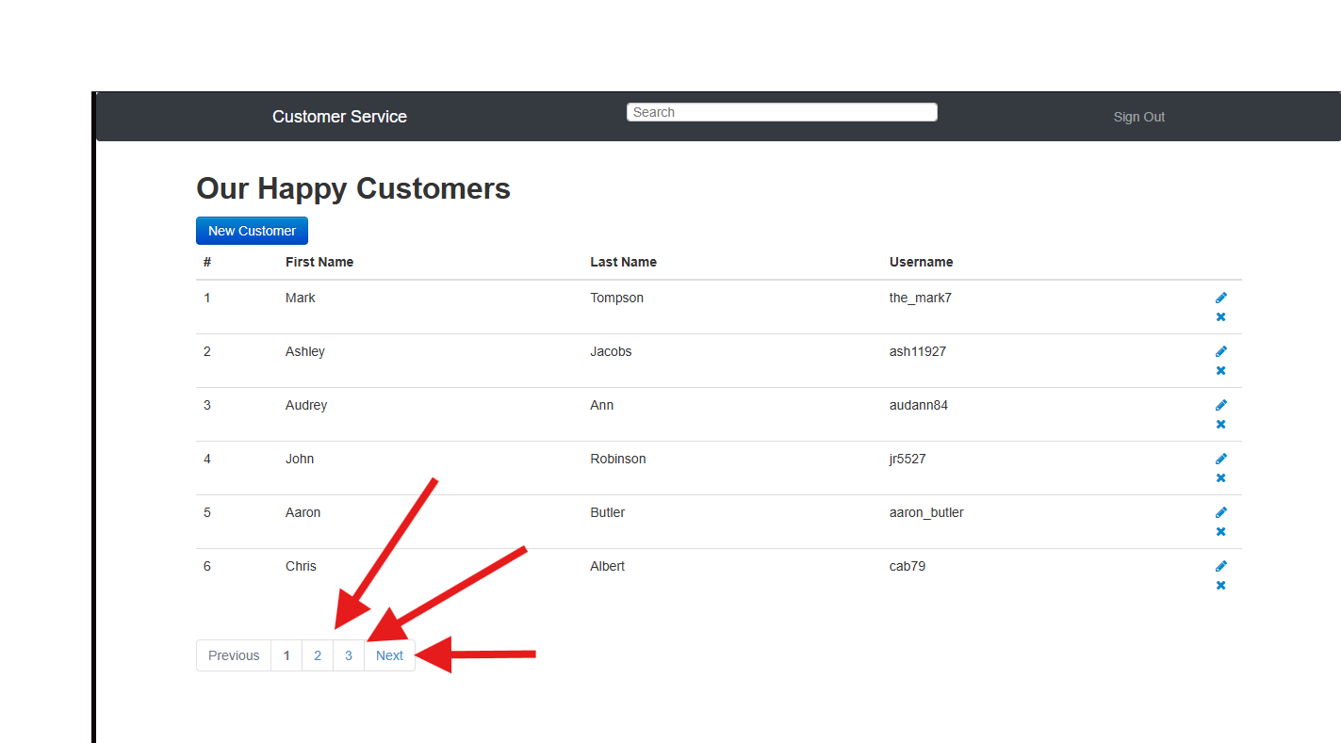
Expected vs actual behavior
Expected: data should change between pages and different data should be shown
Actual: Same data is shown on all three pages
Severity: Medium

Bug 6
Search
I tried to search but I didn’t receive any data back
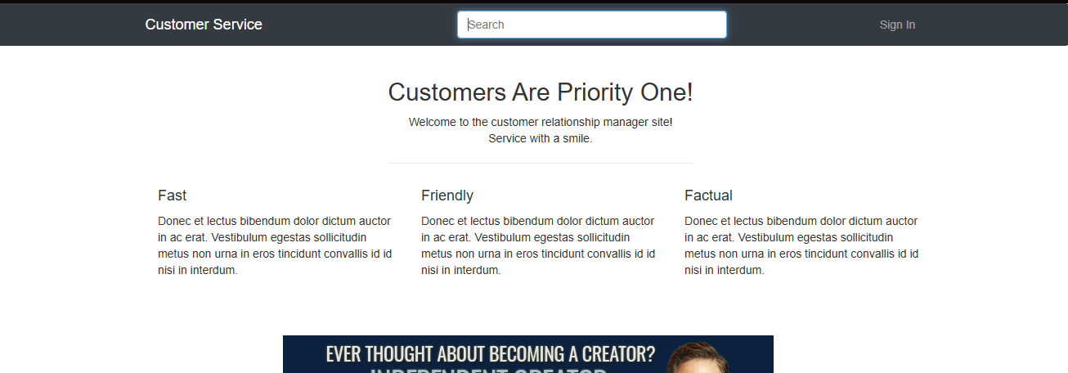
Steps to reproduce:
1-go to Home
2- Press on the New Search field
3- search about anything
Expected VS Actual
Expected: a result is shown either data found or not found

Actual: nothing is shown
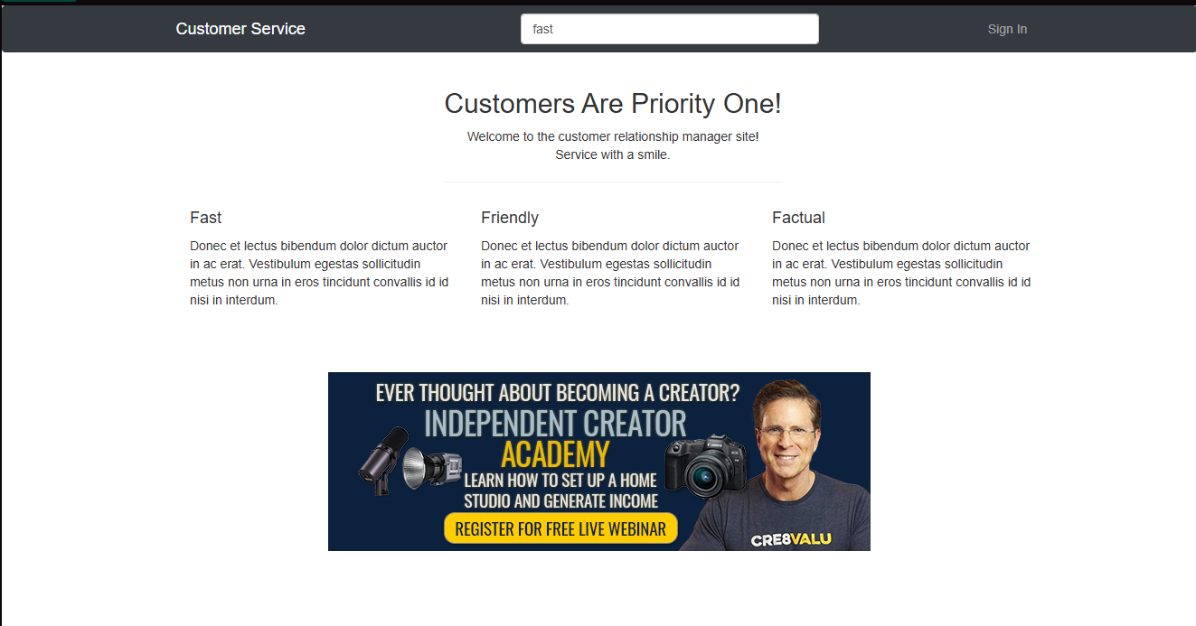

Severity: High
Bug 7
Customer Service
I tried to open the customer service page and when I pressed on the customer service button It directed me to the home page
Steps to reproduce:
1-go to Customer
2- Press on the Customer Service Button
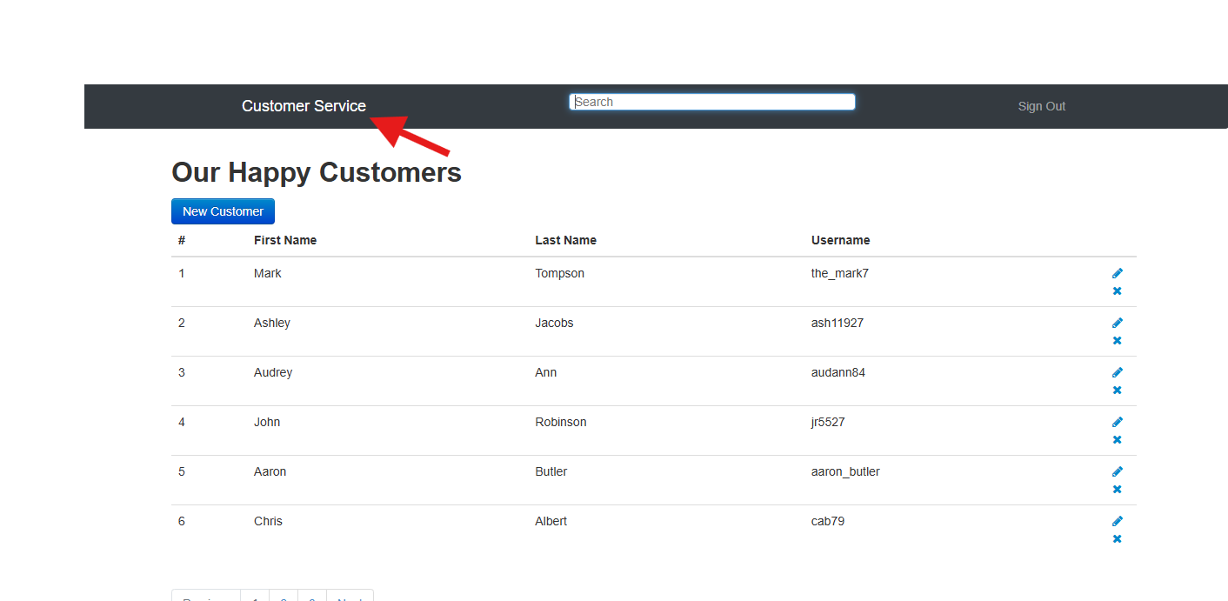
Expected vs Actual
Expected a Customer Service page should be opened up
Actual: the home page opened and it automatically signed out
Severity: Medium
Bug 8
Opening the customers.html without signing in
I tried to open the customer.hml without signing in and it opened normally
Steps to reproduce
Steps to reproduce:
1-go to Customer
Expected vs Actual
Expected: an error should be shown
Actual: opened the customers.html

Severity: Critical

Bug 9:
Opening the customers.html and shown as signed in even without signing in
I tried to open customers.html without being signed in and it opened as a signed in user
Steps to reproduce:
1-go to Customer
Expected vs Actual
Expected: an error should be shown
Actual: opened the customers.html as signed in
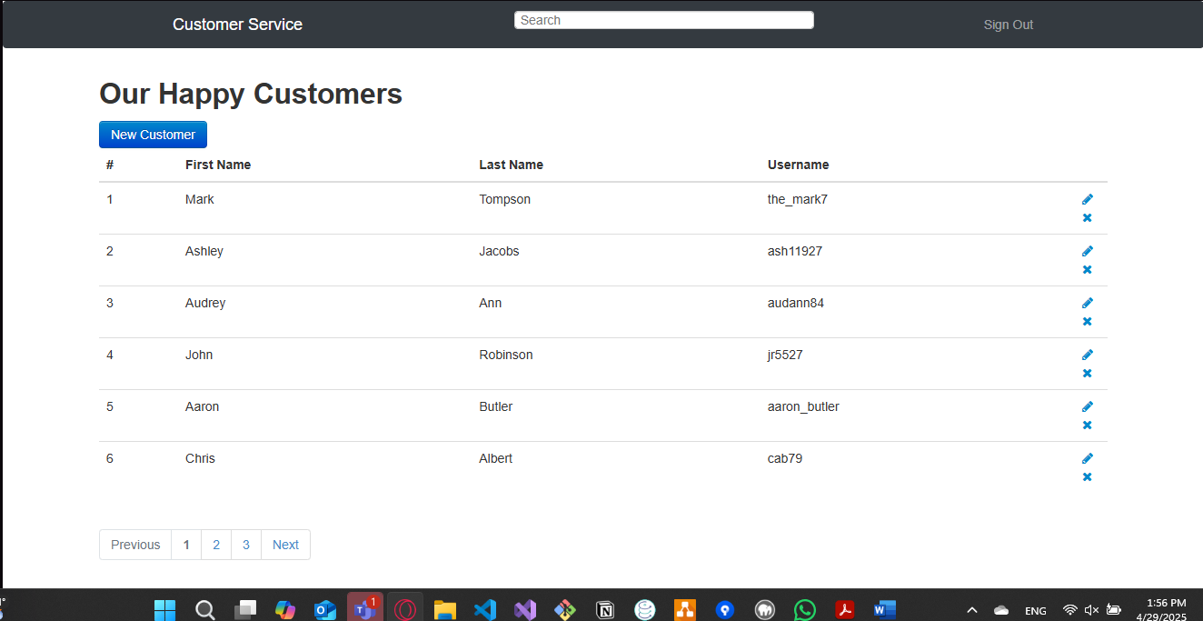

Severity Critical

