CaptionAll Installation Guide
By Daniel Patterson
Last Revised: 02/13/2026

Introduction
The activities of retrieving and installing this version of CaptionAll constitute a multi-branch exercise in the spirit of promoting known, reliable methods of autonomous sustainability to the wider public.
In this exercise, CaptionAll is distributed in multiple channels that each illuminate their own independent methods, advantages, and disadvantages for handling and transmitting data, in the hope that you can find many of your own practical uses of those same data transmission methods.
You are welcome to try as many of the following installation methods as you find useful.

Distribution Philosophy
PowerMake Systems, LLC, Daniel Patterson, and CaptionAll are members of the digital sovereignty movement, and are completely in favor of the following principals.

- Local-first operation reduces or eliminates dependence upon the Internet.
- Technical knowledge must always be shared to the public to achieve and maintain an advanced civilization free from oppression.
- A person's data is always theirs.
- No tracking should ever take place of a person's online activities.
- The standards of trust, good behavior, and successful civilization are set by people behaving well and expecting others to do the same, as opposed to "zero-trust" behaviors, which diminish societies.
- Every individual must be allowed the ability to achieve and excel independently without the oversight, supervision, or gatekeeping of any other institution or organization.

System Requirements
You will need at least 165.9MB of free space on your PC to install the application.
This application currently runs on Windows 8, Windows 10, or Windows 11, and uses only the minimum amount of resources.

Installation
At present, you can get your copy of CaptionAll in one of three ways.

Internet Archive
{ContentStart,InternetArchive}
CaptionAll is available as a .torrent file at The Internet Archive, the world's most comprehensive public digital library and most complete archive of web history. It is a non-profit organization that operates under the ambitious mission of providing Universal Access to All Knowledge.

According to their About page at https://archive.org/about/, their archive consists of the following.
- 1 trillion web pages.
- 49 million books and texts.
- 15 million audio recordings, which include 268,000 live concerts.
- 13 million videos, which include 3 million television news programs.
- 5 million images.
- 1 million software applications.

They also have the distinction of serving as a congressionally designated depository for U.S. Government documents, the public access of which is guaranteed by Title 44 of the United States Code.

Working with Torrent Files
Torrent files, their networks, and their associated applications application enable users to download and share files by distributing small pieces across many peers rather than relying on a single server, improving speed and resilience while using a completely decentralized, peer-to-peer network. Many Linux files are distributed in this way.
They allow groups and individuals to avoid the suppressive efforts of authoritarian, dictatorial, totalitarian, and draconian organizations and institutions, while remaining free to access and publicly available at all times.

Install Transmission
To work with torrent files, you will need to get a torrent file manager if you don't already have one. In this instance, I am going to outline the steps for downloading and installing Transmission, a popular and reliable software application for handling .torrent files. This section describes the basic installation and configuration process.
Follow these steps if you need to install and configure Transmission. Otherwise, you may skip to the next section.

- Navigate to the Transmission home page at https://transmissionbt.com/.
- Click the button most closely resembling "Download v4.1.0 stable".
- In the Windows group, click transmission-4.1.0-x64.msi.
- In your browser downloads list, click to open and run the file.
- If you are presented with any kind of warning that the file is an executable (common in Firefox), click OK.
- Follow the instructions on each page of the wizard, clicking Next to advance to the next page, and finally clicking Finish to perform the installation.
- Assuming that you left the option checked to create a link on your desktop, minimize your windows, find the 'Transmission Qt Client' shortcut on your desktop, and double-click to launch the application.
- In the Change Session dialog, select Start Local Session.
- Click OK.
- If you see a Windows Security Alert for Windows Defender Firewall, do NOT allow access to either Private or Public networks, unless you have specific crowd-based reasons to do so. After unchecking both options, you will notice that the only enabled buttons are "X" and Cancel. Click either button to close the dialog.

Retrieve and Install CaptionAll
With Transmission installed, follow the steps of one of these two processes to retrieve and install CaptionAll.

Download Within Transmission
You can initiate the torrent file download from within Transmission while it is already running.
- Select the menu option File / Open URL.
- In the dialog Open Torrent from URL or Magnet Link, set the following values.
- Source:
{NoLink}https://archive.org/download/caption-all-setup/caption-all-setup_archive.torrent{/NoLink}
- Destination folder: (Your choice. This is set to the Downloads folder by default.)
- Priority: Normal
- Start when added: Checked
- Move .torrent file to the trash: Checked
- Click Open.
- The package will download to your specified folder. This may take a few moments.
- Right-click the download progress bar for caption-all-setup, and from the context menu, select Open Folder.
- Double-click to open the CaptionAll sub-folder.

Following is the file structure you can expect to see within the CaptionAll folder.

- CaptionAll. Main application content folder.
  - CaptionAll-GettingStartedGuide.pdf. Tips and tricks for getting started. Note that several other versions of this document are created and maintained automatically in this folder by Internet Archive for accessibility reasons.
  - LICENSE. AGPL-3.0 License.
  - Setup
    - CaptionAllSetup.exe. CaptionAll setup application.
  - Source
    - CaptionAll-main.zip. CaptionAll source code from the Main branch of the GitHub repository at https://github.com/danielanywhere/CaptionAll.

From here, you can setup CaptionAll by opening the setup folder and double-clicking CaptionAllSetup.exe. Acknowledge the license and follow the instructions on each page, clicking Next each time to advance to the next page. Finally, click Finish to perform the installation.
{ContentEnd,InternetArchive}

Syncthing
Unlike .torrent files, which are used for decentralized, public purposes on any platform, Syncthing is a peer-to-peer file sharing and transmission application that allows you to exchange data in a decentralized fashion, on any platform, and with the utmost privacy in mind.
Unlike .torrent, which is associated with public networks of file distribution helpers, Syncthing uses unique keys that must be shared between any two devices before they can communicate, as well as unique keys on every shared folder.
Following are some of the best uses for this platform.

- Complete security over Internet file transfers and sharing on a consumer-level connection. There is no large company involved and there are no special security devices or settings required for your PC or your router.
- End-to-end encryption of file transfer over the Internet.
- Private on-site or off-site full-disk backup.
- Private, dedicated sharing and synchronization of files between you and your team. Direct replacement for Microsoft OneDrive.
- Private, dedicated sharing and synchronization of files between you and your vendors and customers. Direct replacement for Google Drive, DropBox, Box, and others.

Install Syncthing
Follow these steps to install Syncthing.

- Navigate to the Syncthing home page at https://syncthing.net/.
- Click Downloads.
- Click Syncthing Windows Setup. This will most likely route you to the GitHub page of the person who created the current Windows Setup package for SyncThing at https://github.com/Bill-Stewart/SyncthingWindowsSetup/
- On the right-hand side of the page, under Releases, click the most recent release. At the time of this writing, it is v2.0.1.
- Click the link syncthing-windows-setup.exe.
- If you are using Microsoft Edge browser to download this application, you may see the following warning:
syncthing-windows-setup.exe isn't commonly downloaded. Make sure you trust syncthing-windows-setup.exe before you open it.
If you encounter the above warning, follow these sub-steps.
  - Hover over the warning message and click the 'meatball' menu (three dots).
  - From the context menu, select Keep.
  - In the next dialog, titled Make sure you trust syncthing-windows-setup.exe before you open it, having the text "Microsoft Defender Smart Screen couldn't verify if this file is safe because it isn't commonly downloaded. Make sure you trust the file you're downloading or its source before you open it", to the right of the Delete button, click the down arrow.
  - From the context menu, select Keep anyway.
  - Next to the filename, click the folder icon to open the Downloads folder.
  - Find and right-click the file syncthing-windows-setup.exe.
  - From the context menu, select Properties.
  - Near the bottom of the Properties dialog, check Unblock.
  - Click OK.
- If you run the application and encounter the blue dialog titled Windows protected your PC, follow these sub-steps.
  - Click More info.
  - Click Run anyway.
- Follow the instructions on the setup wizard, clicking Next to advance to the next page, and finally Finish, to install the application.

Open Syncthing and Request Association
Since Syncthing creates much more of a direct party-to-party connection than does a .torrent file, a little more up-front communication and configuration is required to get started. Follow these steps to connect to my personal file share and to receive up-to-date access to my distribution files directory, which includes CaptionAll.

- In your Windows Start Menu, find and click Syncthing / Syncthing Configuration Page.
- In Remote Devices, click Add Remote Device.
- In the General tab, set Device ID to 26DQK3R-GM6WAQY-YHFGCW5-N6SFDLK-I2QFJZD-IGDXMLU-SPQ45EY-YQGGBAV
alternatively, you can scan the following QR code.

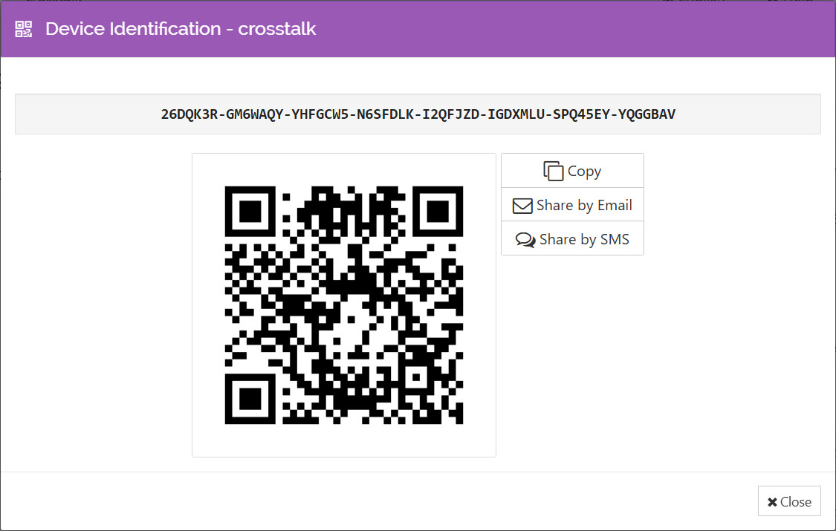

- Set the Device Name to something meaningful to yourself. This might be Daniel Patterson's Software, PowerMake Systems, or some other term familiar to you.
- In the Advanced tab, you can set Device rate limits to limit incoming data rate, outgoing data rate, or both.
- Click Save. At that time, a request will be sent to my Syncthing configuration panel.

Please send an email to danielanywhere@outlook.com with the following information so I know that there is a request and can correlate your request with the folder that should be shared to you, in this case "Distributions". You aren't required to send any identifying information, the request only serves as a cross-reference for the folder.
- Subject: Folder request (or something similar).
- Body: Folder name: Distributions; Device ID: (just the first seven characters of your own device ID, found at This Device / Identification of your configuration page).

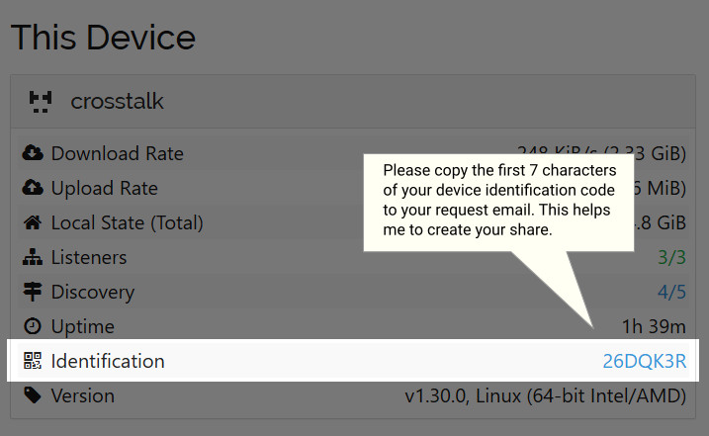

After I have successfully attached your device and shared the Distributions folder with you, I will send you a response email letting you know that you can check your configuration page to finish receiving that folder.
These are the general steps in receiving the share.
- A message appears on your configuration page having a message similar to the following.
New Folder - yyyy-mm-dd hh:mm:ss
{RemoteDeviceName} wants to share folder "Distributions". Add new folder?
Choices: Add, Ignore, Dismiss
- Click Add.
- In the General tab, Folder Path textbox, type or paste the path to the folder to be used or created. You can use a tilde character (~) to indicate your user path, as in ~\PowerMake\Distributions. You could also specify a specialized machine path for file sharing like C:\Files\PowerMake\Distributions, etc.

Install CaptionAll
To install CaptionAll from the Distributions shared folder, double-click to run {BaseSharePath}\Distributions\CaptionAll\Setup\CaptionAllSetup.exe.
Follow the instructions in the Wizard, clicking Next after each page, then finally, Finish to complete the installation.

GitHub
This application and all of its parts are available in source format on a GitHub repository. From there, you can compile and run a version of CaptionAll that gives you complete control over the entire application, including customization, adding or removing features, and contributing to the project, the latter of which is a subject of a different discussion.

There are multiple development environments you can use. Among those are the following.
- Full-featured and free Microsoft Visual Studio Community Edition (https://visualstudio.microsoft.com/).
- Lightweight and free VSCode + .NET platform (https://code.visualstudio.com/ + https://dotnet.microsoft.com/en-us/download).

Using the .NET platform as a common base, you can also download and use several other development systems that range from the full-featured Jetbrains Rider (https://www.jetbrains.com/rider/) to the basic text editor known as Notepad++ (https://notepad-plus-plus.org/).

In this exercise, we'll download and install .NET and VSCode because they both have a wide range of other general uses.

Install GitHub Desktop Client
The easiest and most reliable method for interfacing with GitHub repositories is to download and install the GitHub Desktop application. Follow these steps to get that application.

- Navigate to GitHub's desktop client download page at https://desktop.github.com/download/.
- Click Download for Windows (64bit).
- Open the downloaded file. Installation might occur automatically. In that case, GitHub Desktop will open as soon as the installation has completed.

Clone the CaptionAll Repository
With GitHub installed, there are only a few steps required to clone any repository.

- Select the menu option File / Clone Repository.
- Select the URL tab.
- In the Repository URL textbox, type danielanywhere/CaptionAll
- Type or select a local target path in which to place the project.
- Click Clone.

Install Microsoft .NET
CaptionAll is a .NET application running in safe, managed mode. To run it from source code, you will need to have the .NET SDK installed on your PC. Follow these steps to download and install that SDK.

- Navigate to Microsoft's .NET download page at https://dotnet.microsoft.com/en-us/download
- At the time of this writing the active .NET version was 10.0. Click Download .NET SDK x64.
- In the downloaded files list, click to run the file having the pattern dotnet-sdk-vv.v.vvv-win-x64.exe.
- Click Install to install the SDK.

Install VSCode
Otherwise known as VSCode, Microsoft Visual Studio Code is an extremely versatile, cross-platform, open-source text editor that uses extensions to allow it not only to understand how to format and display text from programming languages, but any other popular kind of structured text. Follow these steps to complete the configuration of VSCode for use with a .NET project.

- Navigate to Microsoft's VSCode download page at https://code.visualstudio.com/.
- Click Download for Windows.
- In your download files list, click to run the file with the naming pattern VSCodeUserSetup-x64-v.vvv.v.exe. Follow the instructions to complete the installation.

Compile and Run CaptionAll
As soon as you have the repository and the .NET SDK installed on your local PC, you can compile and run CaptionAll. The following steps assume you are using VSCode.

- Run VSCode.
- Select the menu option File / Open Folder.
- Select the folder {BaseFolderName}\CaptionAll\Source.
- Click Select Folder.
- Select the menu option View / Terminal.
- Type dotnet build then press [Enter]. The project should build successfully.
- Type dotnet run --project CaptionAll then press [Enter]. CaptionAll should run as expected and be ready to use.

The above steps run the project in a bare-bones approach that allows you to view all of the source files in the process. If you would like to activate features like syntax highlighting, debugging, and hyperlink-style code navigation, you can follow these additional steps to install the C# Dev Kit extension using the following additional steps.

- In VSCode, select the menu option View / Extensions.
- In the Search Extensions in Marketplace textbox, type C# Dev.
- On the extension titled C# Dev Kit, click Install.
- If prompted, click Restart Extensions.

