CaptionAll Closed Captioning Editor

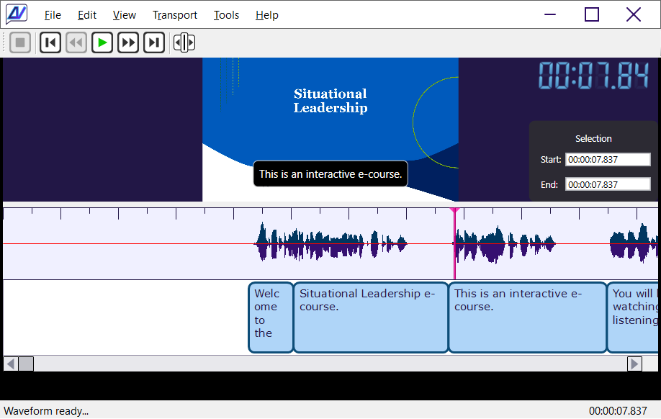
{BannerImage,CaptionAll Page Banner,Images/Screenshot918x582.png}

An intuitive, easy-to-use, fast-action, precise closed-caption editor desktop application for Windows.

{Line}

Current Features
CaptionAll currently offers the following features.

- Head and tail of each caption move in unison unless they are explicitly separated.
- Several styles of available caption editing functions like Text, Width, Insert Space, Insert Caption, Toggle Caption | Space, Merge Captions, Delete Caption and Find and Replace in captions.
- Several selection styles such as Current Time, Selection Start Time, Selection End Time, Select None, Select Time From Caption, Snap Caption To Selection, and Center Cursor On Screen.
- Easy access to track transport like Space or F5 to Play/Pause, F4 or left arrow key to go back 5 seconds, and F6 or right arrow key to go forward five seconds.
- Mouse scroll pans the timeline window left and right.
- Ripple mode editing allows you to decide whether inserting or deleting will affect the position of all remaining captions to the right.
- Speed dial list provides up to nine quick values that can be inserted into the caption text with the press of a button.
- Passive project-based handling. Load a caption file and a media file together with additional settings using a separate project file. Each source file remains available for direct use on the file system.

{Line}

Keyboard Shortcuts
Following is the complete list of available keyboard shortcuts.

Menu | Key | Description
 | Mouse Scroll Down | Pan right on caption timeline.
 | Mouse Scroll Up | Pan left on caption timeline.
 | Esc | Shrink the form back to normal size from full screen mode.
 | F11 | Maximize the form to full screen.
Edit / Caption Properties | Ctrl + Enter | Edit the values associated with the selected caption. (Alt, E, P)
Edit / Caption Text | F2 | Edit the text of the currently selected caption. (Alt, E, T)
Edit / Caption Width | Ctrl + W | Set the width of the selected caption. (Alt, E, W)
Edit / Current Time | Ctrl + T | Set the playhead to a specific time. (Alt, E, R)
Edit / Delete Caption | Ctrl + L | Delete the selected caption. (Alt, E, D)
Edit / Insert Caption | Ctrl + I | Insert a caption at the current selection or mouse position. (Alt, E, C)
Edit / Insert Space | Ctrl + Shift + I | Insert a space at the current selection or mouse position. (Alt, E, S)
Edit / Ripple On | Off | Ctrl + R | Toggle ripple mode on and off. (Alt, E, I)
Edit / Select Time From Caption | Ctrl + Shift + T | Set the selection range to the position and width of the selected caption. (Alt, E, L)
Edit / Selection End Time | F9 | Set the end time of the selection. (Alt, E, E)
Edit / Selection Start Time | F8 | Set the start time of the selection. (Alt, E, A)
Edit / Snap Caption To Selection | Ctrl + E | Set the caption start and width values to the current selection. (Alt, E, N)
Edit / Toggle Caption | Space | Ctrl + G | Convert the area at the current selection or mouse location between a caption and a space. (Alt, E, O)
Edit / Undo | Ctrl + Z | Undo the most recent action. (Alt, E, U)
File / Exit | Alt + F4 | Close the application. (Alt, F, X)
File / Open Captions | Ctrl + O | Open a caption file. (Alt, F, C)
File / Open Media | Ctrl + M | Open a media file. (Alt, F, M)
File / Save Captions | Ctrl + S | Save the currently open caption file. (Alt, F, S)
File / Save Captions As ... | Ctrl + Shift + S | Save the currently open caption file with a new filename. (Alt, F, A)
Transport / Go Back 5 Seconds | F4 or  Left Arrow | Move the playhead backward 5 seconds. (Alt, T, B)
Transport / Go Forward 5 Seconds | F6 or  Right Arrow | Move the playhead forward 5 seconds. (Alt, T, F)
Transport / Go To End | F7 | Move the playhead to the end of the track. (Alt, T, E)
Transport / Go To Start | F3 | Move the playhead to the start of the track. (Alt, T, S)
Transport / Play | Pause (Space Key) | F5 or  Space | Toggle between play and pause. (Alt, T, P)
Transport / Stop | Alt + F5 | Stop playing and reset the playhead position to 0. (Alt, T, S)
View / Center Cursor On Screen | Ctrl + Shift + C | Scroll the caption display area to center the playhead on the display. (Alt, V, C)

{Line}

Coming Soon
The following features are scheduled to be available soon to any existing owners of CaptionAll.
- Much more documentation.
- Easier methods of distribution and setup.
- When in ripple mode, real-time mouse resizing of a caption will be applied when the edge is dropped.
- Export of text-based transcript from current layout of captions.

