CaptionAll - Getting Started Guide
By Daniel Patterson
Last Revised: 02/09/2026

Introduction
CaptionAll is a high-performance closed-captioning editor designed for speed, precision, and smooth media interaction.
This application was originally written to achieve blazing productivity at perfect quality while creating captions from scratch for video or audio media. When used in conjunction with AI captioning services, CaptionAll is even more useful as a tool for achieving and delivering perfect timing and acuity on every project.

Following are only some of the key capabilities at a glance.

- Timeline editing.
- Bubble positioning.
- Ripple mode.
- Speed-dial text.
- Project handling.
- VTT support.

License and Source Repository
This software is distributed as open-source under the GNU AFFERO GENERAL PUBLIC LICENSE Version 3, 19 November 2007. You can find the source code at https://github.com/danielanywhere/CaptionAll

Understanding the Workspace
CaptionAll's workspace is oriented toward providing a large video preview area and large timer at the top, bordered on the bottom by a caption bubble stream oriented horizontally in a timeline-style.

Video Preview
The video preview is the most predominant area of the main form, providing a large, comfortable viewing area. The area automatically sizes to occupy the maximum available space, retaining the original video shape at all sizes.

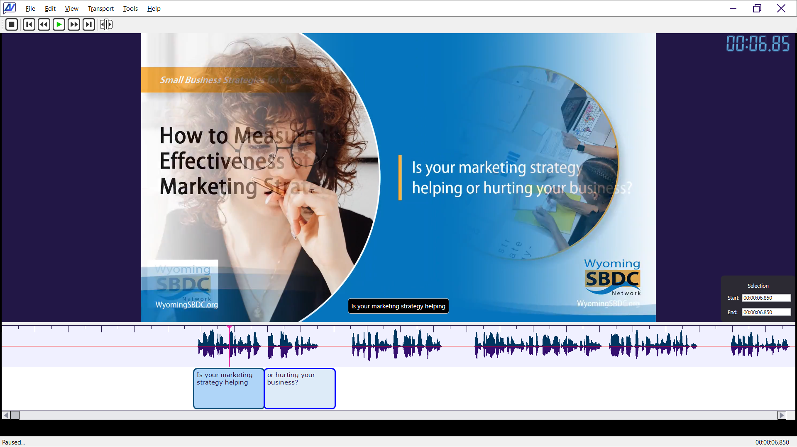
The above image depicts the size of the video preview in a full screen view, while the following image shows the same video preview in a much smaller screen view.

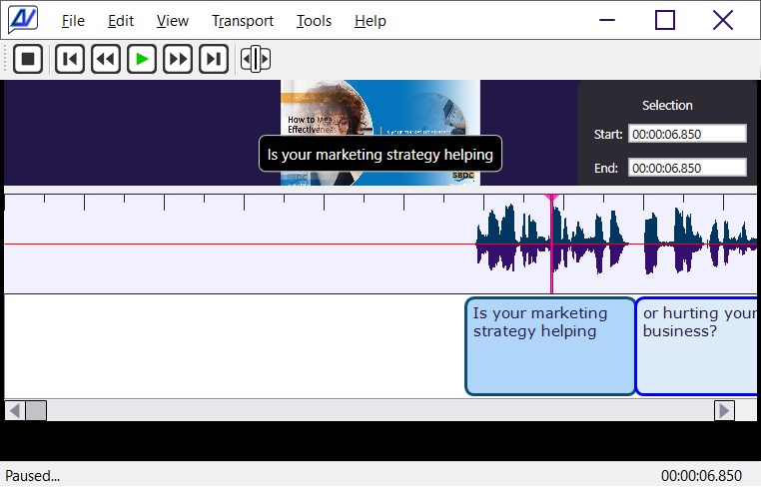

Caption Timeline
The caption timeline is the portion of the editor that displays both the timeline and the caption bubbles in an aligned relationship.
The above image illustrates two horizontal bars in the caption timeline, the timeline bar at the top of the section, and the caption bar at the bottom.

Playhead
The playhead is a small vertical line in the timeline bar indicating the specific active location in time. Click anywhere in the timeline bar to set it.

Selection Area
The selection area is also located in the timeline bar. Following are the mouse behaviors recognized there.
- Single click. Any selected area is cleared and the playhead pointer is moved to that position. Any selected caption bubbles, if present, remain selected.
- Click and drag right. The playhead pointer is positioned at the beginning of the selection and the selected area is extended to the point where you release the mouse button.
- Right-click. Display the caption editing context menu.

Caption Bubbles
Each of the rounded rectangular entries on the caption bar represents a text area. One text entry at a time can be explicitly selected, and the selection state of a text entry can be slightly different than a selected area on the timeline, depending upon the activity.
Following are the mouse behaviors recognized on text objects.
- Single click. Toggle the selection state of this entry. Text item selection is exclusive. When the state changes from unselected to selected, all of the other entries on the timeline are unselected.
- Click and drag near left side of item. Adjust the starting position of the caption, and if present, the ending position of the connected caption to the left.
- Click and drag near right side of item. Adjust the ending position of the caption, and if present, the starting position of the connected caption to the right.
- Double-click. Open the Caption Properties dialog on the caption.
- Right-click. Display the caption editing context menu.

Caption Editing Menus
The caption editing menu is the central focus of tasks and activities while editing anywhere on the caption timeline.
The following commands, available in the caption editing context menu, or in the Edit / Caption and Edit / Selection menus are currently available.
Note that many of the following actions are affected by the status of ripple mode. When ripple mode is off, all changes take place in a local context. When ripple mode is on, in contrast, mouse actions can move all items to the right of the affected item either right or left. For example, when deleting a 1 second caption with ripple mode turned on, all entries to the right of the deleted item will be shifted to the left by 1 second.
- Caption Text [F2]. Add or edit caption text at the currently selected area or caption.
- Caption Width [Ctrl+W]. Adjust the width of the selected caption.
- Insert Space [Ctrl+Shift+I]. Insert a space into the selected space within a caption or across two captions, splitting the caption(s) into two separated units.
- Split Caption [Ctrl+I]. Split the caption at the current playhead position into two separate and connected pieces.
- Toggle Caption | Space [Ctrl+G]. If a caption is selected, that item is converted to a space. Alternatively, if space is selected using the following steps, the space between two captions is converted into a text caption.
  - Steps to convert space to caption:
    - Select an area of blank space.
    - Single click in the blank caption area under the selected range.
    - Right-click and from the context menu, select Toggle Caption | Space.
- Remove Space [Ctrl+R]. Remove the space between two captions, joining the end of the right item to the start of the left item.
- Merge Captions [Ctrl+M]. Merge the contents of two or more captions in the selected area, combining their text.
- Delete Caption [Ctrl+D]. Delete one or more selected captions.
- Caption Properties [Ctrl+Enter]. Set the properties of the caption, including position, width, text, and whether to treat this item as a space.
- Select None [Ctrl+Shift+A]. Clear the selected area and remove any explicit item selection from the selected caption.
- Select Time from Caption [Ctrl+Shift+T]. Use the currently selected caption as the currently selected range.
- Snap Caption to Selection [Ctrl+E]. Adjust the start position and width of the caption under the selected range to the start position and width of that range.

Keyboard-Accelerated Workflow
Most command actions have associated keyboard shortcuts, allowing you to accelerate your workflow significantly over other caption editors. See the Keyboard Shortcut List appendix for a complete list of available shortcut keys.

Using Undo
CaptionAll is very forgiving if you change your mind or make a mistake and want to go back a few steps. Any time you want to reverse an action you've made, either press [Ctrl+Z] or select the menu option Edit / Undo (Recent action name).

Projects versus Raw Caption and Media Files
In this application, the project file is a completely separate and passive information file, not affecting the captions or media at all, but instead, allowing you to create and maintain a cross-reference between those files that allows you to load or unload related files simultaneously for convenience.
When the changes on a project file are saved, any changes to the caption file are saved along with whatever changes there might have been to file associations since the last save was performed.

A Sample Workflow: Creating and Editing Captions
Possibly the best way to visualize a productive workflow in action is to run through an actual activity where we are going to create the captions from scratch.

Load Your Media
With media loaded, you have more of a visual cue by which to insert your captions. One quick way to define captions for media is to bulk select an entire pulse area, like so.

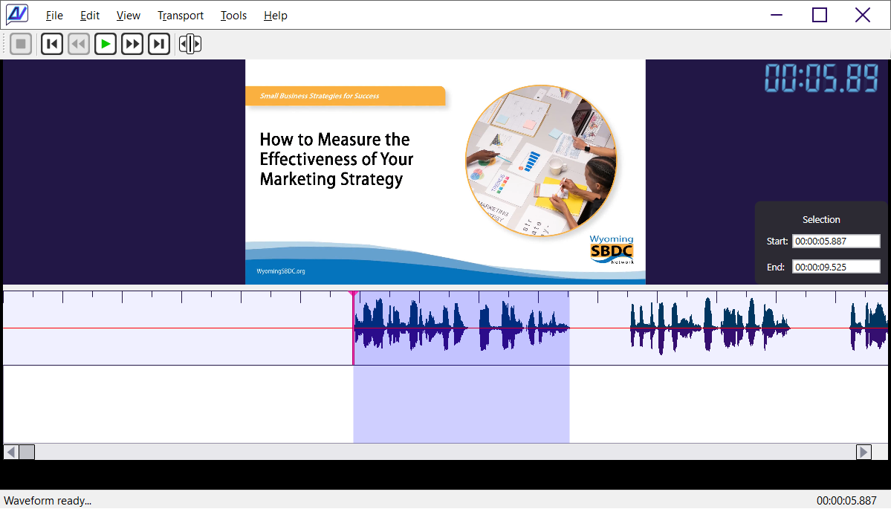

Preview and Edit a Pulse
Press [Space] to preview the selected audio.
Press [F2] to type in about 34 characters of what you have heard.
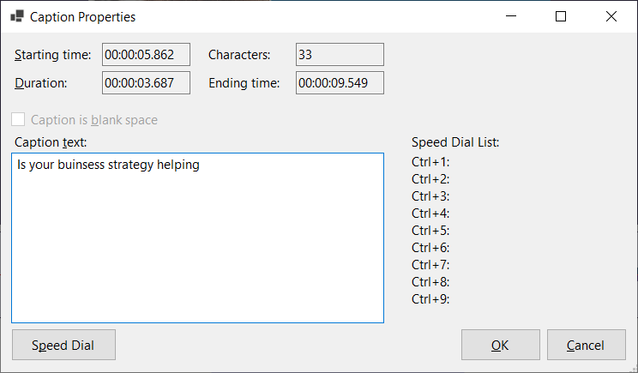

Position and Slice
Reposition the playhead to catch the sub-pulse.

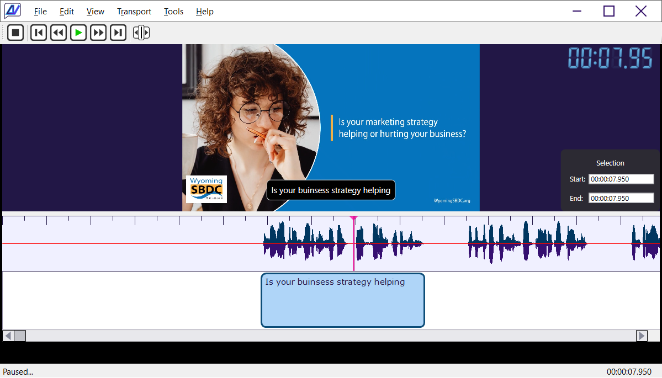
Right-click and select Split Caption, or press [Ctrl+I].

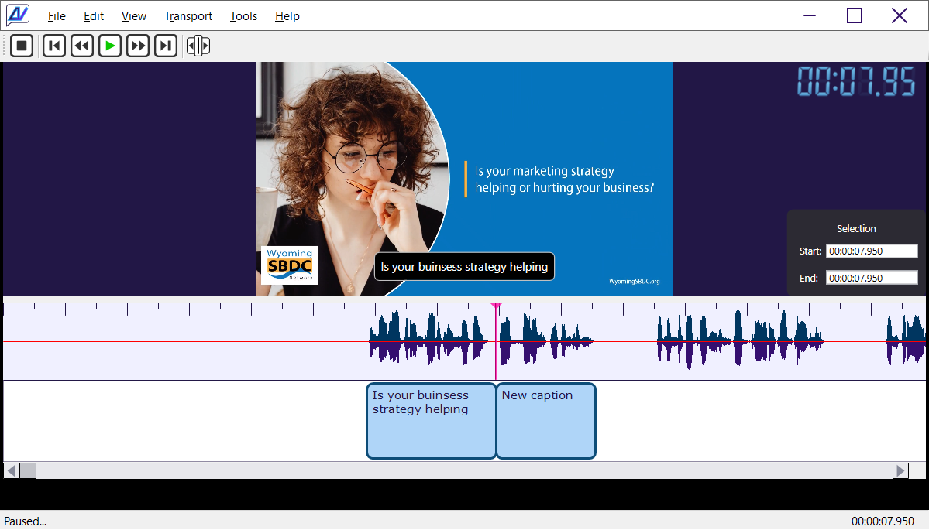

Finish the Phrase
Double-click the second caption to edit its text, then press [Enter].

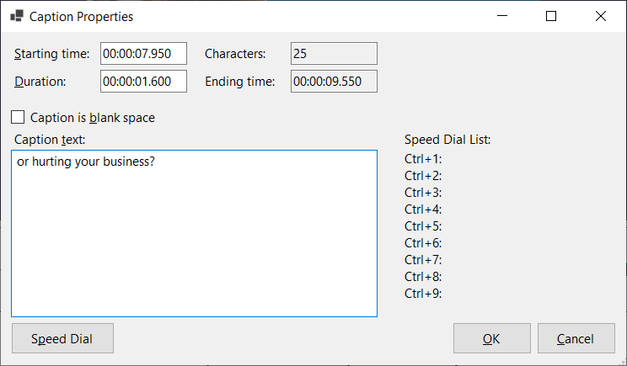
... to result in your first completed audio pulse.

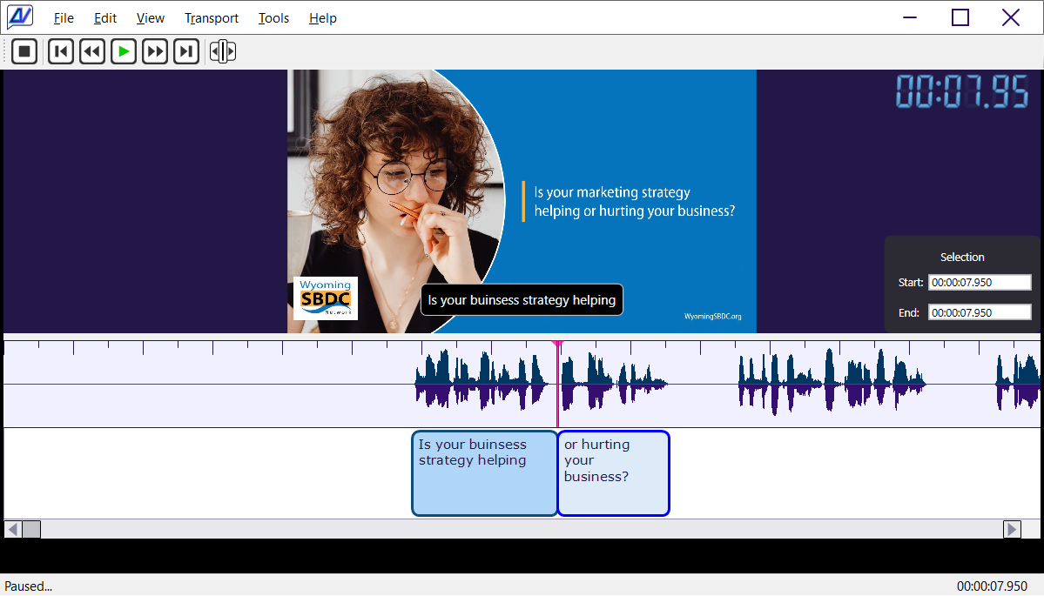
Multiply the above process by approximately 100 times and that's about all there is to creating a complete caption file for a media session. Save your caption file on multiple occasions while in progress so a power outage won't spoil your progress.

Appendices
Reference and support information for CaptionAll.

Keyboard Shortcut List
Following is the complete list of available keyboard shortcuts.
Menu | Key | Description
 | Mouse Scroll Down | Pan right on caption timeline.
 | Mouse Scroll Up | Pan left on caption timeline.
 | Esc | Shrink the form back to normal size from full screen mode.
 | F11 | Maximize the form to full screen.
Edit / Caption Properties | Ctrl + Enter | Edit the values associated with the selected caption. (Alt, E, P)
Edit / Caption Text | F2 | Edit the text of the currently selected caption. (Alt, E, T)
Edit / Caption Width | Ctrl + W | Set the width of the selected caption. (Alt, E, W)
Edit / Current Time | Ctrl + T | Set the playhead to a specific time. (Alt, E, R)
Edit / Delete Caption | Ctrl + L | Delete the selected caption. (Alt, E, D)
Edit / Insert Caption | Ctrl + I | Insert a caption at the current selection or mouse position. (Alt, E, C)
Edit / Insert Space | Ctrl + Shift + I | Insert a space at the current selection or mouse position. (Alt, E, S)
Edit / Ripple On | Off | Ctrl + R | Toggle ripple mode on and off. (Alt, E, I)
Edit / Select Time From Caption | Ctrl + Shift + T | Set the selection range to the position and width of the selected caption. (Alt, E, L)
Edit / Selection End Time | F9 | Set the end time of the selection. (Alt, E, E)
Edit / Selection Start Time | F8 | Set the start time of the selection. (Alt, E, A)
Edit / Snap Caption To Selection | Ctrl + E | Set the caption start and width values to the current selection. (Alt, E, N)
Edit / Toggle Caption | Space | Ctrl + G | Convert the area at the current selection or mouse location between a caption and a space. (Alt, E, O)
Edit / Undo | Ctrl + Z | Undo the most recent action. (Alt, E, U)
File / Exit | Alt + F4 | Close the application. (Alt, F, X)
File / Open Captions | Ctrl + O | Open a caption file. (Alt, F, C)
File / Open Media | Ctrl + M | Open a media file. (Alt, F, M)
File / Save Captions | Ctrl + S | Save the currently open caption file. (Alt, F, S)
File / Save Captions As ... | Ctrl + Shift + S | Save the currently open caption file with a new filename. (Alt, F, A)
Transport / Go Back 5 Seconds | F4 or  Left Arrow | Move the playhead backward 5 seconds. (Alt, T, B)
Transport / Go Forward 5 Seconds | F6 or  Right Arrow | Move the playhead forward 5 seconds. (Alt, T, F)
Transport / Go To End | F7 | Move the playhead to the end of the track. (Alt, T, E)
Transport / Go To Start | F3 | Move the playhead to the start of the track. (Alt, T, S)
Transport / Play | Pause (Space Key) | F5 or  Space | Toggle between play and pause. (Alt, T, P)
Transport / Stop | Alt + F5 | Stop playing and reset the playhead position to 0. (Alt, T, S)
View / Center Cursor On Screen | Ctrl + Shift + C | Scroll the caption display area to center the playhead on the display. (Alt, V, C)

Available Menu Options
Following is a list of all of the available menu options with brief descriptions of their uses.

Main Form
This is the list of menu options found on the main form.
- File / New. Clear the media, captions, and workspace to start work on a different set of files.
- File / Load Project. Load a predefined CaptionAll project file (*.captionproject.json).
- File / Save Project. Save information about the currently loaded media and caption files so they can be loaded again quickly in the future. Note that when using a project, the media and caption files remain separate.
- File / Save Project As. Using a new name, save information about the currently loaded media and caption files so they can be loaded again quickly in the future.
- File / Open Captions. Open a caption file for viewing or editing.
- File / Save Captions. Save the changes to the currently loaded caption file, creating a new file if it has not yet been saved.
- File / Save Captions As. Save the changes to the currently loaded caption file under a new filename.
- File / Open Media. Open a video or audio file for captioning reference.
- File / Exit. Exit CaptionAll.
- Edit / Undo. Reverse the last-known action.
- Edit / Find. Find text in the first matching caption. Match is case-insensitive.
- Edit / Find Again. Find the next caption containing matching text.
- Edit / Find and Replace. Find, and optionally, replace instances of text with another value. Match is case-insensitive.
- Edit / Ripple On | Off. Toggle ripple mode on and off.
- Edit / Speed Dial List. Enter up to 9 separate text values that can be inserted at the cursor in your caption text by pressing a shortcut key [Ctrl+1] through [Ctrl+9].
- Edit / Caption / Caption Text. Edit the currently selected caption or insert a new caption in the selection.
- Edit / Caption / Caption Width. Precisely set the width of the selected caption, in seconds.
- Edit / Caption / Insert Space. Insert a space into a caption, splitting it if a single caption is selected. Otherwise, if multiple captions are selected, insert the selected amount of space between them.
- Edit / Caption / Split Caption. Split the selected caption at the playhead.
- Edit / Caption / Toggle Caption | Space. Convert a text caption to space or visa versa.
- Edit / Caption / Merge Captions. Merge two or more selected captions.
- Edit / Caption / Delete Caption. Delete one or more selected captions.
- Edit / Caption / Caption Properties. Edit the properties of the first selected caption.
- Edit / Selection / Current Time. Set the current playhead time.
- Edit / Selection / Selection Start Time. Focus the cursor on the Selection Start textbox.
- Edit / Selection / Selection End Time. Focus the cursor on the Selection End textbox.
- Edit / Selection / Select None. Deselect the timeline range and any selected caption item.
- Edit / Selection / Select Time From Caption. Set the timeline bar selection from the currently selected caption.
- Edit / Selection / Snap Caption to Selection. Move and adjust the width of the caption within the timeline selection area to the left and right boundaries of that area.
- Edit / Set Track Duration. Set the master width of the caption track, overriding the width that was set when opening the media file.
- View / Center Cursor on Screen. Scroll the caption timeline view to the point where the current playhead position is horizontally in the middle of the screen.
- Transport / Stop. Stop playing loaded media and position the playhead at the beginning of the timeline.
- Transport / Go To Start. Reposition the playhead to the beginning of the timeline.
- Transport / Go Back 5 Seconds. Move the playhead to the left 5 seconds from the current time.
- Transport / Play | Pause (Space Key). Toggle between play and pause status.
- Transport / Go Forward 5 Seconds. Move the playhead to the right 5 seconds from the current time.
- Transport / Go To End. Reposition the playhead to the end of the timeline.

Transport Controls
Transport controls are the core buttons that let users move through audio or video. They provide quick, predictable ways to start, stop, pause, or navigate within media.



Following is a breakdown of the six buttons shown in the image, in the order they appear from left to right.

Icon | Name | Behavior
 | Stop | Playback stops completely, and the playhead returns to the beginning.
 | Skip to Previous | Move the playhead to the beginning of the media.
 | Move Backward | Rewind 5 seconds.
 | Play | Start playback.
 | Pause | Pause the playback, leaving the playhead at its last-known position.
 | Move Forward | Fast-forward 5 seconds.
 | Skip to Next | Move the playhead to the end of the media.

Supported Caption File Formats
The following caption file types are currently supported.
- WebVTT (*.vtt). Real-time editing, open, save.
- SubRip Subtitle (*.srt). Export only.

Supported Media File Formats
The following media file types are currently supported by the File / Open Media menu option.
- *.mp3. MPEG-3 audio files.
- *.mp4. MPEG-4 video files.
- *.m4a. MPEG-4 audio files.
- *.wav. PCM digital audio files.

Glossary of Terms

Bubble Positioning
The process of adjusting where caption bubbles appear on the timeline or screen, ensuring proper timing and readability.

Caption Bar
The lower horizontal bar in the caption timeline that displays all caption bubbles in chronological order.

Caption Bubble
A rounded rectangular block representing a single caption's text and timing. Each bubble can be selected, resized, split, merged, or edited.

Caption Properties
A dialog window that allows editing of a caption's text, timing, width, position, and whether it is treated as a caption or a space.

Caption Text
The written content inside a caption bubble. It can be edited directly or via the Caption Text command.

Caption Timeline
The combined visual area containing the timeline bar and caption bar, used for navigating and editing caption timing.

Connected Captions
Two captions that share a boundary. Adjusting the width of of the left item in the relationship directly adjusts the position of the right item. Conversely, adjusting the position of the right item in the relationship directly adjusts the width of the left item.

Context Menu
A right-click menu offering caption editing commands such as Split, Merge, Delete, or Toggle Caption | Space.

Double-Click
A quick action of the mouse consisting of the sequence click, release, then click and release again.

Insert Space
A command that inserts a gap between captions or splits a caption into two separate bubbles.

Media File
An audio or video file (e.g., MP4, MP3, WAV) loaded into CaptionAll for reference during caption creation.

Playhead
A vertical line on the timeline bar indicating the current playback position. Clicking the timeline moves the playhead.

Project File
A separate file that stores references to both media and caption files, allowing them to be reopened together without altering the originals.

Pulse / Sub-Pulse
A segment of audio used as a natural unit for captioning. Pulses help define where captions begin and end.

Ripple Mode
An editing mode where changes to one caption (such as deleting or resizing) automatically shift all captions to the right. When off, edits affect only the selected caption and any connected partners.

Selection Area
A highlighted range on the timeline bar used to define a time span for editing actions such as snapping, splitting, or inserting.

Snap Caption to Selection
A command that adjusts a caption's start and end times to match the boundaries of the selected timeline area.

Space (Caption Space)
A non-text gap between two captions. Spaces can be inserted, removed, or converted into captions.

Speed-Dial Text
A feature allowing users to store up to nine frequently used text snippets and insert them quickly using keyboard shortcuts.

Split Caption
A command that divides a single caption bubble into two separate captions at the playhead position.

Timeline Bar
The upper bar in the caption timeline that displays time markers and allows range selection and playhead movement.

Transport Controls
Playback buttons (Play, Pause, Stop, Forward, Backward, Skip) used to navigate through media.

Undo
A feature allowing reversal of the most recent action using Ctrl+Z.

VTT (WebVTT)
A caption file format supported for full editing, saving, and real-time updates.

Width (Caption Width)
The duration of a caption bubble, adjustable via dragging or the Caption Width command.

Index
about 6, 9, 12
above 2, 3, 9
Accelerate 5
achieve 1
achieving 1
across 4
action 1, 4, 5, 6, 10, 12, 18, 19, 21
actions 4, 5, 19
active 3
activities 4
activity 3, 6
actual 6
acuity 1
Add 4
Adjust 4, 5, 13, 17, 19, 21
adjustable 21
adjusting 17
adjusts 17, 19
affect 4, 5, 19
affected 4
affecting 5
AFFERO 1
again 12, 18
aligned 3
all 1, 2, 3, 4, 5, 9, 10, 12, 13, 17, 18, 19, 21
allowing 5, 18, 19, 21
allows 5, 17, 19
along 6
also 3
Alt 4, 10, 11, 18
altering 18
Alternatively 4
amount 13
and 1, 2, 3, 4, 5, 6, 7, 9, 10, 11, 12, 13, 15, 17, 18, 19, 21
another 12
any 1, 3, 4, 5, 6, 13
anywhere 1, 3, 4
appear 15, 17
Appendices 10
appendix 5
application 1, 5, 10
approximately 9
are 1, 2, 3, 4, 5, 6, 10, 11, 13, 15, 16, 17, 19
area 2, 3, 4, 5, 6, 10, 11, 13, 17, 19
Arrow 11
associated 5, 10
associations 6
audio 1, 6, 8, 12, 15, 16, 18
automatically 2, 19
available 2, 4, 5, 10, 12
back 5, 10, 11, 13, 15, 18, 20
backward 11, 15, 20
bar 3, 13, 17, 18, 19
bars 3
been 6, 12
begin 3, 13, 15, 18
beginning 3, 13, 15
behavior 3, 4, 15
behaviors 3, 4
best 6
between 4, 5, 10, 11, 13, 18, 19
blank 4, 5
blazing 1
block 17
bordered 2
both 3, 18
bottom 2, 3
boundaries 13, 19
boundary 17
breakdown 15
brief 12
bubble 1, 2, 3, 17, 18, 19, 21
bubbles 3, 17, 18
bulk 6
but 1, 3, 5, 15, 20
button 3, 15, 20
buttons 15, 20
can 1, 3, 4, 5, 12, 17, 19
capabilities 1
Caption 1, 2, 3, 4, 5, 6, 7, 8, 9, 10, 11, 12, 13, 16, 17, 18, 19, 21
captionall 1, 2, 5, 10, 12, 18
captioning 1, 12, 18
captionproject 12
captions 1, 4, 5, 6, 10, 12, 13, 17, 18, 19
case-insensitive 12
catch 7
Center 11, 13
central 4
change 4, 5, 6, 12, 19
changes 4, 6, 12, 19
characters 6
chronological 17
clear 3, 5, 12
cleared 3
Click 3, 4, 5, 7, 8, 18
Clicking 18
close 1, 10
code 1
com 1, 2, 4, 5, 8, 9, 10, 15, 17, 18, 19, 21
combined 17
combining 5
comfortable 2
command 4, 5, 17, 18, 19, 21
commands 4, 18
complete 5, 8, 9, 10, 15
completed 8
completely 5, 15
conjunction 1
connected 4, 17, 19
consisting 18
containing 12, 17
content 5, 17
contents 5
context 3, 4, 5, 18
contrast 4
controls 15, 20
convenience 5
Conversely 17
convert 4, 10, 13, 19
converted 4, 19
core 15
create 5, 6
creating 1, 6, 9, 12
creation 18
cross-reference 5
Ctrl 4, 5, 7, 10, 11, 12, 21
cue 6
current 4, 5, 10, 12, 13, 16, 18
currently 4, 5, 10, 12, 13, 16
cursor 11, 12, 13
daniel 1
danielanywhere 1
define 6, 12, 18, 19
Delete 4, 5, 10, 13, 18
deleted 4
deleting 4, 19
delivering 1
depending 3
depicts 2
description 10, 12
descriptions 12
deselect 13
designed 1
dial 1, 4, 12, 17, 19
dialog 4, 17
different 3, 12
digital 16
directly 17
display 3, 4, 11, 17, 19
displays 3, 17, 19
distributed 1
divides 19
Double-click 4, 8
Down 10, 15
drag 3, 4, 21
dragging 21
Duration 13, 21
during 18
Each 3, 17
edit 1, 3, 4, 5, 6, 8, 10, 12, 13, 16, 17, 18, 19, 21
edited 17
editing 1, 3, 4, 6, 12, 16, 17, 18, 19, 21
editor 1, 3, 5
editors 5
edits 19
either 4, 5
end 3, 4, 5, 10, 11, 13, 14, 15, 18, 19
ending 3, 4
ensuring 17
Enter 5, 8, 10, 11, 12, 13
entire 6
entries 3, 4
entry 3, 4
Esc 10, 12
even 1
every 1
example 4
exclusive 4
Exit 10, 12
explicit 3, 5
explicitly 3
Export 16
extended 3
Fast 15
fast-forward 15
feature 19, 21
few 5
file 5, 6, 9, 10, 12, 13, 16, 18, 21
filename 10, 12
Files 5, 12, 16, 18
files that allows you to 5
find 1, 12
finish 8
first 8, 12, 13
focus 4, 13
following 1, 2, 3, 4, 10, 12, 15, 16
for 1, 2, 4, 5, 6, 9, 10, 11, 12, 13, 15, 16, 17, 18, 19, 20, 21
forgiving 5
form 1, 2, 6, 10, 12, 16, 21
format 5, 10, 12, 16, 21
Formats 16
forward 11, 13, 15, 20
found 12
frequently 19
from 1, 5, 6, 10, 13, 15
full 2, 10, 21
future 12
gap 18, 19
GENERAL 1
Getting 1, 2
github 1
glance 1
Glossary 17
GNU 1
going 6
guide 1, 2
handling 1
has 12
have 5, 6
heard 6
help 18
highlighted 19
horizontal 2, 3, 13, 17
horizontally 2, 13
https 1
Icon 15
illustrates 3
image 2, 3, 15
including 5
Index 22
indicating 3, 18
information 10, 12
Insert 4, 6, 10, 12, 13, 18, 19
inserted 12, 19
inserting 19
inserts 18
inside 17
instances 12
instead 5
interaction 1
into 4, 13, 18, 19
Introduction 1
item 4, 5, 13
items 4
its 4, 8, 15, 18, 19
joining 5
json 12
key 1, 5, 10, 11, 12, 13, 19
Keyboard 5, 10, 19
Keyboard-Accelerated 5
keys 5
large 2
Last 1, 6, 12, 15
last-known 12, 15
leaving 15
left 4, 5, 10, 11, 13, 15
let 4, 5, 8, 9, 10, 13, 15, 18, 19
License 1
like 6
line 1, 2, 3, 4, 10, 13, 14, 17, 18, 19
List 5, 10, 12
load 5, 6, 12, 13, 18
load related files 5
loaded 6, 12, 13, 18
local 4
located 3
location 3, 10
lower 17
made 5
main 2, 3, 5, 12
maintain 5
make 5
many 4
markers 19
master 13
match 12, 19
matching 12
maximize 10
maximum 2
media 1, 5, 6, 9, 10, 12, 13, 15, 16, 18, 20
menu 3, 4, 5, 10, 12, 16, 18
menus 4
merge 5, 13, 17, 18
merged 17
middle 13
might 6
mind 5
mistake 5
mode 1, 4, 10, 12, 19
more 1, 5, 6, 13
most 2, 5, 10, 21
mouse 3, 4, 10, 18
move 3, 4, 5, 11, 13, 15, 18, 19
moved 3, 19
movement 19
moves 18
MPEG 16
much 2
multiple 9, 13
Multiply 9
name 5, 10, 12, 15
natural 18
navigate 15, 20
navigating 17
near 4
new 10, 12
next 12, 15
nine 19
None 5, 13
normal 10
Not 4, 5, 12
Note 4, 12
November 1
objects 4
occasions 9
occupy 2
off 4, 10, 12, 18, 19
offering 18
one 3, 5, 13, 19
only 1, 16, 19
open 1, 4, 10, 12, 13, 16, 18
open-source 1
opening 13
option 5, 12, 16
optionally 12
Options 12
order 2, 15, 17
oriented 2
original 1, 2, 18
originally 1
originals 18
other 4, 5, 12, 13
otherwise 13
our 1, 5, 6, 8, 9, 12
outage 9
over 5, 13
overriding 13
Pan 10, 19
partners 19
passive 5
Patterson 1
pause 11, 13, 15, 20
PCM 16
perfect 1
performed 6
Phrase 8
pieces 4
place 4, 12
play 3, 4, 7, 10, 11, 13, 14, 15, 17, 18, 19, 20
Playback 15, 18, 20
Playhead 3, 4, 7, 10, 11, 13, 14, 15, 18, 19
playing 11, 13
point 3, 13
pointer 3
portion 3
position 1, 3, 4, 5, 7, 10, 11, 13, 14, 15, 17, 18, 19
positioned 3
positioning 1, 17
Possibly 6
power 9
precisely 13
precision 1
predefined 12
predictable 15
predominant 2
present 3, 4, 17
press 5, 6, 7, 8, 12
pressing 12
preview 2, 6
previous 15
process 9, 17
productive 6
productivity 1
progress 9
Project 1, 5, 6, 12, 18
Projects 5
Proper 4, 5, 10, 13, 17
Properties 4, 5, 10, 13, 17
provide 15
providing 2
public 1
Pulse 6, 7, 8, 18
pulses 18
quality 1
quick 6, 12, 15, 18, 19
quickly 12, 19
range 5, 10, 13, 19
Raw 5
readability 17
Real-time 16
Recent 5, 10, 21
recognized 3, 4
rectangular 3, 17
reference 5, 10, 12, 18
references 18
related 5
relationship 3, 17
release 3, 18
remain 3, 12
Remove 5, 19
removed 19
reopened 18
Replace 12
Reposition 7, 13, 14
Repository 1
representing 17
represents 3
reset 11
resized 17
resizing 19
result 8
retaining 2
returns 15
reversal 21
Reverse 5, 12
Revised 1
Rewind 15
right 3, 4, 5, 7, 10, 11, 13, 15, 17, 18, 19
Right-click 3, 4, 5, 7
ripple 1, 4, 10, 12, 19
rounded 3, 17
run 6
Sample 6
save 6, 9, 10, 12, 16
saved 6, 12
saving 21
scratch 1, 6
screen 2, 10, 11, 13, 17
Scroll 10, 11, 13
se 1
Second 4, 8, 11, 13, 15
Seconds 11, 13, 15
section 3
sed 1
See 5
segment 18
select 3, 4, 5, 6, 7, 10, 12, 13, 17, 19
selected 3, 4, 5, 6, 10, 12, 13, 17, 19
Selection 3, 4, 5, 10, 12, 13, 19
separate 4, 5, 12, 18, 19
separated 4
sequence 18
services 1
session 9
set 3, 5, 10, 11, 12, 13
shape 2
share 17
Shift 4, 5, 10, 11, 19
shifted 4
Shortcut 5, 10, 12, 19
shortcuts 5, 10, 19
shown 15
shows 2
Shrink 10
side 4, 17
significantly 5
simultaneously 5
simultaneously for convenience 5
since 6
Single 3, 4, 5, 13, 17, 19
six 15
size 2, 10, 17
sizes 2
Skip 15, 20
Slice 7
slightly 3
small 2, 3
smaller 2
smooth 1
Snap 5, 10, 13, 19
snapping 19
snippets 19
software 1
some 1
source 1
space 2, 4, 5, 6, 10, 11, 12, 13, 17, 18, 19
Spaces 19
span 19
specific 3, 10
speed 1, 12, 19
Split 4, 7, 13, 17, 18, 19
splits 18
splitting 4, 13, 19
spoil 9
srt 16
Start 1, 2, 4, 5, 10, 11, 12, 13, 15, 19
Started 1, 2
starting 4
state 3, 4
status 4, 13
steps 4, 5
Stop 11, 13, 15, 20
stops 15
store 18, 19
stores 18
stream 2
sub-pulse 7
SubRip 16
Subtitle 16
such 18, 19
support 1, 10, 16, 21
Supported 16, 21
take 4, 5
tasks 4
Terms 17
text 1, 3, 4, 5, 8, 10, 12, 13, 17, 18, 19
textbox 13
than 3
that 3, 4, 5, 9, 12, 13, 15, 17, 18, 19
the 1, 2, 3, 4, 5, 6, 7, 8, 9, 10, 11, 12, 13, 14, 15, 16, 17, 18, 19, 21
their 5, 12
them 13, 18, 19
then 8
there 3, 6, 9
they 12, 15
This 1, 4, 5, 12
those 5
through 6, 12, 15, 20
Time 1, 2, 3, 4, 5, 9, 10, 13, 14, 16, 17, 18, 19, 21
timeline 1, 2, 3, 4, 10, 13, 14, 17, 18, 19
timeline-style 2
timer 2
times 9, 19
timing 1, 17
together 18
Toggle 4, 5, 10, 11, 12, 13, 18
tool 1
top 2, 11, 13, 15, 20
top of the section 3
toward 2
track 11, 13
Transport 11, 13, 14, 15, 20
treat 5, 17
treated 17
turned 4
two 3, 4, 5, 13, 17, 18, 19
type 6, 16
types 16
Under 1, 2, 5, 12
Understanding 2
Undo 5, 10, 12, 21
unit 4, 18
units 4
unload 5
unload related files 5
unselected 4
updates 21
upon 3
upper 19
use 1, 3, 4, 5, 10, 11, 12, 13, 15, 17, 18, 19, 20
used 17, 18, 19, 20
useful 1
users 15, 19
uses 12
using 4, 5, 12, 19, 21
value 10, 12
values 10, 12
versa 13, 21
Version 1
versus 5
vertical 3, 18
very 1, 5
via 17, 21
video 1, 2, 12, 15, 16, 18
view 2, 6, 11, 12, 13
viewing 2, 12
visa 13
visual 6, 17
visualize 6
VTT 1, 16, 21
want 5
was 1, 6, 13
wav 16, 18
way 6, 15
ways 15
WebVTT 16, 21
what 6
whatever 6
When 4, 6, 12, 13, 19
where 1, 3, 4, 6, 13, 17, 18, 19
whether 5, 17
which 6
while 1, 2, 4, 9
width 4, 5, 10, 13, 17, 21
will 4
window 17
with 1, 4, 6, 10, 12, 13, 15, 18
within 4, 13, 15
without 18
won 9
Work 2, 5, 6, 12
Workflow 5, 6
workspace 2, 12
written 1, 17
yet 12
you 1, 3, 5, 6, 8, 9, 12
your 5, 6, 8, 9, 12

