# LocalGoods

By Daniel Patterson, MCSD (danielanywhere)

The current prototype version can be seen and used at <https://LocalGoods.azurewebsites.net>

## Index

* Introduction.
* Project Goals.
  + Grower / Maker.
  + Packager / Producer / Distributor.
  + Consumer.

## Introduction

Imagine combining the ease of online shopping giants with the social responsibility and nutritious benefits of both the slow foods and farm-to-fork movements.

Everywhere around the country, we are seeing reports of farmers and ranchers who have excess product to sell to any willing buyers, while at the supermarket, much of that product never becomes available to the end consumer. Instead, there are extreme wastes occurring in a system that was not ready for any kind of change from the status quo of the late 20th century.

In some cases, the bottleneck lies at the meat packer or mid-level producer, while at others, it is a simple lack of packaging that keeps perfectly fine product from being displayed in the store.

Meanwhile, many communities have healthy, functioning co-op stores that not only enjoy the many benefits of local, organic product availability, but who also often have contact information for growing their supply exponentially, if needed.

So, in consideration of increasingly limited supplies available in the commercial supermarket, why haven't we all migrated to our local co-ops already so that we can increase support for our local growers and producers?

There might be multiple reasons we haven't switched to supporting our local economy more fully, but this designer personally believes the main obstacle is only a lack of awareness.

Our culture has lived almost 100 years totally disconnected from our local producers, and now that we are reentering a time in which local sustenance will be the only reliable form of survival for at least some period of time, one thing that can really help both the local producers and our local co-op simultaneously is to make all of the information about local product availability accessible online.

## Project Goals

Multiple distinct types of operations are required to get food from the settings where raw vegetation and animals are grown on an extremely large scale to an individual serving on the consumer's plate. In the recent past, this was a highly proprietary process handled by large-scale organizations, and there wasn't much publicly available information about any of the steps between the farm and the plate, although at the ends of the scale, farming and eating are two professions that a lot of people seem to know a lot about.

The goal of this project can be stated in the single phrase: *Farm-to-fork*. The activities implied by this phrase are as diverse as the day is long, and often distributed into specific segments of specialization.

In the first versions of the system, we will attempt to get the functionality of the modules focused on one of the three following levels.

### Grower / Maker

The grower or original product maker is the source of the local products. Depending upon the output product, this individual needs to purchase grain, soil, seeds, fertilizer, breeding stock, equipment, consumable supplies, and other additional resources.

This individual will most likely be selling to distributor-level parties who can handle the next steps of preparation for the consumer, although he or she can also provide some or all of the final preparation of that product to receive selling prices approaching the final retail value of the product, depending upon the facilities and capabilities available at the source property.

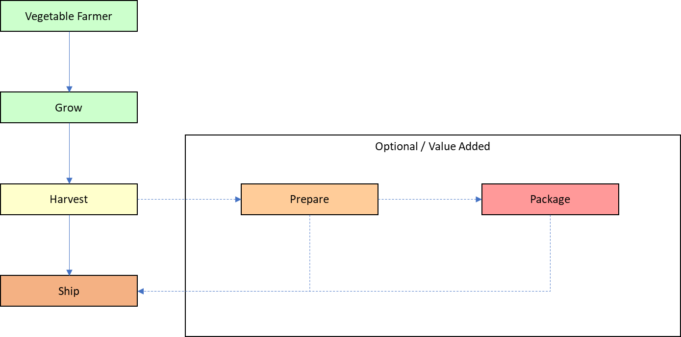

In the above flow chart, the potential activities of a vegetable farmer, and in the following block diagram, some typical activities of a meat producing cattle rancher.

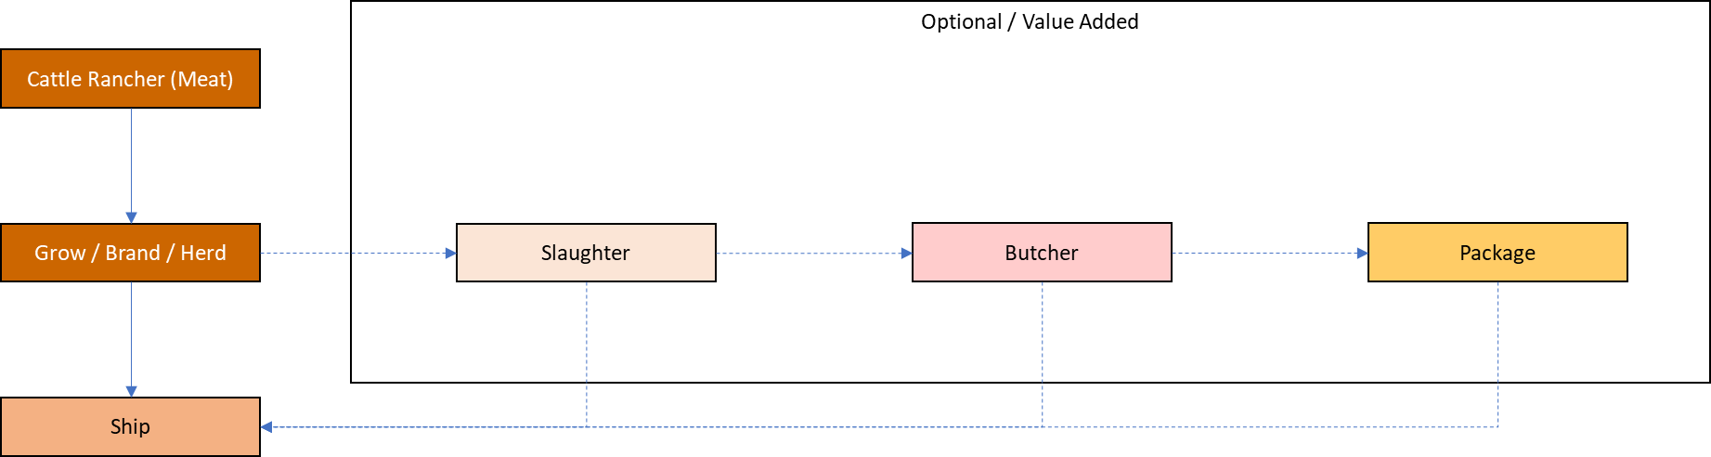

One interesting characteristic to keep in mind about the cyclical nature of markets is that even a large cattle rancher with 1,000 head of grazing cattle will purchase consumer amounts of corn, tomatoes, and possibly even beef on a daily basis. This indicates that the visitor's role on the database should be switchable at any time between vendor, producer, and consumer.

### Packager / Producer / Distributor

In the first versions of this system, all production and distribution functions are hosted at the same role level to help keep the logistics of the system to a minimum. However, a number of functions should be built into the system that allow any mid-level party to perform exchanges with any other.

For example, a hay farmer might place his bails up on the site for sale in the area to be immediately picked up by a warehousing operation that ultimately stores them until fall. In the fall, they are picked up by another distributor who is gathering as many bails as possible for a large ranch 100 miles away. In several cases, the final distributor ends up making transactions with several other handlers prior to the final transaction with the ranch.

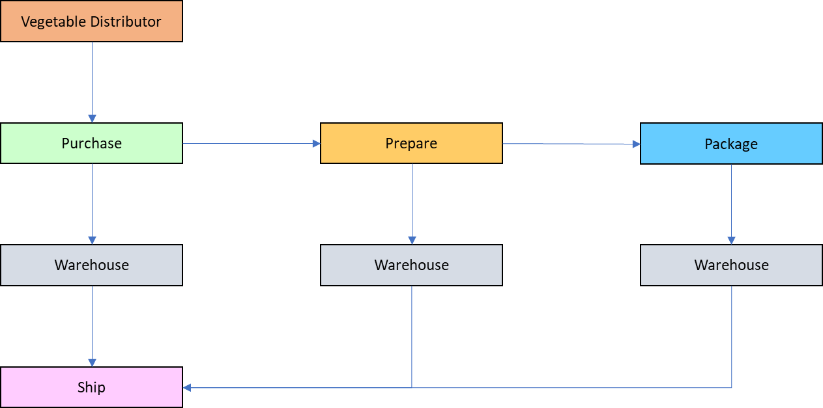

In the above flow chart, a vegetable distributor, and in the following flow chart, some of the general activities of a meat packager and distributor.

Meat distributor feed to market flowchart.


In the earliest versions, activities at the mid-level are considered to be anything that needs to be done to break the high-volume specialized, dirty, unprepared, unpackaged product down into well-defined consumable volumes suitable for individuals and small families.

### Consumer

Although the fewest transitions occur at this stage of production, the fork end of the farm-to-fork concept offers a number of conveniences specifically suited for individual consumption.

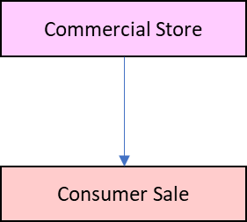

All of the activities at the higher levels of the system are meant to provide the type of infrastructure that can supply the final product to the consumer, meeting the following goals, among others.

* Serving sizes that fit well within the kitchen storage areas of the typical home or apartment.
* General cleanliness and a good basic level of presentation.
* Zero-risk browsing product offerings from farmers, makers, and local co-op centers.
* Shopping list creation and maintenance.
* Online ordering for curbside pickup or direct in-area home delivery.
* Reordering capabilities for often used products.
* Custom ordering capabilities for unstocked items.

The initial phases of the online consumer shopping model are illustrated in the following block diagram.

Online consumer shopping at a local co-op.
