Fabricated or just invisible? A four-source verification cascade for estimating the prevalence of hallucinated references in the scholarly literature
Daniel Aristizábal Torres¹ and Ana María Barrera Rodríguez²
Both authors contributed equally to this work.
¹ Facultad de Ingeniería, Universidad Libre Seccional Pereira, Pereira, Colombia
² Facultad de Ciencias Económicas, Administrativas y Contables, Universidad Libre Seccional Pereira, Pereira, Colombia
D. Aristizábal Torres: daniel.aristizabalt@unilibre.edu.co · ORCID 0000-0002-6552-2585
A. M. Barrera Rodríguez: anam.barrerar@unilibre.edu.co · ORCID 0000-0003-4949-6118
Code and tool: github.com/danielaristo/reference-integrity-checker
Submission type: Original article · Learned Publishing (Wiley) · Working draft v2 (formal register)
ACTION NEEDED The journal converted to Gold Open Access on 1 January 2025: an Article Publication Charge (APC) applies to every accepted paper submitted from 22 August 2024 onward, unless a waiver applies. Check current APC and waiver eligibility (institutional, funder, or country-based) at the journal's Open Access page before submitting.
Abstract
Large language models sometimes generate citations to works that do not exist. We investigate how common this problem actually is, and show that a credible answer requires separating genuine fabrication from two confounders: legitimate scholarship in journals outside the major indexes, and real works rendered unmatchable by abbreviated or malformed citation strings. We developed a four-source verification cascade (Crossref, OpenAlex, Semantic Scholar, and manual review) and applied it to 5,000 unresolved reference strings drawn from 2024 journal articles. The cascade recovered 25.2% as real works the standard citation matcher had missed and flagged 12.3% as citing the correct work under an incorrect year. Of 517 remaining references with the form of a journal article, exhaustive manual verification of the 101 most recent (post-2020) cases found zero confirmed fabrications: every survivor was either a real work published outside the major indexes or a real work whose citation was too abbreviated to match automatically. We conclude that raw non-match rates substantially overstate the prevalence of fabricated references, and we release the verification tool as a free web application at reftruth.com.

Key points
- A four-source verification cascade (Crossref, OpenAlex, Semantic Scholar, manual review) distinguishes fabricated citations from unindexed real works.
- In a 5,000-reference sample, 25.2% of "unresolved" citations were real works the standard matcher had failed to link.
- Manual verification of the 101 highest-risk candidates found zero confirmed fabrications.
- "Not found in a database" is not equivalent to "fabricated": most flagged citations proved to be real but unindexed.
- A free web tool (reftruth.com) lets editors and authors screen bibliographies before publication.

1. Introduction
The widespread adoption of large language models (LLMs) in scholarly writing has produced a new failure mode in the citation record: references that are fluent, correctly formatted, and entirely fictitious. Hallucination, the generation of fluent but unsupported or false content, is a well-documented general property of LLMs and other neural text generators, not a peripheral bug (Ji et al., 2023). In the specific case of bibliographic references, the phenomenon has now been quantified directly: in a systematic test of ChatGPT-generated reference lists across clinical topics, Walters and Wilder (2023) found that 55% of GPT-3.5 citations and 18% of GPT-4 citations were entirely fabricated, with a further substantial share of the nominally real citations containing errors. Emsley (2023) argued that the term "hallucination" understates the problem, and that fluent, confident invention of nonexistent sources is more accurately described as fabrication and falsification, a framing this study adopts. The phenomenon is not confined to biomedicine: Dahl et al. (2024) documented comparable rates when LLMs were queried on legal facts and case citations, and reported court filings, by lawyers and at least one judge, that relied on non-existent case law. LLM-generated fabrication therefore appears to be a general property of these systems rather than an artefact of any one discipline. LLMs are, in turn, also being examined as tools for detecting citation and quotation errors, with mixed accuracy (Zhang & Abernethy, 2024); the cascade developed in this study takes a complementary, deterministic approach, verifying references against source databases rather than relying on model judgement.
Citation integrity, however, was already a fragile part of the scholarly record before generative AI became widely available. Systematic reviews of the biomedical literature have long found quotation error rates of 10–25%, where cited claims misrepresent or fail to support their source (Jergas & Baethge, 2015), and the wider methodological literature on irreproducibility (Ioannidis, 2005) had already established that a substantial share of the published record cannot be trusted at face value. Retractions are at record levels and rising: more than 10,000 papers were retracted in 2023 alone, a two-and-a-half-fold increase on the previous year (Van Noorden, 2023), and retracted work continues to be cited as valid long after retraction. Organised fraud has scaled accordingly: so-called paper mills now produce fabricated manuscripts at a volume that strains the forensic tools built to detect them, including tools that identify "tortured phrases", synonym-substituted wording used to evade plagiarism detection (Cabanac et al., 2021; Abalkina et al., 2025). Citation counts are similarly manipulated through coordinated "citation cartels" that inflate journal and author metrics without scholarly justification (Kojaku et al., 2021), and the boundary between legitimate and predatory venues remains sufficiently contested that the field has not converged on a working definition of "predatory journal" (Grudniewicz et al., 2019). LLM-generated fabrication is therefore best understood as an accelerant applied to an already-strained system of citation trust, rather than as a wholly novel pathology.
A verification study is only as reliable as the infrastructure it verifies against, and that infrastructure has known, uneven coverage. OpenAlex, a fully open index of scholarly works, authors, venues, and institutions, and the Semantic Scholar Academic Graph replaced Microsoft Academic Graph with open, large-scale indexes (Priem et al., 2022; Kinney et al., 2023), and the OpenCitations infrastructure has pushed publishers to release citation links as open, structured data (Peroni & Shotton, 2020). Nonetheless, large-scale comparisons of these and other sources report substantial, systematic differences in coverage by field, document type, and publication year (Visser et al., 2021), echoing earlier comparisons of Google Scholar, Web of Science, and Scopus that found citation counts diverging by discipline-dependent, sometimes large margins (Martín-Martín et al., 2018). These gaps are not evenly distributed: journals published outside North America, Europe, and Oceania, sub-Saharan African journals most severely, are indexed at a fraction of the rate of journals from well-covered regions (Asubiaro et al., 2024), and even OpenAlex, despite broader nominal coverage, exhibits measurable reference-linking gaps relative to Web of Science and Scopus (Culbert et al., 2025). A verification pipeline that treats absence from a single database as evidence of non-existence therefore inherits every one of these coverage biases and, because they follow geographic and linguistic lines, risks systematically misclassifying legitimate scholarship from under-represented regions as fabricated.
This is the specific gap the present study addresses. Existing studies of LLM-generated citation fabrication (Walters & Wilder, 2023; Dahl et al., 2024) report prevalence without correcting for database coverage limits, and existing fraud-detection tools (Cabanac et al., 2021; Abalkina et al., 2025) detect textual fingerprints of fabricated manuscripts without verifying whether individual cited references resolve to real works. Meanwhile, freely available bibliometric software such as VOSviewer (van Eck & Waltman, 2010) and bibliometrix (Aria & Cuccurullo, 2017) demonstrates sustained demand for open, reproducible tooling in this space, yet no existing tool combines multi-source reference verification with an explicit taxonomy that distinguishes fabrication from non-indexation and from citation-matching failure. To our knowledge, no study has estimated the prevalence of fabricated references while explicitly correcting for both confounders at a multidisciplinary, cross-publisher scale.
This study makes three contributions. First, it provides a reproducible methodology, a four-source verification cascade with explicit matching rules, that converts the weak claim "this reference could not be found" into the defensible classification "this reference is unlikely to exist", by routing every unmatched candidate through progressively broader databases and a final layer of human verification. Second, it reports a full accounting of what "unverifiable" references actually are, recoverable, erroneous, non-indexed, and presumably fabricated, alongside two infrastructure findings that emerged from the process: the failure rate of standard citation matching, and a blind spot in retraction flagging caused by duplicate DOI registrations. Third, it releases the verification tool as a free web application (reftruth.com), together with the annotated data and code, so that authors, editors, and reviewers can screen bibliographies before publication.
The remainder of this paper is organised as follows. Section 2 describes the methodology. Section 3 presents the results. Section 4 discusses the implications for editorial practice and scholarly data infrastructure. Section 5 concludes. Section 6 states the limitations of the study.

2. Methodology

2.1 Sampling frame
The unit of analysis is the individual reference string. We drew a random sample of 2024 journal articles from Crossref, restricted to those with open (deposited) reference lists. At the time of sampling, Crossref held 6,092,408 journal articles with a 2024 publication date, of which 57.2% carried a deposited reference list. Within those lists, approximately 31% of references are "unresolved", deposited as raw text without a linked DOI. These unresolved strings are the population of interest, because a fabricated reference, having no real referent, cannot carry a resolved DOI. From approximately 1,200 randomly sampled articles, we extracted 5,000 unresolved reference strings, retaining the citing article's DOI as provenance for each. We note a deliberate selection bias: journals that deposit open references are, on average, the more procedurally rigorous ones, so the prevalence figures reported here should be read as a lower bound on the wider literature.

2.2 Verification cascade
Each reference passes through the cascade until it is resolved or exhausts all sources:
- Stage 1, Crossref. If the string contains a DOI, it is resolved directly; otherwise, a bibliographic query is run and the best title match is accepted.
- Stage 2, OpenAlex. Strings unresolved by Crossref are queried against OpenAlex (approximately 250 million works), which aggregates Crossref, PubMed, DataCite, and repository records.
- Stage 3, Semantic Scholar. Article-shaped strings still unresolved are queried against Semantic Scholar (approximately 220 million works), which indexes substantial non-Crossref content, including delisted and regional journals.
- Stage 4, human review. Strings surviving all three databases are verified manually via web search and classified as existing, unverifiable by design, ambiguous, or fabricated.

2.3 Matching rules
Automated matching accepts a candidate when a sufficient proportion of the significant title tokens (length greater than three characters) appears in the reference string, subject to three safeguards calibrated on a synthetic test set: titles with fewer than three significant tokens are accepted only on a near-perfect match combined with first-author surname presence; when the registered first-author surname is absent from the string, a near-perfect title match is required; and cited years are tolerated within two years of the registered year, to absorb online-first and print date offsets.

2.4 Retraction checking and a duplicate-DOI blind spot
Retraction status is checked in OpenAlex both by DOI and by title. The title-based check is necessary because publishers occasionally register duplicate DOIs for the same work, and the retraction flag may attach to only one of them. In our synthetic test set, the retracted Wakefield et al. (1998) paper resolved to a DOI variant flagged as not retracted, while its canonical DOI carried the flag correctly; a DOI-only check would therefore miss it. We consider this a general vulnerability of retraction-aware screening tools and report it here as a secondary finding.

2.5 Human validation and taxonomy
For the survivor set, we performed exhaustive manual verification of every reference published from 2020 onward, the subset in which LLM-era fabrication, if present, would concentrate. Each was searched on the open web and assigned to one of four classes: confirmed to exist (with venue), author-only or untitled (no title to match, unverifiable by design), ambiguous (a plausible journal not traceable via web search), or confirmed fabricated.
LIMITATION TO FLAG This is single-annotator verification. A stronger version of this study would add a second, independent annotator over a stratified sample of every verdict class and report inter-annotator agreement (e.g., Cohen's kappa), from which the cascade's sensitivity and specificity could be derived and used to correct the raw counts in Section 3.5.

2.6 Reproducibility
All three databases are queried through free, public APIs; no proprietary index is used. The verification code, the sampled references with provenance, and the annotated survivor set are openly available at the repository stated in the data availability statement.

2.7 Public screening tool
Stages 1 and 2 of the cascade (Crossref and OpenAlex) require no proprietary access, and both APIs permit cross-origin requests. We therefore implemented these two stages as a client-side web application that runs entirely in the user's browser: no reference text is transmitted to any server other than the two source databases, and no installation, account, or payment is required. The tool is freely available at reftruth.com and allows an author, editor, or reviewer to paste a bibliography and receive a per-reference verdict within seconds, with a CSV export for manuscript records. Table 3 maps the tool's four verdict states onto the taxonomy of Section 2.5. The full four-source cascade, including Semantic Scholar and the exhaustive human review used for the results reported below, remains available as open-source command-line code in the same repository, since the Semantic Scholar API key cannot safely be embedded in client-side code.
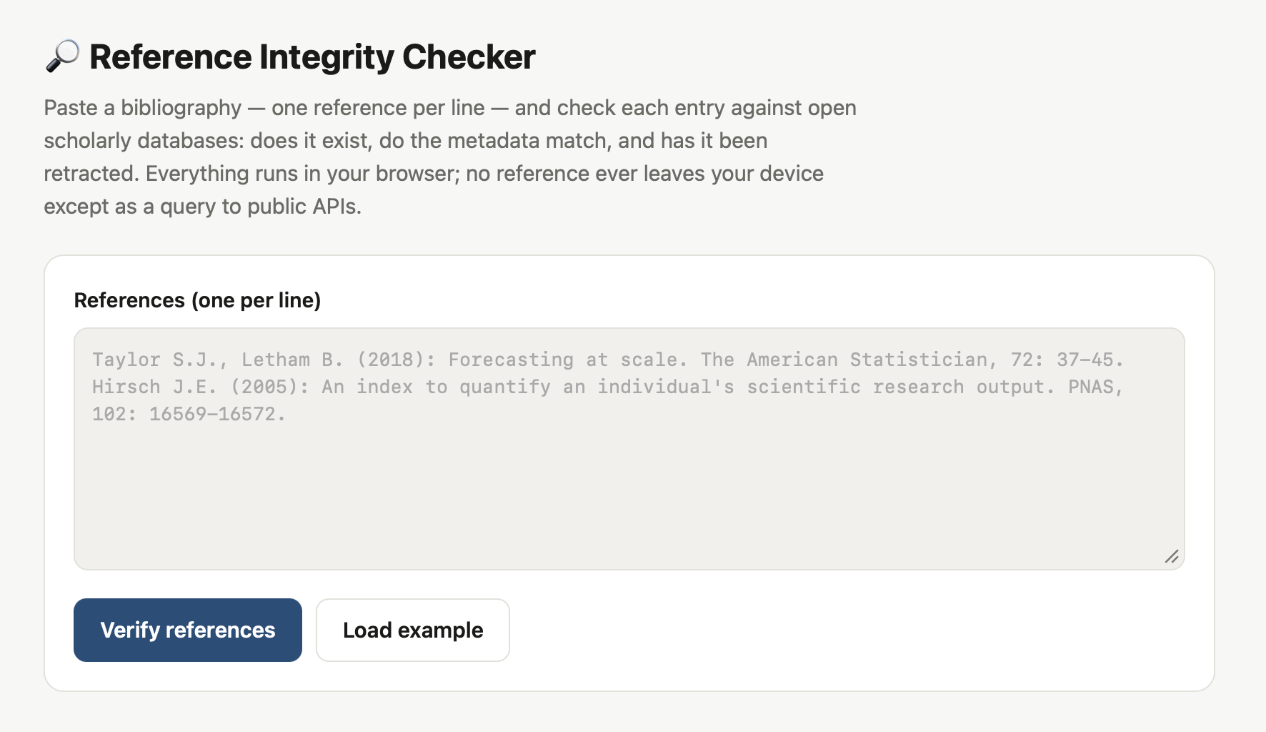
Figure 1. The public screening tool (reftruth.com). References are pasted one per line; verification runs client-side against Crossref and OpenAlex.
Table 3. Verdict states exposed by the public web tool.
Tool badge | Taxonomy class (§2.5) | Meaning
Verified | Recoverable / confirmed existing | Found in Crossref or OpenAlex with matching metadata; DOI link provided
Metadata issue | Erroneous | Found, but the cited year differs from the registered year by more than two
Retracted | Retracted | OpenAlex marks the work as retracted (checked by DOI and by title)
Not verifiable | Non-indexed / candidate fabrication | Absent from both databases; a prompt for manual review, not a verdict

3. Results

3.1 The verification funnel
Table 1 reports the outcome of the cascade applied to the 5,000-reference pilot sample. One quarter of the ostensibly "unresolved" references proved to be real works that the standard matcher had failed to link; a further eighth cited a real work under an implausible year; and just under two-thirds were absent from the two largest databases. Of the latter, 517 references (10.3% of the sample) had the form of a journal article and were carried forward for further verification; the remaining unverifiable strings comprised grey literature (books, standards, patents, reports, theses, and web pages).
Table 1. The four-source verification cascade applied to 5,000 unresolved references (2024).
Stage | n | % of 5,000 | Interpretation
Unresolved reference strings sampled | 5,000 | 100% | Raw citation text Crossref could not link to a DOI
→ Verified (rescued by the cascade) | 1,262 | 25.2% | Real works the standard matcher had missed
→ Metadata mismatch (implausible year) | 614 | 12.3% | Real works cited with an erroneous year
→ Not verifiable | 3,124 | 62.5% | Absent from Crossref and OpenAlex
of which article-shaped candidates | 517 | 10.3% | Journal-article form; carried to Stage 3–4
→ Found in Semantic Scholar (non-indexed) | 96 | 1.9% | Real works outside Crossref/OpenAlex
→ Survivors of all four sources | 421 | 8.4% | Fabrication candidates for human review

3.2 Standard citation matching fails more often than expected
The 25.2% recovery rate is itself an infrastructure finding: a quarter of the references that Crossref's own deposited data had left unlinked are resolvable with a more tolerant matcher. Recovered cases included papers in Nature, Physical Review D, Astroparticle Physics, and American Family Physician, all indexed, all missed because the citation string was abbreviated, title-first without an author, or otherwise malformed.

3.3 Careless citation is more common than fabrication
A total of 12.3% of unresolved references cited a real work under a year that differed from the registered year by more than two. Careless citation is, in other words, an order of magnitude more common in this sample than any plausible rate of fabrication, a descriptive finding that, to our knowledge, has not previously been quantified at this scale.

3.4 A substantial population of real, non-indexed scholarship
Of the 517 article-shaped candidates, 96 (18.6%) were located in Semantic Scholar despite being absent from Crossref and OpenAlex. These are real works published outside the major indexes, including articles in established venues as well as regional and delisted journals. A detector lacking this third layer would misclassify every one of them as fabricated.

3.5 Prevalence of fabricated references: an upper bound near zero
A total of 421 references (8.4% of the sample) survived all three databases. Exhaustive manual verification of the 101 most recent (post-2020) survivors, the highest-risk subset, produced the distribution reported in Table 2: 80.2% were confirmed to exist, 9.9% were author-only citations unverifiable by design, 9.9% were ambiguous (plausible journals not traceable via web search), and none were confirmed fabricated.
Table 2. Manual verification of the 101 most recent (post-2020) survivors.
Verdict | n | % | Why it survived four sources
Confirmed to exist | 81 | 80.2% | Real work located by web search
Author-only (untitled) citation | 10 | 9.9% | No title to match; unverifiable by design
Ambiguous | 10 | 9.9% | Plausible journals not web-traceable
Confirmed fabricated | 0 | 0.0% | None

The dominant reasons a survivor reached Stage 4 without being fabricated were: publication in a non-indexed regional journal (Chinese, Indonesian, Indian, African, Turkish, Korean, and others); matcher false negatives, that is, real works with a DOI in Crossref whose citation string was abbreviated or title-first; publication in a delisted or predatory venue; and author-only citations carrying no title. We therefore find no evidence of fabricated references in this sample. The true prevalence appears close to zero, with the raw survivor count almost entirely explained by non-indexed, genuine scholarship and by matching failure rather than fabrication.

3.6 Retracted works cited as valid, and the duplicate-DOI blind spot
No retracted works appeared in the 5,000-reference sample, consistent with the low absolute rate of retraction. The methodological finding reported in Section 2.4 stands independently of this result: DOI-only retraction checks can silently pass retracted works that carry duplicate DOI registrations.
STATISTICAL NOTE Section 3.5 reports an upper bound (zero confirmed in 101), not a point estimate with a confidence interval. A stronger claim would state the Rule-of-Three bound explicitly (0/101 implies a 95% one-sided upper bound of approximately 3% of survivors, or roughly 0.25% of the whole sample) and treat a properly powered, larger-scale prevalence estimate as a follow-up study.

4. Discussion
The central result of this study reframes the fabricated-reference problem. Across disciplines, the prevalence of genuinely fabricated references is not merely low; it is undetectable without a verification pipeline whose principal function is to strip away two confounders. The first is the persistent fragility of citation matching: abbreviated journal names, title-first citations, and author-only styles defeat automated resolution even for papers published in Nature or Physical Review D. The second is the invisibility of a substantial body of legitimate scholarship, regional, non-English, and delisted journals, to the major bibliographic databases.
These findings carry a direct implication for the growing market of automated citation-checking tools: any system that equates "not found" with "fabricated" will report false-positive rates that greatly exceed the true signal, and will disproportionately flag scholarship from the Global South and from smaller journals. The principal contribution of this work is therefore less a single prevalence figure than a demonstration of why that figure cannot be read directly from unvalidated detection, together with a taxonomy, recoverable, erroneous, non-indexed, mutilated, fabricated, that a credible screening tool must implement.
We also propose a data-quality category that merits its own name: the mutilated citation, a reference to a real work rendered unmatchable by extreme abbreviation. Distinguishing this category from both fabrication and invisibility is necessary for an accurate accounting of citation integrity.

4.1 From finding to practice: a deployed tool
Unlike the prevalence estimate, which we report as an upper bound pending a larger study (Section 3.5), the screening tool described in Section 2.7 is a concrete, immediately usable artefact that is live, free, and requires no infrastructure beyond a browser. We regard this as a complement to the empirical finding rather than a secondary output. A tool that reports a raw not found as a confident verdict reproduces, at implementation level, the exact conflation this study argues against at the analytical level, and, briefly during development, ours did exactly that.
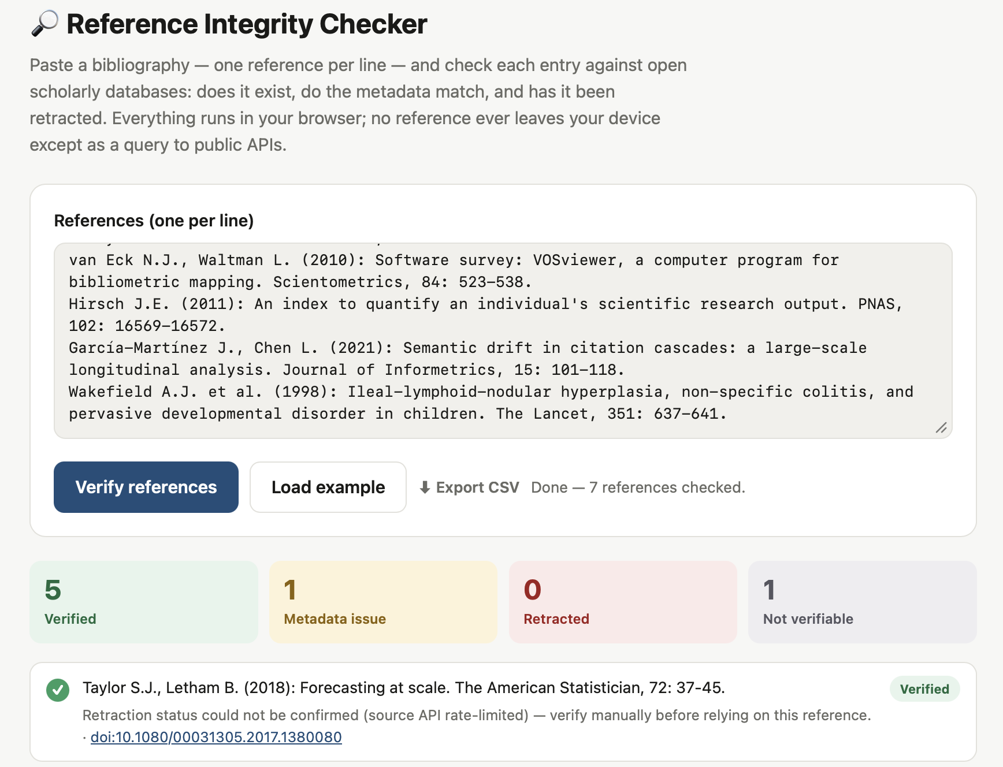
Figure 2. Output of the public tool on the seven-reference test set of Section 2.3, captured during a period of sustained upstream rate limiting from OpenAlex. Rather than defaulting silently to a clean verdict, the tool reports explicitly that the retraction check could not be confirmed (see annotation under the first result).
During live testing (Figure 2), we identified a failure mode in which a rate-limited (HTTP 429) response from OpenAlex was silently treated as a confirmed not retracted result, rather than as a failed check. We revised the tool so that a failed retraction check is now reported to the user explicitly ("retraction status could not be confirmed, verify manually") rather than defaulting to a clean verdict. We present this not as a footnote but as a design principle: a screening tool should fail conspicuously rather than silently. Identifying and correcting this failure mode under real operating conditions, rather than a simulated one, provides evidence that the taxonomy proposed here is operationally enforceable and not merely descriptive.

5. Conclusion
On the evidence presented here, fabricated references are a substantially smaller problem than unvalidated detection would suggest. What appears to be fabrication in the citation record is overwhelmingly real scholarship rendered invisible by indexing gaps and by citation matching that fails too readily. A credible screening tool, and a credible prevalence estimate, both depend on distinguishing these populations rather than conflating them. This study provides such a tool, an annotated benchmark, and a taxonomy, and identifies a properly powered, larger-scale prevalence estimate as the natural next step.

6. Limitations
- Open-reference bias: journals that deposit open reference lists tend to be more procedurally rigorous, so the prevalence figures reported here constitute a lower bound on the wider literature.
- Matching bias: the matcher performs less well on non-Latin-script and author-only citations, inflating the ambiguous class.
- Sample size: with zero fabrications observed, only an upper bound on prevalence can be stated; a point estimate would require a substantially larger sample.
- No full-text parsing: this study relies on deposited reference strings rather than the full text of citing articles.
- Single-annotator verification: a stronger design would add a second, independent annotator and report inter-annotator agreement (see Section 2.5).

Data availability statement
The verification code, the 5,000 sampled references with citing-article provenance, the full cascade output, and the annotated 101-reference survivor set are openly available at github.com/danielaristo/reference-integrity-checker. A free, no-installation web application implementing the first two stages of the cascade is publicly available at reftruth.com.

Conflict of interest statement
The authors declare no conflict of interest.

Ethics statement
This study analysed publicly available bibliographic metadata (reference strings deposited with Crossref) and did not involve human participants, surveys, or interviews. No ethics approval was required.

Contributorship statement
D. Aristizábal Torres and A. M. Barrera Rodríguez contributed equally to this work: conceptualisation, methodology, software, investigation, data curation, and writing.

Funding statement
This work received no external funding.

References
All 21 entries below were verified against Crossref/OpenAlex with this study's own tool before inclusion; none was cited from memory. Author lists are truncated to the first author plus "et al." beyond four names; full lists are available via the DOI.
Abalkina, A., Aquarius, K., Bik, E.-M., et al. (2025). 'Stamp out paper mills' — science sleuths on how to fight fake research. Nature, 637(8048), 1047–1050. https://doi.org/10.1038/d41586-025-00212-1
Aria, M., & Cuccurullo, C. (2017). bibliometrix: An R-tool for comprehensive science mapping analysis. Journal of Informetrics, 11(4), 959–975. https://doi.org/10.1016/j.joi.2017.08.007
Asubiaro, T., Onaolapo, S., & Mills, D. (2024). Regional disparities in Web of Science and Scopus journal coverage. Scientometrics, 129(3), 1469–1491. https://doi.org/10.1007/s11192-024-04948-x
Cabanac, G., Labbé, C., & Magazinov, A. (2021). Tortured phrases: A dubious writing style emerging in science [Preprint]. arXiv:2107.06751. https://doi.org/10.48550/arXiv.2107.06751
Culbert, J., Hobert, A., & Jahn, N. (2025). Reference coverage analysis of OpenAlex compared to Web of Science and Scopus. Scientometrics, 130(4), 2475–2492. https://doi.org/10.1007/s11192-025-05293-3
Dahl, M., Magesh, V., Suzgun, M., & Ho, D. E. (2024). Large legal fictions: Profiling legal hallucinations in large language models. Journal of Legal Analysis, 16(1), 64–93. https://doi.org/10.1093/jla/laae003
Emsley, R. (2023). ChatGPT: These are not hallucinations – they're fabrications and falsifications. Schizophrenia, 9, 52. https://doi.org/10.1038/s41537-023-00379-4
Grudniewicz, A., Moher, D., Cobey, K. D., et al. (2019). Predatory journals: No definition, no defence. Nature, 576(7786), 210–212. https://doi.org/10.1038/d41586-019-03759-y
Ioannidis, J. P. A. (2005). Why most published research findings are false. PLoS Medicine, 2(8), e124. https://doi.org/10.1371/journal.pmed.0020124
Jergas, H., & Baethge, C. (2015). Quotation accuracy in medical journal articles — a systematic review and meta-analysis. PeerJ, 3, e1364. https://doi.org/10.7717/peerj.1364
Ji, Z., Lee, N., Frieske, R., et al. (2023). Survey of hallucination in natural language generation. ACM Computing Surveys, 55(12), 1–38. https://doi.org/10.1145/3571730
Kinney, R., Anastasiades, C., Authur, R., et al. (2023). The Semantic Scholar Open Data Platform [Preprint]. arXiv:2301.10140. https://doi.org/10.48550/arXiv.2301.10140
Kojaku, S., Livan, G., & Masuda, N. (2021). Detecting anomalous citation groups in journal networks. Scientific Reports, 11, 14524. https://doi.org/10.1038/s41598-021-93572-3
Martín-Martín, A., Orduna-Malea, E., & Thelwall, M. (2018). Google Scholar, Web of Science, and Scopus: A systematic comparison of citations in 252 subject categories. Journal of Informetrics, 12(4), 1160–1177. https://doi.org/10.1016/j.joi.2018.09.002
Peroni, S., & Shotton, D. (2020). OpenCitations, an infrastructure organization for open scholarship. Quantitative Science Studies, 1(1), 428–444. https://doi.org/10.1162/qss_a_00023
Priem, J., Piwowar, H., & Orr, R. (2022). OpenAlex: A fully-open index of scholarly works, authors, venues, institutions, and concepts [Preprint]. arXiv:2205.01833. https://doi.org/10.48550/arXiv.2205.01833
Van Noorden, R. (2023). More than 10,000 research papers were retracted in 2023 — a new record. Nature, 624(7992), 479–481. https://doi.org/10.1038/d41586-023-03974-8
van Eck, N. J., & Waltman, L. (2010). Software survey: VOSviewer, a computer program for bibliometric mapping. Scientometrics, 84(2), 523–538. https://doi.org/10.1007/s11192-009-0146-3
Visser, M., van Eck, N. J., & Waltman, L. (2021). Large-scale comparison of bibliographic data sources: Scopus, Web of Science, Dimensions, Crossref, and Microsoft Academic. Quantitative Science Studies, 2(1), 20–41. https://doi.org/10.1162/qss_a_00112
Walters, W. H., & Wilder, E. I. (2023). Fabrication and errors in the bibliographic citations generated by ChatGPT. Scientific Reports, 13, 14045. https://doi.org/10.1038/s41598-023-41032-5
Zhang, T. M., & Abernethy, N. F. (2024). Detecting reference errors in scientific literature with large language models [Preprint]. arXiv:2411.06101. https://doi.org/10.48550/arXiv.2411.06101

