AUTOMATE — Automated Student Record Payment Management System
PRODUCT REQUIREMENTS DOCUMENT (PRD) — MODIFIED MVP
New Modified AUTOMATE

Document Item Details
Project / Team | AUTOMATE — Hackathon 2.0
Product | AUTOMATE — Student Record & Payment Management System
Primary Users | Students and Administrators
Platform | Responsive Web Portal
MVP Status | Hackathon MVP / Deployable Prototype

1. Product Summary
AUTOMATE is a responsive web portal designed to streamline the IT student onboarding process from department selection and eligibility assessment through student capturing and verified payment. The system also provides administrators with a centralized dashboard, registration records, visual reports and Excel export.

2. Problem Statement
The current onboarding process can involve repeated manual entry, difficulty confirming department capacity, manual eligibility checking, payment tracking and fragmented reporting. AUTOMATE brings these activities into one rule-driven workflow, improving traceability, reducing administrative workload and giving administrators a reliable view of registration and payment records.

3. Product Goal & SMART Objectives
Goal: Create a reliable, rule-driven student registration and payment workflow that reduces manual work while improving payment traceability and administrative visibility.
Objective | SMART Target / Measure | Primary Workflow Area
1. Department & Eligibility | By MVP completion, show department availability, automatically score the eligibility test, apply a ≥60% pass rule, record attempts/results and enforce a maximum of 3 attempts. | Student Capturing
2. Student Capturing | By MVP completion, collect required IT student registration information only after the student satisfies department and eligibility rules. | Student Capturing
3. Payment & Confirmation | By MVP completion, initiate Paystack payment, verify payment through backend/webhook, show a successful-payment message only after verification and send registration details by email. | Payment
4. Administration | By MVP completion, centralize completed registrations and payment records, provide dashboard visualizations and generate an Excel report on demand. | Admin

4. Target Users & Value Proposition
User | Needs / Value
IT Student | Clear guided registration flow, department availability check, eligibility assessment, student capturing, secure Paystack payment, successful-payment confirmation, receipt and timetable delivered by email.
Administrator | Protected access to dashboard visualizations, complete registration/payment records, searchable/filterable records and Excel report export.

5. Proposed Solution & User Experience
The MVP is organized around three major buttons on the main portal: Student Capturing, Payment and Admin. The student workflow is rule-driven so that each stage is unlocked only when its required condition is satisfied.

5.1 Main Portal Flow
STUDENT CAPTURING → PAYMENT →ADMINE
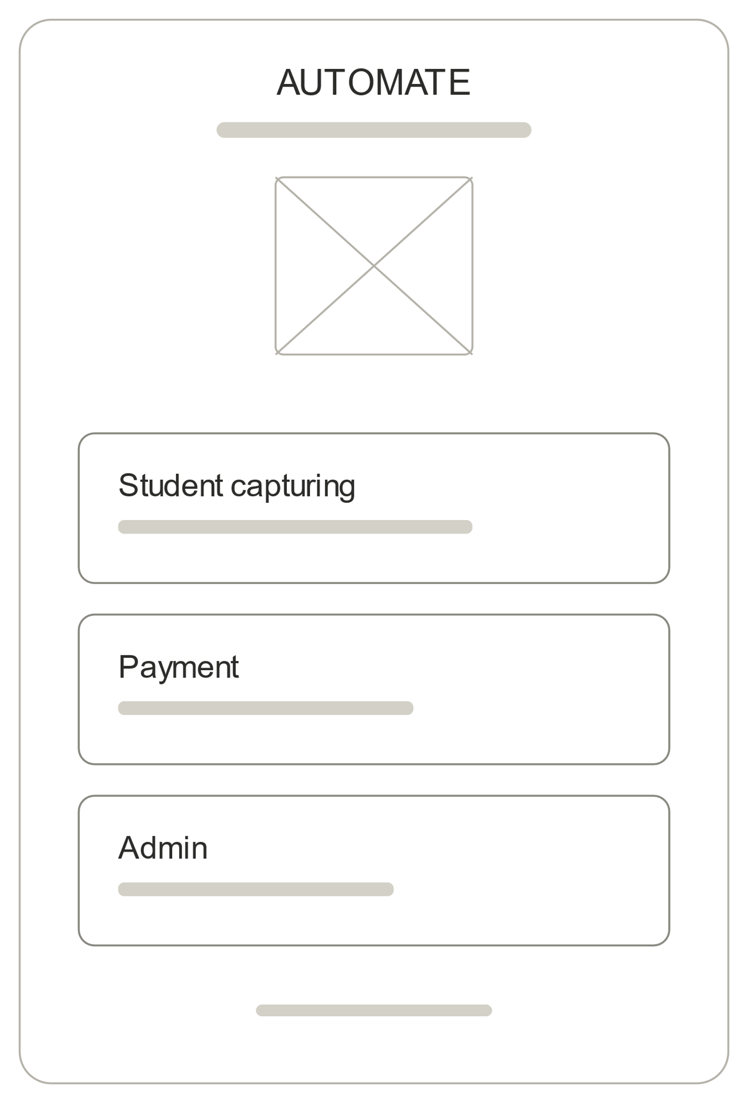

- Student Capturing: Department Selection → Department Slot Check → Eligibility Test → Student Capturing.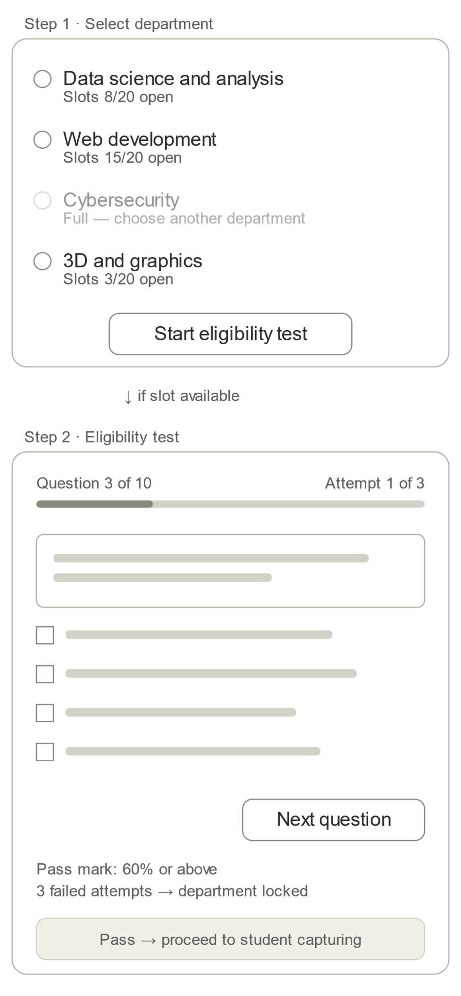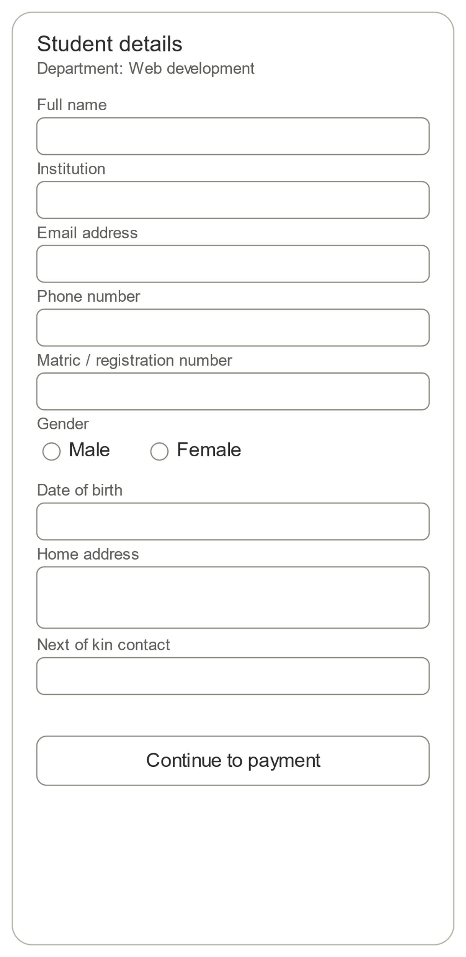

- Payment: Paystack Payment Process → Backend/Webhook Verification → Successful Payment Message → Email 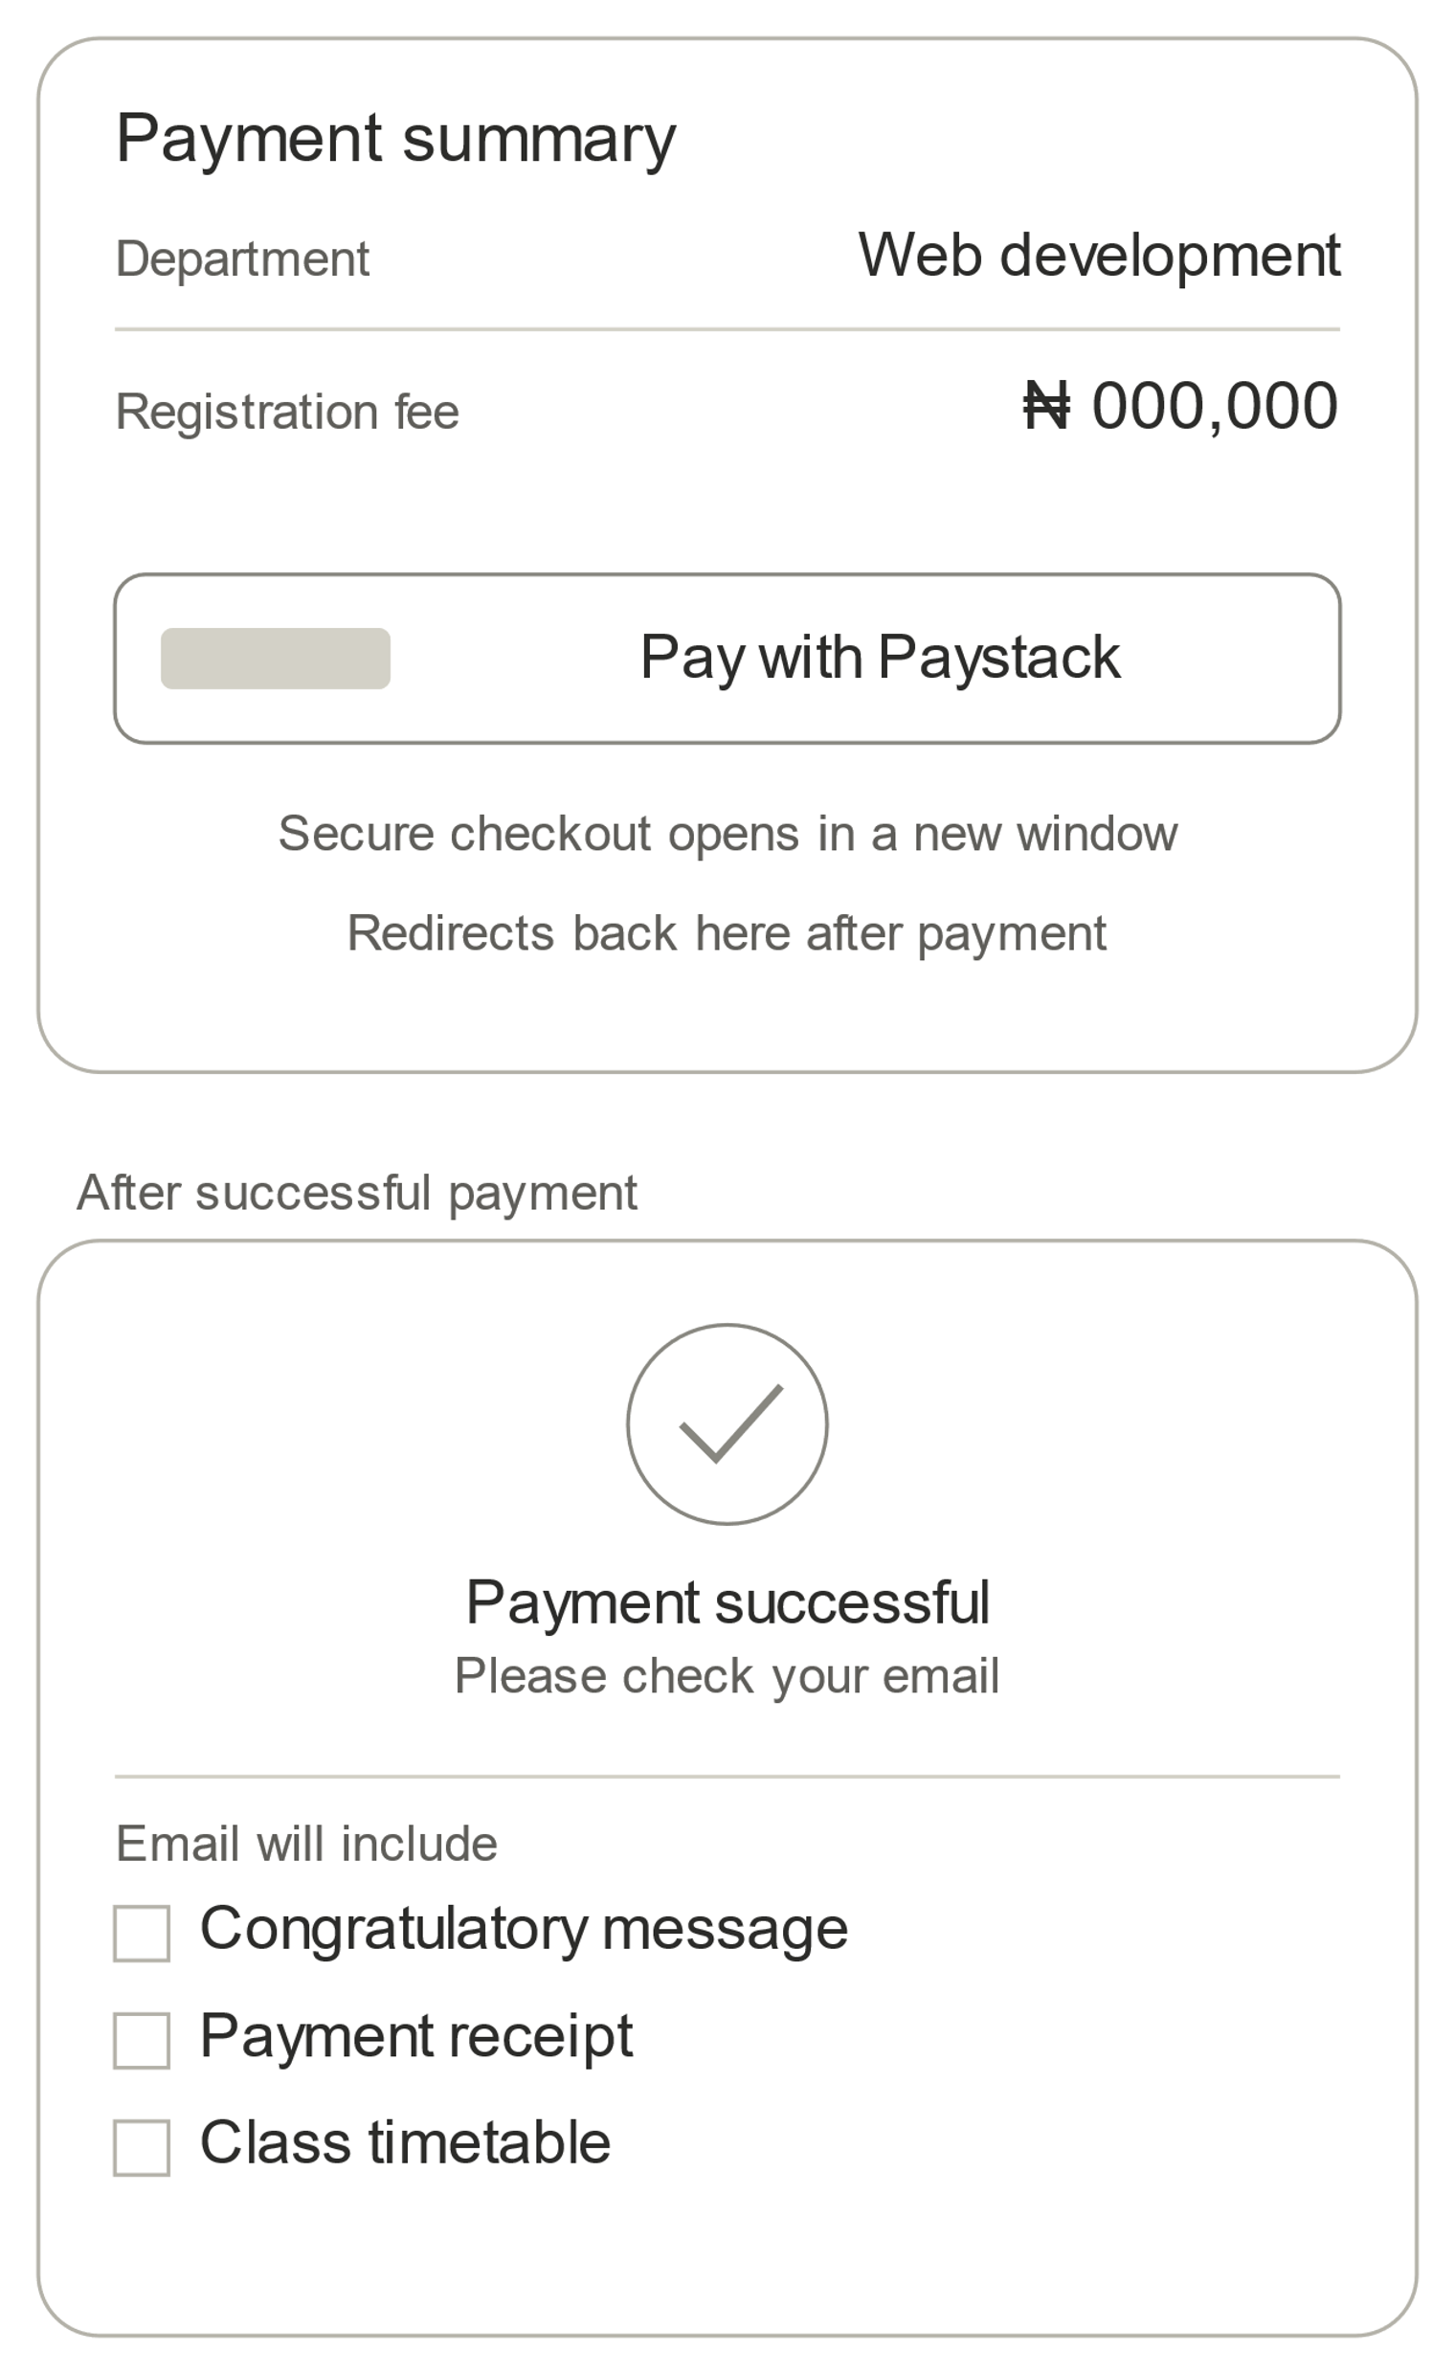
With registration Details, Receipt and timetable

- Admin: Secure Admin Access → Dashboard Visualizations → Registration & Payment Records → Excel Report Export.
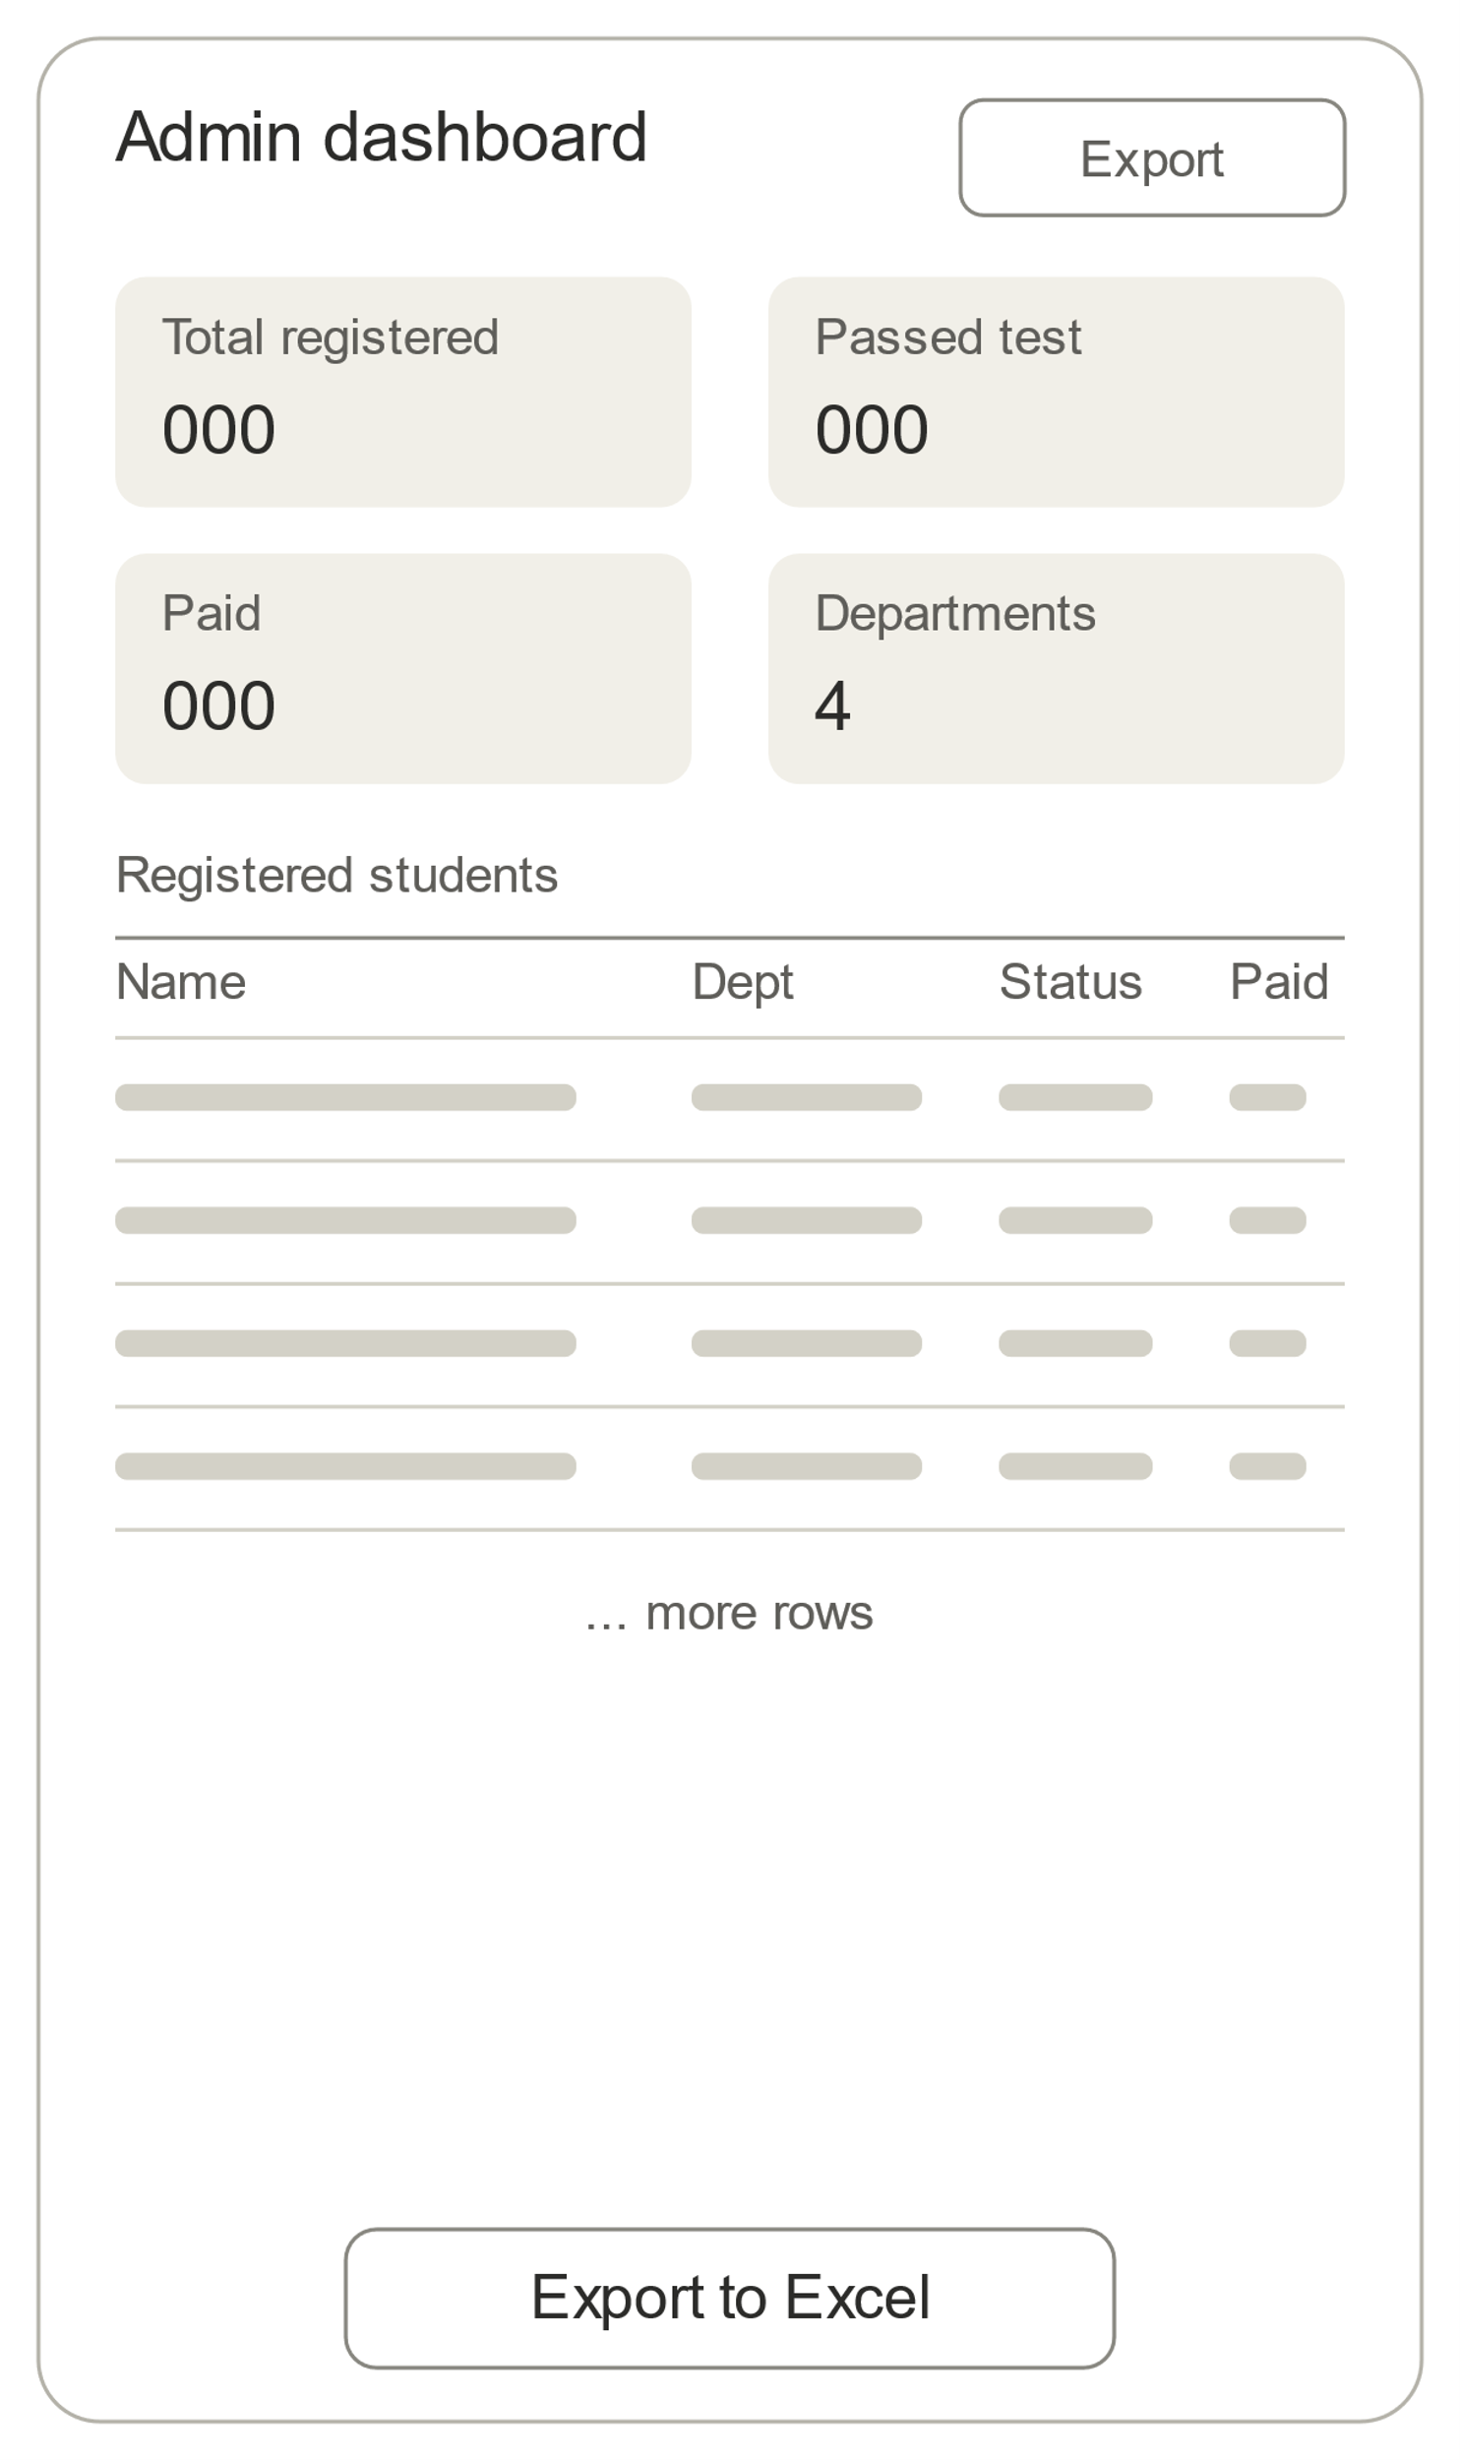

5.2 Student Capturing Flow
Step | Screen / Action | System Behaviour | Progression Rule
1 | Department Selection | Student selects the intended IT department/course. | Selection is checked against configured department capacity.
2 | Department Slot Check | System checks whether a free slot exists for the selected department. | If full, progression is blocked and the student is informed. If a slot is available, the student may continue.
3 | Eligibility Test | System presents the configured eligibility assessment and calculates the score automatically. | Student passes with ≥60%. Maximum of 3 attempts.
4 | Student Capturing | Student enters required registration information such as name, email, phone, institution, IT duration and other required fields. | Capturing is available after eligibility requirements are satisfied; successful submission creates the registration record.

5.3 Payment Flow
Step | System Behaviour | Output
1. Payment Process | Student proceeds to the Payment button and pays the applicable registration fee through Paystack. | Payment request and Paystack reference are created.
2. Verification | Backend verifies the payment using Paystack webhook/backend verification before treating it as successful. | Authoritative payment status is stored.
3. Successful Message | After verified payment, the portal displays: “Successful payment. Check your email for more inquiries.” | Student receives clear confirmation.
4. Email | System sends registration details, a congratulatory message, payment receipt/reference and programme timetable to the student's email. | Digital confirmation package delivered by email.

5.4 Admin Flow
- Admin securely signs in through the protected Admin button.
- Admin views dashboard visualizations showing key registration and payment information.
- Admin views the complete registration records for registered students, including payment status and relevant registration details.
- Admin can search/filter records where required.
- Admin can download registration/payment reports as an Excel (.xlsx) file for local use and reporting.

6. Functional Requirements — 10 Combined Functions
The original 18 functional requirements have been consolidated into 10 broader functions so that related requirements are managed as one coherent product capability.
ID | Combined Function | Requirement / Description
FR-01 | Portal Navigation & Workflow | Provide the three major entry points—Student Capturing, Payment and Admin—and guide users through the appropriate protected workflow.
FR-02 | Department Selection & Slot Management | Display configured departments/courses, check available slots and block selection/progression when capacity is full. Capacity must be enforced server/database-side to prevent overbooking.
FR-03 | Eligibility Assessment & Attempt Control | Present the configured eligibility test, automatically calculate the score, apply the ≥60% pass threshold, store attempts/results and allow a maximum of 3 attempts; block progression after a third failure.
FR-04 | Student Capturing & Registration Record | Collect required IT student information, validate inputs and create the authoritative registration record after the student satisfies the required workflow conditions.
FR-05 | Paystack Payment Processing & Verification | Initiate payment using the configured fee, store payment reference/status/timestamps and verify payment through Paystack webhook/backend before confirmation.
FR-06 | Payment Integrity & Recovery | Prevent duplicate confirmed payments, make payment processing idempotent, and preserve clear pending/failure states so payment records can recover safely.
FR-07 | Success Confirmation & Email Package | Show the successful-payment message only after verified payment and send the student a congratulatory message, receipt/reference, registration details, fee information and timetable by email; log/retry failed email delivery and support resend where required.
FR-08 | Admin Authentication & Record Management | Provide protected administrator access and allow authorized administrators to view, search and filter registration and payment records.
FR-09 | Admin Dashboard & Visualizations | Provide dashboard visualizations for registration totals, fees, department/course distribution/frequency, payment status and other key operational indicators.
FR-10 | Excel Reporting & Export | Allow administrators to export complete registration/payment records as an .xlsx file on demand for local reporting and analysis.

7. Non-Functional Requirements
Area | MVP Requirement
Performance | Core pages should respond quickly under expected load; dashboard/report generation should be practical for the expected pilot volume.
Responsive Design | Mobile-first layout with practical breakpoints for phones, tablets and desktop; no horizontal scrolling on core screens.
Accessibility | Keyboard-accessible assessment questions, visible focus states, clear labels, readable contrast and useful validation messages.
Security | HTTPS; server-side authorization; input validation; protected secrets; hashed credentials; Paystack webhook signature verification; secure payment/registration logs.
Privacy / Retention | Collect only required student PII; define retention rules before deployment; restrict access and delete/anonymize records when the approved retention period expires.
Reliability | Webhook retries/idempotency, email queue/retry, transactional registration/capacity operations and safe handling of payment failure states.

8. MVP Scope & Prioritization
Priority | Scope
P0 — Must | Department selection/slot availability; eligibility test/scoring/3-attempt control; student capturing; Paystack payment; webhook/backend verification; success confirmation; email package; timetable; admin authentication; dashboard; Excel export.
P1 — Should | Search/filter; email resend/recovery; audit logging; configurable department capacity and fees.
P2 — Later | Malpractice prevention; student photo & ID records; IT letter and digital acceptance letter; course information; advanced analytics/reporting.

9. System Architecture & Technical Design
Recommended architecture: a modular monolith suitable for a 4-week hackathon MVP. The browser provides the interface; the application server enforces business rules and integrations; PostgreSQL stores authoritative records.
Layer | Recommended Technology / Role
Frontend | Next.js + React + TypeScript; Tailwind CSS + shadcn/ui; responsive student forms and admin dashboard.
Backend | Next.js server/API routes; Zod validation; server-side business rules and authorization.
Database | PostgreSQL + Prisma ORM; transactions and unique constraints for capacity/payment integrity.
Authentication | Secure session-based admin authentication / Auth.js; server-side protected credentials.
Payment | Paystack API + webhook; backend verification; idempotent payment processing.
Email | Transactional email provider with queue/retry and delivery-status logging.
Reporting | SheetJS (xlsx) for Excel export; Recharts for dashboard visualizations.
Testing / Deployment | Vitest + Playwright; Git/GitHub; Vercel + managed PostgreSQL.

9.1 Core Data Entities
- Department/Course: name, capacity/slot limit, fee, active status.
- Eligibility Attempt: student/session reference, attempt number, score, pass/fail result, timestamp.
- Student Registration: personal/contact details, institution, IT duration, selected department/course, registration status.
- Payment: registration reference, Paystack reference, amount, status, timestamps.
- Email Delivery: registration/payment reference, message type, delivery status, retry information.
- Admin/User: authenticated administrator account and access information.

9.2 Critical Business Rules
- A student may proceed to the eligibility test only when the selected department has an available slot.
- Eligibility pass = score ≥60%; maximum 3 attempts; a third failure blocks progression.
- Student capturing follows successful eligibility and collects the required registration information.
- Payment is not confirmed from browser redirect alone; Paystack webhook/backend verification is authoritative.
- Paystack reference must be unique for confirmed payment; duplicate webhook events must not create duplicate records.
- The central database is authoritative; Excel exports are reporting copies.
- Administrative records must be protected through authenticated access and server-side authorization.

10. Acceptance Criteria & Success Metrics
Measure | Target
Registration Workflow | Student can complete Department Selection → Slot Check → Eligibility → Capturing → Payment → Email confirmation when all rules are satisfied.
Eligibility | 100% of test scores calculated automatically; ≥60% pass rule and 3-attempt limit enforced.
Payment Reliability | Payment is confirmed only after Paystack backend/webhook verification; duplicate confirmed payments are prevented.
Administrative Visibility | Admin can view dashboard visualizations and complete registration/payment records.
Reporting | Admin can download an Excel report of registration/payment records.
Core Quality | At least 90% of core test cases pass before demo.

11. Risks, Constraints & Assumptions
Risk / Constraint | Mitigation / Assumption
Department overbooking | Use server/database transaction and capacity constraints rather than frontend-only checks.
Eligibility abuse | Record attempts/results and enforce the 3-attempt rule server-side.
Payment verification failure | Use Paystack webhook + backend verification, retries and idempotency; never treat browser success as final proof.
Duplicate payment/webhooks | Use unique Paystack reference constraints and idempotent processing.
Email deliverability | Log email status, queue/retry failed delivery and provide a resend mechanism.
Student PII exposure | Least-privilege access, protected admin routes, HTTPS, secure secrets and defined retention policy.
Hackathon time | Prioritize P0 requirements, combine related functions and avoid unnecessary microservices or complex infrastructure.
Internet/payment dependency | Show clear pending/failure states and preserve registration/payment status for recovery.

12. 4-Week MVP Roadmap
Weeks | Monday–Thursday Focus | Friday Deliverable / Pitch Progress
Week 1 — Planning & Design | Requirements freeze; modified user flow; database design; low-fidelity wireframes; UI design; PRD; architecture; define departments, capacity, eligibility and fees. | Design review and Week 1 research/design pitch.
Week 2 — Core Build | Database; admin authentication; department selection/slot logic; eligibility assessment and attempt control; student capturing; initial dashboard. | Core workflow progress demo.
Week 3 — Integration & Testing | Paystack integration; webhook verification; payment integrity; confirmation message; email package; timetable; Excel export; testing and bug fixes. | Integrated MVP progress demo and test results.
Final Preparation | Final end-to-end testing; UI/UX improvements; bug fixes; deployment; data/demo preparation; performance and security checks; pitch rehearsal; finalize metrics and presentation. | Final product demo, pitch rehearsal and impact/results presentation.

13. Definition of Done
- Student can complete the intended workflow from department selection through eligibility and capturing.
- Department capacity and eligibility rules are enforced server-side.
- Verified Paystack payment creates one authoritative payment record and confirmation.
- Successful payment triggers the required on-screen message and email package containing registration details, receipt/reference and timetable.
- Email failures are logged/retried and can be resent where implemented.
- Admin can securely sign in, view dashboard visualizations, search/filter records and export .xlsx data.
- Capacity, duplicate payment and 3-attempt rules are enforced server-side.
- Responsive/accessibility checks and core tests are completed before the final demo.

14. Open Questions / Configuration Before Deployment

Scalability & Configuration
AUTOMATE is being prototyped around the Nascomsoft student onboarding process but is designed to be configurable for other training centres, schools and similar institutions. Departments/courses, fees, eligibility rules and slot limits should be configurable without rebuilding the core system. Configure, Don't Rebuild.

Future Scope
- Transparent assessment and malpractice prevention.
- Student passport/photo upload and reusable ID records for easier ID-card creation.
- IT letter upload and online acceptance-letter delivery.
- Course information.
- Advanced analytics and reporting.

