**Allerseelen – Strauss (split every 20 seconds)**

|  |  |  |  |
| --- | --- | --- | --- |
| **Non-Isolated Vocals** | | **Isolated Vocals** | |
| 0  20  40  60  80  100  120  140  160  180  200 | sad  calm  calm  calm  calm  calm  calm  calm  sad  **sad**  angry | 0  20  40  60  80  100  120  140  160  180  200 | sad  calm  calm  calm  calm  calm  calm  calm  sad  **calm**  angry |

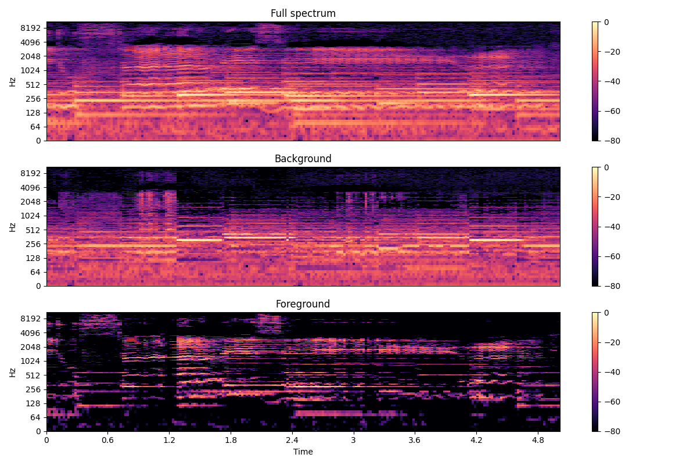

**Lenski’s Aria – Tchaikovsky (split every 20 seconds)**

|  |  |  |  |
| --- | --- | --- | --- |
| **Non-Isolated Vocals** | | **Isolated Vocals** | |
| 0  20  40  60  80  100  120  140  160  180  200  220  240  260  280  300  320  340  360  380 | sad  **calm**  calm  calm  calm  calm  calm  **calm**  calm  calm  calm  **calm**  calm  **calm**  **calm**  **calm**  calm  calm  sad  angry | 0  20  40  60  80  100  120  140  160  180  200  220  240  260  280  300  320  340  360  380 | sad  **neutral**  calm  calm  calm  calm  calm  **sad**  calm  calm  calm  **happy**  calm  **sad**  **fear**  **fear**  calm  calm  sad  angry |

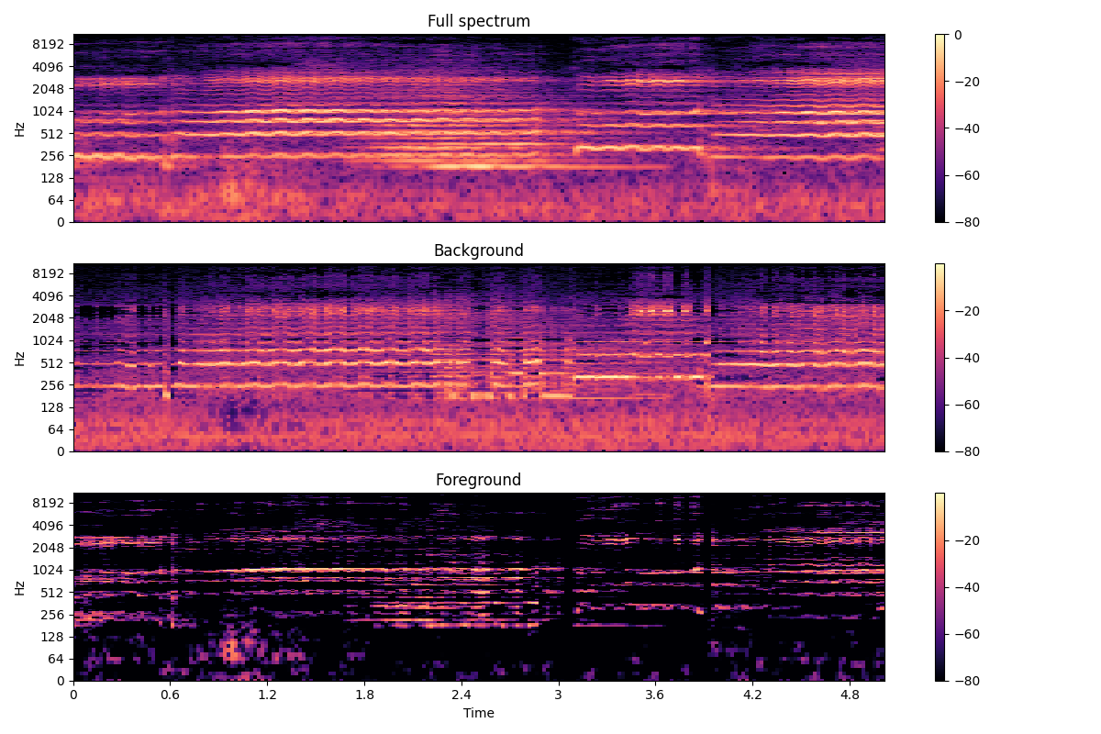

**Lenski’s Aria – Tchaikovsky (split comparison)**

|  |  |  |  |  |  |  |  |  |  |
| --- | --- | --- | --- | --- | --- | --- | --- | --- | --- |
| **Isolated Vocals Split 10 Seconds** | | **Isolated Vocals Split 20 Seconds** | | **Isolated Vocals Split 40 Seconds** | | **Isolated Vocals Split 60 Seconds** | | **Isolated Vocals Split 120 Seconds** | |
| 0  10  20  30  40  50  60  70  80  90  100  110  120  130  140  150  160  170  180  190  200  210  220  230  240  250  260  270  280  290  300  310  320  330  340  350  360  370  380 | sad sad sad  sad  calm  happy  calm  calm  calm  sad  calm  calm  calm  calm  calm  calm  happy  happy  calm  calm  calm  calm  happy  calm  calm  happy  calm  fear  fear  happy  fear  calm  sad  happy  calm  calm  calm  calm  angry | 0  20  40  60  80  100  120  140  160  180  200  220  240  260  280  300  320  340  360  380 | sad  neutral  calm  calm  calm  calm  calm  sad  calm  calm  calm  happy  calm  sad  fear  fear  calm  calm  sad  angry | 0  40  80  120  160  200  240  280  320  360 | calm  calm  calm  happy  happy  calm  calm  fear  sad  calm | 0  60  120  180  240  300  360 | sad  calm  angry  sad  happy  angry  sad | 0  120  240  360 | calm  happy  sad  calm |

**Sure on this Shining Night – Lauridsen (split every 20 seconds)**

|  |  |  |  |
| --- | --- | --- | --- |
| **Non-Isolated Vocals** | | **Isolated Vocals** | |
| 0  20  40  60  80  100  120  140  160  180  200  220  240  260 | calm  **calm**  calm  calm  sad  calm  happy  **sad**  angry  calm  calm  **calm**  calm  **calm** | 0  20  40  60  80  100  120  140  160  180  200  220  240  260 | calm  **happy**  calm  calm  sad  calm  happy  **fear**  angry  calm  calm  **sad**  calm  **sad** |

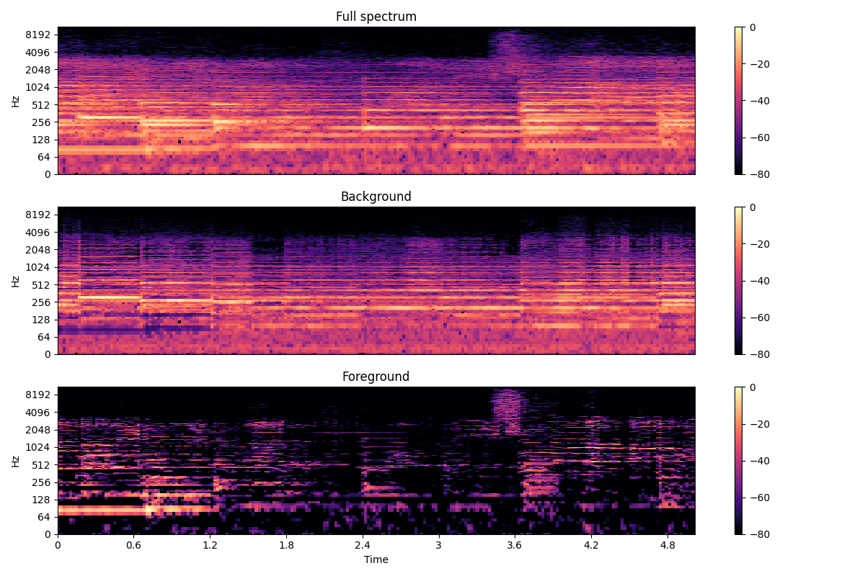

**Coriolan Overture – Beethoven (split comparison)**

|  |  |  |  |
| --- | --- | --- | --- |
| **Orchestral Split 20 Seconds** | | **Orchestral Split 40 Seconds** | |
| 0  20  40  60  80  100  120  140  160  180  200  220  240  260  280  300  320  340  360  380  400  420  440  460  480 | calm  calm  calm  calm  calm  calm  calm  calm  calm  calm  calm  calm  calm  calm  calm  calm  calm  calm  calm  calm  calm  neutral  calm  calm  calm | 0  40  80  120  160  200  240  280  320  360  400  440  480 | calm  calm  calm  calm  calm  calm  calm  calm  calm  calm  calm  sad  calm |

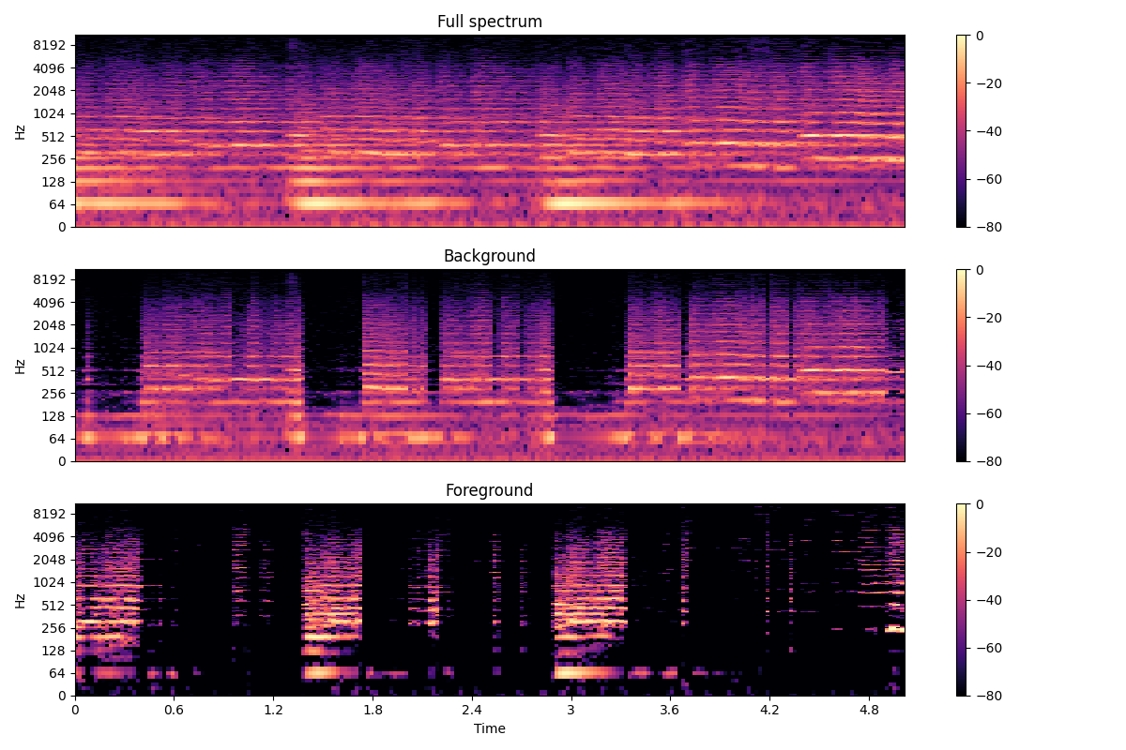

**Der Erlkönig – Schubert (split every 10 and 20 seconds)**

|  |  |  |  |  |  |  |  |
| --- | --- | --- | --- | --- | --- | --- | --- |
| **Non-Isolated Vocals**  **(10 seconds)** | | **Isolated Vocals**  **(10 seconds)** | | **Non-Isolated Vocals**  **(20 seconds)** | | **Isolated Vocals**  **(20 seconds)** | |
| 0  10  20  30  40  50  60  70  80  90  100  110  120  130  140  150  160  170  180  190  200  210  220  230  240 | calm **calm calm** calm calm **calm calm calm calm** calm calm **fear** calm calm calm happy calm **calm neutral** happy angry **happy** happy **calm fear** | 0  10  20  30  40  50  60  70  80  90  100  110  120  130  140  150  160  170  180  190  200  210  220  230  240 | calm **sad sad** calm calm **sad sad sad sad** calm calm  **happy** calm calm calm happy calm **sad sad** happy angry **calm**  happy **sad calm** | 0  20  40  60  80  100  120  140  160  180  200  220  240 | calm  **sad**  calm  sad  **calm**  calm  calm  **sad**  calm  calm  angry  **happy**  **fear** | **0**  **20**  **40**  **60**  **80**  **100**  **120**  **140**  **160**  **180**  **200**  **220**  **240** | calm  **fear**  calm  sad  **sad**  calm  calm  **calm**  calm  calm  angry  **angry**  **calm** |

